### Activities to enhance students’ understanding of acceleration

M N Khwanda

Physics Department, P. O. Box 524, University of Johannesburg, Auckland Park 2006, South Africa.

pmolefe@uj.ac.za

**Abstract**. Challenges in the teaching and learning of physics existed as far as education existed worldwide. During the period, various approaches were continuously suggested and implemented but the learning gains were always disappointing, and physics was labelled as a difficult subject for the chosen few and that idea encouraged instructors accept high failure rate in physics as normal. Departing form that belief that physics is for the chosen few. The current study explored how pre-service teachers understand the concept of acceleration. Google form was used to collect data that informed the instructor about students’ prior understanding of the concept of acceleration. Data collected were used to determine if acceleration is also threshold concept. Threshold concepts open productive ways of thinking in a domain and are troublesome in nature. Troublesome knowledge is said to be knowledge that is “alien, or counter-intuitive or even intellectually absurd at face value”. Learning can be blocked if learners are experiencing difficulties in grasping a certain threshold concept. Threshold concepts were rationally classified into liminal states. The aim of this paper was to: 1. Explore if acceleration is a threshold concept and, 2. Categorize pre-service students’ knowledge of acceleration in terms of liminal states

Keywords: Preservice teachers, acceleration, threshold concepts and troublesome knowledge

1. **Introduction and background**

It took nearly 2000 years from the time of Aristotle to reach a clear understanding of motion [1]. The following subsections highlight some of the challenges in the teaching and learning of the concept acceleration. It is regarded as essential and a fundamental concept in mechanics [2] but less understood qualitatively as is normally expressed qualitatively.

.

* 1. *Mathematical treatment of definitions by introductory physics textbooks*

The way textbooks present the topic of acceleration [3] can also contribute to deny students to apply the concept in real life context. For example, after speed and velocity is introduced, then average acceleration is defined mathematically as ratio of change in velocity over an elapsed time, and later SI units are given directly from the ratio. Similar pattern was observed in [4]. The sequence in [4] becomes a challenge because mathematically we expect no units since only same quantities can be divided.[5] on the other hand, acceleration is defined as the rate of change in velocity but the ratio and rate concepts are not clearly differentiated and that cause a challenge to learning. According to [3], acceleration is regarded as an abstract higher order concept that cannot be taught without strong understanding of the rate of change concept which cut across different topics. In addition [3] noted the following challenges as barrier to understanding definitions qualitatively:

* failure to point out when it is appropriate to use particular definitions or that an alternative definition might be more appropriate in specific situations,
* inclusion of operational definitions without conceptual explanations,
* a focus on quantitative treatments while overlooking the development of qualitative understanding.

*1.2 The everyday usage of the word acceleration*

The everyday usage of the word acceleration is also a challenge. In **everyday** terms, **acceleration** refers to objects which are moving fast. Generally in real world, fast is associated with an event occurring many times in a very short space of time. Students are also familiar with some parts of the car that changes the state of motion as shown in figure 1 below

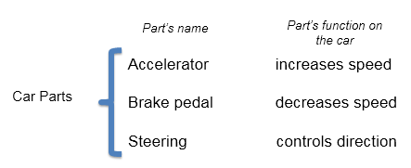

Figure 1: Car parts

*1.3 What is known by students from high schools?*

Based on experience as a high school teacher and an introductory physics lecturer, high school sstudents entering university can (a) differentiate between a vector and a scalar quantity, (b) Students can reproduce the definition of acceleration as a rate of change in velocity without understanding the meaning, (c) they memorised that velocity and acceleration vector quantities, and lastly (d) they can get numerical answers correctly by substituting in a formula.

*1.4 Aim of the study*

Literature claimed that physics students feel that the content is abstract and they are unable to relate the materials in real-life contexts [6]. In the context of this study, by analogy, it can be claimed that students only study or memorized acceleration to answer physics questions but they don’t apply the knowledge. It is against this background that the first aim of this study explores if acceleration can be regarded as a threshold concept. The second aim was to assess pre-service students’ understanding of the concept of acceleration by categorizing pre-service teacher’s knowledge according to liminal states. This knowledge will be helpful in planning instruction that will help students to relate acceleration with real life phenomena

1. **Theoretical Background**
   1. Threshold concept

The Threshold Concepts Framework represents a way of thinking about curricula where specific elements that are challenging for students to understand have a transformational impact on their learning once they are understood [7].Threshold concepts open productive ways of thinking in a domain and are troublesome in nature. Troublesome knowledge is said to be knowledge that is “alien, or counter-intuitive or even intellectually absurd at face value”.[8]. Learning can be blocked if learners are experiencing difficulties in grasping a certain threshold concept.The journey towards the acquisition of a threshold concept is seen to be initiated by an encounter with a form of troublesome knowledge in the pre-liminal state. The teacher’s role is to help students to cross conceptual threshold [9] Learning can be blocked if a student is experiencing difficulties in grasping a certain threshold concept [9] Crossing the threshold involves “both mastering the concept and also feeling comfortable in their new knowledge” [10]. It was noted that: “Difficulty in understanding threshold concepts may leave the learner in a state of ‘liminality’, a suspended state of partial understanding, or ‘stuck place’, in which understanding approximates to a kind of ‘mimicry’ or lack of authenticity. Insights gained by learners as they cross thresholds can be exhilarating but might also be unsettling, requiring an uncomfortable shift in identity, or, paradoxically, a sense of loss [11].

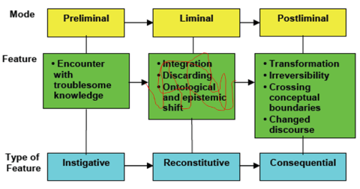

Figure 2: A relational view of liminal states

As shown in figure 2 preliminal stage is an investigative stage where one is not sure and encounters troublesome knowledge. Liminal state is a reconstitutive state which involves the process of transformation where there is ontological and epistemological shift which should be facilitated by instructor or teacher. Once the liminal stage is crossed to post liminal, there will be new irreversible understanding of the concept which will not depend on mimicry or memorisation. Once post-liminal state is reached, students will be able to apply the knowledge of the concept of acceleration.

1. **Methodology**
   1. *Participants in the study*

The study involved first-year pre-service teachers before the first lesson during the first semester at University of Johannesburg. Students were still fresh from high-school where they were last taught the concept of acceleration in mechanics. All participants in the study had either a smart phone or a computer that can be connected to university WI-FI system. These smart phones and/or computers are accepted as learning tools.

* 1. *Instrument used for data collection*

This was a snapshot once-off pre-test design aimed at exploring students understanding of the concept of acceleration before instruction at university. Two questions in the form of two tier questionnaires focusing on vector nature of acceleration were developed by researcher because it was noted that students tended to omit the vector nature of both acceleration and velocity [2]. Questions were based three parts of a car that changes the state of motion, namely: an accelerator, a brake pedal and a steering wheel. The main aim of choosing these parts was to show how these parts in car can be used as examples where the concept of acceleration is applicable in real life context. These parts are never mention when acceleration is taught. Previously, [12] indicated how a roller-coaster can be used to teach the concept of acceleration. According to [13] different types of motion can be illustrated using a rollercoaster.The questionnaire was administered the first week during the first term. Student’s responses were collected using Google form and took on average 30 minutes to complete. Students were instructed to answer all questions honestly to the best of their abilities since no score were attached to questionnaire. Google form was opted because it allows an instant retrieval of student’s responses.

1. Results and Discussion

The first question explored if pre-service students know that when the speed/velocity of an object decreases, then the object is accelerating because there is a change in speed/velocity. The main focus was on change in magnitude of speed or velocity.

***Question 1:***

*An automatic car has two pedals used to control its motion. The accelerator pedal once pressed increases the speed while the brake pedal lowers the speed. Do you think the brake pedal can accelerate the car? Choose either Yes or No and then justify your answer*

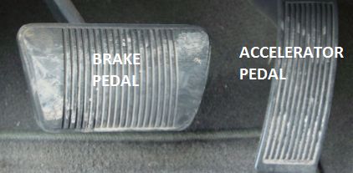

Figure 3: Automatic Pedals

|  |  |
| --- | --- |
|  |  |

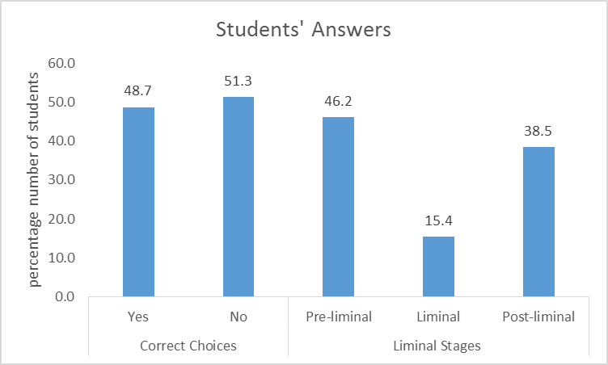

Figure 4: Categories of students’ answers for question 1

Figure 4 shows students’ answers to the question represented by figure 3. Figure 4 shows that less that 50 % or to be exact 48.7 % do not associate a brake pedal as an accelerator because it does not increase the speed of the car. The results revealed that even if students are able to define acceleration as the rate of change in velocity, but do not recognise that the decrease in speed or velocity is regarded as the change in speed and velocity. In real life our body feel the change in velocity [13] which technically is called acceleration. That means if the brake pedal is pressed, we feel acceleration.

The second question focused on the most ignored [3] feature of acceleration, direction. In most cases, linear motion is considered. As acceleration is vector quantity, students from high school entering university do not think changing direction is accelerating. This is caused by the way they are trained to answer question when only linear motion is considered. For example in calculation strategies, they are taught to memorise that: “*when velocity or speed is constant, then acceleration is zero*”

***Question 2:***

*All cars have steering wheels. Do you think the steering wheel can accelerator a car? Explain your answer in details*



Figure 5: A steering wheel

Pre-service students’ answers are shown in figure 6. The correct answer is a “yes” option.Figure 6 shows that 82.1% do not think a steering wheel can sometimes act as an accelerator, but they know that it can change direction. The results of 82.1 Preservice students concur with [2] because it seems as if the omitted role of steering in changing direction while explaining their answers.

|  |  |
| --- | --- |
|  |  |

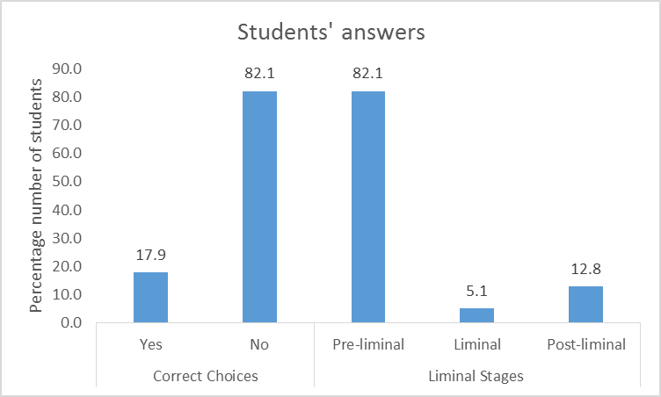

Figure 6: Categories of students’ answers for question 2

. on the other hand out of 17 % of preservice students who opted for the correct choice, only 12.8 % The results suggest that only yes and no questions are not enough if the focus is understanding, which means that in terms of liminal categorization, 12.8 % have crossed the liminal stage and are in post liminal stage*.* Majority of students indicated that the steering wheel doesn’t change the car’s magnitude of the velocity of the car, hence cannot be an accelerator. An example of explanation given was as follows: “*No, the only purpose of the steering wheel is to change the direction of the car not to help accelerate the car faster” .*

1. Conclusions

Based on the answer’s students gave, one can conclude that students who cross liminal state have shown an understanding of acceleration because they were able to mention that both change in magnitude of speed or velocity and the change in direction during their justifications. The analysis of students’ explanations revealed that most students are still at preliminal state in terms of understanding acceleration. That implies that students under study do not understand acceleration qualitatively, hence instruction should start with activities that enhances qualitative understanding of acceleration. That can be achieved by using real life contexts where the knowledge of acceleration can be applied. It should be the aim of all instructions to deliver students to post liminal state for the knowledge to be useful. Since only two questions were used, further probe is needed to conclude if acceleration is a threshold concept even if the results partially shows revealed the troublesomeness of the concept.

1. Acknowledgements

I thanks UJ for financial support and all participants are acknowledged.

# References

[1] Hewitt, P G, Conceptual Physics (2006). Pearson International Edition, (Pearson Upper Saddle River, NJ) 10th ed.

[2] Sutopo, Liliasari, Waldrip, B., & Rusdiana, D. (2012). IMPACT OF REPRESENTATIONAL APPROACH ON THE IMPROVEMENT OF STUDENTS’ UNDERSTANDING OF ACCELERATION. *Jurnal Pendidikan Fisika Indonesia 8, 8*, 161-173.

[3] Dall’Alba, G., Walsh, E., Bowden, J., Martin, E., Masters, G., Ramsden, P., & Stephanou, A. (1993). Textbook Treatments and Students’ Understanding of Acceleration. *JOURNAL OF RESEARCH IN SCIENCE TEACHING, 30*(7), 621-635.

[4] Cutnell, J., & Johnson, K. (2012). *Introduction to physics* (9th ed.). Hoboken, NJ: John Wiley & Sons, Inc.

5] Taşar, M. F. (2010). Which part of the concept of acceleration is difficult to understand:the mathematics, the physics, or both? *ZDM, 42*(5), 469-482.

[6] Kwok, S. (2018). Science Education in the 21st Century. *Nature Astronomy, 2*, 530-533.

[7] Land, R. (2016). TOIL AND TROUBLE Threshold Concepts as pedagogy of Uncertainty. In R. Land, J. J. F. Meyer, & M. & Flanagan, *Threshold Concepts in Practice* (pp. 11-24). Sense Publisher

[8] Meyer, E., & Land, R. (2003). *Threshold Concepts and Troublesome Knowledge:Linkages to Ways of Thinking and Practising within the Disciplines.* Universities of Edinburgh. Durham: ETL Project. Retrieved June 14, 2018, from URL: http://www.tlrp.org

[9] Stokes, A., King, H., & Libarkin, J. (2007). Research in Science Education: Threshold Concepts. *Journal of Geoscience Education, 55*(5), 434-438.

[10] Felten, P. (2016). On the threshold with students. In R. Land, J. F. Meyer, & M. T. Flanagan, *Threshold Concepts in Practice* (pp. 3-10). Sense Publisher.

[11] Meyer, J., Land, R., & Baillie, C. (2010). Editors’ Preface: Threshold Concepts and Transformational Knowldege. In J. Mayer, R. Land, & C. Baillie, *Threshold Concepts and Transformational Knowldege.* Sense Publisher.

[12] Pendrill, A. (2008). Acceleration in School in Everyday Life and in Amusement Parks. In I. V. Eriksson, *Science Education in the 21st Century* (pp. 183-204). New York: Nova Publishers, Inc.

[13] Eager, D., Pendrill, A.-M., & Reistad, N. (2016). Beyond velocity and acceleration: jerk,snap and higher derivatives. *European Journal of Physics, 37*, 1-11.

# References

Basson, I. (2002). Physics and mathematics as interrelated fields of thought development using acceleration as an example. *International Journal of Mathematical Education in Science and technology*, 679-690.

Bowden, J., & Marton, F. (1998). *The university of learning: Beyond quality and competence.* London: Kogan Page Limited.

Cutnell, J., & Johnson, K. (2012). *Introduction to physics* (9th ed.). Hoboken, NJ: John Wiley & Sons, Inc.

Dall’Alba, G., Walsh, E., Bowden, J., Martin, E., Masters, G., Ramsden, P., & Stephanou, A. (1993). Textbook Treatments and Students’ Understanding of Acceleration. *JOURNAL OF RESEARCH IN SCIENCE TEACHING, 30*(7), 621-635.

Eager, D., Pendrill, A.-M., & Reistad, N. (2016). Beyond velocity and acceleration: jerk,snap and higher derivatives. *European Journal of Physics, 37*, 1-11.

Felten, P. (2016). On the threshold with students. In R. Land, J. F. Meyer, & M. T. Flanagan, *Threshold Concepts in Practice* (pp. 3-10). Sense Publisher.

Kwok, S. (2018). Science Education in the 21st Century. *Nature Astronomy, 2*, 530-533.

Land, R. (2016). TOIL AND TROUBLE Threshold Concepts as pedagogy of Uncertainty. In R. Land, J. J. F. Meyer, & M. & Flanagan, *Threshold Concepts in Practice* (pp. 11-24). Sense Publisher.

Marton, F., & Booth, S. (1997). *Learning and awarenes.* New Jersey: Lawrence Erlbaum Associates.

Marton, F., & Tsui, A. (2004). *Classroom discourse and the space of learning.* New jersey: Lawrence Erlbaum Associates.

McDermott, L., & Reddish, E. (1999). Resource Letter on Physics Education Research. *American Journal of Physics*.

Meyer, E., & Land, R. (2003). *Threshold Concepts and Troublesome Knowledge:Linkages to Ways of Thinking and Practising within the Disciplines.* Universities of Edinburgh. Durham: ETL Project. Retrieved June 14, 2018, from URL: http://www.tlrp.org

Meyer, J., Land, R., & Baillie, C. (2010). Editors’ Preface: Threshold Concepts and Transformational Knowldege. In J. Mayer, R. Land, & C. Baillie, *Threshold Concepts and Transformational Knowldege.* Sense Publisher.

Pendrill, A. (2008). Acceleration in School in Everyday Life and in Amusement Parks. In I. V. Eriksson, *Science Education in the 21st Century* (pp. 183-204). New York: Nova Publishers, Inc.

Stokes, A., King, H., & Libarkin, J. (2007). Research in Science Education: Threshold Concepts. *Journal of Geoscience Education, 55*(5), 434-438.

Sutopo, Liliasari, Waldrip, B., & Rusdiana, D. (2012). IMPACT OF REPRESENTATIONAL APPROACH ON THE IMPROVEMENT OF STUDENTS’ UNDERSTANDING OF ACCELERATION. *Jurnal Pendidikan Fisika Indonesia 8, 8*, 161-173.

Taşar, M. F. (2010). Which part of the concept of acceleration is difficult to understand:the mathematics, the physics, or both? *ZDM, 42*(5), 469-482.