Photobiomodulation activates the JAK/STAT signalling pathway in diabetic wounded cells in vitro
S W Jere, H Abrahamse and N N Houreld

Laser Research Centre, Faculty of Health Sciences, University of Johannesburg, P.O. Box 17011, Doornfontein, 2028 South Africa.
Tel: +27 11 559 6833; Fax: +27 11 559-6884

Email: nhoureld@uj.ac.za

Abstract. The Janus Kinase/Signal Transducer and Activator of Transcription (JAK/STAT) pathway is involved in the transmission of external signals via receptors to the nucleus. Diabetic wounds develop due to various mechanisms, including decreased cell migration. Photobiomodulation (PBM) induces cellular migration and wound healing. However, the mechanism/s involved in the stimulation of migration are not completely understood. This investigation aimed to determine the effect of PBM on migration and the activation of the JAK/STAT signaling pathway in a diabetic wounded cell model. Diabetic wounded human skin fibroblast cells (WS1) were exposed to a diode laser at 660 nm with a fluence of 5 J/cm² and incubated for 48 h. Non-irradiated (0 J/cm²) cells served as controls. Cellular migration was monitored microscopically and the activation (phosphorylation) of JAK2, STAT1 and STAT5 was analyzed by the enzyme linked immunosorbent assay (ELISA). PBM significantly increased p-JAK2, p-STAT1 and p-STAT5, and increased cellular migration. We suggest that PBM stimulates migration of diabetic wounded cells in vitro via the JAK/STAT signaling pathway, which enhances wound healing in hyperglycemic conditions.
- Introduction
Diabetes is a metabolic disease characterized by increased blood glucose that affects several organs and systems of the body. The projected global prevalence of diabetes is 438 million, representing 7.8% of the global populous by 2030. Diabetes mellitus (DM) is involved in the impairment of acute wound healing, posing a threat to diabetic patients who are prone to developing chronic diabetic foot ulcers (DFU). It is estimated that 3% of the 15% of diabetic patients who develop lower limb ulcers end up with an amputation [1]. Literature elucidates that reduced growth factors/receptors due to an imbalance in proteinases and proteinase inhibitors, and the increased presence of senescent cells reduce or stop the healing process in diabetic wounds [2]. Immediately after injury, damaged tissue initiates a dynamic series of interactive and overlapping phases, involving hemostasis, inflammation, proliferation and remodeling. A complex cascade of pathways for cytokines and growth factors regulate the initiation of these processes. The wound repair process may be arrested or delayed in one of the phases, usually inflammation, that leads to chronic wound formation as inflammatory cells persistently deposit pro-inflammatory cytokines and proteases causing cell death and abnormal development of granulation tissue [3]. In wound healing, the JAK/STAT signaling pathway is critical in transducing signals for cytokines and growth factors, and are negatively regulated by phosphatases and suppressor of cytokine signaling (SOCS) proteins [4]. While this process is true in acute wounds, it is disrupted in chronic wounds due to reduced cell potency, growth factors and growth factor receptors. Proteinases play a crucial role in remodeling of the extracellular matrix (ECM). However, their uncontrolled expression, as observed in chronic wounds, degrade proteins including growth factors and receptors [3].

The JAK/STAT pathway is one of the most critical pleiotropic signaling pathways used by cells to pass external cellular signals for cytokines and growth factors to the nucleus [5]. The binding of cytokines and growth factors to the JAK/STAT associated receptor triggers receptor dimerization, leading to the activation of JAK. This in turn phosphorylates the intracellular receptor tyrosine residues that become docking sites for the latent cytoplasmic transcription factor, STAT. The phosphorylated STATs detach from the receptor tyrosine residues to dimerize and translocate to the nucleus where they bind to specific sequences on the deoxyribonucleic acid (DNA) for signal translation [6]. Deregulation of this pathway may lead to pathological consequences including chronic inflammatory and cancer defects [2]. A variety of cytokines, chemokines, hormones and growth factors use the JAK/STAT pathway to initiate critical events including cell proliferation, migration, cytokine secretion and apoptosis [7]. Specific combinations of JAK/STAT are paired with each receptor resulting in the transduction of specific information culminating into a specific cellular response pattern [8]. The potential of the JAK inhibitor, AZD1480, for the treatment of small cell lung cancer (SCLC) resulted in the attenuated growth of SCLC cells in vitro and in vivo. AZD1480 was also seen to effectively prevent interleukin (IL)-6-induced JAK2 and STAT3 phosphorylation, exerting anti-tumor function effects by decreasing proliferation and increasing apoptosis of colorectal cancer (CRC) cells. The tumor genesis inhibition was found consistent with the reduced activated JAK2 and activated STAT3, including a reduced expression of the targeted genes c-Myc, cyclin D2 and IL-6 for STAT3 [9].

Photobiomodulation (PBM) is a therapeutic modality that involves the modulation of bio-systems by low-energy light to stimulate cellular biologic activities. It requires the exposure of compromised tissue to low energy light (typically in the form of laser light or light emitting diodes) to induce healing, and is used for various pathological conditions like wound repair and pain control among others. PBM induces wound healing by activating cell proliferation and migration, and strengthening the tensile of the wound matrix. The technique is believed to be effective if used at an appropriate and optimal wavelength, usually in the visible red and near infrared (NIR) region of the spectrum [10]. Cellular responses to PBM are induced by increased cellular chemical energy that is stimulated by the photon energy absorbed by cellular mitochondrial chromophores. Cellular metabolism is then initiated by activating or deactivating enzymes that alter other macromolecules such as DNA and ribonucleic acid (RNA) [11]. PBM at a fluence of 5 J/cm² and a wavelength within the visible red and NIR spectrum has positive effects on wound healing and normalizes cellular processes.

- Methodology
WS1 human skin fibroblast cells purchased from the American Type Culture Collection (ATCC, CRL-1502) were grown using standard culture procedures. For experiments, 6 X 10⁵ cells were seeded into 3.4 cm diameter tissue culture plates and incubated at 37°C in 5% CO₂ to allow for attachment. Two models were used in the study, namely diabetic and diabetic wounded. After 24 h, a central scratch was performed 30 min pre-irradiation in the wounded model by creating a cell free zone bordered by cells on both sides of the “wound” in the confluent monolayer [12]. An in vitro diabetic model was achieved by continuously growing WS1 cells in supplemented Minimum Essential Medium (MEM) containing an additional 17 mM/L D-glucose, thereby creating a hyperglycemic condition [13]. Cell culture plates with the lids off were exposed to laser light from above in the dark. A 660 nm diode laser at 5 J/cm² was used (table 1) and cells incubated for 48 h. Morphology and cell migration was assessed by light microscopy. The Enzyme Linked Immunosorbent Assay (ELISA), at an absorbance of 450 nm, was used to detect phosphorylated (p-)JAK2, p-STAT1 and p-STAT5. Each experiment was repeated four times (n=4) and each assay done in duplicate, the average of which was used. Statistical analysis was done using SigmaPlot version 13 (Systat Software, Inc.). The Student t test was used to determine statistical significance between irradiated experimental groups and non-irradiated control groups. Statistical significance is shown in the graphs as *p<0.05, **p<0.01 and ***p<0.001.

Table 1. Laser parameters.
Light source | Diode laser
Energy density (J/cm²) | 5
Power density (mW/cm²) | 11
Wavelength (nm) | 660
Emission | Continuous wave
Spot size (cm²) | 9.1
Power output (mW) | 100
Irradiation time | 7 min 6 sec

- Results
In this study, PBM at a wavelength of 660 nm with a fluence of 5 J/cm² resulted in a significant increase in cellular migration (figure 1). Cells appeared spindle shaped with two or more polar projections. This is characteristic of fibroblast cells. Following irradiation, diabetic wounded cell models presented with a significant increase in cell migration towards the center of the scratch compared to non-irradiated diabetic wounded cell models. There was complete wound closure in irradiated cells at 48 h, while non-irradiated control cells displayed incomplete closure. These results are consistent with results reported from other studies that were conducted under similar conditions [14]. Irradiation at a wavelength of 660 nm with a fluence of 5 J/cm² resulted in the activation and phosphorylation of JAK2, STAT1 and STAT5 (figure 2). There was a significant increase in p-JAK2 in irradiated diabetic and diabetic wounded cells (p<0.05), as well as in p-STAT1 in both diabetic and diabetic wounded cells (p<0.001 and p<0.05, respectively), and p-STAT5 (p<0.01).

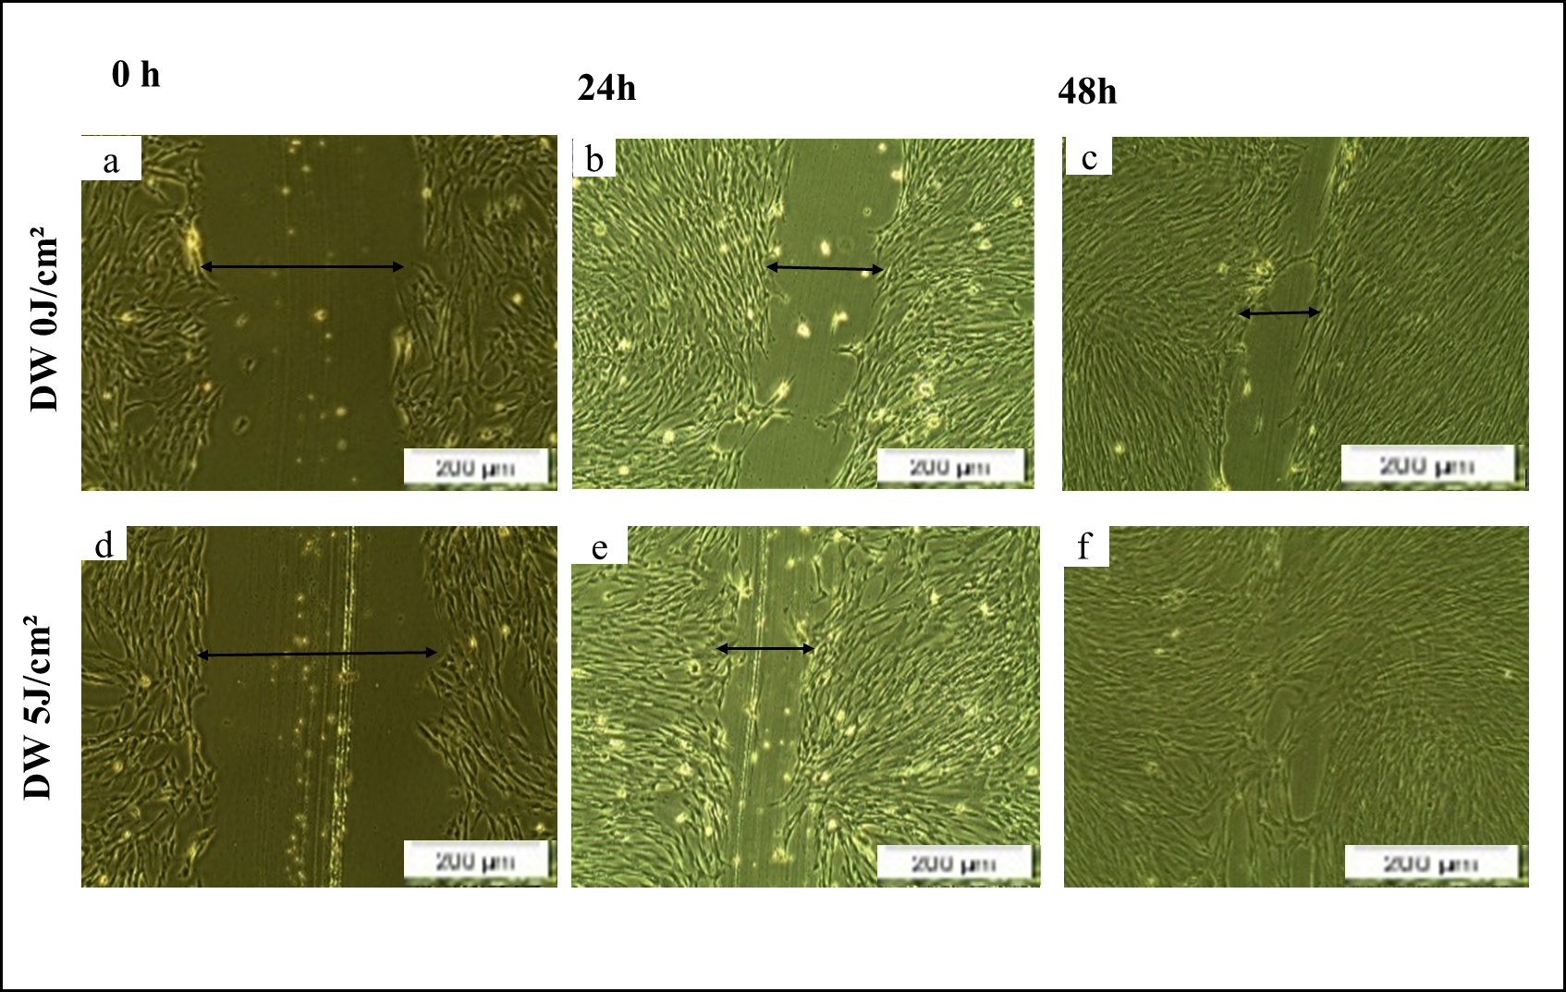

Figure 1. Cell migration was assessed by inverted light microscopy at 0 h, 24 h and 48 h in (a, b, c) diabetic wounded non-irradiated cells (DW 0 J/cm²) and diabetic wounded (d, e, f) irradiated cells (DW 5 J/cm²). Irradiation increased cellular migration rate.

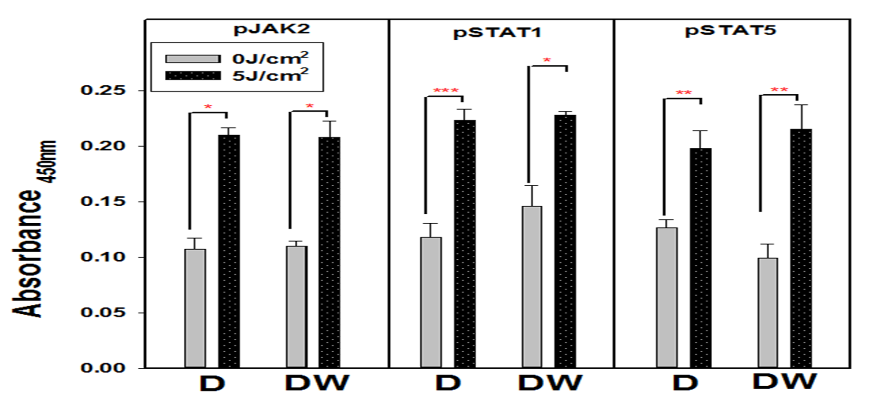
Figure 2. Phosphorylated (p)-JAK2, p-STAT1 and p-STAT5 as determined by ELISA. Irradiated (at 660 nm with 5 J/cm²) diabetic (D) and diabetic wounded (DW) cells were compared to non-irradiated (0 J/cm²) cells. Significant probability is shown as *P<0.05 **P<0.01 and ***P<0.001.

- Discussion and Conclusion
JAK/STAT is one of the signaling pathways that is critical in wound healing [15]. It is involved in the transduction of extracellular cytokine and growth factor signals to the nucleus, resulting in cell migration. In chronic diabetic wounds, there is a reduced presence of growth factors and overall cellular function and migration [16]. Irradiation of diabetic wounded cells at a wavelength of 660 nm with a fluence of 5 J/cm² stimulates the JAK/STAT signaling pathway in vitro by phosphorylating JAK2, STAT1 and STAT5. Therefore, therapeutic agents that would target this signaling pathway, such as PBM, may reduce the healing time and resources for chronic diabetic wounds. However, further investigations on the molecular response of wounded diabetic cells following PBM may be required for a better understanding of the mechanisms and signaling pathways involved. In conclusion, the present study suggests that PBM at a wavelength of 660 nm with a fluence of 5 J/cm² has a therapeutic effect on diabetic wounded cells in vitro by increasing cell migration through the JAK/STAT signaling pathway.

Acknowledgements
This work is based on the research supported by the South African Research Chairs Initiative of the Department of Science and Technology and National Research Foundation (NRF) of South Africa (Grant No 98337), as well as grants received from the University of Johannesburg (URC), the African Laser Centre (ALC) (student scholarship), and Council for Scientific and Industrial Research (CSIR) - National Laser Centre (NLC) Laser Rental Pool Program (grant number LREHA01). All lasers were supplied and set up the NLC.

References

[1] Wukich D K 2015 World J. Orthop. 6 331-9
[2] Feng Y, Sanders A J, Ruge F, Morris C, Harding K G and Jiang W G 2016 Int. J. Mol. Med. 38 1349-58
[3] Dhall S 2014 Retrieved from; http://escholarship.org/uc/item/8q0019n4 .
[4] Sasi W, Sharma A K and Mokbel K 2014 Mol. Biol. Int. doi: 10.1155/2014/630797
[5] Groner B and Vafaizadeh V 2014 Mol. Cell Endocrinol. 382 552-9
[6] Villarino A V, Kanno Y, Ferdinand J R and O’Shea J J 2015 J. Immunol. 194 21-7
[7] Zundra S and Neurath M F 2016 Vaccines doi:10.3390/vaccines4010005
[8] Murry P J 2007 J. Immunol. 178 2623-9
[9] Lee J H, Park K S, Alberobello A T, Kallakury B, Weng M, Wang Y and Giaccone G 2013 Clin. Cancer Res. 19 6777-86
[10] Ma H, Li Y, Chen H, Kang M and Liu T C 2012 Int. J. Photoenergy. doi:10.1155/2012/838496
[11] Houreld N N 2014 The Scientific World Journal. doi: 10.1155/2014/398412
[12] Ayuk S M, Houreld N N and Abrahamse H 2012 Diabetes Technol. Ther. 14 1110-7
[13] Houreld N N 2012 9th WALT Congress (QT Gold Coast, Surfers Paradise, Australia, September 28-30, 2012,)
[14] Houreld N N and Abrahamse H 2010 Diabetes Technol. Ther. 12 971-8
[15] Belacortu Y and Paricio N 2011 Dev. Dyn., 240 2379- 404
[16] Mat Saad A Z, Khoo T L and Halim A S 2013 ISRN Endocrinol. doi: 10.1155/2013/608313

