**First-principles stability study of olivine NaMPO4 (M: Mn, Fe, Co)**

**NL Lethole, HR Chauke and PE Ngoepe**

Materials Modelling Centre, University of Limpopo, Private Bag X1106, Sovenga, 0727, South Africa

E-mail: [Lesley.lethole@ul.ac.za](mailto:Lesley.lethole@ul.ac.za)

**Abstract.** First-principles calculations were carried out to investigate the structural, thermodynamic, electronic and mechanical properties of olivine NaMPO4. All calculations were performed using plane-wave pseudopotential method within the generalised gradient approximation (GGA) functional with Hubbard *U* correction. We note that the calculated lattice parameters are in good agreement to within 6 % with the experimental data. The predicted heats of formation suggest that NaMnPO4 is the most thermodynamic stable structure, with the lowest formation energy (-1292 kJ/mol). The calculated density of states showed that Fe 3*d* states for the NaFePO4 system overlap the Fermi level EF, suggesting a semi-metallic behaviour leading to good electronic conductivity. On the other hand, NaCoPO4 and NaMnPO4 show insulator behaviour due to the existence of energy band gap around the Fermi Level. Lastly, all the independent elastic constants for all structures satisfy the necessary stability criterion, indicating that all NaMPO4 structures are mechanically stable.

# Introduction

Sodium transition metal phosphates (NaMPO4), with olivine structure, have recently attracted a lot of interest in battery applications as potential candidates for future cathode battery material. However, very little work has been done on the sodium-based material as many studies have primarily focused on well-developed counterpart, olivine lithium metal phosphates (LiMPO4), due to the significant discoveries and investigations on lithium ion batteries [1, 2, 3, 4, 5]. Concerns regarding the abundance and possibilities of drastically increase in lithium ion batteries prices when demand intensifies may arise. Unlike the olivine LiMPO4, the sodium-based olivine transition metal phosphates are more abundant and inexhaustible in the world [6].

Figure 1 shows the simulation models for olivine NaMPO4 with space group *Pnma*. The M atoms are located in the octahedral sites, while P atoms occupy tetrahedral sites with a distorted hexagonal close-packed framework. The framework is coordinated by oxygen atoms forming layers of edge-sharing MO6 octahedra, separated by PO4 tetrahedra. Na ions move within the one-dimensional tunnel formed by the edge sharing LiO6 octahedrons.

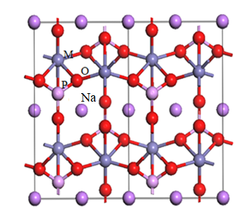

Figure 1 Atomic arrangement of NaMPO4 olivines structures.

The major drawback for the sodium metal phosphates has been their low charge/discharge capacities. Previous studies by Shakoor *et al*. [7] reported that NaFePO4 and NaCoPO4 offer charge/discharge capacities of 12 mAh/g and 2.0 mAh/g, respectively, which is very less compared to the olivine LiFePO4 (170 mAh/g) [8, 9], LiMnPO4 (165 mAh/g) [10] and LiCoPO4 (70 - 86 mAh/g) [9] and other sodium based cathode materials such as Na1.5VOPO4F0.5 (80 mAh/g) and Na3V2(PO4)F3 (90 mAh/g) [11]. Several studies have suggested that the low capacities may be attributed to slow diffusion kinetics of sodium into the structure and the closed packed crystal structure which causes the sodium ion immobility [7, 12]. On the other hand, a study by Sun and Manivannan have shown that the NaFePO4 electrode is capable of maintaining capacity for a large number of cycles, despite low capacity. It was reported that the charge/discharge densities continued to increase for more than 300 cycles [13], making this material a good candidate for large scale energy storage systems for smart grid applications. In addition, studies are required to enhance the NaMPO4 electrochemical activity at room temperature, an important attribute for producing better sodium ion batteries.

Previous studies have reported the maricite NaFePO4 to be seemingly the most thermodynamically stable phase as compared to olivine. It is reported that the maricite phase is 0.016 eV/formula unit more stable than the olivine [6, 14]. However, the edge-sharing FeO6 octahedrons and lack of cationic channels for Na diffusion make this material an unlikely candidate for sodium ion battery development. In this study, we investigate the structural, thermodynamic, electronic and mechanical properties for the olivine NaMPO4 (M=Fe, Co, Mn) structures to determine their stability and competences as future cathode materials. The heats of formation, electronic densities of states (DOS) and elastic constants will be calculated to mimic the stability trend at 0 K.

# Methodology

First-principles DFT+*U* calculations were performed using the Vienna *Ab Initio S*imulation Package, VASP [15] to determine stability of olivine NaMPO4. We used the spin-polarised generalised gradient approximation (GGA). A plane-wave cut-off of 500 eV and suitable k-mesh point of 4x6x6 was chosen for geometric optimisation. The Hubbard parameter of *U*=5.5 eV and *J=1* eV were found to correctly predict the lattice constants of transition metal phosphates [16]. Phonon dispersion curves were calculated with an interaction range of 7.0 Å. The DOS were calculated with the spin taken into account with a smearing width 0.05 eV using a Methfessel–Paxton smearing approach [17].

# Results and discussion

## *Structural and thermodynamic properties*

In table 1, we present the calculated lattice constants, heats of formation, elastic constants, moduli and Pugh ratio of NaMPO4 systems. The experimental data are given in parenthesis where available. The structural lattice parameters are obtained by performing full geometry optimisation. The calculated lattice constants have been found to be in good agreement with the experimental to within 6 %, which is expected for a DFT transition metal calculation [18]. Moreover, we note that NaMnPO4 (326.4 Å3) has a larger volume over NaFePO4 (318.2 Å3) and NaCoPO4 (311.7 Å3): this may be due to the large ionic radii of Mn (81 pm) over Fe (75 pm) and Co (71 pm), respectively. The heats of formation of the NaMPO4 olivines have been evaluated to mimic the thermodynamic stability using equation 1:

|  |  |  |
| --- | --- | --- |
|  | , |  |

where  is the total energy of NaMPO4, while , ,  and  are the total elemental energies of , ,  and  in their respective ground-states. We note that NaMPO4 structures show relatively low heats formation, with NaMnPO4 structure showing the lowest value (-1292.6 kJ/mol), suggesting stability over NaFePO4 (-1143.6 kJ/mol) and NaCoPO4 (-1085.5 kJ/mol), respectively. Moreover, we note that our calculated heat formation value for NaCoPO4 (-1086 kJ/mol) overestimates the experimental value (-1547.5 kJ/mol) [19].

Table 1 Calculated lattice constants, heats of formation and elastic properties of olivine NaMPO4 systems. Experimental data is given in parenthesis.

|  |  |  |  |  |  |  |  |  |  |  |  |  |  |  |  |
| --- | --- | --- | --- | --- | --- | --- | --- | --- | --- | --- | --- | --- | --- | --- | --- |
| **Structure** | **a (Å)** | | | | **b (Å)** | | | **c (Å)** | | **V (Å3)** | | | **ΔHf (kJ/mol)** | | |
| NaFePO4 | 9.07 (8.99) | | | | 6.90 (6.86) | | | 5.08 (5.05) | | 318.26 (311.35)a | | | -1143.6 | | |
| NaCoPO4 | 8.95 (8.88) | | | | 6.86 (6.80) | | | 5.07 (5.03) | | 311.68 (303.28)b | | | -1085.5 (-1547.5) | | |
| NaMnPO4 | 9.17 (9.08) | | | | 6.92 (6.90) | | | 5.14 (5.11) | | 326.38 (320.84)c | | | -1292.6 | | |
| **Elastic Constants (GPa)** | | | | | | | | | | | | | | | |
| **Cij** | | **C11** | | **C12** | | **C13** | | **C22** | **C23** | | **C33** | **C44** | | **C55** | **C66** |
| NaFePO4 | | 166.83 | | 59.67 | | 80.58 | | 161.17 | 65.83 | | 175.17 | 53.00 | | 61.67 | 49.33 |
| NaMnPO4 | | 178.17 | | 59.83 | | 70.17 | | 163.67 | 61.50 | | 163.33 | 50.33 | | 62.33 | 51.33 |
| NaCoPO4 | | 184.83 | | 50.00 | | 75.25 | | 178.33 | 55.58 | | 168.33 | 47.67 | | 65.67 | 41.67 |
| **Modulus (GPa) and Pugh Ratio** | | | | | | | | | | | | | | | |
|  | | | **BH** | | | | **GH** | | | **EH** | | | | **B/G** | |
| NaFePO4 | | | 101.37 | | | | 52.29 | | | 133.86 | | | | 1.94 | |
| NaMnPO4 | | | 98.55 | | | | 53.49 | | | 135.89 | | | | 1.84 | |
| NaCoPO4 | | | 99.10 | | | | 53.43 | | | 135.87 | | | | 1.86 | |

a [20] b [19] c [6]

## *Electronic properties*

In order to gain knowledge on the electronic conductivity of NaMPO4 systems as cathode materials, we have calculated their densities of states (DOS). The partial and total DOS of NaMPO4 structures are presented in figure 2. We note that the total and partial DOS are separated, forming a band gap near the Fermi level (EF). The concepts of Fermi level and band gaps are necessary to understand electronic conductivity of materials. The spin polarised densities of states calculations show that the olivines NaMnPO4, NaFePO4 and NaCoPO4 have energy band gaps of 3.51 eV, 1.17 eV and 1.87 eV, respectively. The energy band gaps for NaMnPO4 and NaCoPO4 are relatively wide, suggesting insulator behaviour. NaFePO4 show a relatively narrow energy band gap. Moreover, the Fermi level is located on the Fe 3*d* band, suggesting that some valence band states jumps the Fermi level barrier to the conduction band. The energy band gap value and the location of the Fermi level suggest that NaFePO4 is semi-metallic leading to good electric conductivity in Na-ion batteries. The partial density of states shows that the M 3*d* states contribute significantly around the Fermi level, while Na, P and O states contribute minimally. Furthermore, we observe spin-down 3*d* peaks at about 2 eV in all systems and minimum contribution from Na, P and oxidation states. The NaMnPO4 show a single 3*d* peak which may correspond to the Mn2+ oxidation state (most stable state), while two degenerate peaks are observed for NaFePO4 suggesting Fe2+ and Fe3+ oxidation states. Clearly, Na intercalation causes the coexistence of Fe2+ and Fe3+ in the FeO6 layers, which may have effect on charge neutrality. This may solved by extracting two electrons from O2- which is reduced and released in the vacuum as O2 [21]. As a result, the Fermi energy level shifts to higher conductive band, leading to the enhancement of electronic conductivity of NaFePO4 as well as reversible capacity [22], which will be favourable for Na deintercalation. On the other hand, NaCoPO4 shows only Co2+ states, since there is no clear distinction between the Co 3*d* peaks.

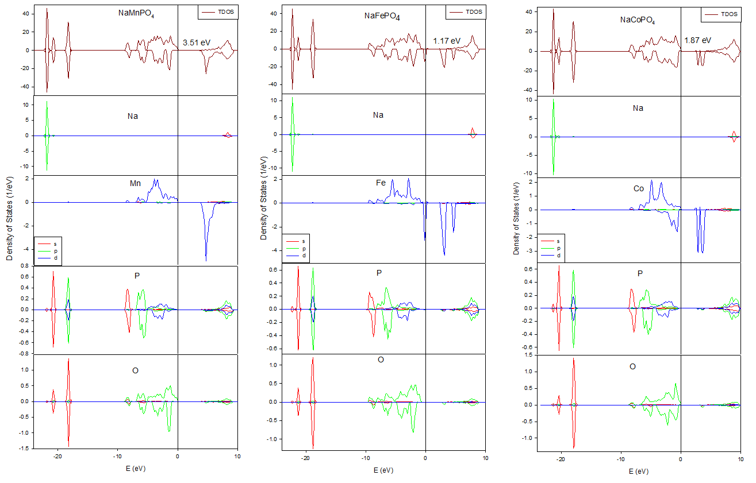

Figure 2 Partial and total density of states plots of olivine NaMPO4 structures.

## *Mechanical properties*

The elastic constants calculated using a Taylor expansion are presented in table 1 [23].

|  |  |  |
| --- | --- | --- |
|  |  | 2 |

where  represents the unstrained system energy,  is the equilibrium volume,  is the element in the stress tensor, and  is a factor of Voigt index. The orthorhombic NaMPO4 structures have nine independent elastic constants (Cij), which are presented in table 1. The Born mechanical stability criteria for orthorhombic systems are [24, 25]:

, , ,

, , , 

We note that all stability criteria are satisfied, indicating that NaMPO4 compounds in the olivine structure are mechanically stable. To the best of our knowledge, these are the first recorded elastic constants on NaMPO4 systems.

From the calculated elastic constants, the macroscopic mechanical parameters, namely, Bulk, Shear and Young’s modulus are obtained using the Voigt-Reuss-Hill approach [26],



where B, G and E are the bulk, shear and Young’s modulus, while V, R and H are the Voigt, Reuss and Hill bounds, respectively and  is the inverse matrix of the elastic constants matrix , which is given by [27];



,,.

The resultant bulk, shear and Young’s modulus are listed in table 1. The bulk and Young’s moduli determines hardness and stiffness of the material, respectively, while the shear determines the resistance to deformation under shear stress. The bulk modulus also measure resistance to volume change under pressure [28, 29]. We note that NaMPO4 structures show relatively large positive bulk, shear and Young’s moduli, suggesting hardness, high resistance to volume change and deformation and stiffness, respectively. Moreover, we note that BH>GH, which implies that the parameter limiting the mechanical stability of NaMPO4 structures is the shear modulus (GH) [30]. Moreover, the Pugh criterion of ductility and brittleness was calculated. Pugh proposed that if BH/GH is more than the critical value (1.75), the material is ductile and if less than (1.75), the material is brittle [31]. We note all NaMPO4 structures are ductile, since BH/GH is greater than 1.75, suggest that these materials are able to band without deformation, leading to minimal cracks during battery operation [32].

# Conclusions

First-principles calculations on NaMPO4 structures have been performed, particularly, structural parameters, heats of formation electronic density of states and elastic constants. It has been shown that the structural parameters obtained by full optimisation are in good agreement with the experimental data to within 6 %, suggesting validity of the approach employed. The heats of formation suggested thermodynamic stability of NaMnPO4 structure (-1292.6 kJ/mol) over NaFePO4 (-1143.6 kJ/mol) and NaCoPO4 (-1085.5 kJ/mol), respectively. The electronic density of states has shown that the NaFePO4 structure is semi-metallic, while NaMnPO4 and NaCoPO4 show insulator behaviour characteristics. The semi-metallic behaviour of NaFePO4 strongly suggest that this system has better electronic conductivity, hence preferred. Lastly, the elastic properties show that the olivine NaMPO4 structures are all mechanically stable and behave in a ductile manner, suggesting lack of cracks during battery operation.

# Acknowledgement

This work has been performed at the Materials Modelling Centre, University of Limpopo, supported by the National Research Foundation.

# References

|  |  |
| --- | --- |
| [1] | Padhi A K, Nanjundaswamy K S and Goodenough J B 1996 *Electrochem. Soc.* **96** 73 |
| [2] | Amatucci G G and Pereira N, 2007 *J. Flourine Chem.* **128** 243 |
| [3] | Ellis B L, Makahnouk W R M, Weetaluktuk W N R, Ryan D H and Nazar L F 2010 *J. Chem. Mater.* 22 1059 |
| [4] | Barker J, Saidi M Y and Swoyer J 2003 *J. Electrochem. Solid-State Lett.* **6** A1 |
| [5] | Zhou H, Wang X, Tang A, Liu Z, Gamboab S and Sebastian P J 2006 *J. Power Sources* **160** 698 |
| [6] | Lee K T, Ramesh T N, Nan F, Botton G and Nazar L F 2011 *Chem. Mater.* **23** 3593 |
| [7] | Shakoor R A, Park Y U, Kim J, Kim S W, Seo D H, Gwon H and Kang K 2010 *J. Korean Battery Soc.* **3** 00 |
| [8] | Mizushima K, Jones P C, Wiseman P J and Goodenough J B 1980 *Mater. Res. Bull.* **15** 799 |
| [9] | Amine K, Yashuda H and Yamachi M 2000 *Electrochem. Solid-State Lett.* **31** 179 |
| [10] | Pivko M, Bele M, Tchernychova E, Logar N Z, Dominko R and Gaberscek M 2012 *Chem. Mater.* **24** 1041 |
| [11] | Sauvage S, Quarez E, Trascon J M and Baudrin E 2006 *J. Electrochem. Soc.* **8** 1215 |
| [12] | Moreau P, Guyomard D, Gaubicher J and Boucher F 2010 *Chem. Mater.* **22** 4126 |
| [13] | Sun A and Manivannam A 2011 *ASC Transactions* **35** 3 |
| [14] | Moreau P, Guyomard D, Gaubicher F and Boucher F 2010 *Chem. Mater.* **22** 4126 |
| [15] | Kresse G and Furthmüller J 1996 *Phys. Rev. B* **54** 11169 |
| [16] | Kresse G and Joubert D 1999 *Phys. Rev.* **59** 1758 |
| [17] | Methfessel M and Paxton A 1989 *Phys. Rev. B* **40**, p. 3616 |
| [18] | Li G, Azuma H and Tohda M 2002 *Electrochem. Solid-State Lett.* **5** A135 |
| [19] | Le S N, Eng W and Navrotsky A 2006 *Solid State Chem.* **179** 3731 |
| [20] | Bridson J N, Quinlan S E and Tremaine P R 1998 *J. Chem. Mater.* **10** 763 |
| [21] | Wu Y 2015 Lithium-ion batteries, fundamentals and Applications *Tayor and Francis Group* Boca Raton |
| [22] | Kinyanjui M K 2010 Electronic and Structural Properties of Li(1-x)FePO4 (X=0, 0.5,1) Ph.D. Thesis ULM University |
| [23] | Fast L, Wills J M, Johansson B and Eriksson O 1995 *Phys. Rev. B* **51** 17431 |
| [24] | Sinko G V and Smirnov N A 2002 *J. Phys. Condens. Matter* **14** 6989 |
| [25] | Grimsditch M, Polian A, Brazhkin V and Balitskii D 1998 *J. Appl. Phys.* **83** 3018 |
| [26] | Patil S K R, Khare S V, Tuttle B R, Bording J K and Kodambaka S 2006 *Phys. Rev. B* **73** 104118 |
| [27] | Ravindran P, Fast L, Korzhavyi P A, Johansson B, Wills J and Eriksson O 1998 *J. App. Phys.* **84** 4904 |
| [28] | Chung H Y, Weinberger M B, Yang J M, Tolbert S H and Kaner R B 2008 *Appl. Phys. Lett.* **92** 261904 |
| [29] | McHargue C, Darby Jr J B, Yacaman M J and Gasga J R 1997 Norwell, Massachusetts, USA: Kluwer Academic Publishers |
| [30] | Shein I R and Ivanovskii A L 2008 *J. Phys. Condens. Mater* **20** 415218 |
| [31] | Pugh S F 1954 *Philos. Mag.* **45** 833 |
| [32] | Wang D, Wu X, Wang Z and Chen L 2005 *J. Power Sources* **140** 125 |