Tunable photoluminescence emission of sol-gel ZnO films prepared by spin coating technique
E Hasabeldaim, O M Ntwaeaborwa, R E Kroon, E Coetsee and H C Swart
Department of Physics, UFS, Bloemfontein ZA-9300, South Africa

E-mail: swarthc@ufs.ac.za

Abstract. ZnO thin films were successfully synthesized by the sol-gel method using the spin coater technique. The films were annealed at 600 °C in air for two hours and in a H₂ flow for different time periods. The un-annealed film showed an amorphous structure. The c-axis orientation along (002) plane was obtained for the films annealed in air and in the H₂ flow. The crystallite sizes were 47 nm, 44 nm and 38 nm for the films annealed in air and in H₂ for 30 min and 60 min, which were very close to the average particle size obtained from scanning electron microscopy images, confirming the excellent crystallinity of the films. The films (as-prepared and annealed in air) exhibited a broad visible emission as well as a high intense ultraviolet emission. The films annealed in H₂ atmosphere emitted a single greenish emission centred at ~ 511 nm, and this was attributed to oxygen related defects.
- Introduction
Over the last fifty years, research on metal oxide semiconductors has drawn significant interest because of their optical and electrical potential in electronic devices. ZnO has emerged as a II - VI group compound semiconductor with fascinating properties, the direct wide bandgap (3.37 eV) and the large exciton binding energy (60 meV) of ZnO [1] make it suitable and stable for such application conditions. Furthermore, ZnO has inherent defects which are responsible for its optical properties (visible emission from 400 nm to ~ 750 nm). The interests on ZnO thin films have been considered as a promising route to improve its optical and electrical properties, and to obtain a high quantum efficiency. Excellent crystallinity and particle morphology can easily be adapted by preparing ZnO as a thin film.
Various techniques have been used to fabricate ZnO thin films such as sputtering, pulsed laser deposition, chemical vapour deposition and spray pyrolysis [2]. Amongst these techniques, the sol–gel process is in the forefront in both research and industrial fabrications because of its ease, low cost and above all, the sol-gel process is able to provide homogeneous films, excellent control of the film composition and lower crystallization temperature. These are due to the mixing of liquid precursors. Post-annealing treatments and annealing in reducing atmosphere are some of the laboratory tricks to control the film stoichiometry and to enhance the film structure and morphology in order to obtain required properties.
In this work, sol-gel ZnO films were successfully deposited by using the spin coating technique. The structural and morphological properties were studied by X-ray diffraction (XRD) and scanning electron microscopy (SEM). Although, much research has been done on sol-gel ZnO thin films, different results were obtained in this article. In particularly, a single peak of green emission around 500 nm was obtained, which was attributed to oxygen vacancies (V_{o}).
- Experimental procedure
Sol-gel ZnO thin films were prepared by using the spin coating technique. Zinc acetate dihydrate (Zn (CH₃COO)₂•2H₂O, Alfa Aesar, purity 99.95%) was used as a starting material. Mono-ethanolamine (MEA) and methanol were used as a stabilizer and solvent, respectively. A concentration of 0.2 mol/L zinc precursor solution was prepared by dissolving the zinc acetate dihydrate in the methanol. Mono-ethanolamine was dissolved into the solution. The molar ratio of the MEA:Zn was fixed at 1:1 for all the samples. The final solution was obtained by stirring the mixture for 30 min at room temperature using a magnetic stirrer. The final solution was kept for 48 hours at room temperature of 24 °C. Silicon (100) substrates were used for the film fabrication. The silicon substrate was cleaned ultrasonically for 15 min using acetone to remove the organic contaminations, and then rinsed with ethanol and deionised water, and was then dried by N₂ gas. The solution was dropped onto the silicon substrate, which was rotated at 2500 rev/min for 30 s using the spin coater. After deposition, the films were preheated in air on a hot plate at a temperature of 250 °C for 10 min to evaporate the solvent and remove the organic residuals. The procedures from coating to preheating were repeated 7 times until the desired thickness of ~ 500 nm was obtained. The films were annealed in air at 600 °C for 2 hours using a controlled tube furnace. After annealing at 600 °C, a mixture of H₂:Ar gas was introduced into the tube furnace. A ratio of 5:95 H₂:Ar gas was used during the annealing of the films with a flow ratio of 10%. The H₂/Ar flow was introduced for different annealing times (30 min and 60 min).
For structure and phase analysis, a Bruker X-ray diffractometer (40 kV, 40 mA) with CuKα (0.15406 nm) was utilized. The scan range was from 2θ =15° to 100° and steps were 0.0178°. A JEOL JSM-7800F SEM was employed to probe the particle morphology. Photoluminescence (PL) spectra were collected at room temperature with a PMT detector. The films were excited with a He-Cd laser PL system with a 325 nm excitation wavelength.
- Result and discussion
  - XRD and structure analysis
XRD spectra of the sol-gel ZnO films are shown in figure 1. The un-annealed film has an amorphous nature, while the films annealed in different conditions have shown highly c-axis orientation along the (002) plane, which is perpendicular to the substrate surface. It is a common physical phenomenon that ZnO film crystallises by post-annealing treatment. Although the ZnO thin films have been prepared by different methods, the orientation along the c-axis has always been the preferred orientation. This is due to the lower energy of the (002) plane [3]. The crystallite size was estimated by using the well-known Scherrer equation. The crystallite sizes were 47 nm, 44 nm and 38 nm for the films annealed in air, H₂ flow for 30 min and H₂ flow for 60 min, respectively. The crystallite size decreased with increasing time of the H₂ flow. This may be due to the removal of more oxygen atoms from the crystal sites. The peak at 2θ = 32.86° on the films annealed in reducing atmosphere (H₂) for different times is due to the forbidden Si (200) from the substrate that is observed in some cases and not due to changes in the film thickness.
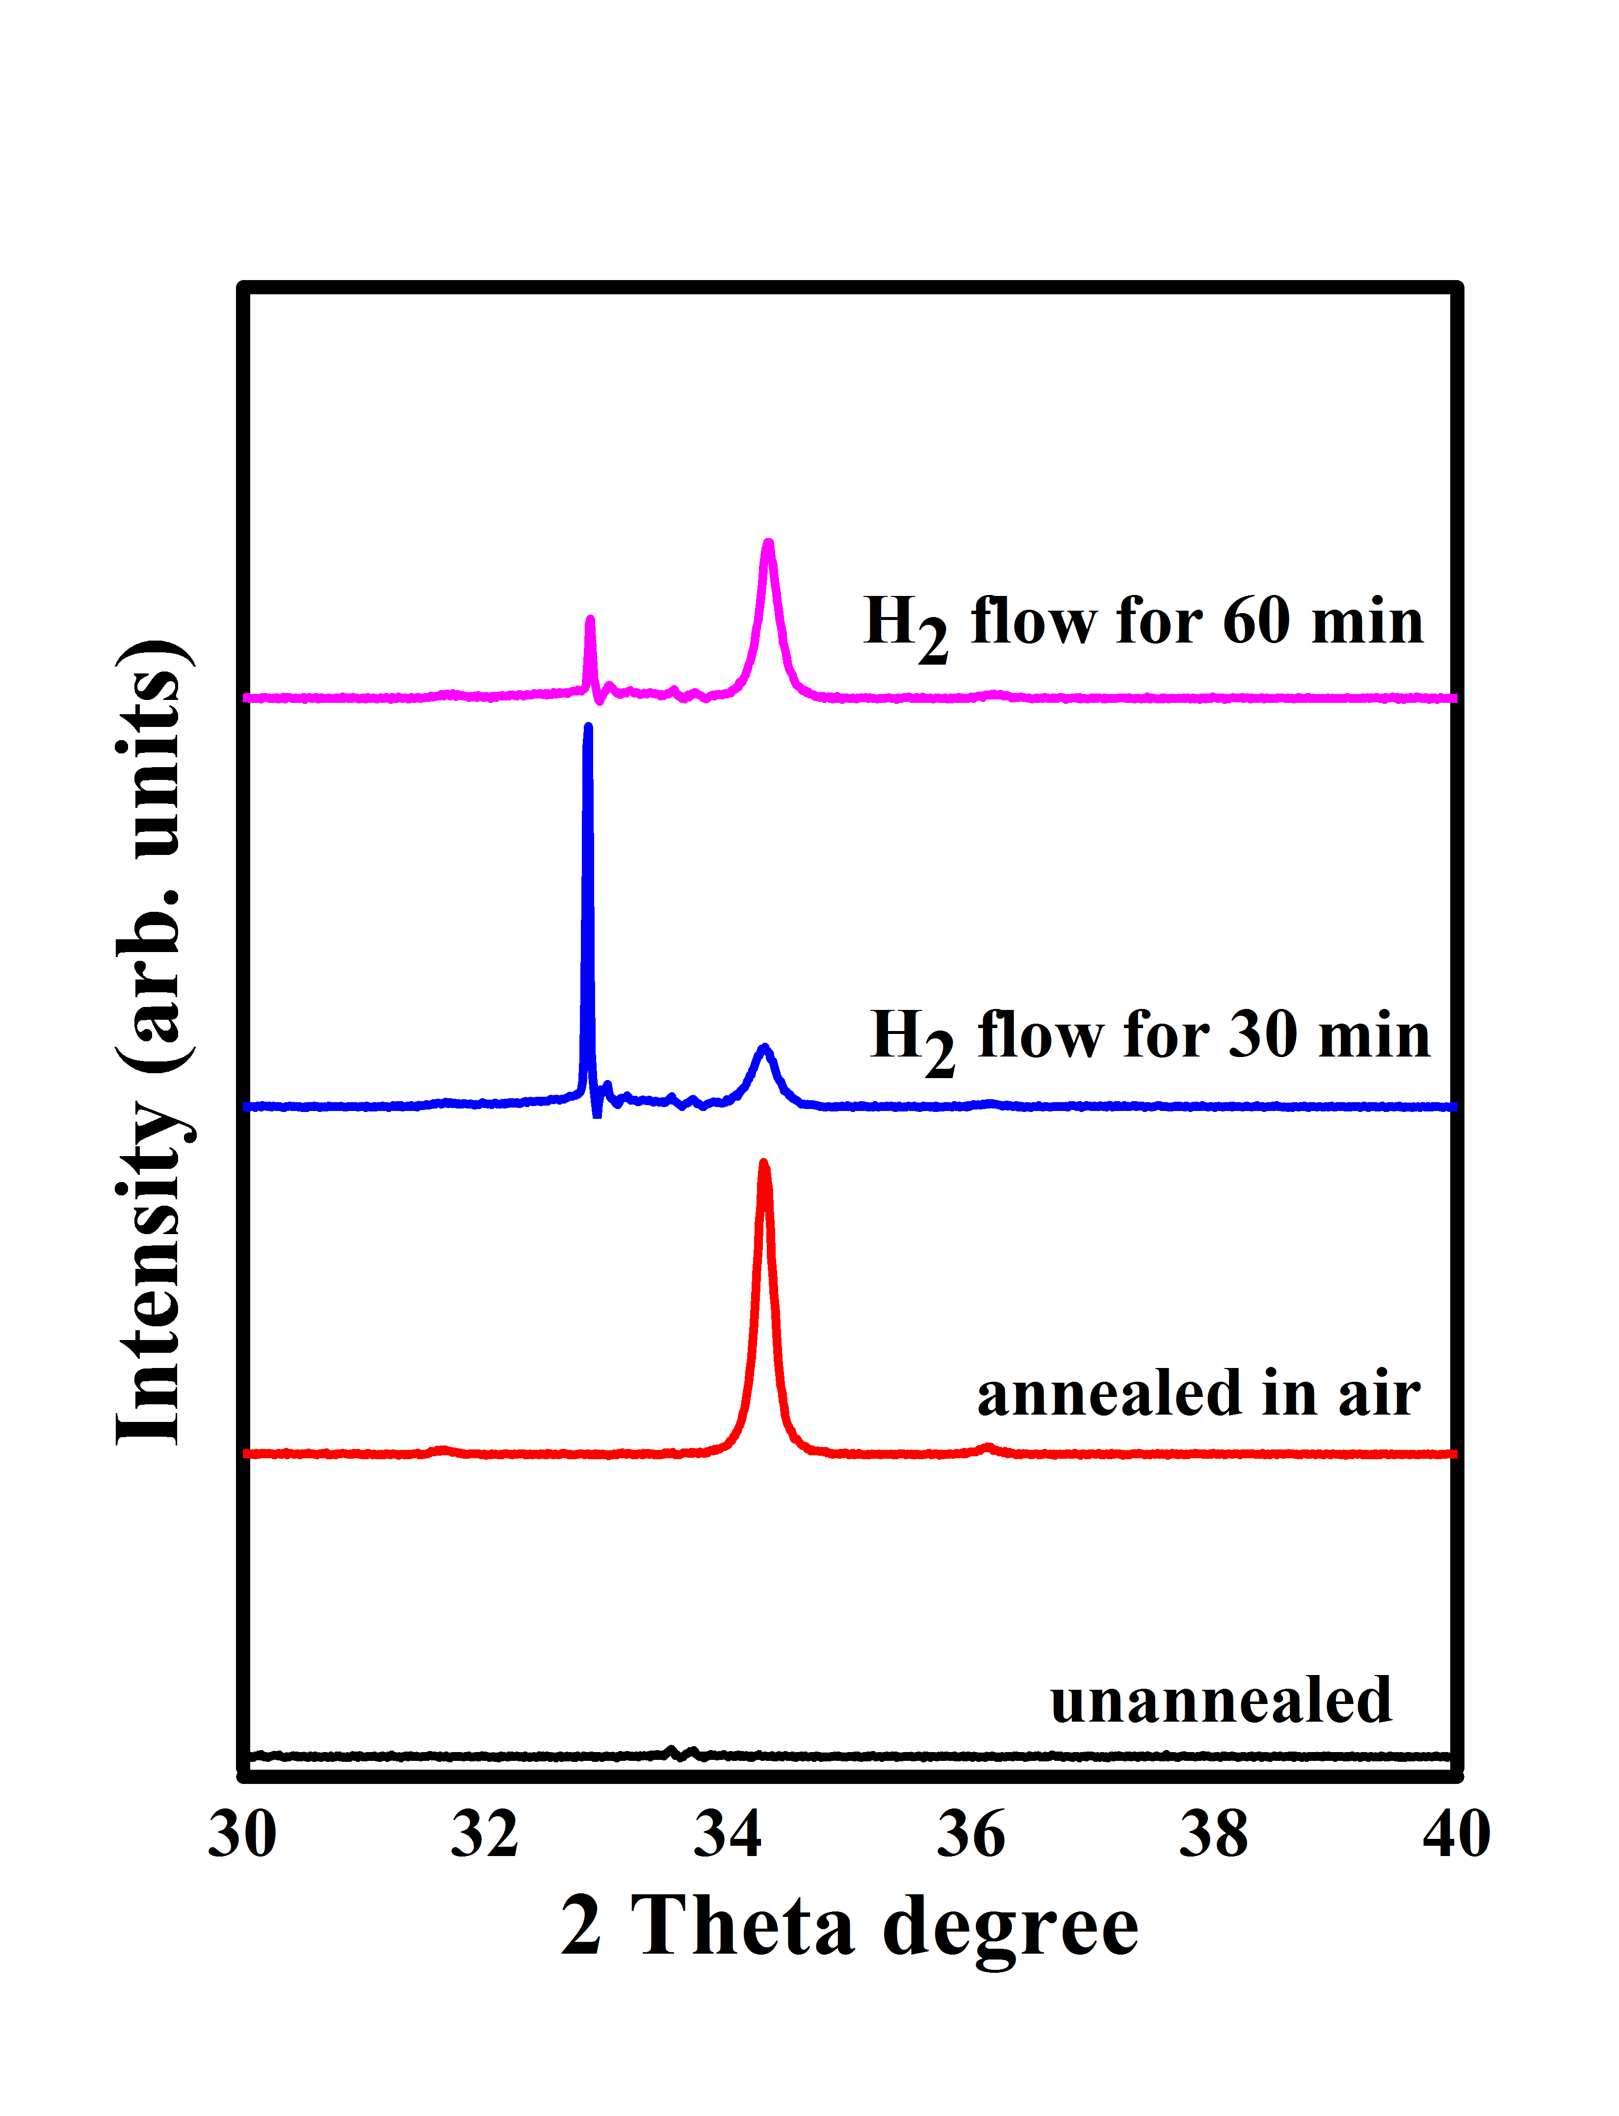
(002)
Figure 1. XRD patterns of the films as described in table 1.
  - Surface morphology
Figure 2 shows the surface morphology of the sol-gel ZnO films annealed at different conditions. The as-prepared film (un-annealed) showed an amorphous nature as confirmed by XRD results, where no particles were observed, meaning that the film was not crystalline. The films annealed under different conditions (b), (c) and (d) shown spherical particles and their average particles sizes were found to be 42 nm, 28 nm and 46 nm, respectively. Of interest, the particles size computed on the basis of SEM images are in the same order size to the crystallite sizes calculated from XRD (figure 1), hence the annealed films have a high quality of crystallinity. The small differences between the crystallite and the particle size is associated to the un-uniformity of the particle size distribution and the agglomeration of crystallites, however, the obtained bigger crystallite size in comparison to the particle size for the 30 min annealed sample is unexpected and need further investigation. These results have directly contributed into the optical properties of the films, where the films provided a high PL intensity. The particles of the annealed films have a lower particle density compared to the results of Davood Raoufi et al. [4]. Therefore, the films may be porous.
  - Photoluminescence properties
Figure 3 shows the PL spectra of the sol-gel ZnO films annealed in different experimental conditions. The un-annealed film figure 3(a) and (de-convoluted in b), exhibited strong excitonic emission around the UV region centred at 379 nm as well as a weak deep level emission centred at 400 nm (blue) and 609 nm (orange), the emission band at 400 nm is probable due to the electron transition from the conduction band or Zn_{i} to the deeply trapped hole at the zinc vacancies (V_{zn}). The emission at 609 nm arises from the recombination between the photogenerated electron close to the conduction band (Zn_{i}) and the deeply trapped single ionized oxygen interstitial (O_{i}) [5]. The weakness of the visible emission on the un-annealed sample means that the film has the lowest concentration of ZnO intrinsic defects. Therefore, the strongest UV emission was due to the lack of competition between the defects and exciton recombination. It is worth noting that with annealing and increasing the reducing atmosphere annealing time, the deep level emission intensity increased while the band to band emission (UV) decreased. Annealing in air and reducing atmosphere introduced more defects in the film structure. The question is, why the un-annealed film contained such low defect concentration? This may be explained by understanding the ZnO structure and the role of annealing temperature on the film structure. ZnO has a non-centrosymmetric hexagonal wurtzite symmetry composed of Zn and O sub-lattices, which are responsible for the generation of the defects. The un-annealed film showed an amorphous structure nature from the XRD pattern (figure 1) which referred to an incomplete crystallization structure, therefore, no more defects were formed in the film matrix, where the annealed films have well crystallized (XRD (figure 1)), and the defects were generated as confirmed by XRD and their high deep level emission.
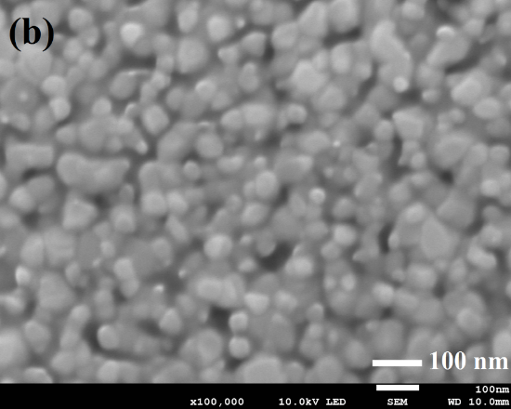
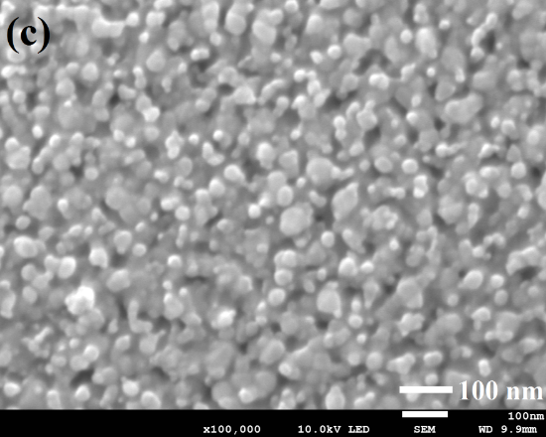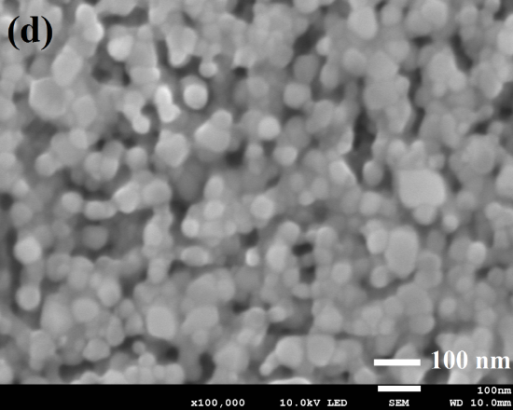
Figure 2. SEM images of the sol-gel ZnO films deposited by spin coating technique, (a) as prepared (un-annealed), (b) annealed in air for two hours at 600 °C, (c) exposed to a H₂ flux for 30 min during annealing, (d) exposed to a H₂ flow for 60 min during annealing.

The un-annealed film may possess residual organic solvents and structural defects which acted as non-radiative recombination centres, and hence the film emitted low defects related emission. After annealing in air at 600 °C, the intensity of the visible emission increased relative to the UV emission, and the violet emission around 400 nm disappeared which was probably due to the disappearance of the Zn_{i} while a new green emission at 504 nm has appeared. The increasing of the visible emission intensity was due to the film crystallinity, and may be due to the removal of non-radiative centres that came from the residual organic solvents and structural defects. Oxygen vacancies (V_{o}) are commonly reported defects in ZnO because of their low formation energy, and it is these that are speculated to play a role in the green emission of ZnO [6]. Therefore, Zn_{i} which caused the blue emission in the un-annealed films may have diffused to form a new V_{o} in the annealed film. The orange (609 nm) emission of the un-annealed film was red-shifted to 660 nm after the annealing process. The following reaction (1) possibly occurred during the air annealing process:
ZnO ZnO_{1-x}$+xV_{o}^{•}+{xO}_{i}^{-}$ (1)
The oxygen interstitial (O_{i}) may be also be introduced to the film from the atmospheric oxygen during the annealing process [7]. The shift in the orange emission from 609 nm to 660 nm after annealing in air could be due to the formation of and/or change in local position of the related defects [8]. The peak around 753 nm on the un-annealed film and the film annealed in air is due to the scattered UV second order peak.

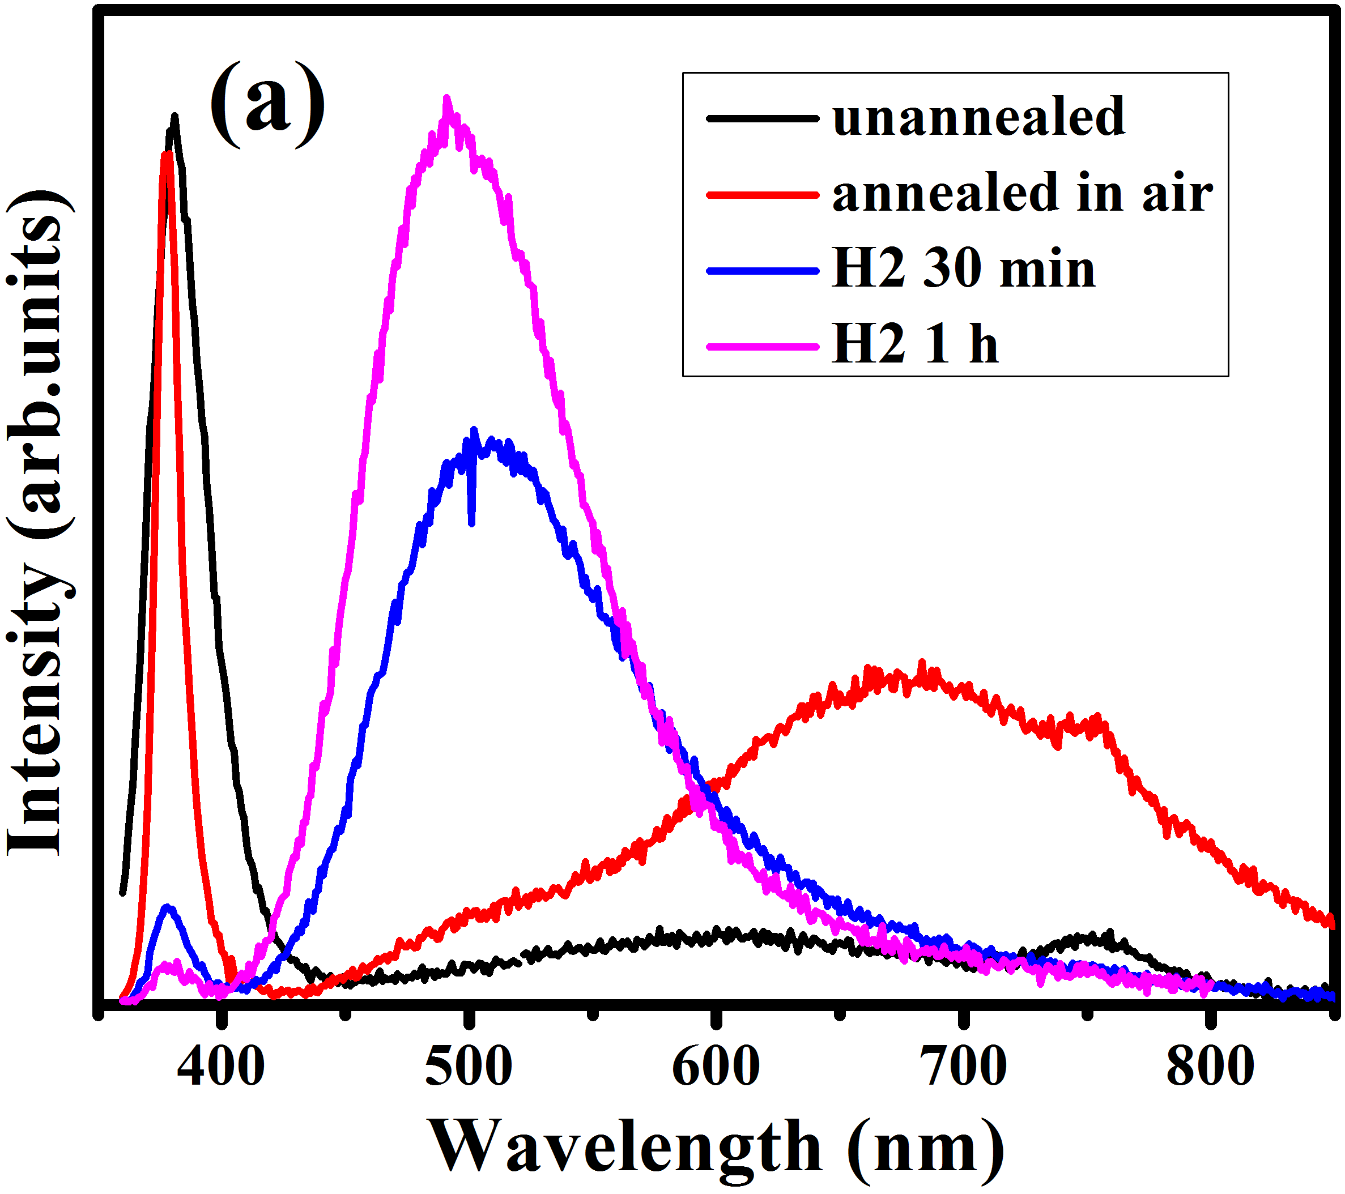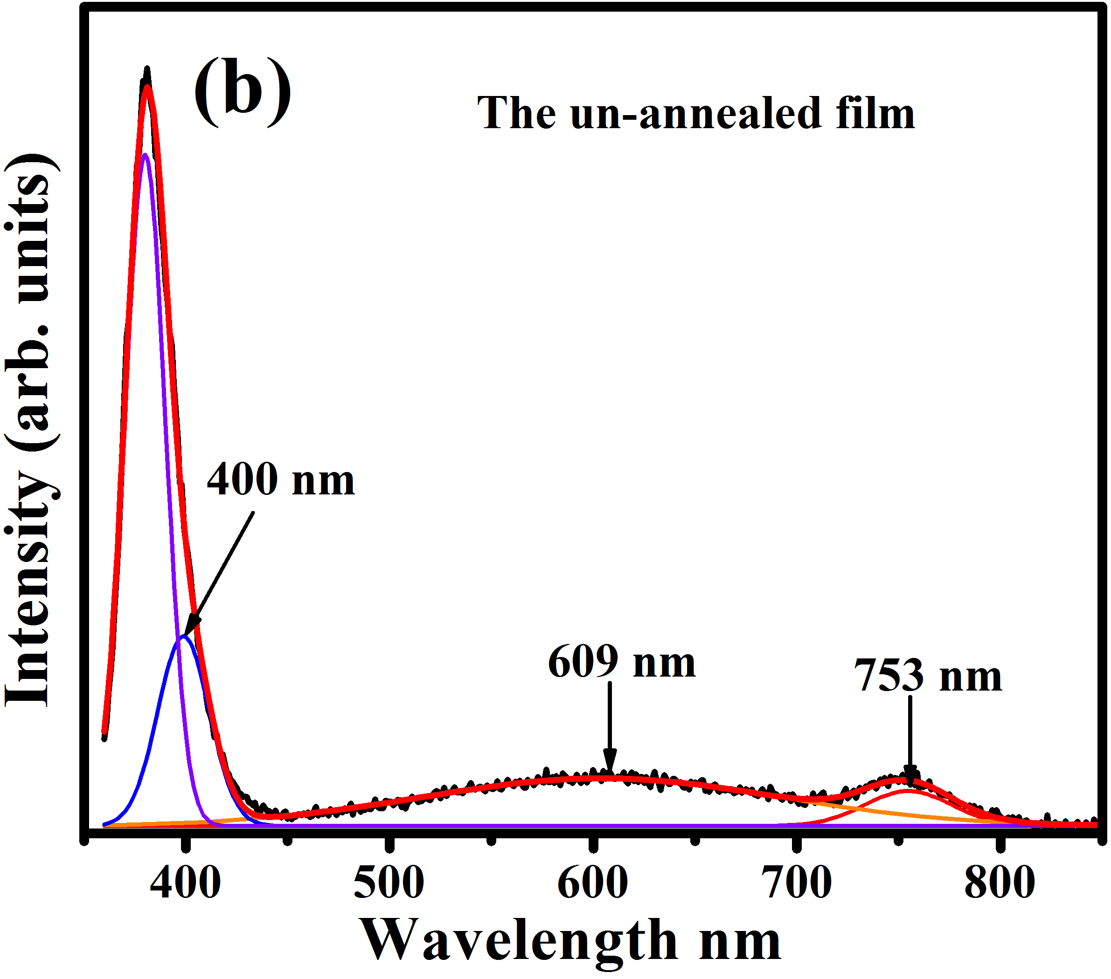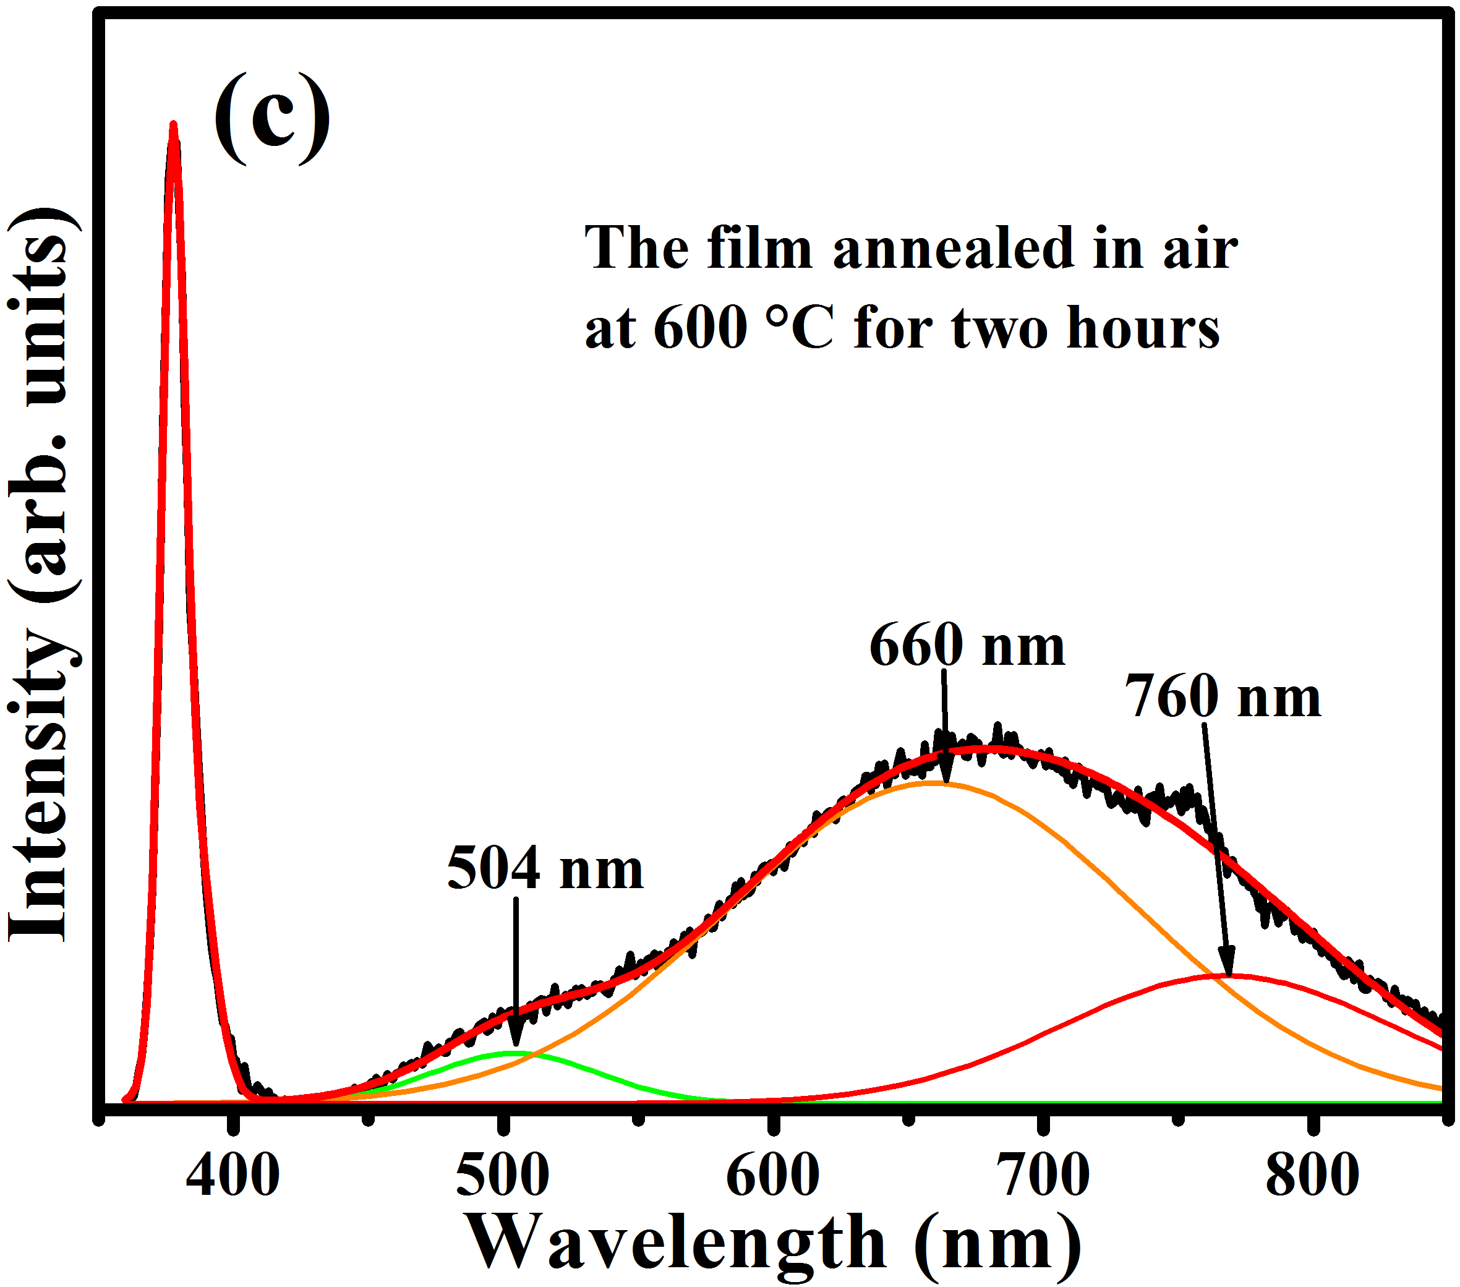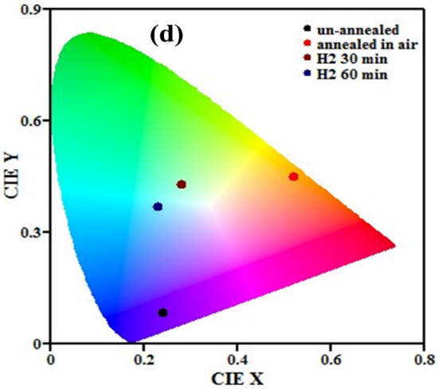
Figure 3. Photoluminescence spectra of (a) the sol-gel ZnO films prepared and annealed in different conditions, (b) De-convoluted peaks of the un-annealed film, (c) De-convoluted peaks of the film annealed in air and (d) CIE colour coordinates.
The film annealed in H₂ for 30 min exhibited a broad green emission peak around 507 nm with a high intensity, while the UV intensity has drastically decreased. The disappearance of orange and red emission is probably due to the removal of some of the oxygen-related defects. H₂ may have reacted with oxygen atoms and ions in the film resulting in the formation of evaporated H₂O or metallic Zn. The film annealed in H₂ for 60 min emitted a higher intensity green emission centred at 500 nm as well as a very weak UV emission, meaning that more/new defects were formed in the film structure leading to an increase in the competition between the defects and the exciton recombination. The blue shift on the green emission after increasing the reducing atmosphere time could be related to a change in the related defects local positions and therefore a shift in the defect level energy position.
Since the photometric characteristics are very important factors in optoelectronic applications, the colour coordinates (X, Y) and the colour correlated temperature (CCT) of the samples were studied by the CIE 1931 software and are displayed in figure 3(d). The CIE coordinate values are important in the sense that they give a quantitative link between the distributions of wavelengths in the electromagnetic visible spectrum, and the physiological perceived colours in the human colour vision. The McCamy equation was used to calculate the parameters which were tabulated in table 1.
CCT = -437 n³ + 3601 n² – 6861 n + 5514
where n = (x - x_{e})/(y - y_{e}) and the chromaticity epicentre is at x_{e} = 0.332 and y_{e} = 0.186.
Table 1. The colour coordinates (X, Y) and colour correlated temperature (CCT) of the sol-gel ZnO films.
Sample name | X | Y | CCT (K)
Un-annealed | 0.24 | 0.08 | 1986
Annealed in air | 0.52 | 0.45 | 2296
H₂ for 30 min | 0.28 | 0.43 | 7143
H₂ for 60 min | 0.23 | 0.37 | 10497
- Conclusion
C-axis oriented ZnO thin films were successfully prepared by sol-gel method using the spin coating technique. Structural, morphological and optical properties of the films were studied. The deep level defect related emission of ZnO was discussed. The tuneable green emission with colour coordinates (X = 0.28, Y = 0.43) and (X = 0.23, Y = 0.37) were obtained from the films annealed in H₂ for different times. The results indicate that oxygen vacancies and interstitials are responsible for the green emission. These films are useful for luminescent thin film applications, particularly where green emission is required.
Acknowledgement
This work is supported both by the South African Research Chairs Initiative of the Department of Science and Technology, the National Research Foundation of South Africa (84415) and African Laser Centre (ALC). The PL system used is supported by the rental pool progamme of the National Laser Centre (NLC).
References
- Özgür Ü, Alivov Y I, Liu C, Teke A, Reshchikov M, Doğan S and Morkoc H 2005 J. Appl. Phys. 98 041301
- Bao Dinghua, Gu Haoshuang and Kuang Anxiang 1998 Thin Solid Films 312 37
- Natsume Y and Sakata H 2000 Thin Solid Films 372 30
- Raoufi Davood and Raoufic Taha 2009 Appl. Surf. Sci. 255 5812
- Zeng By Haibo, Duan Guotao, Li Yue, Yang Shikuan, Xu Xiaoxia and Cai Weiping 2010 Adv. Funct. Mater. 20 561
- Lin Y, Xie J, Wang H, Li Y, Chavez C, Lee SangYeol, Foltyn S R, Crooker S A, Burrell A K, McCleskey T M and Jia Q X 2005 Thin Solid Films 492 101
- Kumar Vinod, Kumar Vijay, Som S, Yousif A, Singh N, Ntwaeaborwa O M, Avinashi Kapoor and Swart H C 2014 J. Colloid Interf. Sci. 428 8
- Wang Zhenling, Lin Cuikun, Liu Xiaoming, Li Guangzhi, Luo Yan, Quan Zewei, Xiang Hongping and Lin Jun 2006 J. Phys. Chem. B 110 9469

