Title: A new approach to teaching Graphs to first year Science Students
Presenter: Mr Alfred Tsipa - Unizulu Science Centre
Email Address: alfred.tsipa@gmail.com
Despite being one of the most important concepts in the study of physics, graphs continue to be a problem area for most first year students. This is mainly because of the poor grounding they received while at high school. Most of them arrive at university without a strong background in understanding basic concepts like graphs.
Graphs are a very important part in the study of physics at university, especially when conducting research at post-graduate level. Interpretation of data is the cornerstone of science education. Graphs show rates at which things happen, relationship between variables and are a good tool for representing data visually to see relationships and trends.
The Unizulu Science Centre developed a very simple method of teaching graphs to first year physics students through the use of multimedia technology. Because data can be abstract, using simple tools like user friendly software programmes, which are freely downloadable from the internet, can make graphs very clear to the students.
A study is under way to help first year physics students to master the skills of handling graphs. A full paper on how the students responded to this method will hopefully be presented at next year’s SAIP Conference.
This paper seeks to showcase the use of these simple teaching tools in teaching abstract concepts in physics at university level. The presenter will demonstrate these concepts with the hope that others can learn and use them to improve in the teaching of physics.
The workshop was first presented to more than 5000 matric learners from different schools in the uThungulu, uMkhanyakude and Zululand magisterial districts. In total, more than 100 schools came to the workshop.
The workshop looked at all the CAPS Curriculum topics on graphs which included the following:
Motion Graphs
Motion graphs: 9 types
Motion graphs: Δx, v and a vs. t
Motion Graphs: Examples
Projectile Motion (1 D): exam questions
Newton’s Second Law: experiment & graphs
Inverse Square Law
Electro-Magnetic Spectrum
Photo-electric effect: simulation
Photo-electric effect: exam questions
Ohm’s Law: experiment & graph
Ohm’s Law: exam questions
Internal resistance: experiment & graph
Internal resistance: exam questions
Alternating Current: experiment & graphs
Alternating Current: exam questions
Sound Waves
The Doppler Effect: exam questions

It became very clear that the best way to approach this topic was to group all the graph sections together, teach the content, followed by practical demonstrations and graphic simulations. At the end of each section we looked at typical exam questions.
A forty page booklet carrying all the content was produced and each learner who attended was given a copy. The response was very phenomenal. At one venue more than 1000 learners attended.
At the beginning 3 types of graph were emphasized. These were;
- Rates graphs – eg Position vs time
- Relationship graphs – eg Pressure vs volume
- Representation graphs – eg Pie graphs and histograms
One thing that we emphasized was that a graph is not a photograph, but a representation of data on a set of axes. It is NOT a picture of the landscape, hills and valleys etc! The next thing we looked at was “how to draw a graph.”
A simple acronym T.A.L.S.I.P.P was all that was needed for this. It stands for
T – Choose an appropriate TITLE
A – Select variables to go on the AXES. Dependant (Y) and independent (X)
L – LABELS for axes, with Units
S – Choose a SCALE which allows the graph to fill as much of the page as possible.
I – INTERVALS: Use the scale to determine how much each small block equals
P – PLOT your data from the table onto the graph carefully check the order (X & Y )
g) P – PLOT the best fit line (or curve) for the data points.
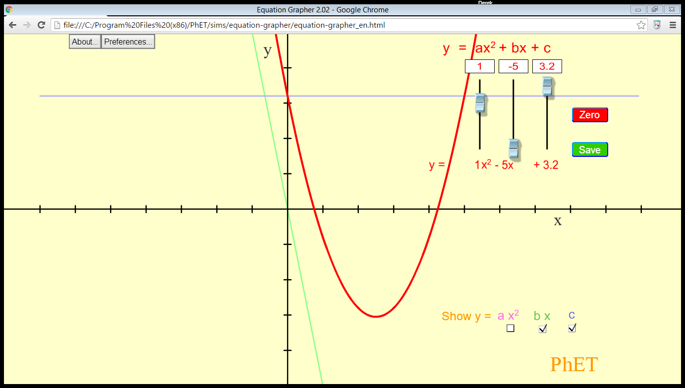
From this they would be able to calculate intercept and gradient.

A program called PHET, which is a free download, was used to simulate various types of graphs including linear graphs and parabolas, showing how a change of constants can change the shape of graphs.

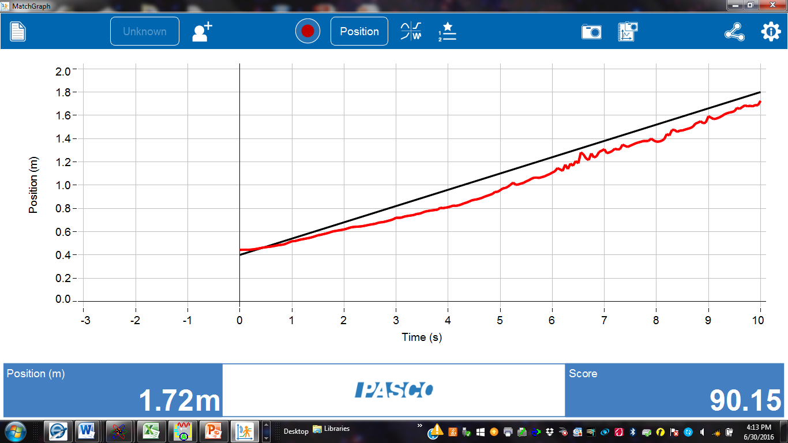
A simple motion sensor was used to demonstrate different kinds of motion and the graphs were plotted in real time. This was a good link between theory and practice. The learners were asked to generate the graphs by walking in front of the sensor, which was connected to a laptop and the results could be seen by all on the big screen, thus making learning both fun and informative.
Topics treated under this section include motion, momentum and forces.
The last section we included was on the Photo electric effect. Here, a simple animation programme showing the emission of electrons from the surface of the metal was used.

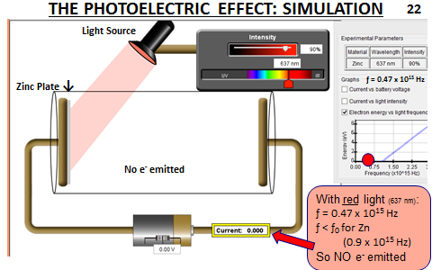

Typical exam questions dealing with the graph relationship of the energy of the incident photon and the light of different frequencies were dealt with, making abstract concept easy to understand for the learners.
This presentation is a work in progress and in future we hope to present a full picture of the students’ response towards this method.

