Effect of calcination on the structural and magnetic properties of nickel chromite
P Mohanty, C J Sheppard and A R E Prinsloo
Department of Physics, University of Johannesburg, P. O. Box 524, Auckland Park 2006, South Africa

E-mail: alettap@uj.ac.za
Abstract. The magnetic and structural properties of NiCr₂O₄ synthesized through chemical co-precipitation technique are reported. In-situ high temperature x-ray diffraction (XRD) studies of the as-synthesized NiCr₂O₄ samples measured in air as well as He atmosphere suggests the phase formation takes place around 800 to 900 °C suppressing the Cr₂O₃ impurity phase. Upon cooling no change in crystal structure is observed confirming the phase formation process is thermodynamically irreversible one. Cubic structure of NiCr₂O₄ is retained up to 1100 °C contrary to the reported tetragonal phase observed at such elevated temperature. NiCr₂O₄ samples calcined at 900 °C and 1100 °C respectively, have been used for microstructural and magnetic studies. The particles are found to have a broad size distribution in the micrometer range without any undesired impurities. Curie temperature (T_{C}) is found to be 86.5 ± 0.2 K for the sample calcined at 900 °C whereas it is reduced to 74.2 ± 0.08 K for the sample calcined at 1100 °C. For both the samples the magnetic transition observed at 30.2 ± 1.7 K (T_{S}) is remained unchanged that marks the ordering of antiferromagnetic component below it. The spontaneous magnetization (M_{s}) values for NiCr₂O₄ calcined at 900 °C and 1100 °C are found to be 0.122 ± 0.002 µ_{B}/f.u. (at 5 K) and 0.179 ± 0.002 µ_{B}/f.u. (at 3 K), respectively that are less than the reported value. Magnetic field dependent magnetization measurements under zero field cooled (M_{ZFC}) and field cooled (M_{FC}) condition shows absence of exchange bias effect in these samples at low temperatures.
1. Introduction
The spinel compound NiCr₂O₄ is of the general formula AB₂O₄ and demonstrates ferrimagnetic ordering below Curie temperature, T_{C} = 74 K [1]. It has a normal spinel structure with magnetic Ni²⁺ and Cr³⁺ ions occupying tetrahedral A and octahedral B sites, respectively. The structure of NiCr₂O₄ is an elongated tetragonal below 310 K [2]. The magnetic moments of NiCr₂O₄ are comprised of a ferrimagnetic (longitudinal) and an antiferromagnetic (transverse) component [2, 3]. Ordering of both these components occur simultaneously at T_{C} [3]. Having a normal spinel ferrimagnetic structure with two characteristic magnetic components, NiCr₂O₄ demonstrate different magnetic, as well as structural behaviour when compared to the other members of the chromite family [3]. From specific heat-capacity measurements Klemme et al. [4] observed an unknown transition at 29 K for NiCr₂O₄. Later this transition was defined by Tomiyashu and Kagomiya [3] through neutron as well as magnetic measurements. The authors proposed a new magnetic structure below 34 K with a spontaneous magnetization of about 0.3 µ_{B}/f.u., in which the B sites are grouped into two sublattices for both the longitudinal and transverse components similar to MnCr₂O₄ and CoCr₂O₄ [3].
In NiCr₂O₄ structural phase transition from cubic to tetragonal occurs at 310 K due to Jahn-Teller effect on Ni²⁺ ions at tetrahedral site [1]. Earlier results [1, 4] have also shown further distortion of tetragonal NiCr₂O₄ to an orthorhombic phase, that occurs at the transition temperature T_{N} = 65 K, which is quite different from the magnetic transition temperature [5]. Recently, Baramn et al. [6] have observed exchange bias effect in NiCr₂O₄ due to anisotropic exchange interaction between the ferrimagnetic and the antiferromagnetic components of the magnetic moment. This exchange bias effect finds important applications such as magnetic read heads and spintronics devices, etc. [7, 8].
Motivated by the concurrent structural and magnetic phase transition in the NiCr₂O₄ compound, the present study gives a detailed investigation of high temperature structural phase changes, as well as the effect of calcination on magnetic properties of NiCr₂O₄.
2. Experimental
NiCr₂O₄ powders were synthesized using chemical co-precipitation techniques, starting with stock solutions of 0.5 M of nickel nitrate (Ni(NO₃)₂.6H₂O) and chromium nitrate (Cr(NO₃)₃.9H₂O). The desired amount of chromium nitrate solution was poured into a beaker and stirred using a magnetic stirrer. The required amount of nickel nitrate was then added drop wise to the solution. The mixture was stirred continuously at room temperature for 1 hour, while diluted aqueous ammonia (30 %) solution was added to maintain the pH of 9.8. The precipitates were filtered, washed several times using distilled water, then with acetone and finally with methanol. The precipitated powders were dried overnight on a hot plate and crushed to powder using an agate mortar and pestle.
Structural characterizations of these samples were carried out using a Phillips PAN analytical X-pert Pro X-ray diffractometer utilizing Cu-K_{α} radiation (λ = 1.54056 Å). Temperature dependent XRD studies were carried out in-situ in a non-ambient Anton Parr HTK 1200 Oven-Chamber under He and air atmosphere. The oven is designed for non-ambient XRD studies measured from room temperature to 1200 °C. Data were acquired in a range of 10° ≤ 2θ ≤ 80°, with a waiting time of 10 minutes before each measurement. A hybrid monochromator on the primary beam side of the diffractometer was used to avail a quasi-parallel x-ray beam. This configuration makes the XRD data collection insensitive to height difference of the sample during the course of heating. The sample holder was rotated continuously during the measurement. A JEM-2100 transmission electron microscope (TEM) was used to study the microstructure of the calcined powders. Energy dispersive x-ray spectroscopy (EDS) was carried out using a detector from Oxford attached to the TEM. The magnetic measurements were performed using a 14 T Cryogen Free Physical and Magnetic Measurement System (CRYOGENIC Ltd., UK) with a vibrating sample magnetometer (VSM) insert [9].
3. Results and discussion
The XRD patterns of NiCr₂O₄ particles calcined at 600 °C and 900 °C are depicted in Fig. 1 (a). The XRD pattern of the dried, as-synthesized NiCr₂O₄ samples (marked ‘Raw’) show amorphous nature as shown in Fig. 1 (a). When heated to 600 °C, the Cr₂O₃ phase dominate (Fig. 1 (a)), similar to previous reports [10]. Further heating at 900 °C, the cubic phase of NiCr₂O₄ is obtained (Fig. 1 (a)). The reflections corresponding to planes (111), (220), (311), (222), (400), (422), (511) and (440) are well matched with the cubic structure of NiCr₂O₄ (ICDD: 89-6615). To observe the phase formation with increasing temperature, in-situ temperature dependent XRD was carried out under He as well as air atmosphere up to 1100ºC using the dried NiCr₂O₄ powders. Fig. 1(b) depicts the phase evolution of NiCr₂O₄ upon heat treatment under air atmosphere. From this figure it is clear that the NiCr₂O₄ phase formed around 800 °C. However, a minute peak is also seen associated with the Cr₂O₃ impurity phase (marked with ‘*’ in Fig. 1(b)). With increasing calcination temperature, the Cr₂O₃ peak intensity reduces, suggesting phase purity enhancement persisting up to 1100 °C. The formation of the tetragonal phase of NiCr₂O₄ was previously reported by Ptak et al. [10] at a synthesis temperature of 1000 °C. However, the present results show that the cubic phase of NiCr₂O₄ is retained up to almost
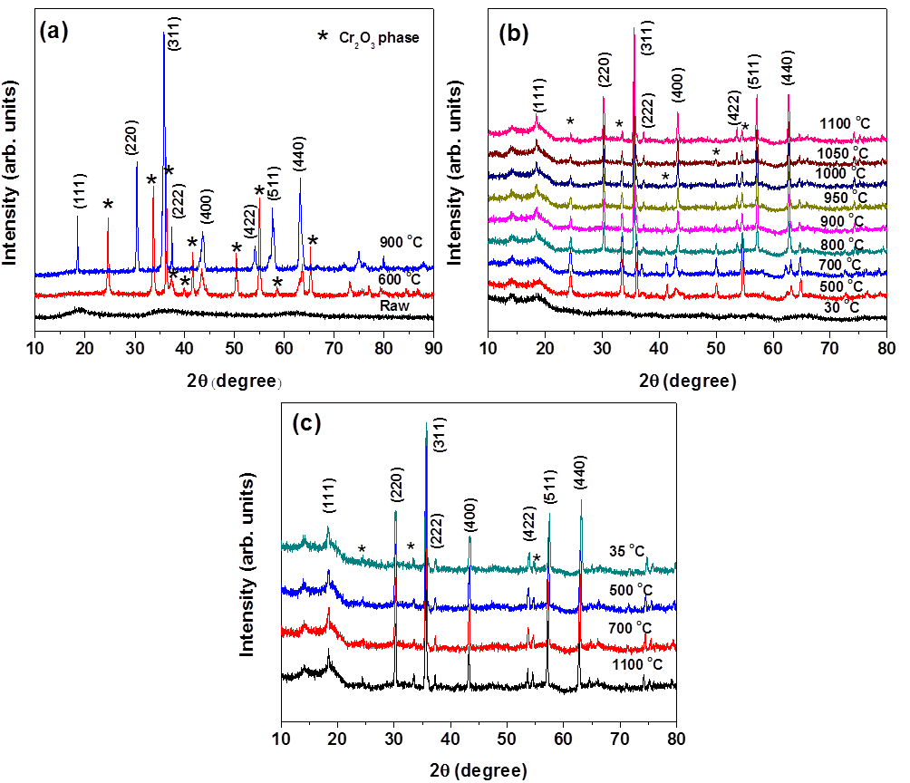
Figure 1. XRD patterns of the NiCr₂O₄ powders synthesized at pH~ 9.8 and measured: (a) ex-situ, (b) in-situ with increasing temperature up to 1100 °C, (c) during the cooling cycle from 1100 °C to 35 °C. The reflections corresponding to planes (111), (220), (311), (222), (400), (422), (511) and (440) are well matched with the cubic structure of NiCr₂O₄ (ICDD: 89-6615). In these figures ‘*’ mark the peaks indicating the presence of the Cr₂O₃ phase.

1100 °C.The XRD patterns of the sample while cooling from 1100 °C to 35 °C was also recorded (Fig. 1(c)). No remarkable difference in the XRD profile was observed. This clearly suggests that the NiCr₂O₄ phase formation process is thermodynamically irreversible. Similar trends in the XRD patterns under heating as well as cooling in He atmosphere was observed (figure not shown).
In order to investigate the effect of calcination on microstructural and magnetic properties, two samples were calcined at 900 °C and 1100 °C in a tubular furnace for 2 hours, respectively. Fig. 2 (a) and (b) shows the TEM images of the NiCr₂O₄ sample calcined at 900 °C and 1100 °C, respectively. Both the micrographs show distribution of particle sizes in the micrometer range, with the largest crystallites have a size about few micrometers whereas smaller particles fall in the nanometer regime. The presence of bipyramidal structures is clearly seen in the TEM images, characteristic morphology of NiCr₂O₄ (Fig. 2) [10]. The well distinct lattice fringes (from high resolution electron microscopy (HREM)) confirm the periodicity of the atoms in the crystal (inset of Fig. 2 (a)). EDS results of the two samples (see Fig. 2 (c) and (d) and insets therein) confirm the presence of elements Ni, Cr and O without any signatures of foreign impurities. In order to explore the magnetic properties, temperature dependent magnetization measurements were carried out in zero field cooled (M_{ZFC}) and field cooled (M_{FC}) conditions by applying an 0.1 T probing field. For NiCr₂O₄ sample calcined at 900 °C, a decrease in temperature from 300 K both the M_{ZFC}(T) and M_{FC}(T) curves show a rapid increase around 86.5 ± 0.2 K. This is indicative of a paramagnetic to ferrimagnetic transition and termed as the Curie temperature, T_{C} (Fig. 3 (a)). T_{C} is obtained from the extrapolation of the linear part of the magnetization to zero as shown in Fig. 3. The value of T_{C} is higher than the previously reported value [1]. However, the value of T_{C} is found to be 74.2 ± 0.08 K in case of the sample calcined at 1100 °C (Fig. 3(b)), which is in agreement with the reported value i.e. 74 K [1]. For both the samples, M_{ZFC} shows a sharp peak below T_{C}. Increasing the temperature up to 27 K, the M_{ZFC} is negative for sample calcined at 1100 °C whereas M_{ZFC} is always positive for the other. The phenomenon leading to negative magnetization has been reported for molecular-based ferrimagnets and is arising due to the change in the direction of the magnetization in the ferromagnetic component at the compensation temperature [11-13]. For spinel compounds, if the sublattice magnetizations M_{A} and M_{B} have different temperature dependences, the resultant magnetization changes sign at a temperature known as the compensation temperature [14]. The negative magnetization mostly arises due to the presence of uncompensated spins [15]. In both the samples anomaly in magnetization is observed around 30.2 ± 1.7 K (Fig. 3) termed as T_{S}, below which ordering of antiferromagnetic component takes place [1, 3]. To gain a deeper understanding of the behaviour of these samples, magnetization as a function of applied magnetic field at various temperatures was measured. Fig. 4 (a) shows the M-H loops of the

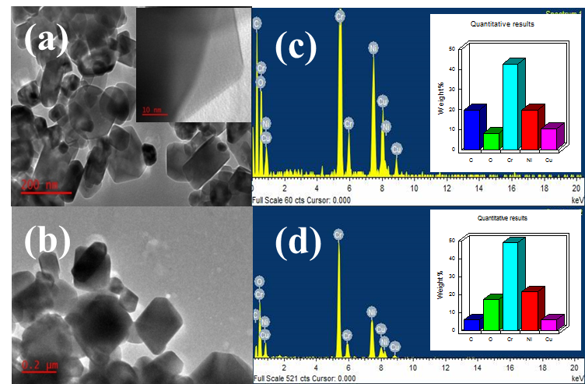
Figure 2. (a) TEM micrograph of NiCr₂O₄ calcined at 900 °C (inset shows the HREM image), (b) TEM micrograph of NiCr₂O₄ calcined at 1100 °C, (c) EDS of NiCr₂O₄ calcined at 900 °C and (d) EDS of NiCr₂O₄ calcined at 1100 °C. The insets of both (c) and (d) depict the elemental distribution.

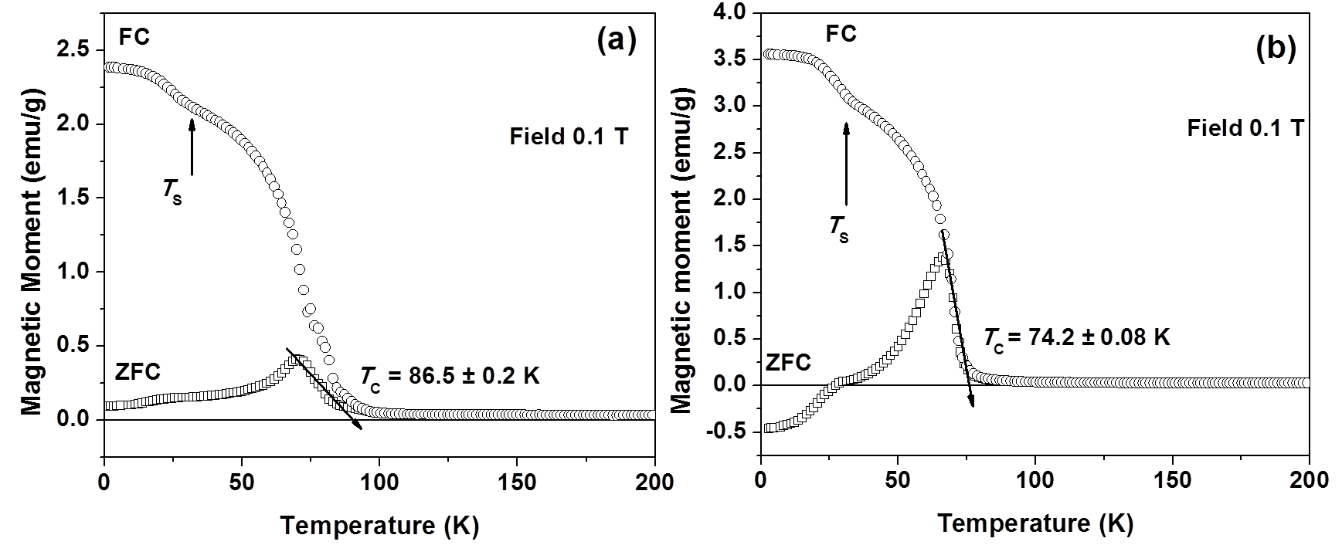
Figure 3. Temperature dependent magnetization under zero field cooled (ZFC) and field cooled (FC) conditions. For the field cooled scenario measurements were done in a 0.1 T applied magnetic field for NiCr₂O₄ samples calcined at (a) 900 °C and (b) 1100 °C.
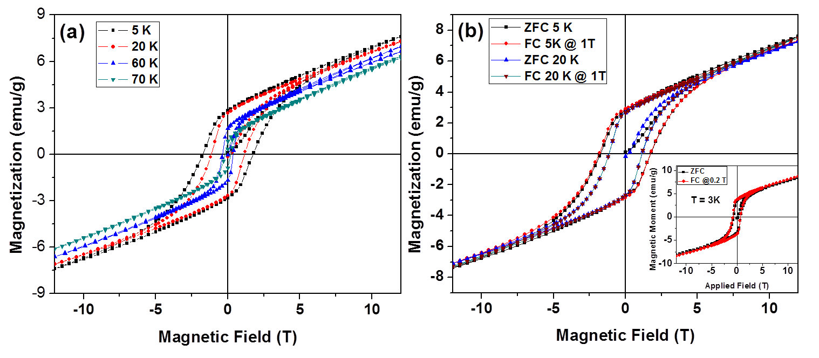
Figure 4. Magnetic field-dependent magnetization at measured at different temperatures for NiCr₂O₄ calcined at 900 °C under: (a) zero field cooled (ZFC) and (b) field cooled (FC) condition. Inset of (b) shows the M-H loop for the sample calcined at 1100 °C at 3 K under ZFC and FC (at 0.2 T) condition.

NiCr₂O₄ sample calcined at 900 °C and measured at temperatures 5, 20, 60 and 70 K. Both coercivity (H_{C}) as well as remanent magnetization (M_{r}) decreases with temperature approaching T_{C}. It is also noted that the magnetization does not saturate up to an applied field of 12 T. To obtain spontaneous magnetization (M_{s}), a linear extrapolation of high field magnetization to zero field is done. The M_{s} values for NiCr₂O₄ calcined at 900 °C and 1100 °C are found to be 0.122 ± 0.002 µ_{B}/f.u. (f.u. refers to formula unit) at 5 K and 0.179 ± 0.002 µ_{B}/f.u. at 3 K, respectively. These M_{s} values are less than the previously reported at 5 K by Mufti et al. [15] and Tomiyashu and Kagomiya [3], 0.2 and 0.3 µ_{B}/f.u., respectively. In view of the recent observation of exchange bias in NiCr₂O₄ by Barman et al. [6], in the present study M-H loops have been traced under 1 T cooling field at 5 K and 20 K as shown in Fig. 4 (b). The inset of Fig. 4 (b) shows the M-H loops of NiCr₂O₄ calcined at 1100 °C and measured under 0.2 T cooling field measured at 3 K. As there is no shifting in the loop for different fields, including for the case of the lowest temperature of 3 K, it suggests the absence of exchange bias phenomenon in the present case.
4. Conclusions
Phase of NiCr₂O₄ samples synthesized through chemical co-precipitation technique was achieved at calcination at 900 °C. In-situ temperature dependent x-ray diffraction studies showed no change in structural phase even up to 1100 °C and cubic phase was retained contrary to tetragonal phase reported for the sample calcined at 1000 °C. NiCr₂O₄ samples calcined at 900 °C and 1100 °C were used to investigate the magnetic properties. TEM analyses showed wide variation of particle sizes of both the samples that mostly contains bipyramidal shaped particles. EDS did not show the presence of any unwanted impurity in the samples. NiCr₂O₄ sample calcined at 1100 °C showed the T_{C} to be 74.2 ± 0.08 K and T_{S} equals to 30.2 ± 1.7 K. However, for the sample calcined at 900 °C, T_{C} was found to be 86.5 ± 0.2 K with T_{S} unchanged. The negative magnetization in low temperature regime for the 1100 °C sample suggests the presence of uncompensated spins in the material. M-H loops measured at various temperatures confirmed the ferrimagnetic nature of the samples. No exchange bias was observed for both the samples even at lowest temperature.
Acknowledgements
Authors acknowledge the financial support from the South African National Research Foundation (Grant numbers: 80928, 93551 and 88080) and the Faculty of Science, University of Johannesburg (UJ), South Africa. The use of facilities at UJ Spectrum is acknowledged.
References
- Ishibashi H and Yasumi T 2007 J. Magn. Magn. Mater. 310 e610
- Prince E 1961 J. Appl. Phys. 32 68S
- Tomiyashu K and Kagomiya I 2004 J. Phys. Soc. Japn. 73 2539
- Klemme S and Miltenburg J C 2002 Phys. Chem. Miner. 29 663
- Armbruster T, Lager G A, Ihringer J, Rotella F J and Jorgensen J D 1983 Z. Krist. 162 8
- Barman J, Bora T and Ravi S 2015 J. Magn. Magn. Mater. 385 93
- Tsang C, Fontana R E, Lin T, Heim D E, Speriosu V S, Gurney B A and Williams M L 1994 IEEE Trans. Magn. 30 3801
- Guo S, Liu X H, Cui W B, Liu W, Zhao X G, Li D and Zhang Z D 2009 J. Appl. Phys. 105 064702
- Cryogenic Ltd, 29-30 Acton Park, Industrial Estate, the Vale London, W3 7QE, UK
- Ptak M, Maczka M, Gagor A, Pikul A, Macalik L and Hanuza J 2013 J. Sol. Stat. Chem. 201 270
- Ohkoshi S, Yorozu S, Sato O, Iyoda T, Fujishima A and Hashimoto K 1997 Appl. Phys. Lett. 70 1040
- Mathoniere C, Nuttal C J, Carling S G and Day P 1994 J. Chem. Soc., Chem. Commun. 1994 1551
- Mathonière C, Nuttall C J, Carling S G and Day P 1996 Inorg. Chem. 35 1201
- Néel L 1948 Ann. Phys. 3 137
- Dutta D P, Manjanna J and Tyagi A K 2009 J. Appl. Phys. 106 043915
- Mufti N, Nugroho A A, Blake G R and Palstra T T M 2010 J. Phys.: Condens. Matter 22 075902

To whom any correspondence should be addressed

