Internal quantum efficiency and energy transfer processes in Ce3+ co-doped ZrO3: Eu3+

Ahemen I.1 and Dejene F.B.2

Department of physics, *University of the Free State-Qwaqwa Campus, Private Bag X13,* Phuthaditjhaba, 9866, South Africa

E-mail: ahemior@gmail.com

**Abstract.** Cerium (III) ion co-doped ZrO2: Eu3+ nanorods at varying Ce3+ ion concentration were synthesized by a simple chemical dehydration route. Their structural, morphological and optical properties were investigated. Structural studies revealed a tetragonal phase. Field emission scanning electron microscopy images show nanorods of different dimensions. Diffraction peaks shifted towards smaller angles indicating the incorporation of the rare-earth ions. Both Ce3+ (donor) and Eu3+ (activator) emission peaks were obtained when the samples were excited via the Ce3+ excitation band indicating energy transfer from the donor to activator. The process of energy transfer is multiipolar. However, no significant enhancement of the activator’s emission intensity, because concentration quenching process dominated the energy transfer process. The internal quantum efficiency, though low (20 – 25%), increased with increasing Ce3+ concentration.

1. Introduction

Zirconia has wide band gap in the range 4 to 6 eV; monoclinic phase (m-ZrO2) 4.2 – 5.83 eV, tetragonal (ZrO2) 4.2 – 5.78 eV and cubic (c-ZrO2) 4.6 – 6.1 eV [1]. The wide band gap, low phonon energy of 470 cm-1 and excellent physical properties of the oxide has made it a strong candidate as an efficient host matrix for rare earths based phosphors. These properties have attracted several studies which are directed towards understanding the properties of rare earth doped bulk and nanocrystalline ZrO2 of different crystalline phases. Zirconium oxide (ZrO2) has three polymorphs; m-ZrO2 with a lattice symmetry of Cs is thermodynamically stable at temperatures below 1170 oC while the t-ZrO2 structure with symmetry of D2d stabilizes at temperatures in the range 1170 to 2370 oC. The c-ZrO2 is stable at temperatures beyond 2370 0C [2]. Among these polymorphs, the cubic and tetragonal phases are the most stable and symmetric, and are considered crucial for technological applications.

Cerium (III) ion has 4f electron with 5d1 level as the lowest excited state. Since the 4f orbital of Ce3+ is not shielded from the surrounding, it readily absorb radiation within a large band. On the other hand, the 4f orbital of Eu3+ is shielded from the host surrounding by the 5s25p6 orbitals and therefore, has a narrow absorption line. This narrow absorption line limits the absorption of Eu3+ ion and may affect the overall quantum emission efficiency of a phosphor based on this ion. Hence, the need to assist the absorption process of Eu3+ through co-doping with other ions or finding a suitable host.

The aim of co-doping in some cases is to facilitate energy transfer between two ions species in a host matrix and possibly enhance the internal quantum efficiency of the phosphor. Therefore, co-doping Ce3+ cerium with Eu3+ in ZrO2 host is expected to facilitate energy transfer from the host to the Eu3+ ion. Besides, internal quantum efficiencies of co-doped systems are rarely studied. To date, no study has been conducted to study the quantum efficiency of Eu3+ co-doped ZrO2: Eu3+ system. In this work, a simple chemical reaction route is employed to prepare Eu3+ co-doped ZrO2: Ce3+ nanorods with different Ce3+ ion concentrations. The intrinsic emission quantum efficiency and site symmetry of the Eu3+ ion in the host crystal before and after co-doping are investigated.

1. Experiment

Europium and cerium co-doped zirconia nanorods (ZrO2: xCe3+, 0.04 Eu3+; x = 0.01, 0.02, 0.03, 0.04 and 0.05) were prepared following our previous report. In a typical synthesis, 0.2 M Zr(OC4H4)4 solution with appropriate concentration of Ce3+ (x = 0.01, 0.02, 0.03, 0.04, 0.05) and a fixed 0.04 Eu3+ ion concentration in mole ratios were prepared using deionized water (30%) – ethanol (70%) mixture. An equal volume of 0.2 M hexamethyltetramine (HMTA) solution was added to a mixture of the above solutions and the pH set at 2 by the adding HCl. The final solution was kept for 24 hours to allow complete reaction and a transparent solution was obtained. Next, the mixture was heated at 50 oC for 1 hour and then increased to 110 oC while the stirring continued until complete evaporation of solvent. The obtained solid was dried at 120 oC for 8 hours and made into fine powders by grinding followed by annealing at 800 oC for 2 hours. The samples were labelled EC1, EC2, EC3, EC4 and EC5 for 1, 2, 3, 4 and 5 mol% of Ce3+ ion, respectively.

The powder samples were characterized using Siemen powder X-ray diffractometer with Cu K radiation. The morphology and composition were obtained using the Jeol JSM-7800F Field Emission Scanning Electron Microscope (FESEM) equipped with Oxford Aztec Energy Dispersive Spectroscopy (EDS) and Gatan Mono CL4. Diffused reflectance was measured using PerkinElmer Lambda 950 UV Vis spectrophotometer. The PL measurements were performed at room temperature using Varian Cary Eclipse fluorescence spectrophotometer with a monochromatized 150 W xenon lamp as excitation source.

1. Results and discussion
   1. Morphology

Figure 1a presents a representative field emission scanning electron microscopy image of ZrO2: xCe3+, 0.04 Eu3+nanorods. The nanorods have rectangular shapes with projected edges, which form a groove at four of the six faces. The rods have an average length of 0.85. All samples have the same morphology.

* 1. X-ray diffraction analysis

The X-ray diffraction patterns of Ce3+ and Eu3+ singly doped, and ZrO2: Ce3+, Eu3+ co-doped nanorods at varying Ce3+ ion concentrations are presented in Figure 1b and Figure 1c, respectively. The doped samples show mix crystal phases of m-ZrO2 and t-ZrO2. However, with the addition of Ce3+ ion to ZrO2: Eu3+, the phases completely transformed to a single tetragonal phase indicating that co-doping facilitated phase stabilization. The patterns of co-doped samples clearly match with t-ZrO2 with JCPDS card no. 81-1544. Figure 1d shows the normalized (101) peak shift as a function of Ce3+ ion concentration. The dash vertical line indicate the peak position of undoped sample. It is clear from this figure that the (101) peak shifts towards smaller angles as the Ce3+ ion concentration increases. This is an indication that both or either Ce3+ and Eu3+ ions are incorporated into the ZrO2 lattice. Since the ionic sizes of Eu3+ (0.109 nm) and Ce3+ (0.115 nm) are larger than Zr4+ ion (0.088 nm), it is expected that if either of these rare-earth ions are incorporated at the Zr3+ ion site, it will create lattice deformation. From the XRD patterns, the crystallite sizes, Dhkl of nanocrystal rods were calculated using the Scherrer formula [3]. The mean crystallite size of each sample was obtained by taking the average of crystallite sizes obtained from the three most prominent diffraction peaks. The results displays crystallite sizes in the range 11 to 15 nm, increasing with concentration.

* 1. UV—visible spectroscopy

Diffuse reflectance measurement carried out on ZrO2: Ce3+ and Eu3+ co-doped ZrO2: xCe3+ (x = 0.01, 0.02, 0.03, and 0.04) nanorods are shown in Fig. 2a. The optical band gap was derived from the diffuse reflectance using the Schuster-Kubelka-Munk (SKM) function [4]. The obtained energy band gaps are 5.10 eV for undoped zirconia, 3.13 and 4.96 eV for Ce3+ and Eu3+ singly doped ZrO2, respectively. The co-doped samples have energy band gaps of either 3.19 or 3.23 eV. There is no significant variation of the energy bang gaps with increasing Ce3+ concentration.

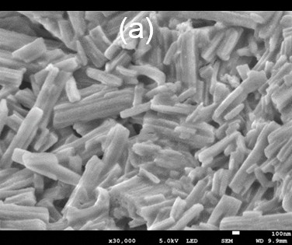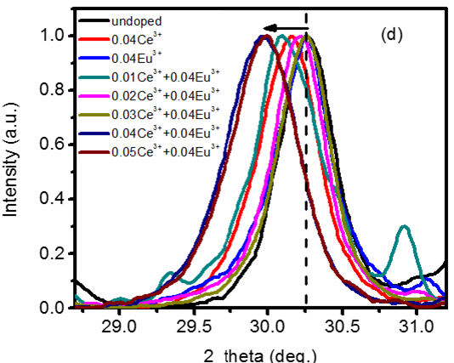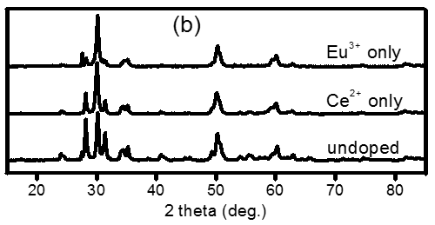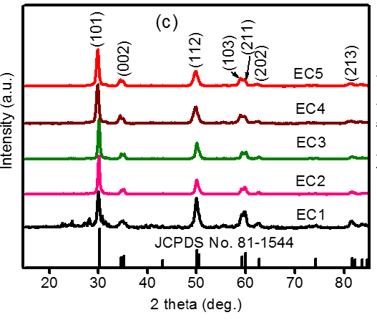

**Figure 1.** (a) FESEM image and XRD patterns of (b) undoped, Ce3+ & Eu3+ singly doped, (c) Ce3+ coped ZrO2: Eu3+ nanorods and (d) peak shift of (101) diffraction plane

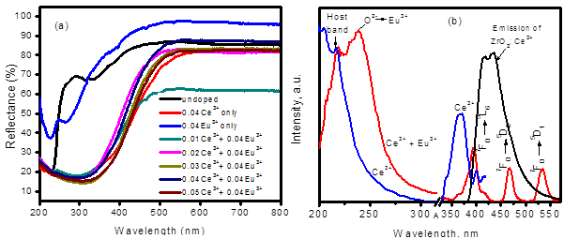

**Figure 2.** (a) Diffuse reflectance and (b) excitation spectra of Ce3+ singly doped; Ce3+-coped ZrO2: Eu3+ (Ce++Eu3+) and emission spectrum of undoped ZrO2 nanorods

* 1. Photoluminescence

Figure 2(b) displays excitation spectra for Ce3+ singly doped (blue) and Ce3+ co-doped ZrO2: Eu3+ (red) nanocrystal rods on monitoring emissions at 435 nm and 606 nm for cerium and europium ions, respectively.. Both spectra consist of the host/charge transfer band and the bands associated with the dopant ion. For the Ce3+ singly doped sample, the peak at 206 (6.01 eV), 218 nm (5.69 eV) and the broad band in the range 330 – 408 nm (enlarged) are assigned to band edge, near band edge and the *f-d* transitions of Ce3+ ions, respectively. The spectrum for the co-doped sample also has the near edge band at 5.69 eV, Eu3+ - O2- charge transfer band and interconfigurational Eu3+ (7FJ to 5L6, 5D2 and 5D1) transition lines at 395, 465 and 535 nm, respectively. The excitation band associated with Ce3+ could not be seen in this spectrum probably because of its low intensity. Figure 2b also shows the emission spectrum of Ce3+ singly doped ZrO2. The spectrum can be decovoluted into two peaks; 418 nm and 436 nm peaks which can be ascribed to the electric dipole-allowed transitions of Ce3+ [5]. Figure 3 shows the emission spectra of Eu3+ co-doped ZrO2: xCe3+ (x = 0.01 to 0.05) nanocrystal rods obtained at 340 nm excitation wavelength (corresponding to Ce3+ ion excitation band). The spectra consist of the host/Ce3+ (300 – 550 nm) bands, and Eu3+ emission transition lines at 592 nm () and 606 nm ().

* 1. Energy transfer and site symmetry

Since no absorption line of Eu3+ is located at 340 nm, it is evident that there is energy transferred from 5d1 state of Ce3+ to the 5D0 state of Eu3+ ion. The overlap of Ce3+ ion emission band with the excitation lines of Eu3+ as shown in Figure 2b indicate the possibility of energy transfer between these two ions. Direct excitation in the absorption line of Eu3+ ion at 395 or 465 nm produced only the transition lines of Eu3+ ion. However, irrespective of the excitation wavelength, the magnetic dipole transition () dominates the electric dipole transition (), which shows that Eu3+ ions are situated at high symmetry sites with inversion center, apparently at the Zr4+ ion site. This result is consistent with XRD peaks shift to smaller angles as Ce3+ ion concentration increases. Using Blesse formula [6,7], the critical distance for samples at low concentration of Ce3+ ion (0.60, 0.56, 0.54 and 0.51 nm for EC1, EC2, EC3 and EC4) were calculated to be greater than 0.5 nm, signifying that the energy transfer involves multipolar processes and less than 0.50 nm at high Ce3+ ion concentration (0.49 nm for EC5) implying exchange interaction.

Photoluminescence decay profiles of the orange-red emitting levels of Ce3+ co-doped ZrO2: Eu3+ nanorods were recorded as a function of Ce3+ concentration. All profiles display bi-exponential decay. A bi-exponential decay given by equation (1) is often ascribed to either one or all of the following; distribution of dopant ions at different regions of the crystal [8], an inhomogeneous distribution of the dopant ions in the host or the transfer of excitation energy from donor to the activator ion [9]

 (1)

where I(t) is the luminescence lifetime at time t, A1 and A2 are fitting parameters, and are the fast and slow decay lifetime components, respectively. The average decay lifetime values for the activator ion are presented in Table 1 shows decreasing lifetime values with increase Ce3+ concentration. These variation is in agreement with previous reports on co-doped systems [10].captions not placed at the side of the figure, captions should be set to the width of the figure for wider figures, centred across the width of the figure, or, for narrow figures with wide captions, slightly extended beyond the width of the figure. The caption should finish with a full stop (period).

* 1. Internal quantum efficiency

The internal quantum efficiency, Eu3+ ion site symmetry and Eu3+– O2- covalency in host ZrO2 nanorods were obtained or confirmed from experimental intensity (Judd-Ofelt) parameters (J = 2, 4). These parameters were evaluated using the integrated emission intensity values of the  (J = 2, 4) and the  transitions using equations defined in [11]. Also, the energy band gap and refractive indices were obtained from equations given by Davis Mott [12], and Dimitrov and Sakka [13]. The calculated internal quantum efficiencies are between 20 to 25%, which is quite low (Table 1). When compared to the internal quantum efficiency of Eu3+ doped ZrO2, it is seen that the efficiency values decreased by half for the co-doped samples. This result confirms that quenching might be responsible for low efficiency. The  Intensity parameter is known to vary with local symmetry and bond covalency of ligand field [14,15]. Table 1 shows  parameter as having nearly constant values irrespective of the Ce3+ ion concentration, which is in agreement with the average values of asymmetry ratios, R0 also presented in Table 1. This result indicate that the symmetry around the dopant ions is the same and does not significantly vary with increasing concentration of the donor (Ce3+) ion.

**Table 1**. Intensity parameters and internal quantum efficiency of Eu3+ singly doped and co-doped ZrO2: Ce3+ nanorods.

|  |  |  |  |  |  |
| --- | --- | --- | --- | --- | --- |
| **Sample** | **Exc. 395 nm** | | | | **%** |
| (10-21)  cm-1 | (10-21)  cm-1 | ms | R0 |
| Eu3+ only  0.01Ce3++0.04Eu3+  0.02Ce3++0.04Eu3+  0.03Ce3++0.04Eu3+  0.04Ce3++0.04Eu3+  0.05Ce3++0.04Eu3+ | 30.3  9.99  9.71  9.89  10.23  9.91 | 7.80  0.25  0.25  0.26  0.38  0.38 | 2.60  9.98  9.25  9.06  8.71  8.98 | 2,10  0.90  0.87  0.89  0.92  0.89 | 51.8  20.5  21.4  22.5  24.5  23.4 |



**Figure 3.** (a) Photoluminescence emission spectra () and (b) decay lifetime at for Eu3+ co-doped ZrO2: xCe3+ nanorods.

1. Appendices

Cerium (III) ion co-doped ZrO2: Eu3+ nanorods at varying concentration of Ce3+ ion were synthesized using a simple chemical dehydration method. The result shows that addition of Ce3+ stabilizes the material in tetragonal phase. Substitution of the rare earth ions was also observed from the shift of the diffraction planes to smaller angles. Energy transfer from Ce3+ to Eu3+ was recorded; however, the quantum efficiency was low because of concentration quenching, though efficiency increased with increasing Ce3+ concentration.

References

[1] Smits K, Grigorjeva L, Millers D, Sarakovskis A, Opalinska A, Fidelus J D and Lojkowski W 2010 *Opt. Mater. (Amst).* **32** 827–31

[2] Vidya Y S, Anantharaju K S, Nagabhushana H, Sharma S C, Nagaswarupa H P, Prashantha S C, Shivakumara C and Danithkumar 2015 *Acta - Part A Mol. Biomol. Spectrosc.* **135** 241–51

[3] Parganiha Y, Kaur J, Dubey V, Shrivastava R and Dhoble S J 2015 *Superlattices Microstruct.* **88** 262–70

[4] Liu Y, Luo W, Li R, Liu G, Antonio M R and Chen X 2008 686 *J. Phys. Chem. C* **112** 686–94

[5] Luo Q, Wang L S, Guo H Z, Lin K Q, Chen Y, Yue G H and Peng D L 2012 *Appl. Phys. A* **108** 239–45

[6] Zhang X, Zhou L, Pang Q, Shi J and Gong M 2014 *J. Phys. Chem. C* **118** 7591−7598

[7] Som S and Sharma S K *J. Phys. D: Appl. Phys.* **45** 415102

[8] Meetei S D and Singh S D 2014 *J. Alloys Compd.* **587** 143–7

[9] Wang R, Zhou D, Qiu J, Yang Y and Wang C 2015 *J. Alloys Compd.* **629** 310–4

[10] Lee S Y, Bang S, Kim S, Jo S Y, Kim B-C, Hwang Y and Noh I 2015. *Biomater. Res.* **19** 12

[11] Binnemans K 2015 *Coord. Chem. Rev.* **295** 1–45

[12] Ahemen I, De D K, Dejene F B and Viana B 2016 *Mater. Res. Express* **3** 045016

[13] Dimitrov V and Sakka S 1996 *J. Appl. Phys.* **79** 1736

[14] Sreena T S, Prabhakar Rao P, Linda Francis T, Raj A K V. and Babu P S 2015 *Dalt. Trans.* **44** 8718–28

[15] Balaji S, Sontakke A D, Sen R and Kalyandurg A 2011 Opt. Mater. Express **1, 2** 138–150