Low voltage electron beam induced degradation and surface chemical changes of Zn₃(PO₄)₂:Tb phosphor

I. M. Nagpure*, Shreyas S. Pitale, Liza Coetzee, O. M. Ntwaeaborwa,
J. J. Terblans and H. C. Swart**
Department of Physics, University of The Free State, P. O. Box 339, Bloemfontein, 9300, Republic of South Africa

Corresponding authors: *indrajitnagpure@yahoo.co.in (I M Nagpure) / **swarthc@ufs.co.za (HC Swart)

Abstract: Tb activated α-Zn₃(PO₄)₂ phosphor powders have been subjected to low voltage electron bombardment of 2 keV-10 µA at an oxygen pressure of 1 x 10⁻⁶ Torr. The phosphor consists out of the monoclinic structure. Zn is present at two different sites Zn₁ and Zn₂ in the Zn₃(PO₄)₂ host, as inferred from the crystallographic study. Cathodoluminescence (CL) and Auger electron spectroscopy of the phosphor excited by the same electron beam were used to monitor changes in the surface state during electron bombardment. A direct correlation between the surface reactions and the degradation of the CL brightness was observed. The surface chemical composition measurements of the powder before and after electron degradation indicated the formation of new compounds on the surface. Ametal rich P and/or metal oxide layer of phosphorous were formed on the degraded surface, which was responsible for the degradation. The layer formed according to the electron stimulated surface chemical reactions mechanism.

- Introduction
The development of flat panel displays device such as Field emission displays (FEDs) requires highly efficient cathodoluminescent (CL) materials [1-2]. Rare earth ion activated phosphors such as Ce³⁺ co-doped with Mn²⁺ and Tb³⁺ in Zn₃(PO₄)₂ [3] exhibited favorable spectroscopic properties for use in various optical applications. The phosphate based Zn₃(PO₄)₂:Mn,Tb red emitting phosphor has been prominently used as a phosphor for color television screens [2]. The phosphate chemistry has attracted a lot of attention during the past decades and has undergone a lot of developments. Interest in this material is also generated due to the crystallographic arrangement of the crystal. Zinc orthophosphate Zn₃(PO₄)₂ has three crystalline modifications, labeled as α, β and γ [4]. A lliterature survey confirms that the β and γ phases of zinc orthophosphate are more chemically and thermally stable compared to the α phase [4]. The ideal apatite α-Zn₃(PO₄)₂ crystallizes into the monoclinic system with a uni-axial lattice that belongs to the crystallographic group C₁₂/c₁(15) [5]. The structure consists of two non-equivalent crystallographic sites for the Zn, namely Zn₁ (Zn in a column) with a C_{s} symmetry and Zn₂ (Zn screw axis) with a C₃ symmetry [5].
Mn and Tb doped α-Zn₃(PO₄)₂ phosphor was tested for good thermal stability [2] and showed good CL efficiency for cathode ray tube colour television. There is, however, no report to confirm the CL stability of the phosphor under continuous electron beam bombardment. This study deals with the CL emission and chemical stability of the phosphor under continuous electron bombardment for low voltage FED applications. The surface chemical reactions and influence on the CL intensity induced by prolonged electron beam bombardment were also monitored using in situ Auger electron spectroscopy (AES) combined with CL spectroscopy.
- Synthesis and characterization methods
2.1 Synthesis method
The gel-combustion method was used for the synthesis of the α-Zn₃(PO₄)₂:Tb crystalline phosphors. Zinc nitrate (Zn(NO₃)₂4H₂O), ammonium dihydrogen phosphate (NH₄H₂(PO₄)), citric acid (C₆H₈O₇H₂O) and Tb(NO₃)₃.5H₂O, all of analytical purity were used as starting materials. Hydrated citric acid was the source of the citrate anions that were used as both chelating agent to metal cations and fuel for the combustion. The zinc nitrate, ammonium dihydrogen phosphate and terbium nitrate were combined to yield a composition with the general formula (Zn_{1-x}Tb_{x})₃(PO₄)₂ with x = 1m%. The ratio of nitrate to citrate used in the present work is 1:1. The mixed solution was heated at 120ºC and continuously stirred using a magnetic stirrer for 3-4 hours. The auto-combustion took place accompanied by the evolution of a brown fume and formation of a citrate complex. The solution turned to a bluish brown sticky gel. The bluish brown sticky gel was then heat treated at 900ºC for 2 h in a muffle furnace in air. The evolution of a gaseous fume was observed during annealing and the final product appeared to be a white crystalline powder.
2.2 Characterization methods
The as-prepared sample was characterized with a Bruker X-ray diffractometer (XRD) with CuKα radiation (λ = 1.541 Å). PL measurements were carried out on a Varian Cary Eclipse fluorescence spectrophotometer at room temperature. The Auger measurements were made in an UHV chamber with a PHI Model 549 system. The phosphors powder was excited for CL measurements by the same primary electron beam (beam voltage 2 kV, current of 10 µA) which was use for Auger excitation. CL measurements were done on the emitted light at an angle of 60º to the incident electron beam. CL intensity data for the peak at 541 nm were collected up to an electron dose of590 C/cm² with a PC2000 Spectrometer using OOI Base32 computer software. The CL experiment was done at an oxygen pressure of 1 x 10⁻⁶ Torr.
3. Results and discussion
3.1 Structural analysis
XRD data of the Zn₃(PO₄)₂ matrix is shown in figure 1. The crystalline lines are in agreement with the pure crystalline α-Zn₃(PO₄)₂ phase referenced in ICCDs data file No. 029-1390. It ishaving a monoclinic structure with the space group C₁₂/c₁ (15) and Z =4 [5]. The unit cell of the α-Zn₃(PO₄)₂ structure is shown in figure 2. In the pyrophosphate family the α-Za₃(PO₄)₂ belongs to oxyphosphate, has the highest symmetry with the space group corresponding to C₁₂/c₁ (15) which can be attributed to the occurrence of oxygen ions in the planes of triangles constituted out of alkaline earth atoms [5]. The Zn₁ atoms (C_{s} symmetry) occupies the 4e Wyckoff position along the plane that forms the tetrahedral with the oxygen atoms and is present in between the Zn₂ (C₃ symmetry) and the oxygen tetrahedral at the 8f Wyckoff position [5]. Polarization of the Zn²⁺ divalent metal ions in the triangles by the small O²⁻ ions might play the role of reducing the effective radius in the direction towards the O⁻ ion showing more effective PL and CL properties. This structure can accommodate a variety of substitutions such as rare earths, transition metals and alkaline earths.

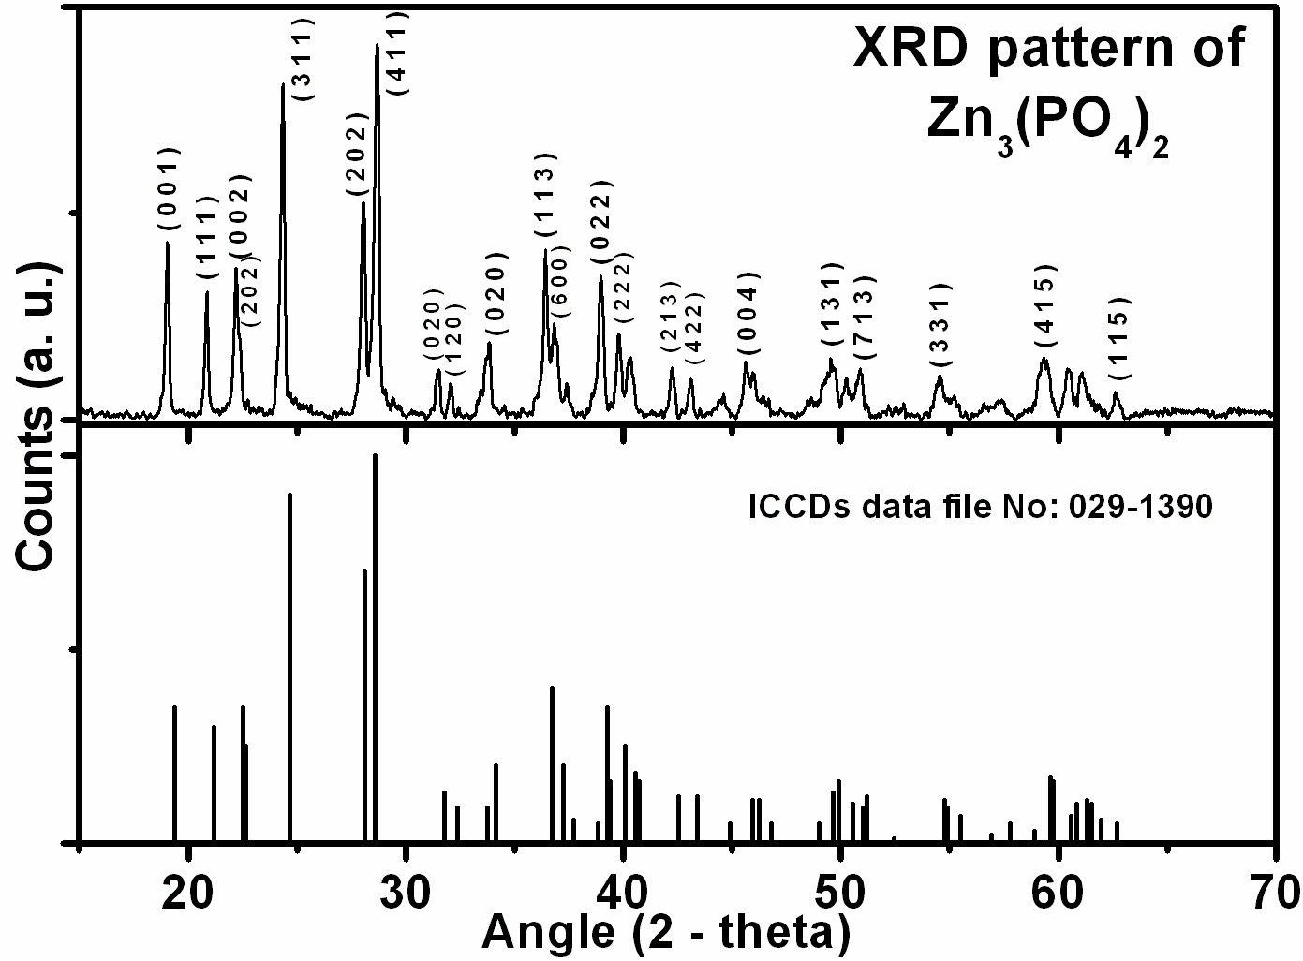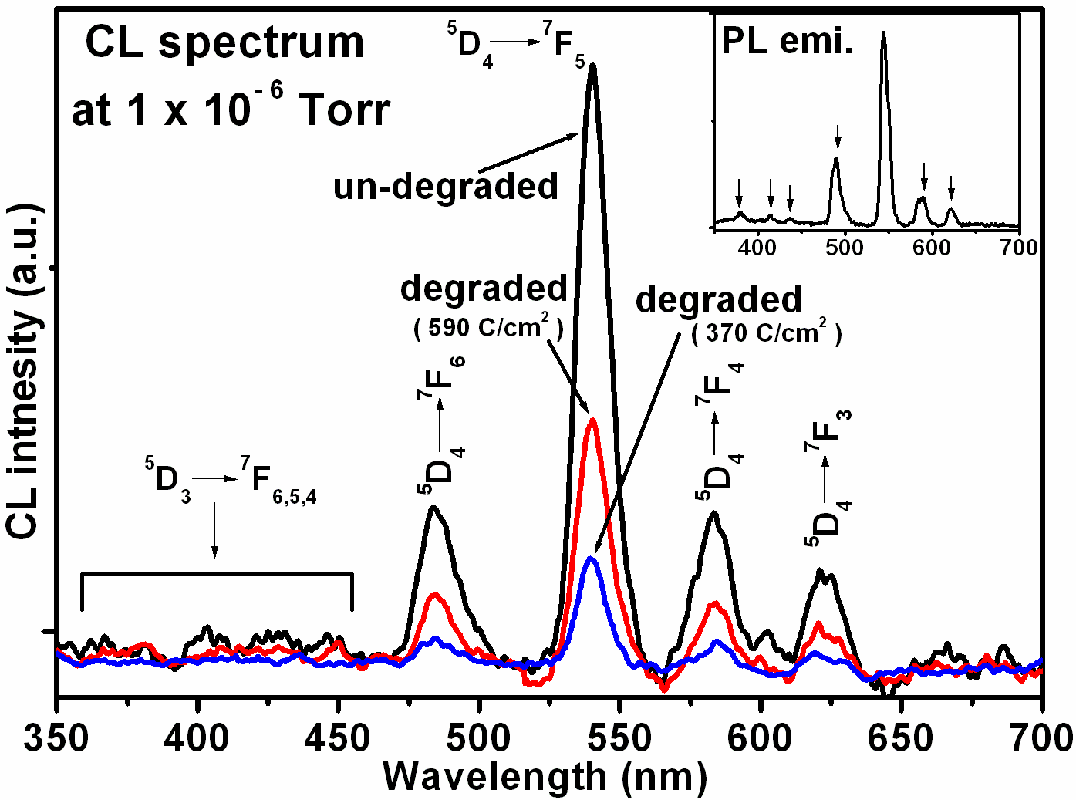

Figure-1: XRD crystal peaks of the Figure-3: The CL spectra of the Zn₃(PO₄)₂:Tb_{1mol.%} α-Zn₃(PO₄)₂ powder phosphor, (PL emission spectrum is shown
in the inset).

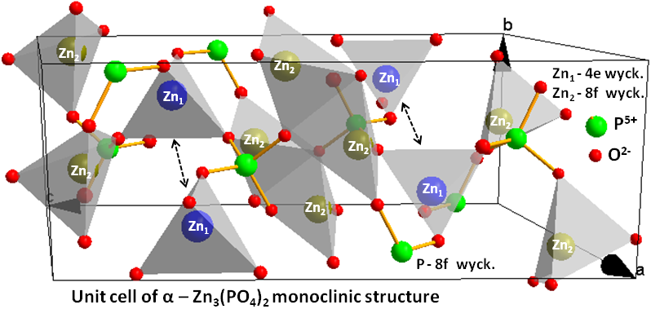

Figure-2: Crystal structure of the unit cell of the α-Zn₃(PO₄)₂ host.
3.2, CL and PL analysis
Figure 3 illustrate the CL emission spectrum of α-Zn₃(PO₄)₂:Tb excited with a 2 keV-10 µA electron beam. The CL spectra were measured at 1 x 10⁻⁶ Torr when the chamber was backfilled with oxygen. The CL spectrum consists of several emission peaks in the 470-700 nm range. The CL emission peaks due to the ⁵D₄ → ⁷F₆, ⁷F₅, ⁷F₄ and ⁷F₃ transitions are observed at 485, 541, 583 and 622 nm, respectively [6]. The green CL emission at 541 nm due to the the ⁵D₄ → ⁷F₅ transition of Tb³⁺ appeared to be more prominent compared to the blue and red emissions. The PL emission spectrum of α-Zn₃(PO₄)₂:Tb measured at a 230 nm excitation wavelength is shown in the inset of figure 3. The PL emission spectrum also has weak blue emission peaks in the region between 350-480 nm. The weak PL emission peaks at 380, 420, 440 nm are due to the transitions from the excited level ⁵D₃ to the ⁷F₆, ⁷F_{5,} ⁷F₄ levels of the Tb³⁺ ions, respectively. These peaks are almost completely absent in the CL emission spectra. The prominent PL emission peaks observed at 490, 543, 584 and 620 nm are also due to the ⁵D₄ → ⁷F₆, ⁷F₅, ⁷F₄ and ⁷F₃ transitions of the Tb³⁺ ions, respectively [6]. Also shown in figure 3 are the CLspectra after different electron doses. The intensity clearly decreased during electron bombardment..
3.3, CL degradation and APPHs analysis
CL degradation measurements were carried out by monitoring the 541 nm Tb ion CL emissions peak simultaneously with the Auger peak to peak heights (APPH’s). Figure 4 shows the normalized CL intensity and APPHs spectra as a function of electron dose at an oxygen pressure of 1 x 10⁻⁶ Torr. Figure 4 shows an initial decrease of the CL intensity up to an electron dose of 70 C/cm² followed by a rapid decrease from 70 to 370 C/cm², which later increased and stabilized after 470 C/cm². This behaviour is due to the prolonged electron bombardment of the sample, which caused changes in the surface chemistry of the sample as indicated in the APPH changes as shown in figure 4. The adventitious carbon (C) desorbed from the surface as CO₂ and CH₄ as a result of the electron beam exposure (decrease in C APPH’s) [7]. The concentration of the oxygen (O) and zinc (Zn) rapidly decreases with an increase electron dose. Simultaneously with the decrease in C, Zn and O a dramatic change in the phosphorous (P) elemental concentration was observed. Elemental APPH analysis indicates that P initially increases (i.e from 0 to 30 C/cm²) and then stabilized (i.e from 30 to 220 C/cm²) and which latter start to increases from 380 C/cm². It is therefore clear that electron stimulated surface chemical reactions (ESSCRs) [8] occurred on the surface of the α-Zn₃(PO₄)₂:Tb phosphor during prolonged electron bombardment.
3.4, AES analysis
The differentiated Auger spectra (AES) of Zn₃(PO₄)₂:Tb_{1m%} phosphor before and after 490 C/cm² electron exposure at 1 x 10⁻⁶ Torr oxygen pressure is shown in figure 5. After prolonged electron exposure the Auger spectra confirm the removal of adventitious carbon (C) and desorption of O from the surface as observed in the APPHs of figure 5. After an electron exposure of 490 C/cm², the P peak at 98 and 118 eV is altered in shape and shift in a peak position to a lower energy as shown in figure 6. This indicates that a phosphorous (P) rich surface was formed on the degraded surface [9]. The shift in the energy position clearly shows that during the surface modification the workfunction of the material changed and charging occurred. The charging has a detrimental effect in the peak AES peak intensity and shape and also on the CL intensity. Band bending will occur if charging takes place. Electron and holes are swept apart before recombination and less light will be excited, with a consequence loss in CL intensity. The change in concentration on the surface of the sample can be attributed to the formation of new chemical co-ordinates related to the pure P metal or as oxide based P on the surface as explained by the ESSCR mechanism [8].

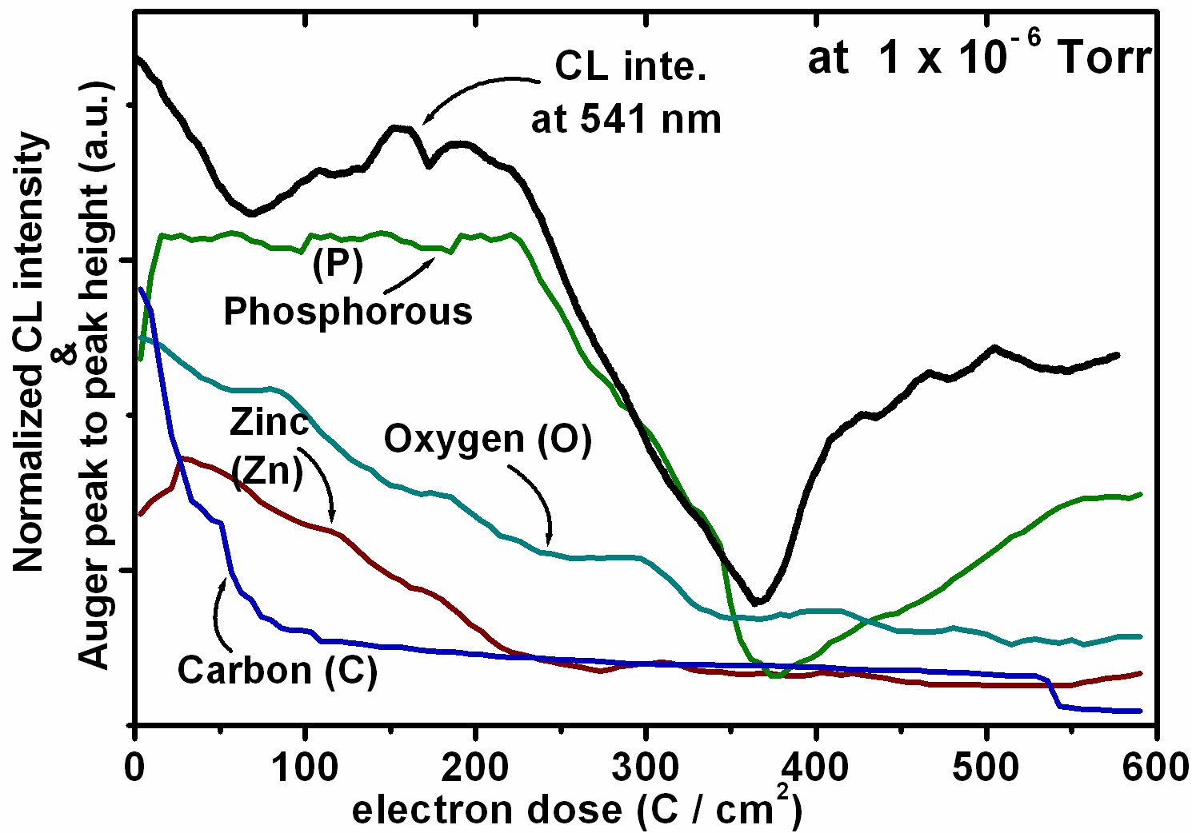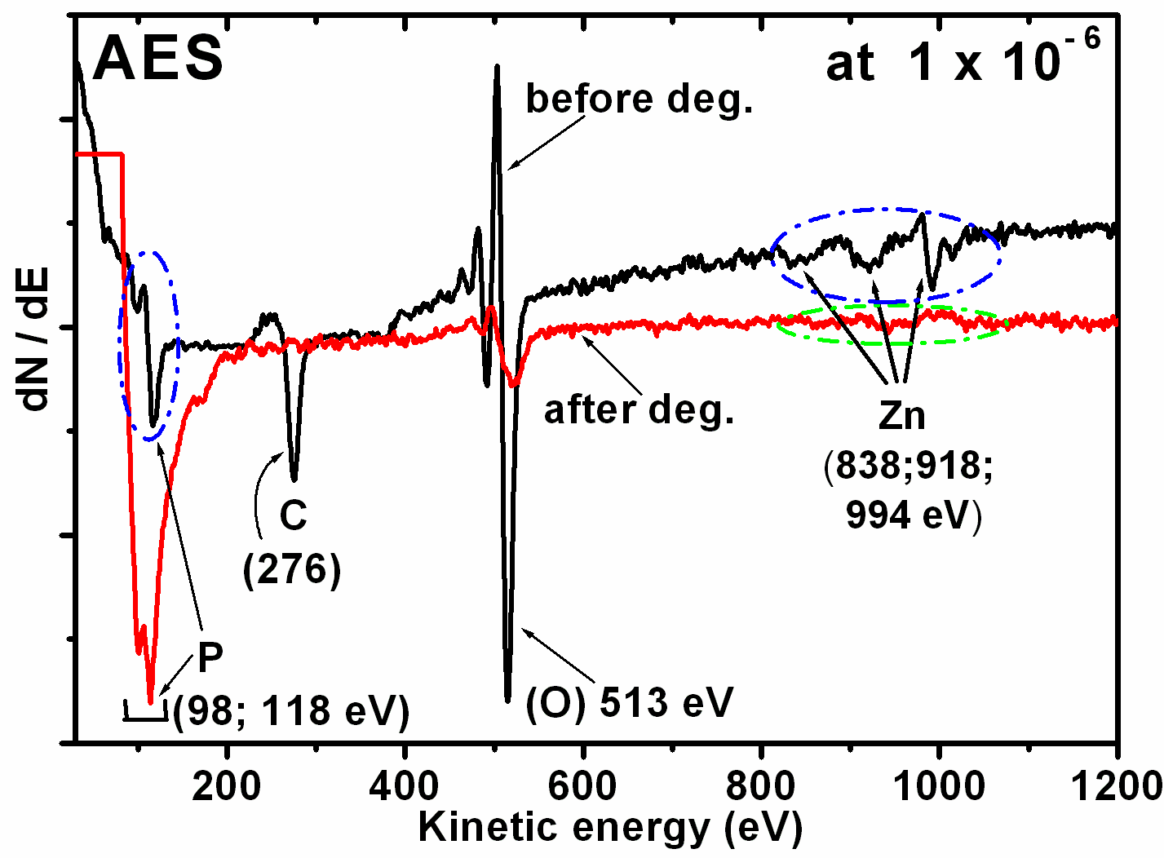

Figure-4: The APPHs variation and normalized CL Figure-5: The AES measurements before intensity of the Zn₃(PO₄)₂:Tb_{1 mol.%} phosphor. and after degradation

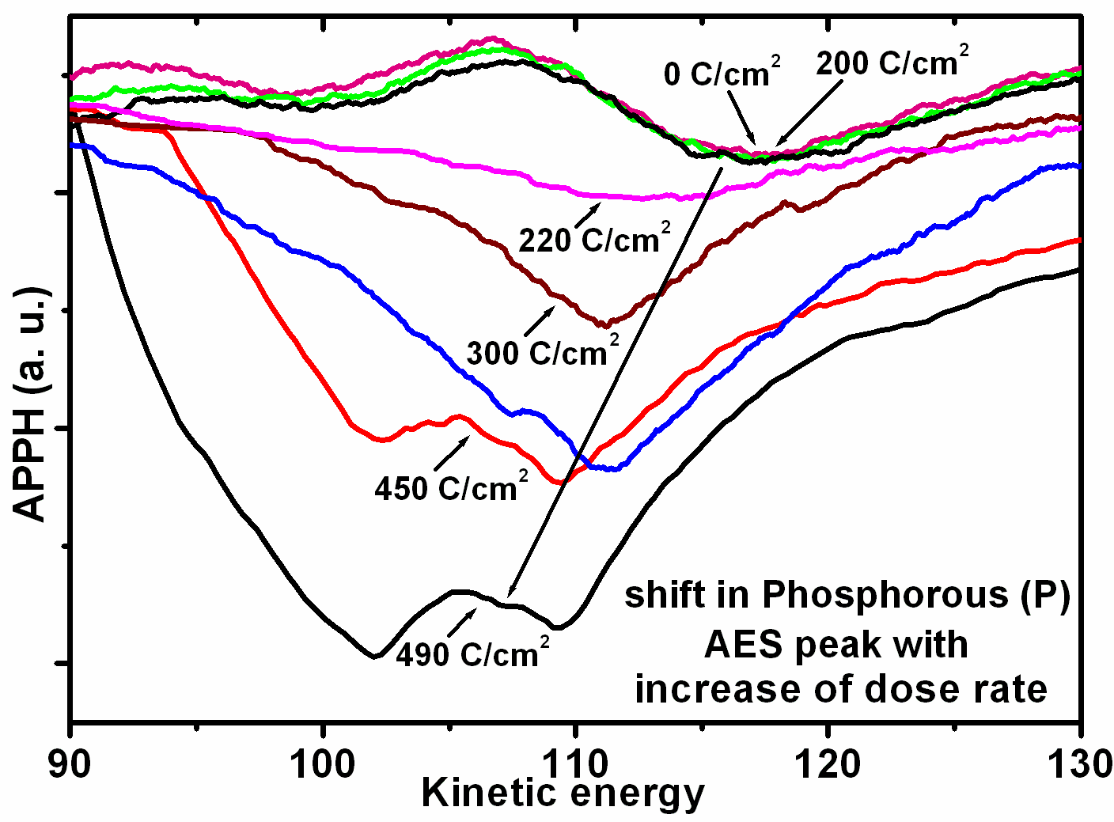

Figure-6: The P AES peak after different coulomb doses as indicated.

According to the ESSCR model the Zn–O and P–O bonds are likely to be broken into free oxygen, zinc and phosphorous when irradiated with a beam of electron. This will be followed by a chemical reaction resulting in new chemical compounds forming on the surface. In most cases the new oxide layers are non-luminescent and therefore will reduce the CL intensity. Simultaneous with the O₂ desorption during CL degradation, it is most likely that P (metallic), and P₂O₇ [9] mixed layers were formed on the surface according to the ESSCR mechanism. In this case these layers may form according to the following chemical reaction as mentioned in equation-1:
7.Zn₃(PO₄)₂ ↔ 21Zn + 2P + 7P₂O₇ + CH₄ ↑ + CO₂ ↑ (ΔH_{f298K}) --- Eq-1
(–270.31) ↔ (–137.35) + (–6.19) + (-104.36) + (0)↑ + (0)↑ (ΔH_{f298K}) = 22.39 kcal/mol O₂)
- Conclusion
Sol-gel combustion synthesized α-Zn₃(PO₄)₂:Tb phosphor was used for the CL degradation study. The optical properties such as PL and CL were evaluated and compared for the α-Zn₃(PO₄)₂:Tb phosphor. The green CL emission at 541 nm due to the ⁵D₄ → ⁷F₅ transition of Tb³⁺ appeared to be the more prominent emission. The APPHs and AES results of the degraded sample at 10⁻⁶ Torr oxygen pressure confirmed the formation of new coordinated related metal rich P species on the surface during degradation with a direct consequence of CL intensity degradation. The CL degradation nature is directly related to the change in P elemental concentration on the surface. It is clear that ESSCR’s were responsible for the degradation in CL intensity and the effect of band bending due to charging is not excluded.
Acknowledgement: Authors are thankful to the University of the Free State (UFS) and South African National Research Foundation (NRF) for the financial support.
References
[1] Swart HC, Greeff AP, Holloway PH and Berning G.L.P., 1999 Appl. Surf. Sci.,vol. 140 p 63.
[2] Franz KA, Hehr WG, Siggel A, 1985, Luminescent materials, Ullmann's Encyclopedia of Industrial Chemistry A15, VCH, Veinheim, Germany.
[3] Wang Jing, Wang Shubin and Su Qiang, 2004 J. Mater. Chem., vol. 14 p 2569.
[4] Song Yan-Hua, Zou Hai-Feng, Gan Shu-Cai, Deng Yue-Feng, Hong Guang-Yan, Meng Jian, 2007 J. Mater Sci vol. 42 p 4899.
[5] Calvo Crispin, 1965Canadian J. Chem., vol.43 p 436.
[6] Lu Chung-Hsin, Godbole Shrikant Vasant and Qureshi Mohammad, 2006 Jpn. J. Appl. Phys., vol. 45 p 2606.
[7] Holloway PH, Sebastian JS, Trottier TA, Swart HC and Peterson RO, 1995 Solid State Technology, Augustus, p 47.
[8] Swart HC, Sebastian JS, Trottier TA, Jones SL, and Holloway PH, 1996 J. Vac. Sci. Technol. A vol. 14(3) p 1697.
[9] Shah KV, Goswami M, Manikandan S, Shrikhande VK and Kothiyal GP, 2009 Bull. Mater. Sci., vol. 32 (3) p 329.

