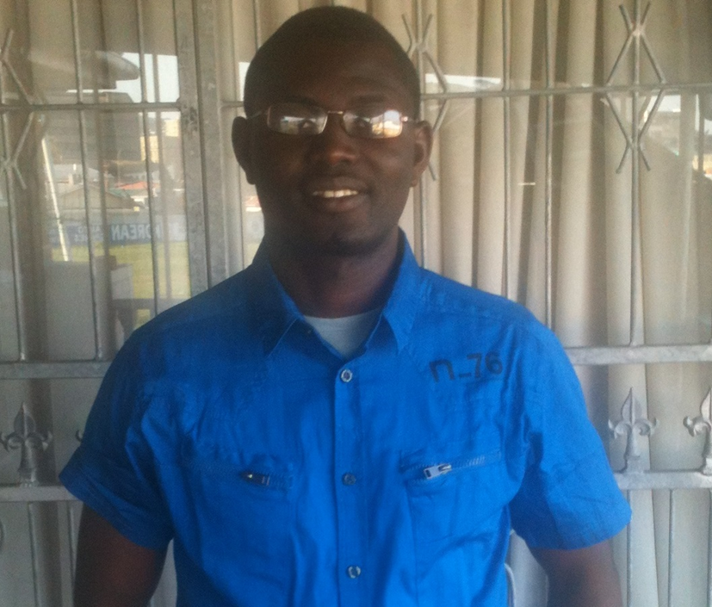 | Abegunde Oluseyi, A. received his Bachelor of Science degree Hons (BSc. Hons) in Chemistry from the then University of Ado-Ekiti (presently known as Ekiti State University), Nigeria in 2008. He proceeded to study for a Master’s degree in Applied Geology from the University of the Western Cape, South Africa (UWC) in 2012. His research interest was geared towards “the assessment of acid mine drainage and heavy metals contamination in the west rand, Witwatersrand basin, South Africa, and the application of GIS and multivariate statistics to environmental studies”. His current MSc. Research is titled “Geologic and geochemical assessment of acid mine drainage and heavy metals contamination in the west rand, Witwatersrand basin, South Africa” where he goes a long way to unravel the AMD potential and transport of selected tailings dam within the Witwatersrand basin. [134 words]  .¹Department of Earth Sciences, University of the Western Cape - Cape Town, SA  Email: 3207599@myuwc.ac.za / e.mail address (clevershy@gmail.com) / Mobile +27 747159354  Supervisor : Okujeni, Charles, Prof / e.mail address: cokujeni@uwc.ac.za

