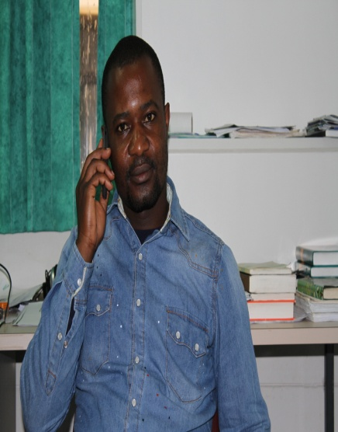 | Forbanka, Derick N.¹ received his BSc (Zoology/MLT) and MSc from the University of Buea, Cameroon in 2004 and 2006 respectively. He then obtained another MSc in 2010 from Walter Sisulu University, Mthatha, South Africa. He is currently doing his PhD with research interest geared towards “Comparison of gummivorous strepsirhines in Madagascar (Phaner) and Cameroon (Euoticus)” in the University of Fort Hare, Alice campus under the Inkaba programme. Derick has been an educator with the Eastern Cape department of Education for five years and has specialization in both entomology and primatology. [89 words]  ¹Department of Zoology and Entomology (DZE), University of Fort Hare - Alice, SA  Email: 201317136@ufh.ac.za / e-mail address (private): dericknomuh@gmail.com / Mobile +27 785697179  Supervisor : Masters, Judith C, Prof / e.mail:jdthmasters@gmail.com

