________________________________________________________________________

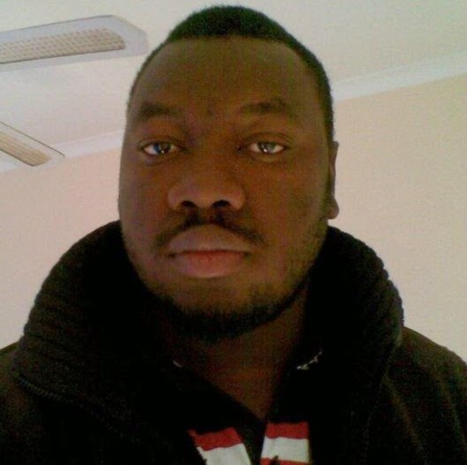 | Samakinde, Chris A.¹ received his BSc hons (Geology) from the University of Ilorin,Nigeria in 2005. He obtained another Honours in 2011 and MSc in 2013 on the Inkaba Programme in Applied Geology from the University of the Western Cape, South Africa. He is currently doing his PhD with research interest geared towards “ Using an integrated approach to understanding gas escape and migration pathways in the northern Orange basin, South Africa”. He has done field studies on part of the Bida Basin in Nigeria, the Permian Submarine Fans of the Karoo sub Basin (South Africa), and Table mountain group. He also presented his Msc work to the Geological Society of London and currently doing research in the Orange Basin of South Africa for his PhD. [127 words]  .¹Department of Earth Sciences, University of the Western Cape - Cape Town, SA  Email: chrissamakinde@gmail.com /Mobile +27 787 333 269  Supervisor : Lanes ,Silvia Dr / slanes@uwc.ac.za

