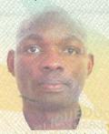

Eric Saffou is a postgraduate student (Msc) at University of Western Cape in the department of Applied Geology. He received his Diploma in Chemistry at the University of Masuku in 2005; a year later he completed another Diploma in Earth Science. In 2011 he was awarded with a Bsc (Hons) in Petroleum Geology. In 2012 he decided to pursuit his scientific career in the field of structural geology. Eric Saffou showed a particular interest for numerical methods and for Geomechanics. In 2013 he has the opportunity to spend few day at the university of Oviedo in Spain, where is strengthen his mathematical and numerical skills.