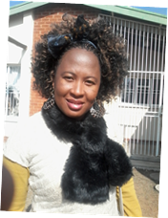 | Christinah Makoae received her BSc (Geology) from the University of the Free State, South Africa in 2012. She obtained her BSc. Honors in Geohydrology from the University of the Free State in 2013. She is currently doing her MSc in Geohydrology at the already mentioned university, with the research that is based on “An Investigation of Possible Augmentation of Water from Groundwater Resources to Mangaung” and the research is funded by the Inkaba yeAfrika. She has done her field studies on the behavior of groundwater relative to the intrusive structures such as ring dykes and the others at Bloemfontein, Free State Province of South Africa, mapping of some geological structure at Barkly East, in the Eastern Cape, South Africa and groundwater quality around mining area of Beatrix Mine at Virginia, South Africa. [133 words]  Institute for Groundwater Studies, University of the Free State - Bloemfontein, SA  Email: cmcmakoae@gmail.com / 2007150051@ufs4life.ac.za/ Mobile +27 842386176  Supervisor: Fourie, Francois, Dr. / Email :fouriefd@ufs.ac.za

