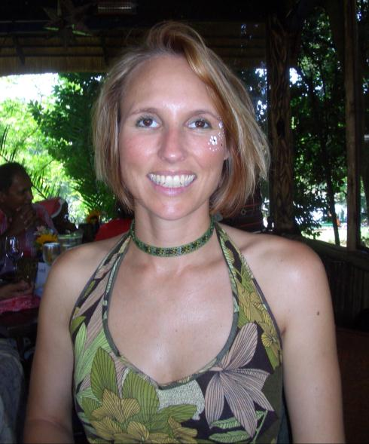 | Andrea Baker received her Bachelor of Science degree (Cum laude) Geology and Honours degree, Environmental Geochemistry from Stellenbosch University in 2009 and 2010, respectively. She is currently undertaking an upgraded PhD in Biogeochemistry, which commenced in 2011 at Stellenbosch University, where her research interests are geared towards Palaeo-climatic & environmental variations in Southern Africa. Field studies included the Congo River plume in the equatorial Atlantic off West Africa, where an ODI core was studied for its geochemical properties and down core variations as part of her honours thesis and currently the Mfabeni Peatland core at St Lucia, Northern KwaZulu Natal where the application of biomarkers (n-alkane, n-alkanoic acids, sterol, ketones and n-alcohols of soil organic matter) and compound specific isotope analysis (C & H) are being used to explore the palaeoclimatic variations and their effects on the environment during the late Pleistocene and Holocene periods.  (145 words)  .¹Department of Earth Sciences, Stellenbosch University - Stellenbosch, SA  Email: andrea_baker@sun.ac.za / private email address: dries_bok@yahoo.co.uk /  Mobile +27 (0) 72 100 8173

