A Study of Crack Formation and its Effect on Internal Surface Area using Micro-Focus X-ray Computerised Tomography and Fractal Geometry.
T Seakamela¹, G Nothnagel², F C de Beer² and B P Doyle¹
¹Department of Physics, University of Johannesburg, P.O. Box 524, Auckland Park, 2006, South Africa
²South African Nuclear Energy Corporation Limited, P.O. Box 582, Pretoria, 0001, South Africa
E-mail:teffoseakamela@gmail.com
Key words: Micro-focus X-ray tomography; Fractal geometry; Cracks
Abstract. Micro-focus X-ray tomography, as a non-destructive analytical technique, has been applied to obtain a virtual three dimensional image (tomogram) of material at a scale as low as 3 μm. Image analysis software was used to extract quantitative information from 2D planar sections of the tomograms to study the geometry of cracks. The aim of the study was to assess the ability of the technique to determine if crack formation in chosen samples has a fractal character, as this may provide a compact means of characterising the effective surface area of the crack plane. Studies were performed on samples of different materials, viz smooth mortar, large and small bricks and coal. It was found that the cracks, or fracture surface edges, show fractal behaviour for a wide range of length scales but do not give consistent values for different cracks in the same material for the samples studied.
- Introduction
There is an interest in the nuclear energy industry in the study of the confinement integrity of nuclear waste encapsulation materials, in which case it is important to study materials for the presence of undesirable micro-cracks and pores. In the coal industry, on the other hand, cracks are desirable for gasification of the coal, and methods to characterise their nature and ways to produce them become important. This paper describes the use of micro-focus X-ray tomography ($μ$CT) [1] for the analyses of cracks found within coal, small and large bricks and smooth mortar samples. The $μ$CT technique, with machines such as the MIXRAD facility at Necsa, produces 3D images of a material's internal structure to a best spatial resolution of about 3 μm [2], depending on the sample size (the smaller the sample, the higher the resolution). However, there are similar techniques that are capable of going down to 500 nm spatial resolution such as the nano-focus X-ray CT facility situated at overseas located synchrotron facilities [3].
Fractal methods have been used to study self-similar natural phenomena in many fields of scientific research [4, 5, 6] and have been used in this work to characterize crack formation via details of the crack edge. Fractal structures show self-similarity, which is revealed through a power–law relationship between two variables, and is characterised by a non-integer fractal dimension [7, 8]. In this work we used the compass method as described in Section 2.2.
- Experimental set-up
The experimental set-up consists of an X-ray source, 2-dimensional high resolution digital X-ray detector and a rotating mechanical sample manipulation stage. Radiographs of the total sample are taken at multiple equally spaced angles between 0 and 360⁰.

2.1 Sample preparation
In μCT scanning there is no need for specific sample preparation. A sample such as a piece of coal was formerly cracked in a predetermined process and then analysed using the calibrated and standardized micro-tomography set-up [9]. Figure 1 below shows the samples that were inspected for this study.

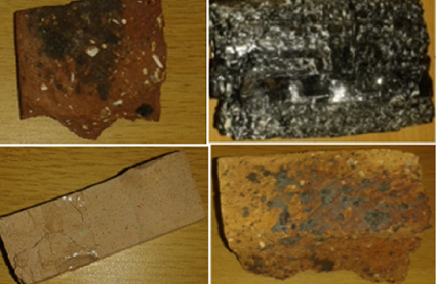
a)
b)
c)
d)
Figure 1: a) Piece of a small brick, b) coal, c) smooth mortar and d) piece of a large brick

  - Experimental set-up, image acquisition, reconstruction and analysis

The samples were scanned using the micro-focus X-ray radiography and tomography system (MIXRAD) located at Necsa [9]. The instrument, shown in figure 2, is equipped with a tungsten X-ray source with anode voltage settings ranging between 30 kV and 255 kV, beam current up to 1 mA and a spot size of 3 μm. A schematic of the process of acquiring 2D radiographic slices, which are then combined into a 3D image via a reconstruction algorithm, is shown on the right.
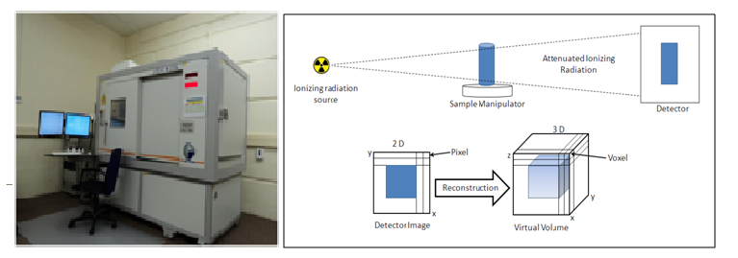
Figure 2: Micro-focus X-ray machine and tomographic process at the MIXRAD facility at Necsa

The X-ray source scanning parameters were set to achieve sufficient contrast in the radiograph to provide a good visualisation of cracks. Due to the size of the samples scanned in this study, the spatial resolution obtained was ≈ 0.022 mm (22 μm).
After tomographic reconstruction, 3D visualisation by means of VGStudio MAX 2.2 software [9] was performed where 2D slices at appropriate crack location were generated. Image analysis software (Image-J) was then used to study crack properties on these 2D planes of the virtual 3D object. For this purpose planes that intersect cracks were chosen so as to visualize the line features of the crack across the selected plane. Figure 3 is an example of the image of a crack intersection line on such a surface.
Image-J allows the linear distance between any two points on the plane to be measured in pixels (or calibrated length units) so that the compass method of length measurement along the crack intersection curve can be used to assess self-similarity and fractal nature.In the compass method a fixed scale length is chosen in terms of which the length along a section of a crack line is measured. This is seen in figure 3 where a given scale length N (small line segments between adjacent points), was used to measure the total crack length $L_{AB}$ between pre-determined starting and end points, A and B respectively.
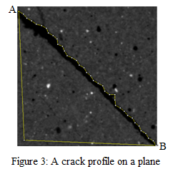
Figure 3: A crack on a plane

The measurement of $L_{AB}\left(s\right)$ where s is the scale, is performed for a number of scales values and $\log{L_{AB}\left(s\right)}$ is then plotted against$\log\left(1/s\right)=log\left(r\right)$, where $r$ is the resolution. If the geometry of the curve edge is fractal in nature, with ever smaller self-similar structure, the measured length will increase indefinitely (within practical limits), with decrease in scale length, as follows [4]:

$$\log{L_{AB}\left(s\right)}=D_{C}\log\left(1/s\right)+k (1)$$

Where $D_{C}$ is the so-called compass dimension and k is a constant.

- Results and discussion
3.1 Smooth mortar sample:
An example of data for a typical measurement on a single crack is shown in table 1 in terms of the quantities defined above and the resulting $(ln{L_{AB})}$ versus $\ln\left(1/s\right)$graph is shown in figure 4.

Table 1. Example of smooth mortar data with an instrument resolution of 0.022 pixel/mm.
(use latest smoot mortar 21 first pltable and plot)

Scale  (Number of pixels) | Number of  scale lengths | Scale  (mm) | Total Length  (mm/pixel) | Ln(1/s)  (s in mm⁻¹) | Ln(L_{AB})  (L_{AB} in mm)
3 | 98.667 | 0.066 | 6.512 | 2.718 | 1.874
4 | 73.00 | 0.088 | 6.424 | 2.430 | 1.860
8 | 34.00 | 0.176 | 5.984 | 1.737 | 1.789
10 | 27.00 | 0.220 | 5.940 | 1.514 | 1.782
14 | 18.16 | 0.308 | 5.732 | 1.178 | 1.746
16 | 16.50 | 0.352 | 5.808 | 1.044 | 1.759
20 | 13.00 | 0.440 | 5.720 | 0.821 | 1.744
22 | 11.55 | 0.484 | 5.581 | 0.726 | 1.721
24 | 10.56 | 0.528 | 5.573 | 0.639 | 1.718

Figure 4: Ln-Ln fractal analysis plot for a crack in the smooth mortar
Similar quantification of cracks was performed in coal, a large and small brick sample were analysed and results are shown in table 2.

Figure 5: Ln-Ln fractal analysis plot for the coal sample.

Figure 6: Ln-Ln fractal analysis plot for the large brick sample

Figure 7: Ln-Ln fractal analysis plot for the small brick sample.
Table 2 contains the summarised results of several cracks in several samples and figure 5 shows the graph for a crack in the coal sample with large fractal dimension. The dimension is large because the crack measured was jagged and sinuated.

Table 2. Tabulation of data from several cracks in several sample types.
Sample description | Fractal dimension | Crack length (mm/ pixels) | Correlation coefficient
Smooth mortar | 1.075  1.026  1.020 | 5.920  2.575  10.10 | 0.987  0.997  0.981
Coal | 1.408  1.083  1.049 | 2.905  1.534  3.885 | 0.970  0.968  0.993  0.994  0.966  198.6  9.109  9.160
Large brick  Small brick | 1.051  1.025  1.696  1.015  1.025 | 8.946  12.51  198.6  9.109  9.160
Figure 8 below shows the crack that was segmented approximately in the middle of the sample. The total volume and surface area of this crack were found to be 49.987 mm³ and 738.863 mm² respectively.
A
B

Figure 8: One crack segmented from the coal and displayed in 3D

In figure 4 both the error bar separation and the correlation coefficient indicate a bona fide linear relationship, despite its low value, thereby suggesting a fractal dimension of ~ 1.07 for this crack. Thus we may conclude that the method allows determination of fractal character down to rather low compass dimension values. A crack and thus the material is only fractal when the slope of ln(L) vs. ln(1/s) holds for a range of spatial resolutions, thus it becomes clear that the scale can vary in the measurement because it does not affect the slope by changing it to negative. For the small brick sample on figure 7, the slope is negative therefore an absolute of (-0.696) will be taken in and the fractal dimension will become 1.696. The results in table 2 indicate low precision for cracks in similar samples and no clear relationship between the length of crack analysed and the outcome of the fractal analysis. This indicates that it may not be possible to assume the same fractal dimension for all cracks in a given sample size, that the details at this resolution for the different sections of the cracks limit the ability to compare or that other factors such as inhomogeneity of impurities may influence the dimension from crack to crack. On the figure 4 to 7 some data points (outliers) are observed distant away from other observation points. This may be due to variability in the measurement or they may indicate experimental error, the latter are sometimes excluded from the data set. Hence they still contribute to the trend line.
4. Conclusions

Based on the findings of this first study, micro-focus X-ray tomography proves to be a fast technique (no special sample preparation) for the 3D visualization and quantitative analysis of cracks in samples penetrable with X-ray energies up to 70 keV. It was found that the fracture surfaces of the smooth mortar, large and small bricks and coal follow fractal behaviour that is represented by the fractal dimensions recorded in table 2.
Preliminary results show that it may be difficult to rely on the absolute value of the fractal dimension for material characterisation, which does not appear to be the same for all samples of the same material. Further research is needed to assess how much of this is due to inherent measurement limitations of the technique, including plane and crack selection, and how much on real sample properties (such as hardness and impurity distribution).

References
[1] Van Dalen G, Don A, Nootenboom P and Blonk J C G2012 Microscopy and Analysis S8 (March)
[2] Landis E N and D T Keane 2010 X-ray MicrotomographyMater.Charact.61 1305
[3] Bruke O, Brockdorf K, Drews S, Müller B, Donath T, Herzen J and Beckmann F 2008
Proceedings on the Developments in X-ray Tomography VI 7078 16
[4] Charkaluk E, Bigerelle M and Iost A 1998 Fractals and Fracture Eng.Fract. Mech.61 119
[5] Normando P G, Nascimento R S, Moura E P and Vieira A P 2013 Phys. Rev. E 87 043304
[6] Jiang M Q, Meng J X, Gao J B, Wang X L, Rouxel T, Keryvin V, LingZand Dai L H 2010 Intermetallics 18 2468
[7] Lee K I, Choi S C, Park T N and You D S 1999 Dentomaxillofac. Rad.28 284
[8] Kraft R 1997 Fractals and Dimensions Journal of Agricultural, Nutrional and Environmental Sciences http://web2.wzw.tum.de/ane/janes.html
[9] Hoffman J W and De Beer F C 2012 Proceedings of the 18th World Conference on
Nondestructive Testing 18 16 http://www.ndt.net/article/wcndt2012/papers/37wcndtfinal00037.pdf

