Structural and luminescent properties of ZnO flake-like nanostructures synthesized using the chemical bath deposition method
FV Molefe, LF Koao, JJ Dolo, BF Dejene

¹Department of Physics, University of the Free State (Qwaqwa Campus), Private Bag
X13, Phuthaditjhaba, 9866, South Africa
²Department of Physics, University of the Free State, P.O. Box 339, Bloemfontein,
9300, South Africa.

*Corresponding author: Tel: +27 58 718 5307; Fax: +27 58 718 5444;
E-mail:
dejenebf@ufs.ac.za

Abstract.
Zinc Oxide (ZnO) nanostructures were synthesized by chemical bath deposition method (CBD) from precursors containing varying molar concentrations of zinc acetate. The structure, morphology, optical and luminescence properties of the samples were investigated using X-ray diffraction (XRD), Scanning electron microscopy (SEM), ultraviolet spectroscopy (UV) and Photoluminescence (PL). The XRD result shows that at low molar concentrations of zinc acetate the structure is modified cubic ZnO. As the molar concentration of zinc acetate increases the well-known hexagonal wurtzite structure of ZnO is developed. The average particle size estimated using Scherer’s formula was about 37 nm. It was found that the average particle size increases with an increase in the molar concentration of zinc acetate. SEM observations showed the presence of nanocrystallites forming aggregated nanoflakes. The morphology was found to dependent on the concentration of zinc acetate. The UV-Vis spectra showed that the absorption band edge shift to the higher wavelength with an increase in molar concentration of zinc acetate. The band gap energy of ZnO nanostructures determined from UV reflectance spectra was found to decrease from 3.2 to 2.8eV with an increase in the zinc acetate concentration. The PL results show that the luminescence intensities decrease with an increase in the molar concentration of zinc acetate. The maximum luminesce band was found around 464 nm without any significant shift in position.
.
- Introduction
Semiconductors with dimensions in the nanometer realm are important because their electrical, optical and chemical properties can be tuned by changing the size of particle size. Optical properties are of great interest for application in optoelectronics, photovoltanics and biological sensing [1-2]. Various chemical synthetic methods have been developed to prepare such nanostructures.Zinc oxide has attracted significant interest because of its nontoxic character, chemical stability, low cost and potential applications in many technological fields [3-4].ZnO is known to be n-type semiconductor with a wide band gap of 3.35 eV at room temperature and a large exciton binding energy of about 60 meV [5]. The ZnOnanoflakes were synthesized by chemical bath deposition method (CBD). CBD is one of the solution phase methods useful for the preparation of compound semiconductors from aqueous solutions [6]. The CBD method has several advantages such as the use of simple equipment, cost effective, less hazardous and the low temperature reaction. The low reaction temperature makes this method attractive and the particle properties such as morphology and size can be controlled via the CBD process by adjusting the synthesizing time [7]. In this paper, the effect of zinc acetate concentration on the structure, morphology, optical and luminescence properties synthesized by CBD were investigated.
- Experimental
The ZnO powders were prepared by the chemical bath deposition method. The following starting materials such as zinc acetate (Zn(O2CCH3)2), Thiourea ((NH2)2CS) and Ammonia (25% NH3) were used. The sample solutions were prepared by dissolving 0.12, 0.13 and 0.14 M of Zinc Acetate in 60mL of H2O, respectively, and 0.4M of Thiourea and also 98.8ml of Ammonia, were disdolvedinto 200mL of deionized water, respectively. Then a magnetic stirrer was used to stir each of the mixtures for overnight at room temperature to ensure homogenous distribution of the solution reagents. An equal volume ratio (1:1:1) was considered for each solution in the following order: 60 mL quantity of zinc acetate was first added to the beaker which was placed in the water bath, followed by addition of 60mL of Thiourea solution while stirring and finally 60mL of ammonia solution was also added while continuously stirring. Water bath was maintained to be at a constant desired temperature of 80ºC. The white precipitates were then formed within 30 seconds after the solution was placed inside the water bath. The beakers were removed from the bath after 10 minute. The solution was allowed to stabilize overnight in the lab. Finally the solution was filtered and the dry precipitate was collected, washed several times with 60ml of ethanol and 60ml of acetone to remove the residue and desiccated for a maximum of three days to ensure that they are dried prior to characterization.The powders synthesizedwere characterizedby of scanning electron microscopy (SEM), X-ray diffraction (XRD), Uv-vis spectroscopy and Photoluminescence (PL).
- Results and Discussion
3.1 Structural analysis and Composition analysis

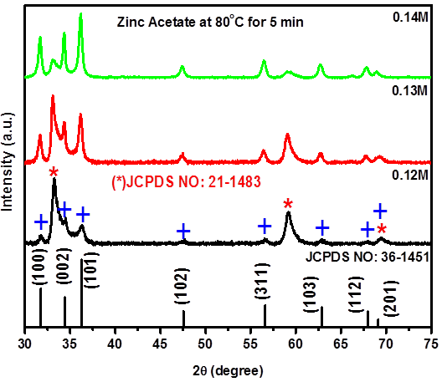

Figure 1: XRD patterns for ZnOstructures prepared at different molar concentration of zinc acetate synthesized using CBD.
Figure 1 shows XRD patterns ofZnOpowders synthesized by varying different molar concentrations of zinc acetate. At low molar concentration of zinc acetate (0.12 M)the ZnO has the mixture of the modified cubic ZnOphase [8-10] ataround 33.5◦, 59.5◦, and 69.6◦marked with star (*),all the peaks of ZnO were consistent with the literature data of JCPDS 21-1486 and the small peaks which are marked with plus (+)at 2θ values of 31.8º, 34.5º, 36.4º, 47.5º, 56.2º, 62.9º and 69.1º.They are in agreement with the standard JCPDS card no. (36-1451) for hexagonal wurtziteZnO. By increasing the molar concentration of zinc acetate it is clear that the peaks of modified ZnO decreases and the one of hexagonal wurtziteZnO increases. Thus the increase in molar concentrationof zinc acetate plays an important role on the growth of ZnO because modified cubic ZnO structure has changed to hexagonal wurtzite structure. By using (100) and (101) peaks the average grain size is 44 nm and was no effect on estimated grains size.

3.2 Surface morphological analysis
Figure 2(a) and (b) shows surface morphologies of the ZnOpowders synthesized at various molar concentrations of zinc acetate. The surfaces aspects of all the SEM images of the ZnOpowders are composed of nanoflakes structures andthe grain size have slightly increased in size with an increase in the molar concentrations of zinc acetate. At low molar concentrations (0.12 M) of zinc acetate the nanoflakes are non-uniform and at high molar concentrations (0.14 M) the nanoflakes are uniform as shown in Fig 2(a) and (b), respectively.

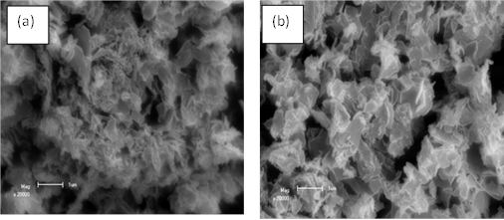
Figure 2: The SEM micrograph of ZnOpowders synthesized at various molar concentration of zinc acetate: (a) 0.12 M and (b) 0.14 M.

3.3 Optical properties

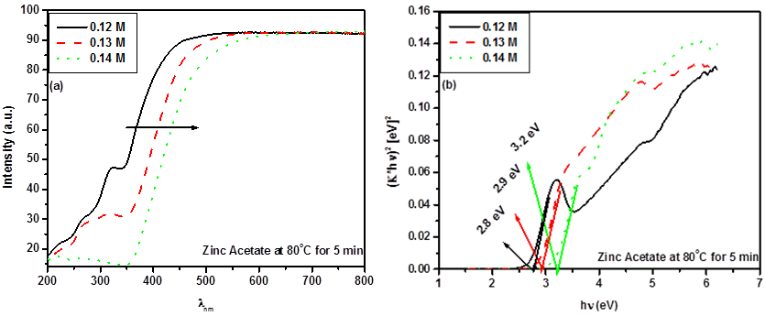

Figure 3. (a) The absorbance spectra and (b) Plot to determine the band gap energy of ZnOpowders prepared at various molar concentrations of zinc acetateby the CBD method.

Figure 3 (a) The UV- visible reflectance spectra of ZnO nanoparticles synthesized at various molar concentrations of zinc acetate. The spectra of all the samples show good optical quality in the visible range due to the complete reflectance in the 200-800 nm range which exhibits the slight fluctuation in percentage reflectance with increasing molar concentrations of zinc acetate. However, as molar concentrations of zinc acetate increases the absorption edges red shift to higher wavelength. At lower molar concentrations of zinc acetate from 0.12 to 0.13 M the absorption edges has unhomogenouse absorption band. This unhomogenouse absorption edges may be due non-uniform morphologies as observed from SEM analysis [paper Ce]. The ZnO is a direct band gap material. The energy band gap of these materials was estimated using the Kubelka-Munk function remission function [12],
K=$\frac{{(1-R)}^{2}}{2R}$ (2)
Where K is reflectance transformed according to KubelkaMunk, R is reflectancy (%), 𝒉𝒗 is the photon energy. Eg is the band gap at n=2 for direct transitions. In Fig.3 (b)the energy band gaps were measured with the help of reflectance spectra plotting graphs of (K*𝒉𝒗)^{n}versus f(𝒉𝒗) [13]. It can be seen clearly that the band gap energy of the ZnOnanoflakesdecreases with an increase in the molar concentration of zinc acetate. The highest band gap energy is obtained at ZnOnanoflakes synthesized at 0.14 M of zinc acetate, with its estimated band gap energy of 3.2 ± 0.1eV. This shift of absorption edge to higher wavelength and the reduction of band-gap energy may be attributed to the change of modified ZnO to the hexagonal wurtziteZnO as confirmed by the XRD analysis. Secondly may be due to the grain sizes that are increasing as the molar concentration of zinc acetate increases as confirmed SEM analyses.

3.4 Photoluminescence

Figure 4 depicts the room temperature emissionspectrum of the ZnOnanoflakes with an excitation wavelength at around 300 nm. The maximum emission intensity was obtained at the ZnOnanoflakes synthesized at 0.12 M of zinc acetate. From the spectra, the intensity of PL peak decreases with the increasing molar concentration of zinc acetate. The luminescence bands were found at around 473 nm. There was no shift in luminescence band as the molar concentration of zinc acetateincreases. The broad emission band between 400 and 600 nm was observed from the synthesized ZnOnanoflakes which can be attributed to transition between singly charged oxygen vacancy and photo excited hole or Zn interstitial related defects [14-15]. The higher molar concentration of zinc acetateresults in a substantial decrease in luminescence intensity. This decrease in luminescence intensity firstly: may be due to the grainsizes that are increasing with increasing the molar concentration of zinc acetate as confirmed by SEM analysis and secondlymay be attributed to the change of modified ZnO to the hexagonal wurtziteZnO as confirmed by the XRD analysis. In this work it was very interesting to observe or find that the structure, morphology, optical and luminescence properties of ZnOnanoflakes depend on the molar concentration of zinc acetate.

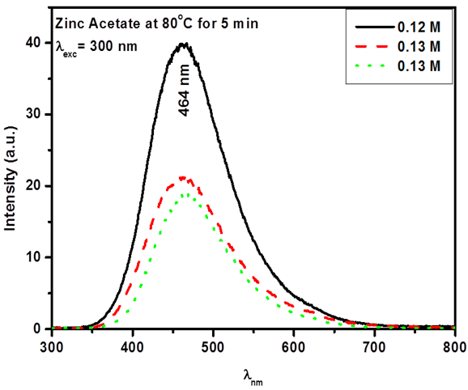

Figure 4. PL emissionspectra of ZnOnanoflakesprepared at various molar concentrations of zinc acetateexcitedat = 300 nm.

- Conclusion
The CBD method was successfully used to prepare ZnO nanostructure at different molar concentrations of zinc acetate. Increasing synthesizing time showed great effect on structural, morphological, optical and luminescence properties of ZnO. XRD showed that the as the molar concentration of zinc acetate increases the modified cubic phase of ZnO changed to hexagonal wurtziteZnO. SEM images depict homogenous ZnOnanoflakesat high molar concentration of zinc acetate. The band gap energy of the ZnOnanoflakes decreases with an increase in the molar concentration of zinc acetate. The PL intensity was found to be maximum for ZnOnanoflakes synthesized for 0.12 M of zinc acetate and after that there was decrease in luminescence intensity as the molar concentrations of zinc acetate increases.
Acknowledgement
The author would like to acknowledge the National Research Foundation, Department of science and technology and the University of the Free State for financial support.
Reference
[1]Weißenrieder KS, Muller-J, 1997Thin Solid Films, 300 30
[2]Masai H, Toda T, Ueno T, Takahashi Y, Fujiwara T, 2009Appl. Phys. Lett. 94 151908.
[3]Fan Z, Wang D, Chang P, Tseng W, Lu JE,2004Appl. Phys. Lett. 85 5932.
[4]Trupke T, Green M A,Wurfel P,2002J. Appl. Phys. 92 1668.
[5]Djurišić AB, Ng AMC, Chen XY, Prog. 2010Quant. Electr. 34 191.
[6]Duran P, CapelF, TartajJ, Moure C,2002Adv. Mater. 14 137-141.
[7]BeheraJK, MSc thesis, National Institute of technology, India. pp. 11-35.
[8] AeugleTH, BialasH, HenekaK,PleyerW,1991Thin Solid Films. 201293-304.
[9] Parhizkar M, Kumar N, NayakP K, Singh S, TalwarSS, Major SS, SrinivasaRS, 2005J. Colloids and Surfaces A: Physicochem. Eng. Aspects257–258 445–449.
[10] Liao Y, Wu X, Wang Z, Chen Y F,2011J. Solid. Sate. Chem. 184 1603-1607.
[11] L.F.Koao, F.B.Dejene, H.C. Swart, J.R. Botha, J. Lumin. 143 (2013) 463–468.
[12] RangaRaoG, RanjanSahuH, 2001Proc. Indian Acad. Sci. (Chem. Sci). 113 651-658.

[13] TaucJ, GrigoroviciR, Vancu Sharma A,1966Phys. Status Solidi. 15 627-629.
[14] VanheusdnK, Warren WL, SeagerCH, TallantDR, Voigt JA, GnadeBE, 1996J.
Appl. Phys.79 7983-7990.

[15] PengWQ, QuSC, Cong GW, Wang ZG, 2006Mater. Sci. Semicond. Process.9
156-159.

