

**Abstracts Review Manual**

The following steps should be followed when reviewing Abstracts:

1. Log in to the SAIP2025 Indico site by visiting [this link](https://events.saip.org.za/event/252/).
2. On the home page, navigate to the left menu panel and select **“Reviewing Area”** under **“Call for Abstracts.”**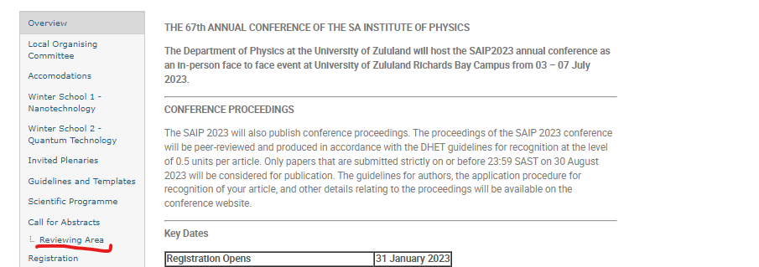
3. Your allocated track will be displayed, along with the number of abstracts assigned to it.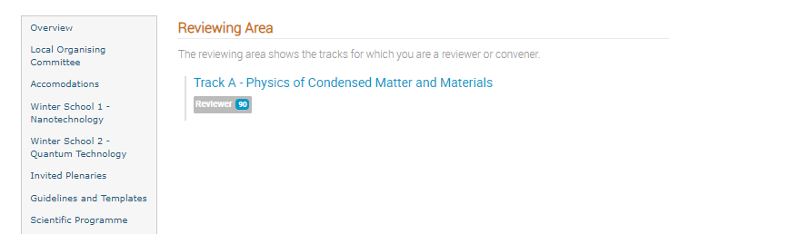
4. Click on the track name to view the list of abstracts assigned for review. Select the abstract you wish to review by clicking on its title.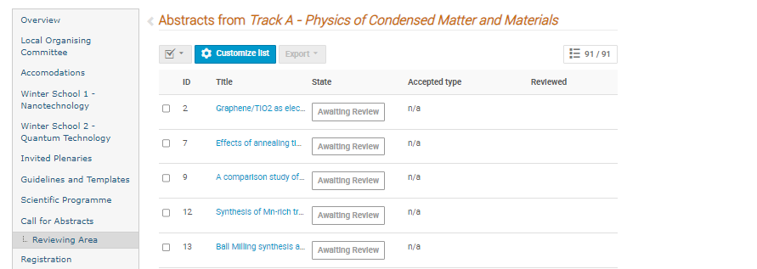
5. Details about the abstract will be displayed. At the bottom, next to the "Leave a comment" text field, you’ll find a **“Review”** button on the right.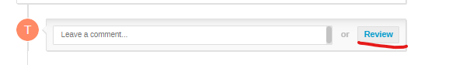
6. Click the **“Review”** button to begin reviewing the abstract. A dedicated review screen will then appear:

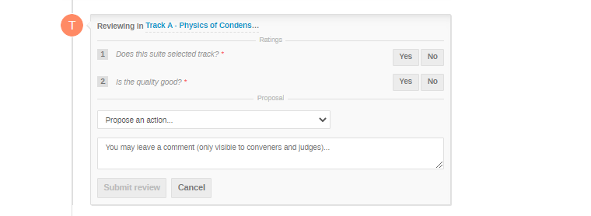

The reviewing screen includes two Yes/No questions and a proposal section with the following options::

* **Accept**: To approve the abstract.
* **Reject**: To decline the abstract.
* Change Track: To reassign the abstract to the appropriate track if it was submitted under the wrong one. *(****Note: If you move an abstract to another track, please email the chairperson of the new track to inform them.****)*
* **Mark as Duplicate**: To flag the abstract as a duplicate if a similar abstract with a different ID exists.
* **Merge**: To combine duplicate abstracts.

1. Once all the information is completed, click the 'Submit Review' button. An automatic email will be sent to the author with the outcome of their submission.

The following email will be sent if abstract is accepted:

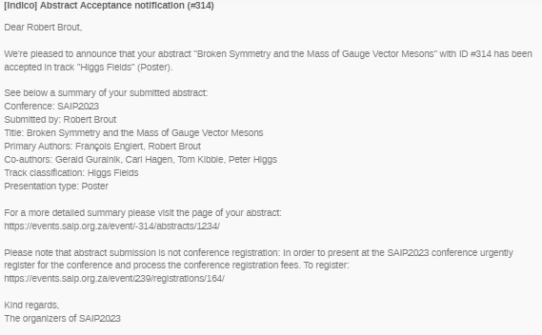

The following email will be sent if abstract is rejected:

