TITLE – INSTRUCTIONS FOR FULL PAPERS
Johann S. Bach¹, Martin Dupont², and Frank Zappa³
¹ The authors’ professional affiliation - Only the senior or corresponding author’s full mailing address (including country name), phone and facsimile numbers. However, e-mail addresses are provided for all authors
² Institute/Company, Street 2, 2413 SE, City, Country; Phone: +1-1234567; Fax: +1-234456; E-Mail: dupont@abcd.ef
³ Institute/Company; E-mail: zappa@vwx.yz

Abstract: These instructions are provided to help you to format your manuscript in a fast and efficient manner, and complying with these instructions helps us to give the SASEC 2021 conference proceedings a consistent, high-quality appearance. In essence, you should format your paper exactly like this document. The easiest way to do this is simply to replace the content with your own material. The template file contains specially formatted styles (given in brackets) that will reduce your work in formatting your submission.
Authors must include a short abstract that briefly states the context and purpose of the research, the principal results, and major conclusions. No references should be mentioned in the abstract. Also see section 3 below for further instructions.
Keywords: Provide up to six keywords; separated by semi-colons.

Introduction (Heading 1 style)
This document serves both as a guideline and a template for the preparation and formatting of your manuscript for the SASEC 2021 conference proceedings. Authors should follow these instructions carefully and must use the predefined styles of this template.
Papers that are considered by reviewers to be written primarily to promote a company and/or its products will not be accepted for the conference. It is also obligatory that the author or a designated substitute attend the symposium to present their paper.

Paper formatting

General specifications (Heading 2 style)
The manuscript must be written in English. The standard font for the manuscript (Normal style) is Times New Roman for the text and Symbol for special characters. Body text should be in Times New Roman, 10 pt, justified. The text should be in a two-column format for the body of the document.

Headings
Number the sections and sub-sections. Sub-headings (Heading 2 style) should be in Arial, 10 pt, italic. Sub-sub-headings (Heading 3 style) should be kept to a minimum and formatted in Times New Roman, 10 pt, italic.

Paper length
The length of the full paper should not exceed 7 pages including all figures, tables and references.

Paper size
The paper size is DIN A4 – 210 mm x 297 mm.

Content

Title
The title of the Full Paper (Title style) should be the same as for the reviewed abstract, and be written in CAPITAL letters (Arial 14 pts, bold, centred). If you need more than one line for the paper title please use a ‘soft’ line break (SHIFT+ Enter) instead of a line break.

Authors
The title of your paper should be followed by the authors (Author style) in Arial 10 pts, bold, centred, and their affiliations (Author Details style) in Arial 10 pts, centred. The corresponding author’s name must be underlined.

Abstract and keywords
Each paper should have a concise and informative abstract of no more than 300 words, giving a concise statement of the problem/context, approach, important results and conclusions of the work, headed by the word “Abstract:” in bold, and followed by up to 6 keywords in italics.

Tables and figures
All figures and tables should be cited in the text, numbered in order of appearance with Arabic numerals, and followed by a centred title.

Tables (Heading 3 style)
All table columns should have a brief explanatory heading. Table captions (Table style) should be centred and placed above the table (Times New Roman, 10 pt, bold, centred).
Table 1. Title (Table style)
Table header | Header | Header
Tables | Text | Text
Figures | Text | Text
Accompanying comments can be included immediately after the table. Tables should be no larger than the printed area of the page and preferably oriented in the same way as the text (portrait). Tables too large to fit on one page should be broken up into smaller tables.

Figures
Figures should be numbered consecutively with Arabic numerals and followed by a caption (Table style). All figures must be provided at the actual size that they are to appear and ideally inserted in the text after the paragraph where each is first mentioned.
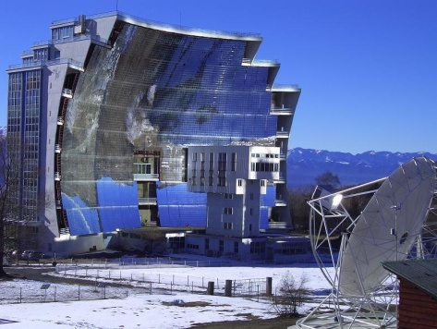
Fig. 1. Title (Table style)
Figure captions should be centred and placed below the figure (Times New Roman, 10 pt, bold, centred).

Equations
If you would like to include a complicated equation that cannot by typed on one line, please use an equations editor, or save it as a graphic with the extension .gif or .png and insert it in the text close to the point where it is mentioned. Number equations consecutively using parentheses and position the number flush right.
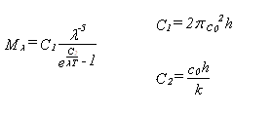 (1)
The size of the equation characters should be similar to that of the body text.

Lists
You may use a bulleted list to arrange information more clearly in the text:
- It helps to write in a straightforward style.
- It allows avoiding long or complex sentence structures.

References
Citations and the reference list should follow the IEEE style.

Page numbers
Do not insert page numbers!

Submission of paper

Data formats
Each completed paper must be converted to an Acrobat PDF file.

Delivery
The full paper in PDF format must be uploaded onto the SASEC website.

Deadline
The completed manuscript is to be submitted in electronic form only on the website http://sasec.org.za by 3 May 2021.

Conclusion
We would like to thank you for complying with these instructions!

Acknowledgements (Heading 5 style)
Use the last paragraph of the paper to acknowledge people, organisations, and funding (you may state grant numbers and sponsors here).

References
- J.Q. Public, (1999). Handbook of Whatever Solar, Excellent Press, London.
- J. Public, E. Mustermann, M. Dupont, Journal of the Most Remarkable Solar Systems, 3 (2008) 12-15.

