South African Institute of Physics: Applied Physics Division

Minutes of AGM held online on Wednesday, 6th July 2022 at 17h00

Attendance: Phil Ferrer, Alan Matthews, Aletta Karsten, Ernest van Dyk, Trevor Derry, Frederick Vorster, Adiel Holtzhausen, GL Kabongo, S Hlongwane, Lindsay Westraadt, Mmantsae Diale, Onesimo Mtinsilana, Philip Pare, Robert Nshimirimana, Ross Dix-Peek, Steve Makoni, NM Thantsha, Tjaart Kruger, Trevor Sewel.

1. WELCOME AND APOLOGIES
1.1 Appointment of minutes secretary: Alan Matthews

2. CONFIRMATION OF THE AGENDA
2.1 Matters to be placed under General : Nil

3. CONFIRMATION OF THE MINUTES OF THE PREVIOUS meeting HELD ON 29th July 2021 Accepted: Proposer: Trevor Derry, Seconder: Frederick Vorster

4. MATTERS ARISING FROM THE MINUTES
4.1 Industry day: Tue 5 July under Education/Development Track E
Should not be parallel with Applied Physics. Could be before the conference. New committee will deliberate and act.
4.2 Website (content): Nil
4.3 Women in Physics Africa workshop (Prof. Mmantsae): Workshop in Aug 2021(many delegates from Africa; focus on early career researchers).
4.4 Engineers in Physics: Wikus van Niekerk gave a presentation, and others.
4.5 Posters: Virtual platform worked well. Many students were not present for judging – hence NO SHOW. Suggest that we provide guidelines to students to have less verbose posters (“less is more”). 17 posters, 5 no-shows.(Orals: 2 plenaries, 1 non-specialist, 32 regular, 2 no-shows.)
4.6 Student rep: Would like a workshop on how to prepare for oral and poster presentations. Could provide guidelines (including video tutorial) on website, with winning posters and talks as examples. Could also encourage supervisors to guide students.
4.7 Conferences: See item 5.

5) CONFERENCE ACTIVITIES (SA) : 2023 – (advertise on website) SACPM (photonic materials) 9-11 May 2023 Kruger park; SASEC 2023 (solar energy) Nelson Mandela Bay Nov 2023 (cross-disciplinary physics-engineering); Congress on computational materials (https://nithecs.ac.za/computational-materials/) Univ Pretoria (in-person + online) 18-22 Sep 2022; Microscopy Soc of SA Gold Reef City Jhb 5-8 Dec 2022 (https://microscopy.co.za/welcome); Africa Material Society conference Dec Senegal 2022; African School of Physics Gqeberha Nov/Dec 2022.

6) BIOPHYSICS REPORT
Prof. T. Sewell to report: START programme has led to expansion of structural biology in SA. SA has been a member of Intl Union of Pure and Applied Biophysics. Would APD motivate to SAIP to continue to pay for membership (R 50 000) without annual re-motivation? Infrastructure is essential (synchrotrons, electron microscopes), available outside South Africa. Could APD/SAIP support motivation for funding for access to such infrastructure via membership of the EU’s Instruct programme to DSI? This will be discussed by the new committee and brought to the attention of the SAIP Council.
7) CHAIRPERSON’S REPORT
Prof Phil Ferrer to report (Report attached). The meeting thanked Phil Ferrer for his chairing of the APD for the last four years.

7) FINANCE REPORT
Prof. Ernest van Dyk to report: Thanks to the Treasurer.

8) MEETINGS ATTENDED IN APD CAPACITY
General: (Info to be provided).

9) SAIP COMMENTS
9.1Winter-school: Biophysics school – good talks, disappointing attendance (approx. 20). Perhaps better to hold the Winter School during the conference week. Low attendance may be due to the online format; on the other hand, online format permitted more international speakers.
9.2 Plenaries: Plenaries were excellent.
9.3 Non specialist lecture: Also excellent. Interesting how Brazil has developed infrastructure.
9.4 Industry Day: Well-received Industry Connection Roadmap talk; video can be placed on the website. Action to be discussed by new committee.
9.5 Talks: Level was good. Videos could be kept to time more strictly.
9.6 Posters: See item 4.5.
9.7 Organisation: Organisation was excellent. Timetable was not too full. Keep adequate time for questions after talks.
9.8 Reviews: Reviews were done well.

13) GENERAL: Nil

14) ELECTION OF NEW COMMITTEE:
Prof Alan Matthews | Chair and Secretary
Prof Phil Ferrer | Past Chair
Prof Ernest van Dyk | Treasurer, Manuscript Review, Judging
Prof Trevor Derry | SAIP Council Liaison
Dr Adiel Holtzhausen | Website and Outreach
Prof Tjaart Kruger | Biophysics Liaison
Dr Freddie Vorster | Industry Liaison
Dr Lindsay Westraadt | Industry Roadmap
Mr Roelof Roodt | Student Representative (co-opted 14 July 2022)
Mr Rorisang Sitoboli | Student Representative (co-opted 14 July 2022)

Meeting closed at 19h15.

Applied Physics Division Chairperson’s Report: 6th July 2022 (Prof Phil Ferrer)

- Applied Physics Division contribution to conference activities: 2 plenary talks, Biophysics Winter school, also important: Academia/Industry

- Industry day speaker for Applied Physics: AM on behalf of APD (Roadmap)

- Prize money to the APD: EvD to comment

- Council contributions: PhF: IYBSSD2022 (International Year of Basic Sciences for Sustainable Development) steering committee, Organiser of Physics centennial event at Wits

- 66th SAIP Annual Conference.
Contributions and attendance: Numbers are slightly up from 2021
 | 2022 | 2021 | 2019 | 2018 | 2017
Oral | 2 Plenary  1 Non-Specialist  32 Regular | 1 Plenary  1 Non-Specialist  26 Regular | 6 Industry Day  31 Regular | 1 Plenary  1 Non – specialist  6 Industry Day  25 Regular | 1 Non – specialist  7 workshop  39 Regular
Poster | 17 | 21 | 29 | 24 | 29
Total | 49 | 47 | 60 | 57 | 76
The number of no-shows were (to date): 2 Orals
5 Orals given by non-students (this must increase!)

- Workshop: No workshops associated with the Division held in 2022.
- Plenary Lecture: Profs W. van Niekerk and T. Kruger
- Non-specialist lecture: Prof Igor Polikarpov

- Website (https://appliedphysics.co.za/): mainly driven by Alan Matthews (layout), Jenee Morton (webmaster) and PF (content).
We have added a lot of content: SAIP APD talks 2021, Info related to SAIP 2022, and recorded talks from wits alumni.
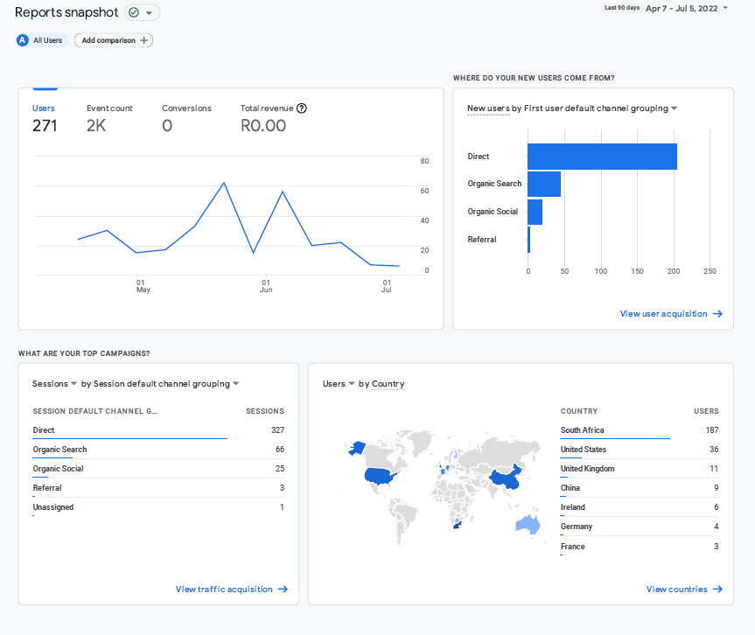
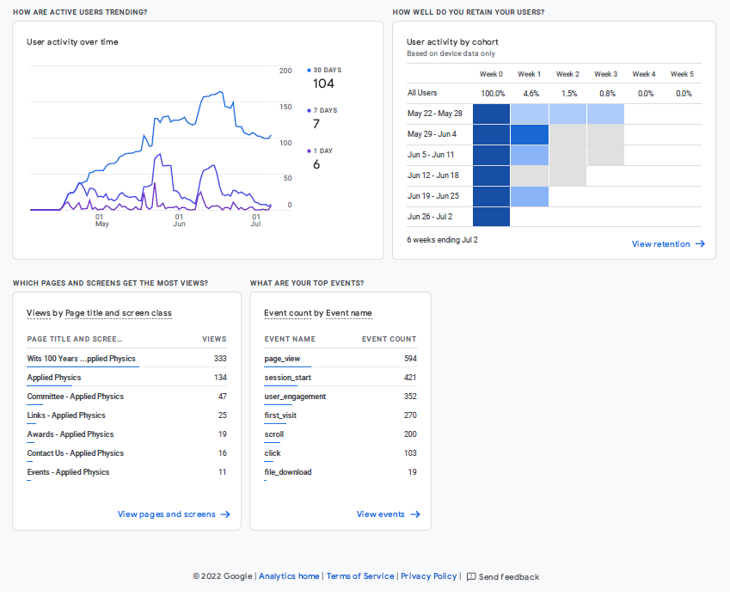

- This is an election year, current council has been active for 4 years. THANK YOU!

Submitted by:
Phil Ferrer
Chair: Applied Physics Division

Treasurer’s Report (submitted by Ernest van Dyk):
