**Development of a nonlinear response surface model to predict the volume of biogas yield of a fixed dome digester charged with cow manure.**

Mzobotshe Mandilakhe, Mukumba Patrick, Tangwe Stephen and Obileke KeChrist

Renewable Energy Research Group, Department of Physics, University of Fort Hare,

Private Bag X1314, Alice 5700, South Africa

E-mail: **MMzobotshe@ufh.ac.za**

**Abstract**. Waste-to-energy conversion is contributing significantly in enhancing the economic growth and health quality in society. One of the technologies that utilized waste-to-energy transformation is biomass technology. The study focused on the development of a nonlinear multiple regression (response surface) model to predict the biogas production with input parameters being relative pH of slurry, slurry temperature, and product of ambient temperature and relative global irradiance using an underground fixed dome digester fed with cow dung by continuous method. The fixed dome digester was fabricated with high-density polyethylene (HDPE) PVC plastic. The data acquisition system comprised of temperature sensors, pH transducer, pyranometer, biogas analyzer, a gas flow meter, and dataloggers. The results depicted that the hydraulic retention period for the anaerobic digestion was 50 days and the cumulative volume of biogas produced was 39.41 m3 while the reactor volume was 2.15 m3. It was determined that the measured daily biogas yield and the predicted values during the hydraulic retention period demonstrated no significant difference with a determination coefficient of 0.945 and a root mean square error of 0.023. The findings from the study can lead to the conclusion that the nonlinear surface response model can predict the biogas yield with high accuracy based on the acceptable values of both the root mean square error and determination coefficient.

Keywords: fixed dome biodigester, waste-to-energy conversion, nonlinear multiple regression model, determination coefficient, root mean error

1. Introduction

There is a need for establishing a balance between satisfying the ever-growing energy demand and mitigating its negative environmental effects. This has led to a massive interest for eco-friendly and sustainable energy development technologies. Bioenergy in the form of biogas, produced in an anaerobic digester is a renewable energy source that can help with the effective management of organic waste particularly animal manure. Biogas technologies offers substitute techniques for reducing pollution from greenhouse gas emissions, and preventing diseases associated with contaminated water and soil.

Anaerobic digestion (AD) is a biological process of breaking down organic waste in the absence of oxygen. Livestock farming is accompanied by massive tons of animal waste depending on the number of livestock, which demand effective management to prevent negative health impacts and environmental deterioration (1). Extensive research has demonstrated the use of anaerobic digesters can be an effective technique for the proper management of animal manure [2]. The biogas produced through anaerobic fermentation is bioenergy which is a renewable energy source with a variety of uses ranging from heating, cooking, transportation and electricity [3].

A mathematical model is a cycle wherein genuine scenarios and relations in these circumstances are communicated by utilizing mathematical equations or computer programming [4], or a recurrent cycle where genuine problems are converted into numerical language tackled inside an emblematic framework, and the arrangements are tried inside the genuine framework [5]. Although it has been demonstrated that kinetic models of differential systems of equations are the most accurate predictors of the production of biogas during the anaerobic digestion process, these models are complex and difficult to execute. Most Anaerobic digestion model no. 1 (ADM1), are complex and dynamic models that includes four stages of the anaerobic digestion process and used mathematical models that predict anaerobic digestion performance [6].

A self-designed anaerobic digester which was lab-based experimental research revealed that the hydraulic retention time affected the production of biogas from cow manure as the feedstock [7]. The author further demonstrated that biogas production reached a steady state after day 44 and predicted daily biogas output as a function of digestion time using a modified Gompertz kinetic model. The study focused on the deployment of a data acquisition system to monitor the volume of biogas yield and to develop a nonlinear regression model, to predict the volume yield. The study employed the one-way ANOVA test to justify that there is no significant difference between the measured and the predicted volume of biogas yield.

1. Methodology of the study

The study methodology consisted of an experimental setup and methods to obtain the relevant parameters required to build and developed the mathematical model. The quantitative data were obtained through experimental methods with the employment of sensors and data loggers while the qualitative data were derived through the developed mathematical model. A fixed-dome digester was used for the anaerobic digestion of cow dung in this study. The biogas plant consists of the slurry and the gas storage space as the major compartments.

* 1. *Reactor Design*

The reactor known as the fixed dome biogas digester consists of three parts namely, the digester chamber, the inlet and the outlet chamber as shown in figure 1. The digester chamber has a cylindrical shape while the gas storage has a spherical shape and a total volume of 2.15 m3. The inlet chamber is connected to the digester chamber with PVC pipe as shown in figure 1.

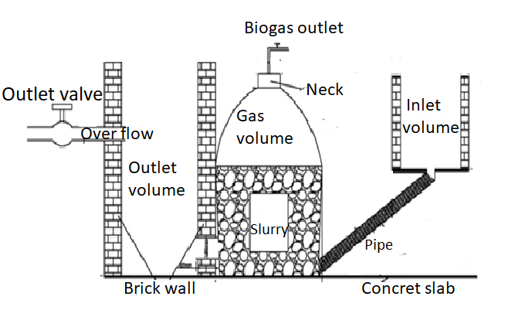

Figure 1: Schematic diagram of the fabricated biogas digester

2.1.1 *Experimental design*.The study used the mono-digestion continuous mode of feeding. 200 litres of the cow slurry were introduced into the bio-digester on the first day. Thereafter, the gas valve was left open for three (03) days for the expulsion of any air. An inoculum from an existing biogas digester near the University was added to the biogas digester system, to increase the rate of fermentation. Subsequently, 50 litres of the cow slurry were fed into the biogas digester every 3 days. It is interesting to note that the cow dung occupies 55-60% of the total volume of the biogas digester, providing sufficient room for the accumulation of the biogas. A data acquisition system was designed to monitor the slurry temperature, pH, global solar irradiance as well as the volume and quality of the biogas produced on a daily basis over the hydraulic retention cycle with a logging interval of 30 minutes. Table 1 gives a summary of the material and method of the study.

Table 1: Summary of materials and equipment used in the study.

|  |  |
| --- | --- |
| **Materials /parameters** | **Key metering property/sensors** |
| Substrate/feedstock | Cow dung |
| Monitoring sensors | K-type thermocouples, pyranometer and pH metre. |
| Biogas composition | Methane and carbon dioxide |
| Data capturing device  Type of plastic  Software used  Input parameters  Desired response | Data loggers  High-density polyethylene (HDPE)  MATLAB  Relative pH, slurry temperature, product of ambient temperature and relative global irradiance  Volume of Biogas |

*2.1.2 Selection and consideration of input parameters and derivation of mathematical model*. Figure 2 shows the schematic for the selected input parameters (relative pH (x1), slurry temperature (x2) and product of ambient temperature and relative global irradiance (x2)), the bio-digester (modelled system) and the output parameter (predicted volume of biogas yield). The developed non-linear multiple regression model is given by equation 1.

$\hat{y}=\frac{β_{1}x_{2}-{x_{3}}/{β_{5}}}{1+β_{2}x_{1}+β_{3}x_{2}+β_{4}x_{3}}$ (1)

Where, $\hat{y}$ is the volume of the daily biogas yield, x1 is relative pH, x2 is slurry temperature, x3 is product of ambient temperature and relative global irradiance, and β1, β2, β3, β4 and β5 are scaling factors.

The mathematical model was developed in MATLAB and by considering the modelled equation as the optimization function, whereby $\hat{y}$ represented the desired response (volume of biogas yield) and x1, x2, and x3 represented the predictors (relative pH, slurry temperature, and product of ambient temperature and relative global irradiance, respectively) while β1 , β2 , β3 , β4, and β5 where the given scaling parameters attributed to specific input variables.

The values of the scaling parameters were determined by performing non-linear function optimization with the modelled equation as the optimization function using the trained (testing) dataset for both the input and output parameters obtained from the experimental data.. The input variable x1 was associated with the scaling value determined for β2 and x2 was assigned with two scaling values determined for β1 and β3, while x3 was assigned with the determined scaling values for β4 and β5. The determination coefficient, root mean square error, and p-value between the volume of the daily biogas yield (y) and the predicted volume of biogas yield ($\hat{y}$) based on the training dataset were 0.941, 0.023, and 0.938, respectively. The high value of the determination coefficient (close to 1), is an indication that the developed non-linear regression model demonstrates a very good agreement between the predicted outputs ($\hat{y}$) and the actual targets (y). The large *p*-value (0.938), which is greater than 0.05 (threshold value), was obtained between the predicted outputs ($\hat{y}$) and the actual targets (y) and confirmed that there was no significant difference between the two groups within a 95% confidence level. The root mean square error between the predicted outputs and the actual targets was smaller than the minimum value for the targets. Therefore, these very good values for the determination coefficient and root mean square error provide adequate reason for the utilization of the developed non-linear regression model.



Figure 2: Schematic representation of the modelled bio-digester

1. Results and Discussion

*3.1**Variation of input factors and measured output*

The variation of the daily average ambient temperature, daily slurry temperature, global irradiance in referenced with the number of days for the retention period are shown in figure 3 while that for the output is displayed in figure 4. The figure 3 shows the daily profiles as stacked bar graphs over the retention period for each input factors. In addition, the profile for the corresponding volume of biogas yield over the retention period was represented as bar plot in figure 4. The profiles of the weather condition, the input and output parameters demonstrated continual variation during the anaerobic digestion process. The daily slurry temperature of the digester may be influenced by ambient temperature, the profiles of the average daily slurry and ambient temperature vary from 3.57- 48.69oC and 10.63-39.09oC with averages of 32.02oC and 29.52oC, respectively. However, the slurry temperature does not solely depend on the ambient temperature as other physicochemical factors as well as the global irradiance can impact the slurry temperature. It was observed that the anaerobic digestion process occurred in the mesophilic range as the average of the slurry temperature was greater than the threshold (20oC) required in the mesophilic regime. The pH during the retention cycle fluctuates between 6.9 and 7.4 with an average of 7.24 which significantly favour the methanogenic bacteria that are responsible for the production of biogas. The global irradiance during the retention cycle varied from 201-890 W/m2 with an average of 629.67 W/m2. Finally, the volume of the biogas yield on a daily basis over the retention cycle was between 0.80 and 0.89 m3/day and the cumulative volume yield was 39.41 m3.

Figure 3: Profiles of input parameters contributing to the biogas yield

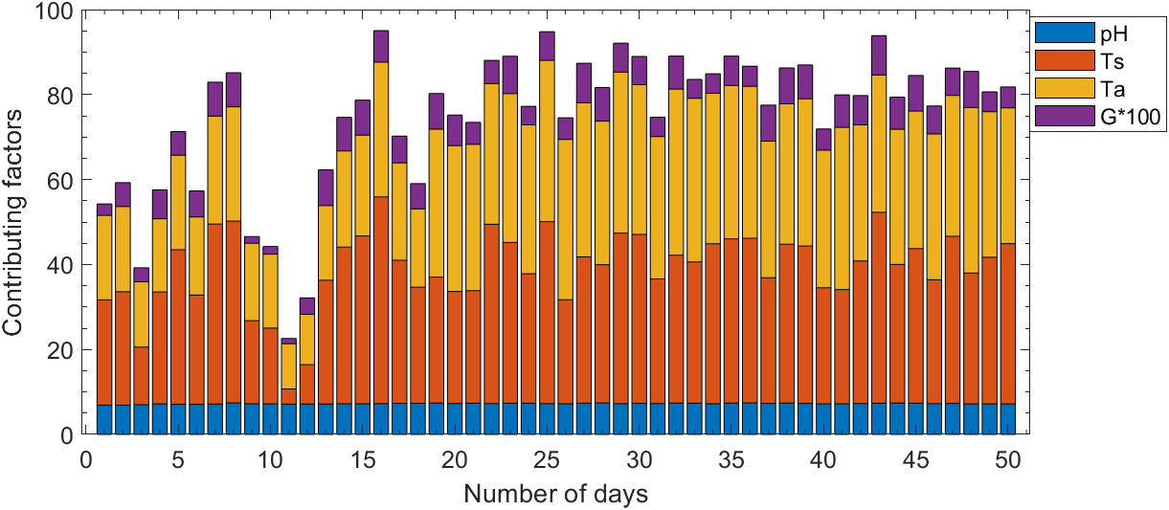

Figure 4: Profile volume of the biogas yield



*3.2. Determination of modelled scaling constants and accuracy.* Table 2 shows the determined scaling values of the scaling parameters β1, β2, β3, β4 and β5  achieved by performing training with the modelled equation as the optimization function. The determined scaling values led to the modelled output accurately predicting the target (measured volume of biogas) with very good determination coefficient and root mean square error of 0.945 and 0.023.

Table 2: Determined scaling values and accuracy of developed modelled

|  |  |  |  |  |  |
| --- | --- | --- | --- | --- | --- |
| **Input parameters** | **Symbol** | **Scaling**  **parameter** | **Scaling values** | **Output** | **Accuracy** |
| Relative pH | $$x_{1}$$ | $$β_{2}$$ | -1.7104 | Volume of biogas yield $\left(\hat{y}\right)$ | r =0.890  r2 = 0.945  RMSE= 0.023 |
| Slurry temperature | $$x_{2}$$ | $β_{1}$ and $β_{3}$ | 0.2983 and 0.3738 |
| Product of ambient temperature and relative global solar irradiance | $$x_{3}$$ | $β_{4}$ and $β_{5}$ | -0.6351 and 1.9816 |

Figure 5 shows the set of measured data set and the best fit line for the modelled based on a two-dimensional graph with the measured volume of biogas yield on the x-axis and the predicted volume of the biogas yield on the y-axis. The correction coefficient between the predicted and measured volume of biogas yield over the retention cycle was 0.890 within the 95% confidence interval. Therefore, the derived correlation coefficient, determination coefficient and root mean square error between the measured and predicted volume of biogas yield are within the acceptable ranged.



Figure 5: Measured and predicted volume of biogas yield

* 1. *One-way analysis of variance to confirm accuracy of model.* Table 3 shows the ANOVA table for the targets (experimentally determined volume of biogas yield) and the model outputs. The groups of targets and model outputs gave the mean square of the columns and error as 0.00001 and 0.20969 as shown in table 3. The F-statistic was 0.01, whereas the p-value was 0.9381. The p-value (0.9381) was larger than the threshold value (0.05) and confirmed that no mean significant difference existed between the targets and predicted model outputs over a 95% confidence level.

Table 3: ANOVA table for the groups of measured and predicted volume of biogas yield

|  |  |  |  |  |  |
| --- | --- | --- | --- | --- | --- |
| **ANOVA Table for both groups of measured and predicted volume of biogas yield** | | | | | |
| Source | Sum of squares | Degree of freedom | Mean square | F-statistic | Prob>F |
| Columns | 0.00001 | 1 | 0.00001 | 0.01 | 0.9381 |
| Error | 0.20969 | 98 | 0.00214 |  |  |
| Total | 0.2097 | 99 |  |  |  |

In addition, the ANOVA plots in figure 6 shows negligible outliers (data points with red markers) for both the measured and predicted groups. The data set for the targets and model outputs were normally distributed with the medians (horizontal red line on the ANOVA plots) for the targets and modelled outputs equal 0.7854 and 0.7790, respectively. The difference between the two medians is insignificant and justified no mean difference existed between the measured and predicted values. Therefore, the developed non-linear multiple regression model can be accepted.



Figure 6: ANOVA plot of the measured and predicted biogas yield

1. *Conclusion*

The study confirmed that cow dung contains sufficient biodegradable materials to generate significant biogas during anaerobic digestion in a fixed dome biodigester. A credible and accurate non-linear multiple regression model was developed to forecast the volume of the daily biogas yield, using three predictors (relative pH, slurry temperature, and the product of ambient temperature and relative global irradiation). The determination coefficient, root mean square value, and p-value between the targets and model outputs were 0.941, 0.023, and 0.938, respectively. Furthermore, the developed modelled can be accepted for making prediction of the volume of biogas yield based on the determined p-value and the no significant difference in the medians between the measured and predicted groups.

**Acknowledgement**

Authors would like to thank the Department of Science and Innovation and Technology Innovation Agency (DSI-TIA) and The Govan Mbeki Research Development Centre (GMRDC) office and the research office of University of Fort Hare, South Africa for the financial support that enable the implementation of the study

References

1. Ayilara, M.S.; Olanrewaju, O.S.; Babalola, O.O.; Odeyemi, O. Waste management through composting: Challenges and potentials. *Sustainability* **2020**, *12*, 4456.
2. Garfí, M.; Martí-Herrero, J.; Garwood, A.; Ferrer, I. Household anaerobic digesters for biogas production in Latin America: A review. Renew. Sustain. Energy Rev. **2016**, 60, 599–614.
3. Manyi-Loh, C.E.; Mamphweli, S.N.; Meyer, E.L.; Okoh, A.I.; Makaka, G.; Simon, M. Microbial anaerobic digestion (bio-digesters) as an approach to the decontamination of animal wastes in pollution control and the generation of renewable energy. Int. J.Environ. Res. Public Health **2013**, 10, 4390–4417.
4. Cioabla, A.E.; Ionel, I.; Dumitrel, G.A.; Popescu, F. Comparative study on factors affecting anaerobic digestion of agricultural vegetal residues. *Biotechnol. Biofuels* **2012**, *5*, 39.
5. Verschaffel L., De Corte E., Lasure S. (1994). Realistic considerations in mathematical modeling of school arithmetic word problems. *Learn. Instr.* 4, 273–294. doi: 10.1016/0959-4752(94)90002-7
6. Enitan, A.M.; Adeyemo, J.; Swalaha, F.M.; Kumari, S.; Bux, F. Optimization of biogas generation using anaerobic digestion models and computational intelligence approaches. *Rev. Chem. Eng.* **2017**, *33*, 309–335.
7. Haryanto, A. Effect of hydraulic retention time on biogas production from cow dung in a semi continuous anaerobic digester. *Int. J. Renew. Energy Dev.* **2018**, *7*, 93–100.