Synthesis, Characterization and simulation of Graphene Oxide Nanomaterial for Application in Hybrid Supercapacitors

**M.T Nemukongwea, J.K Kiruia, N.E Malutaa,b, R.R Maphangab,c**

aDepartment of Physics, University of Venda, Private Bag X 5050, Thohoyandou, 0950

bNational Institute for Theoretical and Computational Sciences, Gauteng, South Africa

cCouncil for Science and Industrial Research, P.O. Box 395, Pretoria, 0001

Email: [maanotry@gmail.com](mailto:maanotry@gmail.com)

**Abstract**. Energy storage is a major challenge in the development of viable storage devices to sustain many electronic devices. Graphene oxide (GO) has been suggested as a promising material for improved energy density in storage devices. In this study, GO was prepared by modified Hummer’s method using graphite, KMnO4, H2SO4 and H3PO4. From Fourier Transformed Infrared Spectroscopy analysis, the transmittance broad band of carbonyl and hydroxyl were present indicating the successful oxidation of graphite. Furthermore, Ultraviolet-Visible spectra support this suggestion with the highest absorption peak at 905 nm, from highest occupied molecular orbital and lowest occupied molecular orbital structures show a band gap of -2.327eV and further confirm that GO can be a very good material for supercapacitors.

1. **Introduction**

Nanotechnology provides essential improvement potential for the development of efficient renewable energy storage (Zhang et al., 2013; Pomeratsea et al., 2016). Application of nanotechnology in renewable energy storage, involves designing and developing of new innovative material properties on the nanoscale dimension to enhance efficiency of energy storage (Manaktala and Singh, 2016). The most commonly used energy storage devices are batteries. However, their reliability does not seem to stand the ever-growing demands in technological applications (Oyeniran, 2018). On the other hand, supercapacitors seem to be a perfect alternative to batteries for energy storage applications.

Physical and chemical properties of nanomaterials differ from one nanomaterial to another, and this can subsequently affect their efficiency in renewable energy storage. As a result, the search for new nanomaterials with relatively better electrochemical properties has spiked in recent years. In addition, researchers are exploring ways to modify properties of nanomaterials for enhanced performance such as high-power density, energy density and cycle stability. This has resulted in the focus on carbon-based nanomaterials for energy applications (Avouris and Dimitrakopoulos, 2012; Ghorbani et al., 2015; Li et al., 2015; Raja et al., 2015; Wang et al., 2017; Antink et al., 2018; Jayachandiran et al., 2018; Chaudhary et al., 2019).

Carbon materials are suitable electrode materials for supercapacitors because of their readily availability, structural diversity, cost-effectiveness and large active surface area (Paul and Dai, 2018; Jana et al., 2019). In addition, the flexibility of these materials permits modification and characterization to meet specific requirements for different applications (Paul et al., 2019).

The aim of this study was to synthesize, characterize and simulate graphene oxide (GO) using both experimental and theoretical methods. In particular, Density Functional Theory (DFT) method was used to investigate the optical properties; whereas experimental methods were utilized to investigate the oxygen functional groups of the synthesized material.

1. **Methods and materials**
   1. Experimental method

The preparation process of GO involved two steps: oxidation and exfoliation. These steps are described in detail below:

Step 1: Oxidation

Graphite powder of 1 g and potassium permanganate (KMnO4) of 9 g were mixed with 180 ml of sulphuric acid (H2SO4), together with 20 ml of orthophoric acid (H3PO4) and stirred using a magnetic stirrer for about 19 hours at a temperature of 40 oC. When the colour of the mixture turned greenish, the, distilled water of 500 ml was added to stop the reaction. Thereafter, 20 ml of hydrogen peroxide (H2O2) was added to reduce manganese ions in the mixture until the colour of the mixture changed to bright yellow, which is an indication of oxidation process completion (Arthi G et al., 2015).

The oxidized mixture was then kept at a room temperature to cool down. After cooling, it was filtered for two days using filter paper. The filtered product, which looked like paste, was washed utilizing 5 % of hydrochloric acid (HCl) for 3 hours and thereafter washed using distilled water for 1 hour with the aid of centrifugation.

Step 2: Oxfoliation

The GO product which was found after centrifugation was dispersed into 100 ml of distilled water for the formation of single-layer GO, and then it was heated while stirring with a magnetic stirrer for 19 hours at 60 oC. Then the resulted black paste was collected by centrifugation and dried at temperature of 70 oC for 24 hours.

* 1. Computational software

DFT is a computational quantum-mechanical modelling method aimed at quantitative understanding of material properties from the fundamental laws of quantum mechanics (Kurth et al., 2005). The theoretical study of GO was done by Material Studio computing software of DFT. Material Studio is a software for simulation and modelling materials. It is used for studying various materials such as ceramics, metals, polymers etc. Inside Material Studio there is a package code called Vienna ab initio molecular dynamics (VAMP). The structure of GO was built using Material Studio and calculation were done using VAMP, which was used for calculation of optical properties of GO using Ultraviolet Visible (UV-VIS) spectrum.

* 1. Characterization techniques
     1. *Fourier Transformed Infrared Spectroscopy:* Fourier Transformed Infrared Spectroscopy (FTIR) measures how much light a sample absorbs at each wavelength. This is achieved when the emitted radiation from an IR source passes through an interferometer composed of a beam splitter, a fixed mirror, and a moving mirror. The interferometer measures the wavelength of emitted light via interference patterns that help to increase accuracy. IR spectra are obtained by applying IR radiation to a sample and measuring the intensity of the passing radiation at a specific wavenumber. Consequently, IR radiation of certain molecular groups can be detected at specific wavenumbers (Faghihzadeh et al., 2016). FTIR is generally used to identify and compare the oxygen functional groups of carbon-based electrode materials (Cheng et al., 2011; Cao and Zhang, 2014; Hidayah et al., 2017).
     2. *Ultraviolet-Visible Spectroscopy:* Ultraviolet-Visible Spectroscopy/Spectrophotometry (UV-VIS), is an optical spectroscopy that is based on the absorption of ultraviolet and visible light by a sample and also corresponds to electronics excitation between the energy levels which provides the molecular orbitals, highest occupied molecular (HOMO) and lowest occupied molecular (LUMO). The absorption or reflectance in the visible spectral range directly affects the perceived colour of the chemical components involved. A UV-VIS measures the intensity of light passing through a sample solution in a cuvette, and compares it to the intensity of the light before it passes through the sample. UV-VIS can be used to examine the optical features, electronic structures of materials and to monitor the degree of oxidation of carbon nanomaterials (Hidayah et al., 2017).

1. **Results and discussion**
   1. FTIR results

From FTIR analysis, there is transmittance broad band between 3100 to 3300 cm-1 hydroxyl group(O-H) and spectral troughs at 1730 cm-1 and 1018 cm-1 which are attributable to carbonyl group (C-O) and indicating the successful oxidation of graphene single layer of graphite after being exfoliated (Figure 1).



Graphite

GO

C-H

C=0

C=C

C-O

O-H

Figure 1: FTIR of graphite and graphene oxide

* 1. Optical properties results
     1. *UV-Vis spectrum:* VAMP calculations, UV-Vis spectra shows the highest absorption peak at 905 nm and the visible light absorption ranging from 700 nm to 1500 nm (Figure 2).

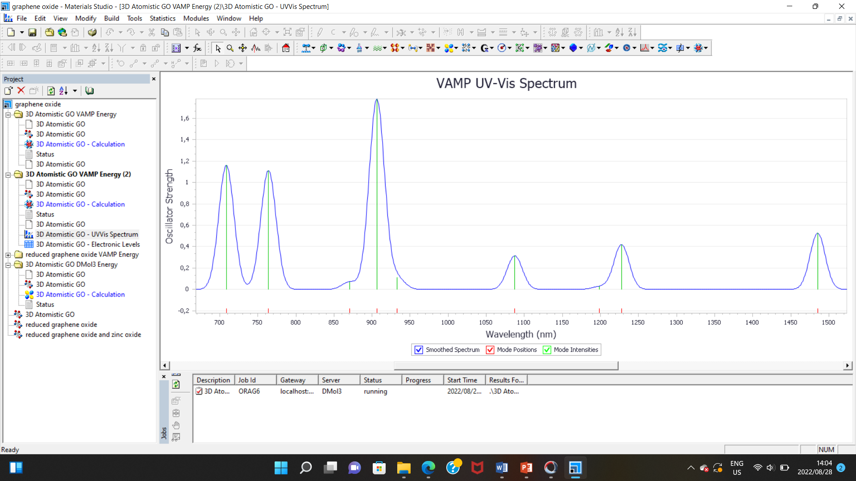

Figure 2: UV- Vis spectrum of GO.

* + 1. *HOMO and LUMO:* The results in figure 5 show the occupied and unoccupied orbitals of semiconductor band of GO. HOMO as highest occupied molecular orbitals and LUMO as lowest unoccupied molecular orbitals.

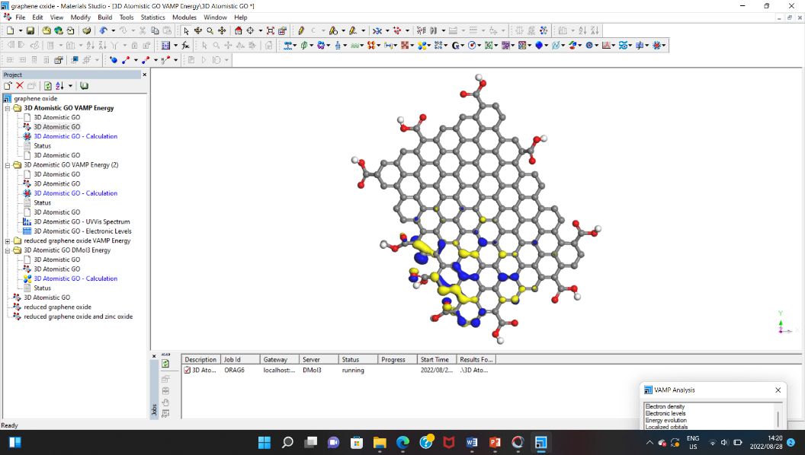LUMO (-4.89 eV)

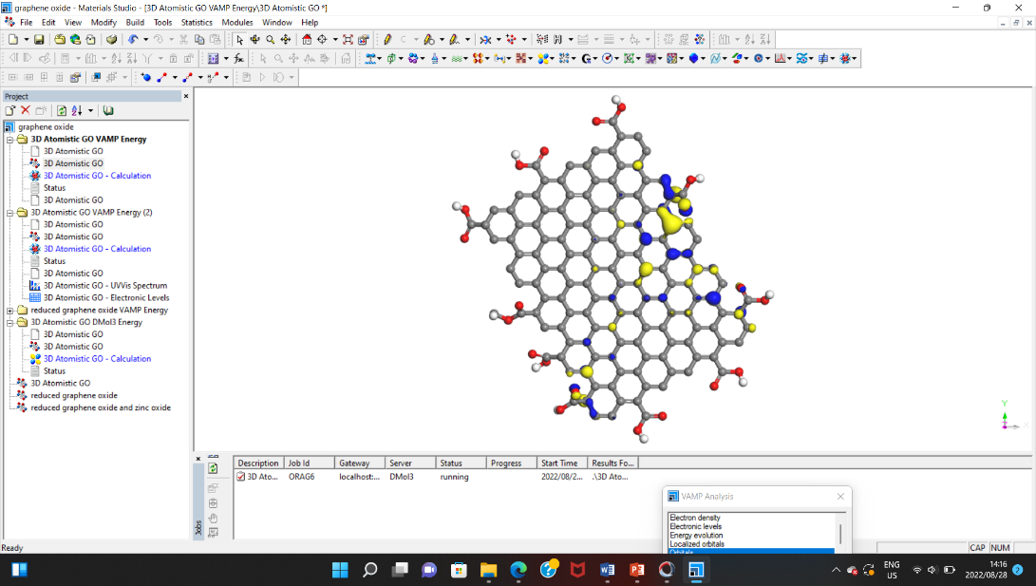HOMO (-7,217 eV)

Band gap (-2.327)

Figure 3: HOMO and LUMO structures.

1. **Conclusion**

Graphene oxide (GO) shows presence of many oxygen-containing surface functional groups of carbonyl and hydroxyl in FTIR. However, the energies of HOMO and LUMO of GO are, -7.217 eV and -4.89 eV, respectively with the band gap of -2.327 eV which represents a semiconductor material which can either behave as a conductor or insulator depending on the condition. There is absorption in the range 700 nm to 1500 nm but with less intensities at the higher wavelengths. No absorption was observed in the ultraviolent range. These results imply GO has very good potential for supercapacitors application.

References

1. Pomerantseva, E., Banaccorso, F., Feng, X., Cui, Y. and Gogotsi, Y., 2016. Energy storage: The future enabled by nanomaterials. Science, vol. 366(969), p. 1-12.
2. Manaktala, S. and Singh, K.M., 2016. Nanotechnology for energy applications. ISST Journal of Electrical & Electronics Engineering, vol. 7(1), p. 63-69.
3. Oyeniran, O.K., 2018. “Synthesis and characterization of carbon-based nanostructured material electrodes for designing novel hybrid supercapacitors,” PHD thesis, Faculty of Natural and Agricultural Sciences, University of Pretoria. Pretoria, South Africa.
4. Ghorbani, M., Abdizadeh, H. And Golobostanfard, M.R., 2015. Reduction of graphene oxide via modified hydrothermal method. Procedia Materials Science, vol. 11, p. 326-330.
5. Avouris, P. and Dimitrakopoulos, C., 2012. Graphene: Synthesis and applications. Materials today, vol. 15(3), p. 86-97.
6. Chaudhary, S., James, L.S., Kumar, A.B.V.K., Ramana, CH.V.V., Thomas, S., Daewon, K., 2019. Reduced Graphene Oxide/ZnO Nanorods Nanocomposite: Structural, Electrical and Electrochemical Properties. Journal of Inorganic and Organometallic Polymers and Materials, vol. 29, p. 2282–2290
7. Jayachandiran, J., Yesuraj, J., Arivanandhan, M., Raja, A., Suthanthiraraj, S. A., Jayavel, R. and Nedumaran, D., 2018. Synthesis and Electrochemical Studies of rGO/ZnO Nanocomposite for Supercapacitor Application. Journal of Inorganic and Organometallic Polymers and Materials, vol. 28(5), p. 2046-2055. https://doi.org/10.1007/s10904-018-0873-0
8. Jana, A., Paul, R. and Roy, A.K., 2019. Architectural design and promises of carbon materials for energy conversion and storage: in laboratory and industry. Carbon Based Nanomaterials for Advanced Thermal and Electrochemical Energy Storage and Conversion, p. 25-61.
9. Antink, W.H., Choi, Y., Seong, K., Kim, J.M. and Piao, Y., 2018. Recent progress in porous graphene and reduced graphene oxide-based nanomaterials for electrochemical energy storage devices. Advanced Materials Interfaces, vol. 5, p. 1-19.
10. Li, F., Jiang, X., Zhao, J. And Zhang, S., 2015. Graphene oxide: A promising nanomaterial for energy and environmental applications. Nano Energy, vol. 16, p. 488-515.
11. Paul, R. and Dai, L., 2018. Interfacial aspects of carbon composites. Composite Interfaces, vol. 25, p. 539-605.
12. Wang, H. and Dai, H., 2013. Strongly coupled inorganic-nano-carbon hybrid materials for energy storage. Chemical Society Reviews, vol. 47(7), p. 3088-3113.
13. Zhang, Q., Uchaker, E., Candelaria, S.L. And Cao, G., 2013. Nanomaterials for energy conversion and storage. Chem Soc Rev, vol. 42, p. 3127-3171.
14. Arthi, G., Paulchamy, B., Lignesh, B.D., 2015. A sample approach to stepwise synthesis of graphene oxide nanomaterial.Nanomedicine & Nanotechnology, vol. 6, p. 1
15. Kurth, S., Marques, M.A. L. and Gross, E.K.U., 2005. Density-Functional Theory. Encyclopedia of Condensed Matter Physics, p. 395-402. <https://doi.org/10.1016/b0-12-369401-9/00445-9>
16. Faghihzadeh, F., Anaya, N.M., Schifman, L.A. and Oyanedel-Craver, V., 2016. Fourier transform infrared spectroscopy to assess molecular-level changes in microorganisms exposed to nanoparticles. Nanotechnology for Environmental Engineering, p. 1-16.
17. Cheng, Y. And Liu, J., 2013. Carbon nanomaterials for flexible energy storage. Material Research Letters, vol 1(4), p. 175-192.
18. Cao, N. and Zhang, Y., 2014. Study of Reduced Graphene Oxide Preparation by Hummers’ Method and Related Characterization. Journal of Nanomaterials, vol. 2015, p. 1-5.
19. Hidayah, N.M.S., Liu, W., Lai, C., Noriman, N.Z., Khe, C.S., Hashim, U. and Lee., H.C., 2017. Comparison on graphite, graphene oxide and reduced graphene oxide: Synthesis and characterization. AIP Conference Proceedings, vol. 1892, p. 1-8.