Recombinant Antibody-Conjugated Silver Nanoparticles for Improved Drug Delivery in Photodynamic Therapy for Metastatic Melanoma

**Zaria Malindi1*, Stefan Barth2 and Heidi Abrahamse1**

1Laser Research Centre, University of Johannesburg, Beit Street, Doornfontein, 2028 Johannesburg, South Africa

2Medical Biotechnology and Immunotherapy Research Unit, University of Cape Town, Anzio Road Observatory, 7925 Cape Town, South Africa

E-mail: [**222116639@student.uj.ac.za**](mailto:222116639@student.uj.ac.za)

**Abstract**. New treatments are needed to overcome the inherent drug resistance observed in melanoma. Immunotherapy uses antibodies to target cancer; photodynamic therapy uses light to produce cytotoxic singlet oxygen and reactive oxidative species; and nanomedicine uses nanocarriers to enhance pharmacokinetics. We aim to establish a chemical conjugation model allowing for directional attachment of SNAP-tag-based recombinant antibodies (rAbs) to silver nanoparticles carrying the photosensitiser ZnPCS4 for the photoimmunotheranostic management of melanoma. The initial aim was to engineer and purify rAbs comprising anti-CSPG4 single-chain variable fragments (scFv) and SNAP-tag and to validate rAb selective binding to melanoma cells. HEK293T cells were transfected with plasmids containing the scFv and SNAP-tag gene sequences. Secreted protein was purified using immobilised metal affinity chromatography and characterised using SDS-PAGE and Western blot. The rAb was then conjugated to fluorescent markers to confirm selective binding to target cells by flow cytometry and confocal microscopy. These preliminary results indicate the feasibility of this rAb as a targeting ligand for antibody-mediated nano-PDT against melanoma.

**1. Background**

The gold standard for melanoma treatment is resection, but this only provides local control of early-stage disease; in late-stage disease, no satisfactory treatment exists and recurrence becomes probable(1).Despite advances in cancer drug development, most clinical trials have produced suboptimal outcomes, with many drugs exhibiting poor or non-specific effects(2). Furthermore, melanoma cells are inherently resistant to treatment owing to their highly developed antioxidant system(3,4). New therapeutic strategies are evidently needed to address these patients’ unmet clinical requirements.

In photodynamic therapy (PDT), a photosensitizer (PS) is irradiated, inducing cell death. When a photon is absorbed by ground state PS, the PS enters an excited singlet state (PSes). Subsequent decay to the ground state causes fluorescent emission. At peak absorption, PSes undergoes intersystem crossing, entering an excited triplet state (PSet). PSet interacts with neighbouring molecules through: 1) the type I photo-oxidative pathway in which PSet transfers electrons or H+ ions to proximate biomolecules, which react with oxygen and produce various reactive oxygen species or 2) the type II pathway in which energy released when PSet decays is transferred to ground state oxygen, creatingsinglet oxygen(5). PDT has been approved for certain cancers(6), though research on its use in melanoma is ongoing. However, PDT utilises passive tissue localisation(7), which can lead to off-target accumulation and side effects. Photoimmunotherapy (PIT) combines PDT with the targeting specificity of antibodies.

SNAP-tag is an engineered enzyme derived from the human DNA repair enzyme O6-alkylguanine-DNA alkyltransferase, which removes DNA alkyl adducts from O6-alkylated guanine, transferring the alkyl group to its Cys145 reactive cysteine residues and releasing guanine. SNAP-tag mimics this chemistry, reacting readily with benzylguanine (BG). In this single-step protein labelling process, SNAP-tag and any BG-modified substrate bond covalently; the benzyl alkyl group is transferred to the reactive cysteine residue of the SNAP-tag and guanine is released, producing a stable thioether (8,9). SNAP-tag can be used as a fusion protein with any ligand of choice. In this study, we cloned the single chain variable fragment (scFv) of the anti-chondroitin sulphate proteoglycan-4 (CSPG4) antibody, mAb2.9.27, at the N-terminus. The scFv is one of the smallest functional antibody formats in which the antigen-binding function can be preserved(10). The scFv-SNAP recombinant antibody’s (rAb) reduced size compared to the full-length mAb enhances the degree of penetration into tumorous tissue(8) and facilitates rapid tumour uptake(11).SNAP-tag further ensures the preservation of antibody integrity and functionality during conjugation because labelling with the payload occurs distal to the antibody fragment(9,12). Furthermore, since SNAP-tag coupling occurs in a site-specific 1:1 stoichiometry, homogeneous products are generated with a known configuration and drug-to-antibody ratio(9), and because SNAP-tag is of human origin(13), it is not immunogenic. Photoimmunotherapy (PIT) combines the phototoxicity of PDT with the targeting precision of antibody technology to form an antibody-photoabsorber conjugate(14).

The CSPG4 antigen is commonly overexpressed in melanoma. It plays an important role in tumour cell survival, proliferation, migration and invasion, facilitating cancer progression(15). During embryonic development, CSPG4 expression is seen in several motile tissues; however, expression is limited in the terminally differentiated melanocytes of normal adult tissue due to post-translationally down-regulation(16).The differential expression of CSPG4 on malignant melanoma cells vs healthy skin tissueand its limited secretion into circulation as a permanently membrane-bound transmembrane protein make CSPG4 a good candidate for targeted therapy(15).

Nanoparticles (NPs) are organic or inorganic structures of up to 100 nm, the physiochemical properties of which can enhance biodistribution and uptake of drugs that are surface-immobilised on or encapsulated within them(17). Their hydrophilicity improves drug solubility and, thus, pharmacokinetics(18); they can be easily functionalised(19,20); they mimic biomolecules, allowing them to go undetected by the host immune system(19); and they have large aspect ratios, allowing for reduced minimal effective doses due to their high drug loading(21). In particular, inorganic NPs are easily modified to possess optimal size, shape, and optical properties(22). Studies have shown that using various NP formats as PS drug carriers augments PDT effects *in vitro*(23). Silver (Ag) NPs are non-toxic, biocompatible and exhibit antimicrobial and anti-inflammatory properties (24), and these NPs have antitumour effects when used as PSs in PDT(25,26). However, while gold (Au) NPs have been well-studied(27), the use of AgNP-drug conjugates is limited in the literature, particularly for PS-loaded AgNPs in PDT. Similarly, the use of antibody-NP drug delivery systems has been increasingly examined for AuNPs (28,29), but not for AgNPs.

This project aims to establish a chemical conjugation model allowing for directional attachment of SNAP-tag-based rAbs to nanobioconjugates composed of the PS zinc phthalocyanine tetra-sulphonic acid attached to silver nanoparticles for the photoimmunotheranostic management of melanoma. The initial aim, herein reported, was to engineer and purify rAbs comprising the anti-CSPG4 mAb9.2.27 scFv and the SNAP-tag enzyme and to validate rAb selective binding to CSPG4-positive melanoma cells.

**3. Methods and Materials**

*3.1 In silico vector design*

SnapGene® software (GSL Biotech, Chicago, IL USA) was used for *in silico* design of the mammalian vector system for transient expression of the SNAP-tag fusion protein, and all necessary production vectors were purchased from GenScript (NJ USA).

*3.2 Molecular cloning*

Plasmid DNA was incorporated into chemically competent DH5α *Escherichia coli* (*E. coli*) cells (NEB, MA United States) using a heat shock method, then inoculated into Luria Bertani (LB) broth (Sigma-Aldrich) and placed at 37oC on a shaker overnight. DNA was isolated using the NucleoBond Plasmid Purification Kit (Macherey-Nagel GmbH & Co, Düren, Germany), and DNA concentration was quantified using a NanoDrop ND-2000 (Thermo Fisher Scientific, DE USA). Restriction enzyme (RE) digests were performed using the NEB Double Digest protocol, and agarose gel electrophoresis was performed to confirm digestion. Agarose bands containing the DNA fragments of interest were excised using the QIAquick Gel Extraction Kit (QIAgen, Hilden, Germany) and subsequently ligated using the NEB T4 Ligase kit and overnight protocol (NEB). Recombinant plasmid DNA was incorporated into chemically competent *E. coli* cells, and the mixture was spread on LB agar plates supplemented with ampicillin and placed at 37oC overnight. Single colonies were picked and amplified in LB broth. Recombinant plasmids were purified from the *E. coli* using the Zyppy Plasmid Miniprep Kit (Zymo Research, CA USA), and the eluted DNA concentration was then quantified using a NanoDrop ND-2000. Single enzyme digest simulations were performed on SnapGene to predicate the cutting patterns for the original and recombinant plasmids, after which RE digest reactions were set up. Agarose gel electrophoresis was performed, and gels were analysed to confirm correct ligation of recombinant plasmids, as predicted by the simulation. Recombinant clones confirmed by restriction mapping were purified using the NucleoBond Plasmid Purification midiprep protocol. Samples were sent to Inqaba Biotec as a pay-for-service to confirm the accuracy of the open reading frame (ORF) sequence.

*3.3 HEK293T cell culture and transfection*

HEK293T cells were cultured in RPMI-1640 medium supplemented with 10% foetal bovine serum (FBS) and 1% penicillin-streptomycin (Gibco by Life Technologies, CA USA) and incubated at 37oC in 5% CO2. The XtremeGENE HP DNA Transfection Reagent Quick Protocol (Sigma-Aldrich, MO USA) was used for transfection, and cells were treated with Zeocin to enrich the Zeocin-resistant transfected population co-expressing the eGFP reporter gene.

*3.4 Protein purification*

Cell-free supernatant containing the secreted his6-tagged fusion protein (mAb9.2.27(scFv)-SNAP) was purified using immobilized metal ion affinity chromatography (IMAC) on an ÄKTA FLPC system (GE Healthcare Europe GmbH, Freiburg, Germany) with a Ni2+-NTA Superflow cartridge column. Elution was achieved through binding competition when applying an imidazole gradient to separate elution peaks; 5 mL fractions were collected throughout. Amicon Ultra-15 Centrifugal Filter Units (Merck Milipore, MA USA) were used to further concentrate purified protein and remove imidazole. The concentration of purified mAb9.2.27(scFv)-SNAP rAb was determined using a NanoDrop ND-2000.

*3.5 Protein characterisation*

Protein samples were separated by size using SDS-PAGE to identify fractions containing protein of the correct weight (~53 kDa). Protein bands were visualised using Coomassie Staining Solution. Western blotting was then used to detect functional his6-tag protein. 1:1000 anti-His6-tag rabbit primary antibody and 1:5000 goat anti-rabbit IgG horse radish peroxidase-conjugated secondary antibody (Bio Rad) were used to detect proteins on a Gel DocTM XR Gel Documentation System (Bio Rad).

*3.6 Mammalian cell culture*

Cancer cell lines were cultured in DMED medium supplemented with 10% FBS and 1% penicillin-streptomycin and incubated at 37oC in 5% CO2.

*3.7 Immunoassays: Binding validation*

The NEB Protein Labelling *in vitro* protocol was used to label mAb9.2.27(scFv)-SNAP with BG-modified SNAP-Surface® Alexa Fluor®488. Binding of the final labelled construct to CSPG4-positive cells was assessed quantitatively through flow cytometry using a FACSCalibur system and FlowJo software for analysis (Be cton & Dickinson, Heidelberg, Germany) and qualitatively using confocal microscopy on the Ziess LSM880 Airyscan (Oberkochen, Germany) with the 40× air objective.

**4. Results and discussion**

*4.1 In silico vector design*

Fig. 1 shows the *in silico* design of the plasmid generated on SnapGene. Annotated nucleotide and amino acid sequences (not shown) were used to order production vectors.

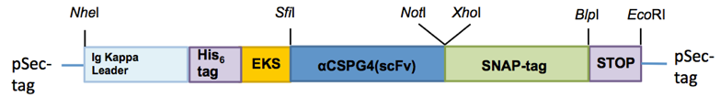

A

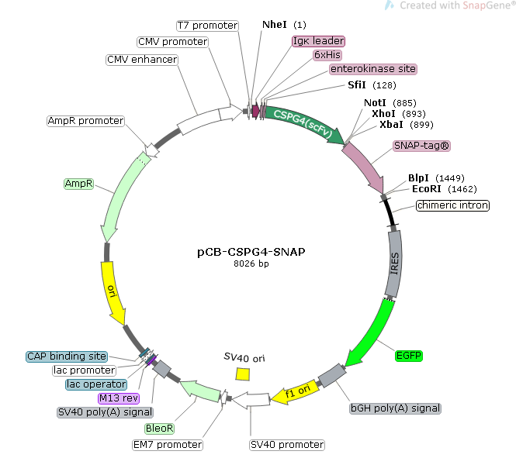

B

**Fig. 1: *In silico* design for anti-CSPG4-SNAP expression vector**. A) Diagrammatic representation of ORF structure showing key components of final protein and restriction sites. B) Expression vector plasmid map showing key gene components for expression.

*4.2 Molecular cloning*

After transformation in *E. coli* cells, extraction and purification, all DNA samples were within the acceptable purity ranges. RE digestion of the production and expression vectors was successful, and agarose gel electrophoresis showed DNA fragments correlating to the expected sizes. The backbone and the insert were both digested with *SfiI* and *NotI* and could thus be ligated in frame. After gel extraction, samples with the highest concentrations were used for subsequent ligation. The vector-only ligation control showed only minimal autoligated clones, indicating minimal partial digestion in the previous step. The bacteria only control showed no colony formation, confirming that all colonies contained the vector. *In silico* and *in vitro* restriction mapping confirmed that DNA fragments were successfully ligated and that no autoligated clones were selected. The clone sequences were confirmed to be accurate for further application.

*4.3 Transfection and protein expression*

With the ORF sequence confirmed, the plasmid was introduced into a HEK293T cells. eGFP reporter gene expression confirmed successful transfection and expression.

*4.4 Protein purification*

Collection of the eluted fractions during IMAC was monitored at wavelength 280 nm (Fig. 2). The first peak, seen before the application of the imidazole gradient was non-specific run-through containing BSA. Peaks 2-4, seen after the imidazole gradient, were considered to potentially contain the rAb and were collected for further analysis.

Imidazole concentration

Absorbance

1

4

3

2

**Fig. 2: Chromatograph from IMAC purification of His6-tagged mAb9.2.27(scFv)-SNAP fusion proteins.**

*4.5 Protein characterisation*

The collected peaks above were run on an SDS-PAGE gel to identify the presence of protein corresponding to the weight of mAb9.2.27(scFv)-SNAP (53.13 kDa). Peak 2 contained BSA contaminant; peaks 3 and 4 showed a single band each of an appropriate weight and were thus pooled for further analysis.During Western blotting, peaks 2 and 3 were confirmed to contained his6-tag rAb, indicating that functional rAb was retained during purification.

*4.6 Immunoassays: binding validation*

Fig. 3 shows binding of labelled mAb9.2.27(scFv)-SNAP to the CSPG4-positive SK-MEL-28 melanoma cell line (other CSPG4-positive cell lines across all melanoma stages and pigmentation levels not shown) with no binding to MDA-MB-468 negative control cells. These results confirm a) that the rAb exhibits selective binding to CSPG4-positive cells and can thus be used for precise, target drug delivery and b) that CSPG4 is over-expressed in melanoma cells in all growth stages, with and without pigmentation, and in it chemoresistant form; therefore, CSPG4 is a suitable therapeutic target for all forms of melanoma. Fig. 4 further demonstrates, using confocal microscopy, that the rAb exhibited significant surface binding to SK-MEL-28 cells but not to the CSPG4-negative control. These results confirm that mAb9.2.27(scFv)-SNAP is suitable for molecular imaging and photodiagnosis of melanoma.

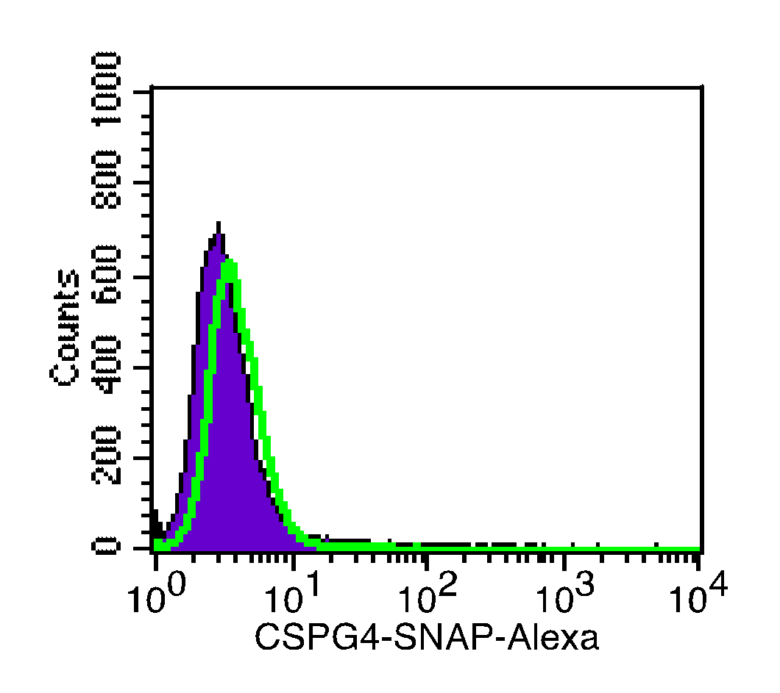

MFI

Events

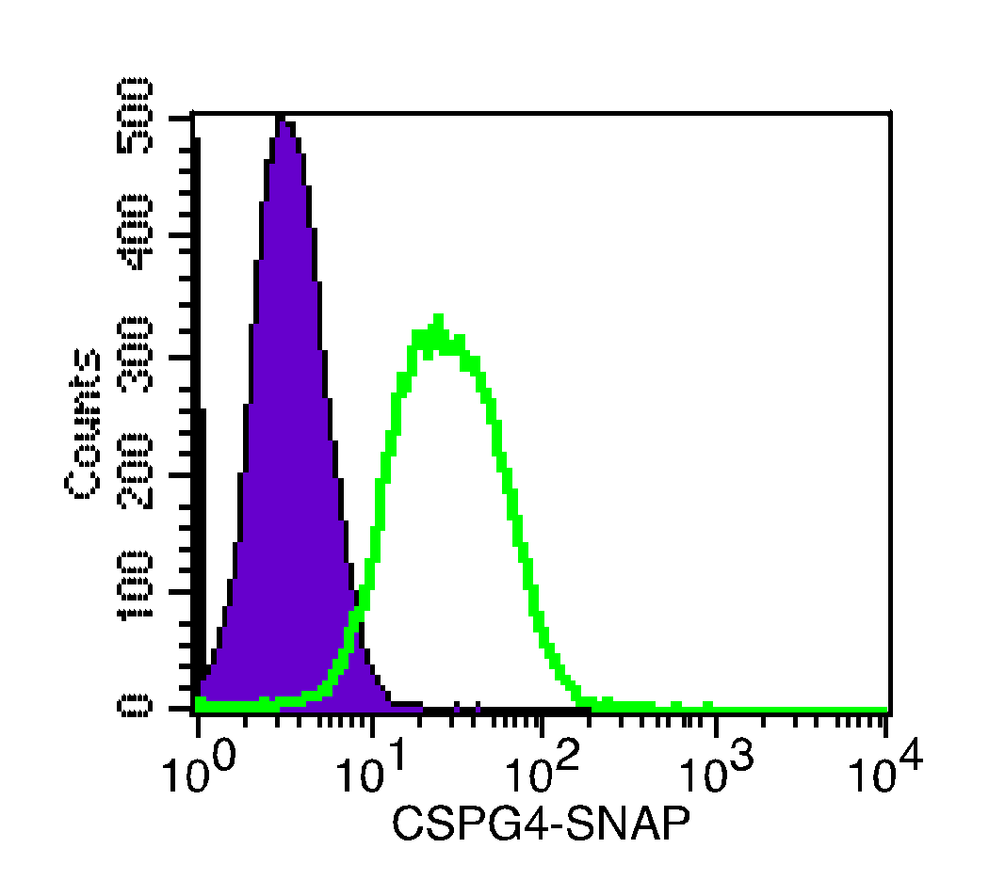

MFI

Events

A

B

**Fig. 3: Quantitative binding validation via flow cytometry.** A) CSPG4-positive SK-MEL-28 cell line. B) MDA-MB-468 negative control.

**Fig. 4: Qualitative binding validation via confocal microscopy.** A) CSPG4-positive SK-MEL-28 cell line. B) MDA-MB-468 negative control.

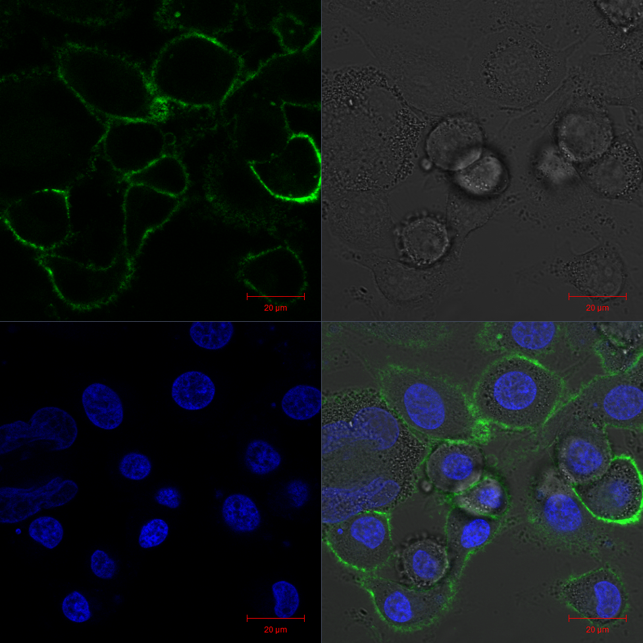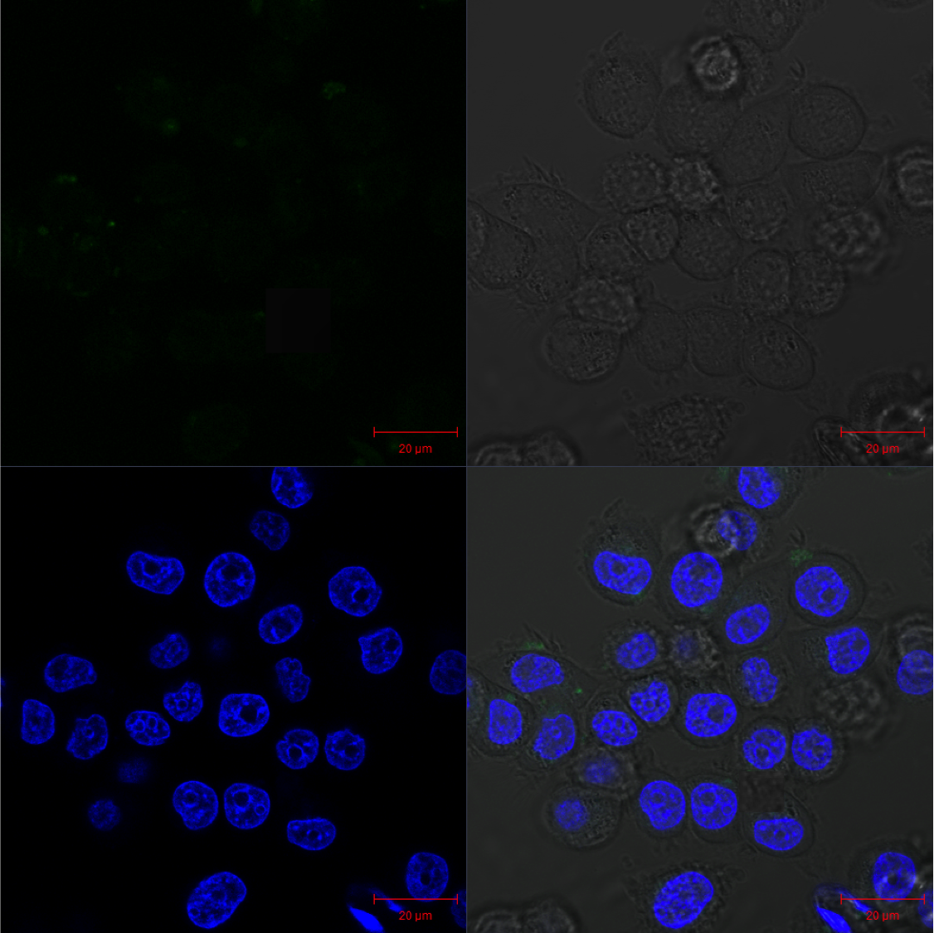

B

A

A

**5. Conclusion**

In summary, using SNAP-tag technology we were able to generate a next generation photoimmunotheranostic in the form of an rAb fusion protein. The conjugate shows retained functionality of the scFv binding region, with antigen-specific binding to CSPG4-positive melanoma cells. Further steps will include the development of a chemical conjugation model to create rAb-NP conjugates for targeted delivery of PSs in PDT for melanoma, internalisation and trafficking studies and assessment of cytotoxicity after PDT application.

**6. References**

1. Rutkowski P, Zdzienicki M, Nowecki ZI, van Akkooi ACJ. Surgery of primary melanomas. Cancers (Basel). 2010 Jun;2(2):824–41.

2. Lin A, Giuliano CJ, Palladino A, John KM, Abramowicz C, Yuan M lou, et al. Off-target toxicity is a common mechanism of action of cancer drugs undergoing clinical trials. Science Translational Medicine [Internet]. 2019 Sep 11 [cited 2022 Aug 5];11(509). Available from: https://www.science.org/doi/10.1126/scitranslmed.aaw8412

3. Yuan L, Mishra R, Patel H, Alanazi S, Wei X, Ma Z, et al. BRAF Mutant Melanoma Adjusts to BRAF/MEK Inhibitors via Dependence on Increased Antioxidant SOD2 and Increased Reactive Oxygen Species Levels. Cancers (Basel) [Internet]. 2020 Jun 23 [cited 2022 Aug 5];12(6):1661. Available from: https://www.mdpi.com/2072-6694/12/6/1661/htm

4. Amawi H, Sim HM, Tiwari AK, Ambudkar S v., Shukla S. ABC transporter-mediated multidrug-resistant cancer. Advances in Experimental Medicine and Biology [Internet]. 2019 [cited 2022 Aug 5];1141:549–80. Available from: https://link.springer.com/chapter/10.1007/978-981-13-7647-4_12

5. dos Santos AF, de Almeida DRQ, Terra LF, Baptista MS, Labriola L. Photodynamic therapy in cancer treatment - an update review. Journal of Cancer Metastasis and Treatment [Internet]. 2019 Mar 29 [cited 2022 Aug 5];5:25. Available from: https://jcmtjournal.com/article/view/3026

6. National Cancer Institute. Photodynamic Therapy to Treat Cancer [Internet]. 2021 [cited 2022 Aug 5]. Available from: https://www.cancer.gov/about-cancer/treatment/types/photodynamic-therapy

7. Castano AP, Demidova TN, Hamblin MR. Mechanisms in photodynamic therapy: Part three—Photosensitizer pharmacokinetics, biodistribution, tumor localization and modes of tumor destruction. Photodiagnosis Photodyn Ther [Internet]. 2005 Jun [cited 2022 Aug 5];2(2):91. Available from: /pmc/articles/PMC4108218/

8. Keppler A, Kindermann M, Gendreizig S, Pick H, Vogel H, Johnsson K. Labeling of fusion proteins of O6-alkylguanine-DNA alkyltransferase with small molecules in vivo and in vitro. Methods. 2004 Apr;32(4):437–44.

9. Kampmeier F, Ribbert M, Nachreiner T, Dembski S, Beaufils F, Brecht A, et al. Site-Specific, Covalent Labeling of Recombinant Antibody Fragments via Fusion to an Engineered Version of 6-O-Alkylguanine DNA Alkyltransferase. Bioconjugate Chemistry. 2009 May 20;20(5):1010–5.

10. Rodrigo G, Gruvegård M, van Alstine JM. Antibody Fragments and Their Purification by Protein L Affinity Chromatography. Antibodies [Internet]. 2015 Sep 11 [cited 2022 Aug 5];4(3):259–77. Available from: https://www.mdpi.com/2073-4468/4/3/259/htm

11. Oliveira S, van Dongen GAMS, Stigter-Van Walsum M, Roovers RC, Stam JC, Mali W, et al. Rapid visualization of human tumor xenografts through optical imaging with a near-infrared fluorescent anti-epidermal growth factor receptor nanobody. Molecular Imaging. 2012 Jan;11(1):33–46.

12. Puettmann C, Kolberg K, Hagen S, Schmies S, Fischer R, Naehring J, et al. A monoclonal antibody for the detection of SNAP/CLIP-tagged proteins. Immunology Letters. 2013 Feb;150(1–2):69–74.

13. Juillerat A, Gronemeyer T, Keppler A, Gendreizig S, Pick H, Vogel H, et al. Directed Evolution of O6-Alkylguanine-DNA Alkyltransferase for Efficient Labeling of Fusion Proteins with Small Molecules In Vivo. Chemistry & Biology. 2003 Apr 1;10(4):313–7.

14. Maruoka Y, Wakiyama H, Choyke PL, Kobayashi H. Near infrared photoimmunotherapy for cancers: A translational perspective. EBioMedicine. 2021 Aug 1;70:103501.

15. Price MA, Colvin Wanshura LE, Yang J, Carlson J, Xiang B, Li G, et al. CSPG4, a potential therapeutic target, facilitates malignant progression of melanoma. Pigment Cell & Melanoma Research. 2011 Dec;24(6):1148–57.

16. Ghosh A, Syed SM, Kumar M, Carpenter TJ, Teixeira JM, Houairia N, et al. In Vivo Cell Fate Tracing Provides No Evidence for Mesenchymal to Epithelial Transition in Adult Fallopian Tube and Uterus. Cell Reports. 2020 May 12;31(6):107631.

17. Kruger C, Abrahamse H. Utilisation of Targeted Nanoparticle Photosensitiser Drug Delivery Systems for the Enhancement of Photodynamic Therapy. Molecules. 2018 Oct 13;23(10):2628–49.

18. Mohanraj VJ, Chen Y. Nanoparticles – A Review. Tropical Journal of Pharmaceutical Research. 2006;5(1):561–73.

19. Zolnik BS, González-Fernández Á, Sadrieh N, Dobrovolskaia MA. Nanoparticles and the immune system. Endocrinology. 2010;151(2):458–65.

20. Lim CK, Heo J, Shin S, Jeong K, Seo YH, Jang WD, et al. Nanophotosensitizers toward advanced photodynamic therapy of Cancer. Cancer Letters. 2013;334:176–87.

21. Liu Y, Yang G, Jin S, Xu L, Zhao CX. Development of High-Drug-Loading Nanoparticles. Chempluschem. 2020 Sep 1;85(9):2143–57.

22. Mfouo-Tynga I, El-Hussein A, Abdel-Harith M, Abrahamse H. Photodynamic ability of silver nanoparticles in inducing cytotoxic effects in breast and lung cancer cell lines. International Journal of Nanomedicine. 2014 Aug 8;9(1):3771–80.

23. Nicol JR, Dixon D, Coulter JA. Gold nanoparticle surface functionalization: A necessary requirement in the development of novel nanotherapeutics. Nanomedicine. 2015 Apr 1;10(8):1315–26.

24. Kumar SSD, Houreld NN, Kroukamp EM, Abrahamse H. Cellular imaging and bactericidal mechanism of green-synthesized silver nanoparticles against human pathogenic bacteria. Journal of Photochemistry and Photobiology B: Biology. 2018 Jan 1;178:259–69.

25. Pradeep Chandran C, Mani Rahulan K, Ganesan S. Synthesis and study of photodynamic activity of silver nanoparticles. In: Photonics 2010: 10th International Conference on Fiber Optics & Photonics. 2010.

26. Erdogan O, Abbak M, Demirbolat GM, Birtekocak F, Aksel M, Pasa S, et al. Green synthesis of silver nanoparticles via Cynara scolymus leaf extracts: The characterization, anticancer potential with photodynamic therapy in MCF7 cells. PLOS ONE. 2019 Jun 1;14(6):e0216496–511.

27. Mohd-Zahid MH, Mohamud R, Che Abdullah CA, Lim J, Alem H, Wan Hanaffi WN, et al. Colorectal cancer stem cells: A review of targeted drug delivery by gold nanoparticles. RSC Advances. 2020;10(2):973–85.

28. Naidoo C, Kruger CA, Abrahamse H. Targeted photodynamic therapy treatment of in vitro A375 metastatic melanoma cells. Oncotarget. 2019;10(58):6079–95.

29. Crous A, Abrahamse H. Effective gold nanoparticle-antibody-mediated drug delivery for photodynamic therapy of lung cancer stem cells. International Journal of Molecular Sciences. 2020 Jun 1;21(11):3742–65.