Photobiomodulation at 660 nm reduces stress-induced apoptosis in diabetic wounded fibroblast cells in vitro
S W Jere and N N Houreld

Laser Research Centre, Faculty of Health Sciences, University of Johannesburg, P.O. Box 17011, Doornfontein, 2028 South Africa.
Tel: +27 11 559 6833; Fax: +27 11 559-6884

Email: sandyj@uj.ac.za / nhoureld@uj.ac.za

Abstract. Uncontrolled diabetes mellitus (DM) increases reactive oxygen species (ROS) and oxidative stress. Oxidative stress provokes apoptosis, a programmed cell death that typically sustains the developmental mechanism for normal body homeostasis. Oxidative damage affects the expression of pro-apoptotic proteins and anti-apoptotic proteins including caspases and B cell lymphoma 2 (Bcl 2). Uncontrolled apoptosis is one of the major causes for the development of chronic diabetic wounds. Photobiomodulation (PBM) involves exposing wounds to light from lasers or light emitting diodes (LEDs) to induce healing. However, its protective mechanisms and the ideal protocol on cellular apoptosis remain unclear. In this investigation, WS1 skin fibroblast cells were split into diabetic (D) and diabetic wounded (DW) cell models and were subjected to a continuous wave diode laser at a wavelength of 660 nm and a fluence of 5 J/cm². Non-treated cells (0 J/cm²) were used as controls. After irradiation, cells were incubated for 48 h and evaluated for viability and apoptosis. PBM at 660 nm significantly increased cellular viability and reduced apoptosis in both irradiated D and DW cells. This study suggests that PBM at 660 nm and 5 J/cm² increases cell viability and reduces apoptosis.
- Introduction
Reactive oxygen species (ROS) including hydroxyl radicals (OH·), superoxide anion (O₂⁻), and hydrogen peroxide (H₂O₂) are derivatives of aerobic metabolism, and have characteristic chemical properties that cause reactivity to cells and tissue. Research has related ROS to the development of oxidative stress, which stimulates pathological conditions by affecting proteins, lipids, and cellular DNA. Nevertheless, controlled ROS is critical for cellular signalling and the alteration of biological and physiological activities including growth and development [1]. In addition, regular ROS concentrations are key regulators of all the phases of wound healing process, fight against microbes, and activates cell survival signalling [2]. To ensure survival in the presence of increased ROS, the human body generates antioxidants, which prevent and slow ROS mediated injury. Two forms of antioxidants including enzymatic components, i.e. catalase (CAT), superoxide dismutase (SOD) and ascorbate peroxidase (APX), and non-enzymatic antioxidants, i.e. ascorbic acid (AA), glutathione (GSH), carotenoids, and flavonoids work together to scavenge ROS [3]. Oxidative stress comes about due to disproportional production of ROS and antioxidants, and over time, oxidative stress can contribute to diseases including atherosclerosis (hardening of the blood vessels), inflammation, high blood pressure (hypertension), heart disease, cancer, and neurodegenerative diseases [4].
DM (a group of metabolic diseases characterised by high blood sugar, also known as hyperglycemia) results from deficiencies in insulin action, secretion or both, and evidence shows that oxidative stress plays a major role in the development of DM complications [5]. Typically, hyperglycemia is associated with increased oxidative stress, and contributes to diminished insulin secretion and action [6]. Diabetic patients have diminished antioxidants, which further increase oxidative stress and development of chronic diabetic wounds [7]. Chronic diabetic wounds exhibit a significant influence on debility, ill health, and death, and the reduction of ROS levels and oxidative stress induced damage through antioxidative methods improves chronic diabetic wound healing [5,6]. In the progression of wound healing, apoptosis is essential in eradicating unwanted cells and advances the development of granulation tissue [8]. Apoptosis is a programmed cell death, enabling a well-coordinated development and removal of cells in wounded and infected tissue, and in DM excessive apoptosis is one of the factors that causes wound chronicity [9,10]. Typically, cellular apoptosis is characterised by morphological changes including shrinkage, condensation of chromatin, blebbing of the cell membrane, and formation of apoptotic bodies with no inflammation [8]. The cells programmed death is a multifaceted process that can either be induced by intracellular or extracellular apoptotic signalling in reaction to a stress, bringing about cell suicide. Cell suicide follows specific overlapping steps of stimulation, recognition, effectors, and elimination. In chronic diabetic wounds, oxidative stress decreases the appearance of antiapoptotic Bcl 2 proteins, and increases the appearance of proapoptotic Caspases, FS-7-associated surface antigen (FAS), and Bcl 2-associated X (BAX) proteins [7]. Caspases are critical players in cellular apoptosis, and all known caspases have three domains consisting of a small subunit, a large subunit, and an amino terminus. Caspase 3 effects and executes cell apoptosis by coordinating DNA degradation [11].
PBM is a process that is initiated by low-powered light from lasers or LEDs that interacts with chromophores present within the cells/tissue to stimulate or inhibit biological activities [12]. The clarification of the mechanism of PBM remains elusive. However, it is suggested that its effect is influenced by the fluence, power, wavelength and period of application. A range of photoreceptor proteins in the mitochondria and other cell partitions including cytochrome c oxidase absorb the light energy and convert it into photochemical energy resulting in increased adenosine triphosphate (ATP) production, protein synthesis and cell proliferation [13]. PBM has anesthetic, anti-inflammatory, and stimulatory effects in wound healing and tissue regeneration, and in chronic diabetic wounds reduces oxidative and nitrosative stress [12,14]. Ayuk et al., [15] noted an increase in cell viability and proliferation when normal, wounded, diabetic wounded, hypoxic wounded, and diabetic hypoxic wounded cells were irradiated at a wavelength of 660 nm with a fluence of 5 J/cm² in vitro. The aim of this study was to assess the effect of PBM at a wavelength of 660 nm and a fluence of 5 J/cm² on stress-induced apoptosis in diabetic wounded fibroblast cells in vitro.
- Methodology
American Type Culture Collection WS1 human skin fibroblast cells (ATCC®, CRL-1502™) were cultivated using standard culture procedures. Two models were used in the study, namely diabetic (D) and diabetic wounded (DW). An in vitro diabetic model was achieved by continuously cultivating WS1 cells in supplemented minimum essential medium (MEM) with a basal glucose concentration of 5.6 mM, with an additional of 17 mM D-glucose, totaling to 22.6 mM glucose concentration, thereby mimicking a hyperglycemic condition [16]. To perform experiments, cells (6 X 10⁵) were cultivated in 3.4 cm diameter tissue culture plates and incubated at 37°C in 5% CO₂ for attachment. After 24 h, a central scratch was performed 30 min pre-irradiation in the wounded cell model thereby creating a cell free zone adjoined by cells on both sides of the “wound” in the confluent monolayer [17]. Cell culture plates, with the lids off, were exposed to laser light from above in the dark. Table 1 shows the laser parameters used in this study. To treat cells with PBM, a 660 nm diode laser at an energy density (fluence) of 5 J/cm² was used, and after irradiation cells were incubated for 48 h. Cells were then analysed for viability using the trypan blue negative staining assay, apoptosis using the caspase-Glo® 3/7 assay (Promega, PRG8090) and beta (β-) catenin using Enzyme Immunosorbent Assay; ELISA (Whitehead Scientific, DYC1329-2). Non-irradiated cells were used as controls. All experiments were repeated three times (n=3), and for the Caspase-Glo® 3/7 and β-catenin assays tests were done in duplicate, and the average of which was used. SigmaPlot version 14 (Systat Software, Inc.) was used for statistical analysis. Statistical difference between groups was distinguished by using the Student t test. Analysis of variance (ANOVA) followed by Dunnett’s test was used to compare differences between D and DW cell models. Cohens d was used to determine the effect size. Results are shown as standard error of the mean (SEM) and statistical significance is shown in the graphs as *p<0.05 and **p<0.01.
Table 1. Laser parameters.
Light source | Diode laser
Wavelength (nm) | 660
Emission | Continuous wave
Power output (mW) | 101
Power density (mW/cm²) | 11
Spot size (cm²) | 9.1
Energy density (J/cm²) | 5
Irradiation time | 7 min 35 s
Energy (J) | 46

- Results
In this study, PBM at a wavelength of 660 nm with a fluence of 5 J/cm² significantly increased cellular viability in PBM treated DW cells (p<0.05) when compared to their control cells at 48 h (Figure 1). However, the increase in cell viability observed in PBM treated D cell models was not significant (p=0.07). When compared to untreated D cells, a significant decrease was noted in untreated DW cells (p<0.05), and a significant increase in PBM treated DW cells (p<0.05). Caspase-3/7 mediates the advancement of cell apoptosis, and in this study, there was a significant decrease in apoptosis in PBM treated DW cells (p<0.01) when compared to their control cells 48 h after irradiation (Figure 2). However, the decrease observed in PBM treated D cell models was not significant when compared to their untreated D cells (p=0.09). In the activated canonical Wnt/β-catenin pathway, the cytoplasmic accumulation and nuclear translocation of β-catenin regulates arrest cell apoptosis [18]. The total β-catenin using ELISA was done to confirm the effect of PBM on apoptosis in untreated and PBM treated cells (Figure 3). There was a significant increase of total β-catenin in PBM treated DW cells (p<0.01) when compared to their control cells 48 h after irradiation. However, the increase observed in PBM treated D cell models was not significant when compared to their untreated D cells (p=0.06).

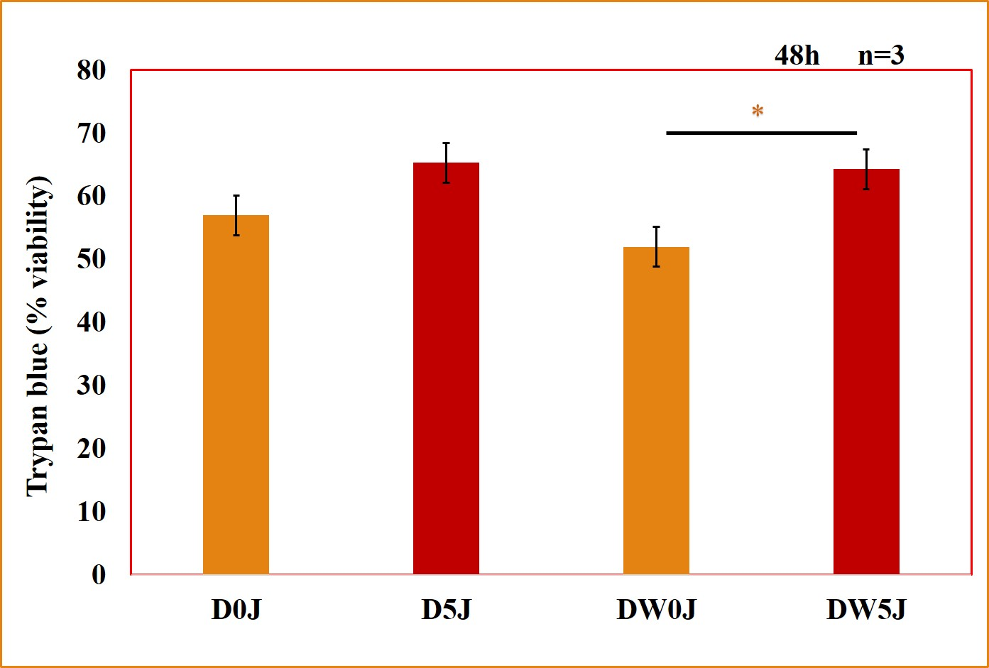
Figure 1. Cell viability was assessed by the trypan blue negative staining assay at 48 h in untreated (0 J/cm²) and photobiomodulation (PBM) treated (5 J/cm²) diabetic (D0J; D5J) and diabetic wounded (DW0J; DW5J) cells. Significant probability is shown as *P<0.05 ±SEM.

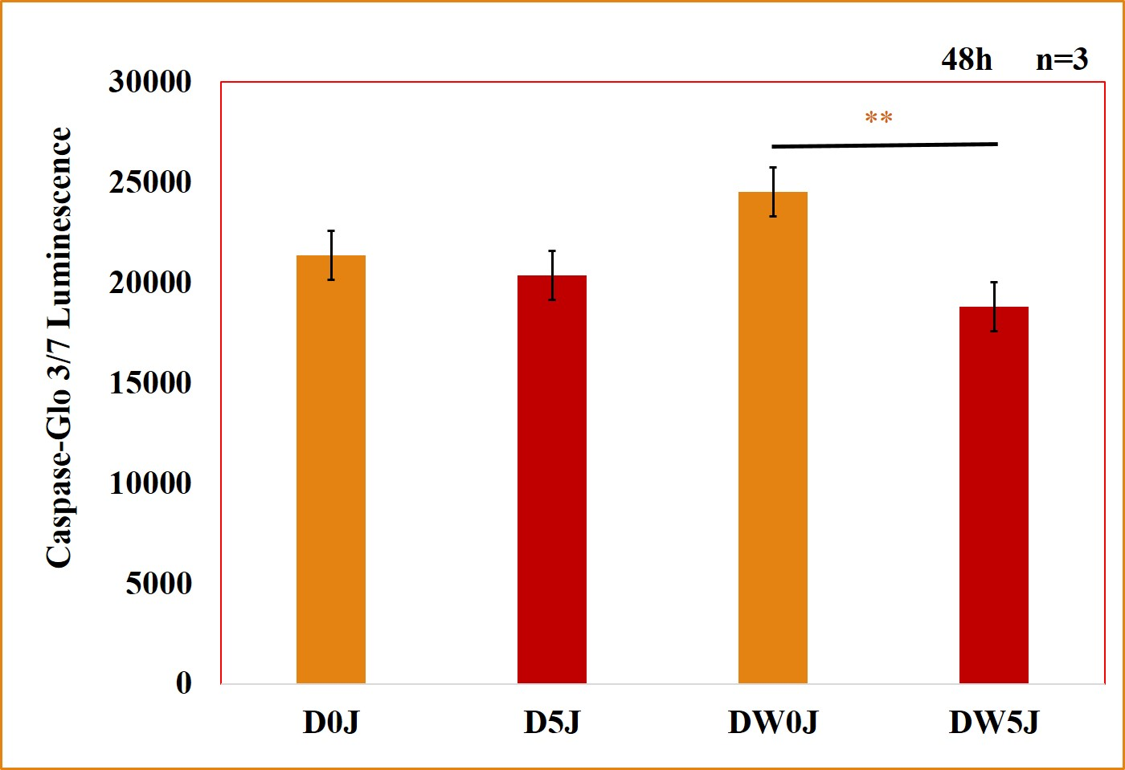

Figure 2. Cellular apoptosis using the Caspase-Glo® 3/7 assay was assessed at 48 h in untreated (0 J/cm²) and photobiomodulation (PBM) treated (5 J/cm²) diabetic (D0J; D5J) and diabetic wounded (DW0J; DW5J) cells. Significant probability is shown as **P<0.01 ±SEM.

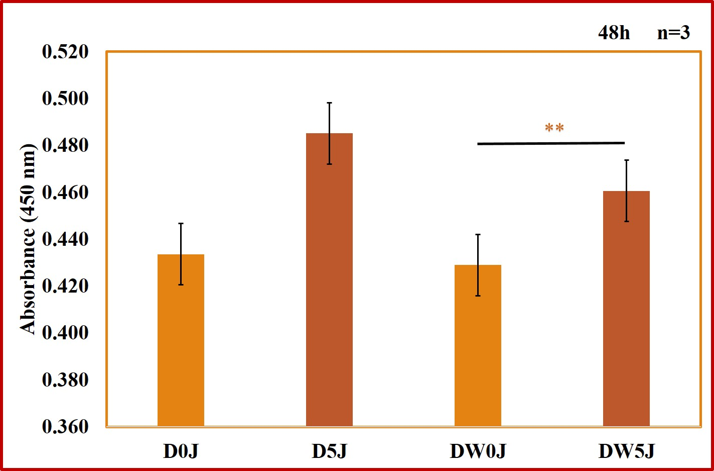

Figure 3. Beta (β-) catenin was determined by Enzyme Immunosorbent Assay (ELISA) 48 h post-photobiomodulation (PBM) in untreated (0 J/cm²) and PBM treated (5 J/cm²) diabetic (D0J; D5J) and diabetic wounded (DW0J; DW5J) cells. Significant probability is shown as **P<0.01 ±SEM.
- Discussion and Conclusion
Among key procedures for the physical development in humans is apoptosis. Defective apoptosis has been linked to a variety of diseases including DM and the development of chronic wounds. Hyperglycemia affects the mitochondrial electron transport chain, resulting in increased ROS and the creation of intracellular oxidative stress. The increased ROS production and creation of oxidative stress are crucial influencers of apoptosis and wound chronicity. DM is fast increasing in prevalence and results in considerable economic loss [19,20]. Chronic diabetic wounds and mitochondrial damage increases the release of pro-apoptotic caspases and membrane proteins of the death receptor family (BAX and FAS), and reduces the expression of anti-apoptotic Bcl 2 proteins, resulting in increased cellular apoptosis. Cytosolic caspase 3/7 plays a critical role in facilitating the progress of apoptosis, and the development of treatment methods that target cell apoptosis is critical in the management of chronic diabetic wounds [21].
PBM is a niche area of phototherapy and biophotonics. This treatment method possesses advantages over current treatment methods because of its simplicity to use, increased efficacy, and reduced cost, and its ability to reduce oxidative and nitrosative stress in chronic diabetic wounds [12,14]. Unclear protective mechanisms and treatment parameters makes the use of PBM and standardisation of protocols challenging for its application in chromic diabetic wound healing. In the present in vitro study, PBM at 660 nm with 5 J/cm² effectively regulated cellular viability and apoptosis in diabetic cells and diabetic cells that were wounded. There was an increase in cell viability in both wounded and non-wounded PBM treated diabetic cells. Diabetic wounded cells are more stressed, and comparing cell viability of diabetic wounded control cells to less stressed diabetic control cells revealed a significant reduction in viability, indicating the effect of high sugar concentration and wounding on cell viability. However, when diabetic wounded cells were irradiated at 660 nm there was a significant increase in viability compared to non-treated diabetic cells, indicating a positive effect of PBM on cell viability in diabetic wounded cells. This observation was confirmed when diabetic wounded PBM treated cells were compared to PBM treated diabetic cells that revealed no significant difference. However, the trypan blue negative staining assay for cell viability has a limitation that during reading lightly stained cells may be difficult to distinguish from unstained cells. When cellular apoptosis was analysed, there was a significant reduction in apoptosis in both diabetic and diabetic wounded PBM treated cells when compared to their control cells. In all these findings, the effect size using cohens d was moderate, indicating that at 660 nm with 5 J/cm², PBM may have a moderate effect on diabetic wound healing by increasing cellular viability and reducing cellular apoptosis, a possible molecular mechanism of PBM in quickening diabetic wound healing in vivo. These findings signify an effectual therapeutic approach for quickened healing of chronic diabetic wounds. Nevertheless, further studies including clinical, are needed to find out more about the effect of PBM at 660 nm with 5 J/cm² on cellular phenotypic variations at a molecular level.
Acknowledgements
This work was supported by the South African Research Chairs Initiative of the Department of Science and Technology and National Research Foundation of South Africa (Grant No 98337), as well as grants received from the University of Johannesburg (URC), the National Research Foundation (NRF; Grant No 129327), and the Council for Scientific and Industrial Research (CSIR)-National Laser Centre (NLC) Laser Rental Pool Program.
References

[1] Schieber M and Chandel N S 2014 CB. 24 453–62.
[2] Cano Sanchez M, Lancel S, Boulanger E, Neviere R 2018 Antioxidants (Basel) 7 98. doi: 10.3390/antiox7080098.
[3] Das K and Roychoudhury A 2014 Front. Environ. Sci. https://doi.org/10.3389/fenvs.2014.00053.
[4] Migdal C and Serres M 2011 Med Sci (Paris). 27 405-12.
[5] Lazo-de-la-Vega-Monroy M and Fernández-Mejía C 2013 IntechOpen. https://doi.org/10.5772/51788.
[6] Tangvarasittichai S 2015 World J Diabetes 6 456-80.
[7] Deng L, Du C, Song P, Chen T, Rui S, Armstrong D G and Deng W 2021 Oxid. Med. Cell. Longev. 2021 8852759. https://doi.org/10.1155/2021/8852759.
[8] Riwaldt S, Corydon TJ, Pantalone D, Sahana J, Wise P, Wehland M, Krüger M, Melnik D, Kopp S, Infanger M, Grimm D 2021 Front. Bioeng. Biotechnol. https://doi.org/10.3389/fbioe.2021.679650.
[9] Bhan S, Mitra R, Arya AK, Pandey HP, Tripathi K 2013 Dermatol 739054. doi: 10.1155/2013/739054.
[10] Arya AK, Tripathi R, Kumar S, Tripathi K. 2014 World J Diabetes. 5 756-762.
[11] Liang Y, Yang C, Lin Y, Parviz Y, Sun K, Wang W, Ren M, Yan L 2019 Apoptosis 24, 542-551.
[12] Rajendran NK, Houreld NN, Abrahamse H 2021 J Cell Commun Signal. 2 195-206.
[13] Salvatore P, Karu T. 2014 J. Photochem. Photobiol. B, Biol. 140 344-58.
[14] Chittoria RK, Kumar SH 2018 In: Shiffman, M., Low, M. (eds) Chronic Wounds, Wound Dressings and Wound Healing. Recent Clinical Techniques, Results, and Research in Wounds 6. Springer, Cham. https://doi.org/10.1007/15695_2017_89.
[15] Ayuk SM, Houreld NN, Abrahamse H 2018 Lasers Med Sci. 33 1085-1093.
[16] Houreld NN, Masha RT Abrahamse H (2012) Lasers Surg. Med. 44 429-434
[17] Ayuk SM, Houreld NN, Abrahamse H 2012 Diabetes Technol. Ther. 14 1110-1117.
[18] Trejo-Solis C, Escamilla-Ramirez A, Jimenez-Farfan D, Castillo-Rodriguez RA, Flores-Najera A, Cruz-Salgado A. 2021 Pharmaceuticals. 871. https://doi.org/10.3390/ph14090871.
[19] Maiese K 2015 Med. Cell. Longev. 2015 875961. https://doi.org/10.1155/2015/875961.
[20] Mehrvar S, Rymut KT, Foomani FH, Mostaghimi S, Eells JT, Ranji M, Gopalakrishnan S. 2019 IEEE J Transl Eng Health Med. 7 1800809. doi: 10.1109/JTEHM.2019.2945323.
[21] Liu Y, Liu Y, Junyu J, Li W, Nie X 2021 Front. Endocrinol. 12 744868. https://doi.org/10.3389/fendo.2021.744868.

