The characterization and crystallization of the TBR1 T-box domain in the presence and absence of the T-box Binding Element

Riyaadh Mayet¹, Sylvia Fanucchi²

¹ University of the Witwatersrand, 1 Jan Smuts Ave, Braamfontein, Johannesburg, 2000
² University of the Witwatersrand, 1 Jan Smuts Ave, Braamfontein, Johannesburg, 2000
Corresponding author e-mail address: riyaadh.mayet@students.wits.ac.za
1. Introduction
TBR1 is a neuron-specific transcription factor expressed during embryonic development. TBR1 is involved in multiple aspects of cortical development, such as the differentiation and migration of neurons and has recently emerged as a master regulator of genes implicated in Autism Spectrum Disorder (ASD) [1]. It is thus possible that aberrant molecular interactions with TBR1 could underlie the altered neuro-molecular networks observed in Autism.

TBR1 belongs to the T-box family of transcription factors, which are defined by an evolutionarily conserved DNA-binding domain of immunoglobulin fold, known as the T-box domain, which is both necessary and sufficient for sequence specific DNA-binding [2]. All T-box family members bind to a seven base-pair long DNA consensus sequence TCACACCT, known as the T-box Binding element [2].

Currently there is no solved structure available of the TBR1 TBOX domain and so a crystal structure would be highly desirable. In this study, we therefore aim to obtain crystal structures of the TBR1 T-box domain in both the presence and absence of the T-box binding element, with the hope of elucidating its DNA-binding mechanism. The structure may be solved by molecular replacement using TBX21. This will shed more light on how TBR1 regulates ASD-related genes and could explain how aberrant molecular interactions influence neurodevelopmental disorders.

The TBR1 T-box domain has been overexpressed and successfully purified using immobilized metal-ion affinity chromatography followed by size exclusion chromatography. Preliminary structural characterization has been made by monitoring intrinsic tryptophan fluorescence in the presence and absence of 6 M guanidine hydrochloride, as well as in the presence and absence of the T-box Binding element and it has revealed that the protein is properly folded. The DNA-binding function has been confirmed using an electrophoretic mobility shift assay. The DNA-binding properties were quantitatively assessed using fluorescence anisotropy in the presence of the T-box Binding Element and revealed a dissociation constant of 320 nM. Since the TBR1 T-box has been successfully characterized, it is ready for crystal trials.

2. Results
The TBR1 T-box has been successfully purified by size exclusion chromatography as shown in Fig. 1 below. The T-box domain exists predominantly as a monomer (26 kDa) but can also dimerize (53 kDa), particularly under oxidizing conditions. Preliminary structural characterization using fluorescence spectroscopy has shown the TBOX domain to be structurally intact both in the presence and absence of DNA and electrophoretic mobility shift assays confirmed that the protein is functional as it displayed sequence specific binding to the TBE. The protein is now ready for crystal trials both in the presence and absence of DNA.
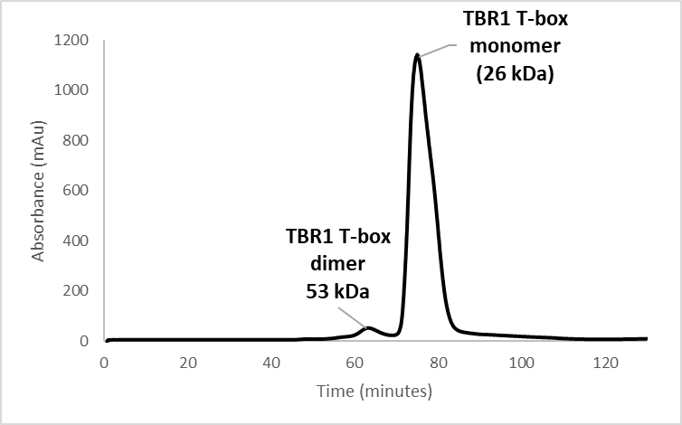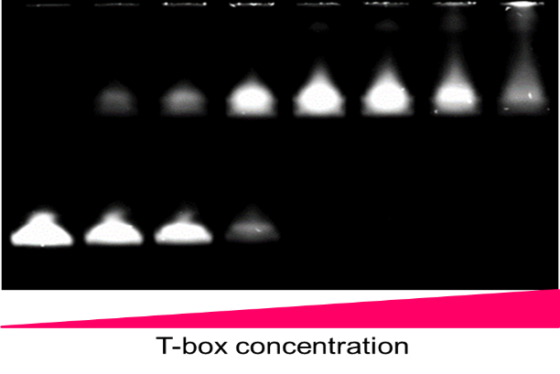
Fig. 1: Elution profile from size exclusion chromatography showing successful purification.

Fig. 2: Electrophoretic mobility shift assay of the TBR1 T-box showing successful binding to the TBE.

3. References
[1] Deriziotis, P., O’Roak, B.J., Graham, S.A., Estruch, S.B., Dimitropoulou, D., Bernier, R.A., Gerdts, J., Shendure, J., Eichler, E.E., Fisher, S.E. Nature Communication 5, (2014) 4954.
[2] Wilson, V., Conlon, F.L. The T-box family. Genome Biology 3 (2002).

