Investigating single-beam CARS for microscopy applications

Ruan Viljoen¹, Erich Rohwer¹ and Pieter Neethling¹

¹ Laser Research Institute, Stellenbosch University, Stellenbosch, South Africa
Corresponding author e-mail address: pietern@sun.ac.za

1. Introduction
Coherent anti-Stokes Raman Scattering (CARS) has been shown to be a useful non-linear optical process for chemical imaging in biological systems [1]. CARS allows for chemically specific imaging where chosen molecular vibrations are stimulated to emit light which can then be measured. A typical CARS setup uses expensive lasers, with a complex experimental geometry, to drive the four-wave mixing process efficiently. This is prohibitive in adapting CARS as a non-linear microscopy of choice. The setup can however be reduced in complexity and cost by retrofitting a femtosecond oscillator for single-beam CARS (SB-CARS) using an appropriate PCF and implementing the pulse characterisation and compression technique i²PIE, which was developed by our group [2].

An 80 MHz fs-laser oscillator was used to pump a polarization-maintaining all-normal dispersion photonic crystal fiber (PM-ANDi-PCF) to produce broadband supercontinuum pulses. Broadband pulses enable simultaneous probing of a broad range of vibrational frequencies, eliminating the need of multiple lasers. The PCF produces stable supercontinuum pulses which are stretched in time, due to dispersion in the PCF, which need to be compressed at the sample plane, for effective use during the CARS process. A spatial light modulator (SLM) in a 4f-shaper geometry can be used to characterize and compress the pulses by utilising a temporal ptychographic reconstruction algorithm, i²PIE. Supercontinuum pulses, in the NIR, delivered to the sample plan have low pulse energy (0.69 nJ per pulse) which allow for non-invasive probing of biological samples.

An initial spectroscopic study was performed to establish a feasible SB-CARS strategy capable of targeting chosen Raman vibrations with an adequate signal-to-background for microscopy applications. The capabilities of the SLM allow for the shaping of the supercontinuum polarization and spectral phase. Porting the principles of spectral focusing to SB-CARS by using an SLM, allows for the targeting of chosen Raman transitions [3]. In our implementation, measurements are taken in an orthogonal polarization relative to the excitation source which localises the generated SB-CARS spectrum and allows for rejection of unwanted non-resonant background signal.

2. Results
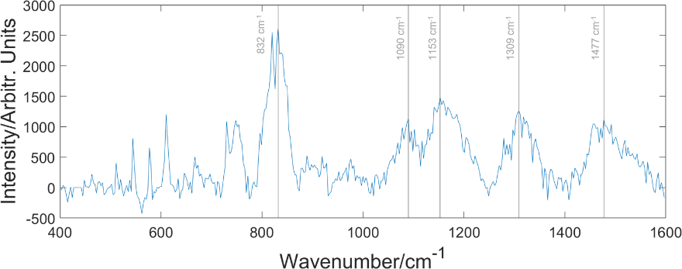
A target scanning measurement was performed on olive oil, as a proxy for biologically relevant lipid molecules, and characteristic transitions were identified and presented in Fig. 1. Such a scanning measurement is performed by targeting transitions over a chosen range and integrating the measured spectrum for each targeted transition.
Fig. 1: SB-CARS spectral measurement of olive oil using spectral focusing and polarization shaping of the excitation spectrum. Prominent transitions identified here are the c-c stretching vibrational modes at 832 cm⁻¹, 1090 cm⁻¹ and 1153 cm⁻¹, identified from [4].

The spectroscopic measurement of olive oil shows that the spectral focusing approach is capable of isolating chosen Raman transitions, as is evident from the labelled peaks assigned according to [4]. With this capability one should be able to isolate and image fatty acids and biologically relevant lipids contained within a biological sample using our approach to spectral focusing SB-CARS combined with i²PIE pulse compression.

3. References
1. C. L. Evans and X. S. Xie, "Coherent anti-Stokes Raman scattering microscopy: Chemical imaging for biology and medicine," Annu. Rev. Anal. Chem. 1, 883–909 (2008).
2. D.-M. Spangenberg, E. Rohwer, M. Brügmann, and T. Feurer, "Extending time-domain ptychography to generalized phase-only transfer functions," Opt. Lett. 45, 300 (2020).
3. L. Brückner, T. Buckup, and M. Motzkus, "Exploring the potential of tailored spectral focusing," J. Opt. Soc. Am. B 33, 1482 (2016).
4. R. M. El-Abassy, P. Donfack, and A. Materny, "Visible Raman spectroscopy for the discrimination of olive oils from different vegetable oils and the detection of adulteration," J. Raman Spectrosc. 40, 1284–1289 (2009).

