Applications of machine learning techniques to the description of quantum coherent excitation energy transfer within the dimer model

Kimara Naicker¹, Ilya Sinayskiy¹, Francesco Petruccione^{1, 2, 3}

¹ Quantum Research Group, School of Chemistry and Physics, University of KwaZulu-Natal, Durban, KwaZulu-Natal, 4001, South Africa
² National Institute for Theoretical Physics (NITheP), KwaZulu-Natal, 4001, South Africa
³ School of Electrical Engineering, KAIST, Daejeon, 34141, Republic of Korea
Corresponding author e-mail address: kimaranaicker@gmail.com

1. Introduction

During the first step of photosynthesis in light harvesting complexes, energy is absorbed by the antenna pigments and subsequently transferred to the reaction center in which photochemical reactions are triggered. This process can be modeled by excitation energy transfer (EET) from an initially excited pigment to a target pigment. One of the possible explanations for the EET in light harvesting systems is the quantum mechanical nature of the transfer process. The way energy is migrated between pigments is in a wavelike manner so that it samples multiple pigments at once. The energy of the absorbed sunlight simultaneously travels along all possible paths to the reaction centre by exploiting quantum superposition. Explanations for observed long-lived quantum coherences have evolved over the past decade. While electronic coherence was first proposed as the source^{[1]}, experimental and theoretical evidence has also supported proposals that the phenomenon resulted from vibronic (electronic–vibrational mixed) coherence^{[2]}.

Understanding the relationship between the structure of these light harvesting complexes and their excitation energy transfer dynamics is of importance in many applications. Insight into long-lived quantum coherence in EET processes can be gained through the reduced equation of motion. Typical situations in photosynthetic EET are such that the electronic coupling strengths, between chromophores and their local environment phonons, span a similar range as the reorganization energies, which characterize the time scale of the coupled phonons relaxing to their respective equilibrium states. The numerically exact formalism of quantum dynamics adopted to study EET processes in the above mentioned non-Markovian regime is the Hierarchical Equations of Motion (HEOM) derived by Ishizaki and Fleming^{[3]}.

However, solving these equations is computationally costly due to the adverse scaling with the number of pigments. In the current research, we develop a scalable and efficient tool for the description of the dynamical and thermodynamical properties of open quantum systems by use of a trained convolutional neural network (CNN) as a representation of the HEOM. A GPU is used to explicitly solve the HEOM to generate training and testing datasets for supervised machine learning tasks where elements of reduced density matrices are translated into features for the model and corresponding excited state energies and electronic couplings are used as labels. We will discuss the investigation of simplest electronic energy transfer system, the spin-boson-type model, where our predictions of the parameters for the Frenkel Hamiltonian are gauged by mean square error and accuracy measures.

2. Results
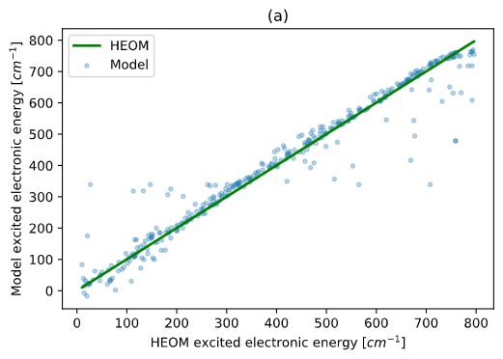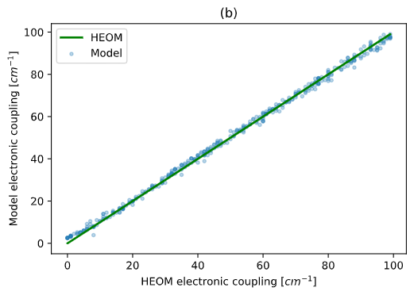
Fig. 1: (a) Excited electronic energy and (b) electronic coupling as computed with the HEOM approach compared to prediction from CNN model. The green line indicates perfect agreement between HEOM results and predictions by the model.

3. References

[1] G. Engel, T. Calhoun, E. Read et al. Nature 446 (2007) 782–786
[2] Fuller, F. D. et al. Nat. Chem. 6 (2014) 706–711
[3] A. Ishizaki and G. R. Fleming. J. Chem. Phys. 130 (2009) 234111

