SINGLE CRYSTAL X-RAY DIFFRACTION CRYSTALLOGRAPHY IN STRUCTURE CHARACTERIZATION OF COORDINATION COMPLEXES

Eunice Nyawade¹, Holger Friedrich² and B. Omondi²,
¹ Jomo Kenyatta University of Agriculture and Technology, Po.O Box 62000-00200, Nairobi, Kenya
²University of KwaZulu Natal, Westville
Corresponding author e-mail address: enyawade@jkuat.ac.ke

Abstract

Coordination complexes find a wide range of applications in nature as biocatalysts; in industry as catalysts for many organic syntheses; and in medicine for tumor diagnosis and therapy, and antimicrobial agents. There is therefore great interest in research on ruthenium metal coordination complexes and their possible application in the mentioned area and more. Although synthesized coordination complexes can be characterized by a series of techniques such as FTIR, ¹H and ¹³C NMR, mass spectrometry, elemental analysis, melting point and thermal analysis, Single-crystal X-ray Diffraction technique is very useful in confirming their synthesis and purity. Single-crystal X-ray Diffraction, a straight forward non-destructive technique, has been used to directly visualize the precise and detailed structural information of coordination complexes. A review on the Single-crystal X-ray Diffraction data reported for a series of η⁵-cyclopentadienylruthenium(II) complex salts will be presented at the ePCCr conference. Some of the ruthenium(II) complex salts include [{(η⁵-C₅H₅)Ru(CO)₂}₂I]BF₄, [CpRu(CO)₂NH₂R]⁺BF₄⁻ (Cp = η⁵-C₅H₅ (R = CH₃, C₂H₅, C₃H₇, C₄H₉, C₅H₁₁ and C₆H₁₃), [Cp*Ru(CO)₂NH₂(CH₂)_{n}CH₃]BF₄ (Cp* = η⁵-C₅(CH₃)₅; n = 0, 1, 2, 3 and 4), [Rp₂NH₂(CH₂)_{n}NH₂]Y₂ (Rp = CpRu(CO)₂ where Cp = η⁵-C₅H₅; n = 2, 3, 4 and 6; Y = BF₄ or SO₃CF₃) and [CpRu(CO)₂NH₂R]BF₄ (Cp = η⁵-C₅H₅; R = C₆H₁₁, C₆H₅, CH₂C₆H₅, CH(CH₃)C₆H₅, CH₂C₆H₄OCH₃, CH₂C₆H₄CN, C₆H₂(CH₃)₃), CH₂CHCH₂ and CH(CH₃)₂).

Graphical abstract

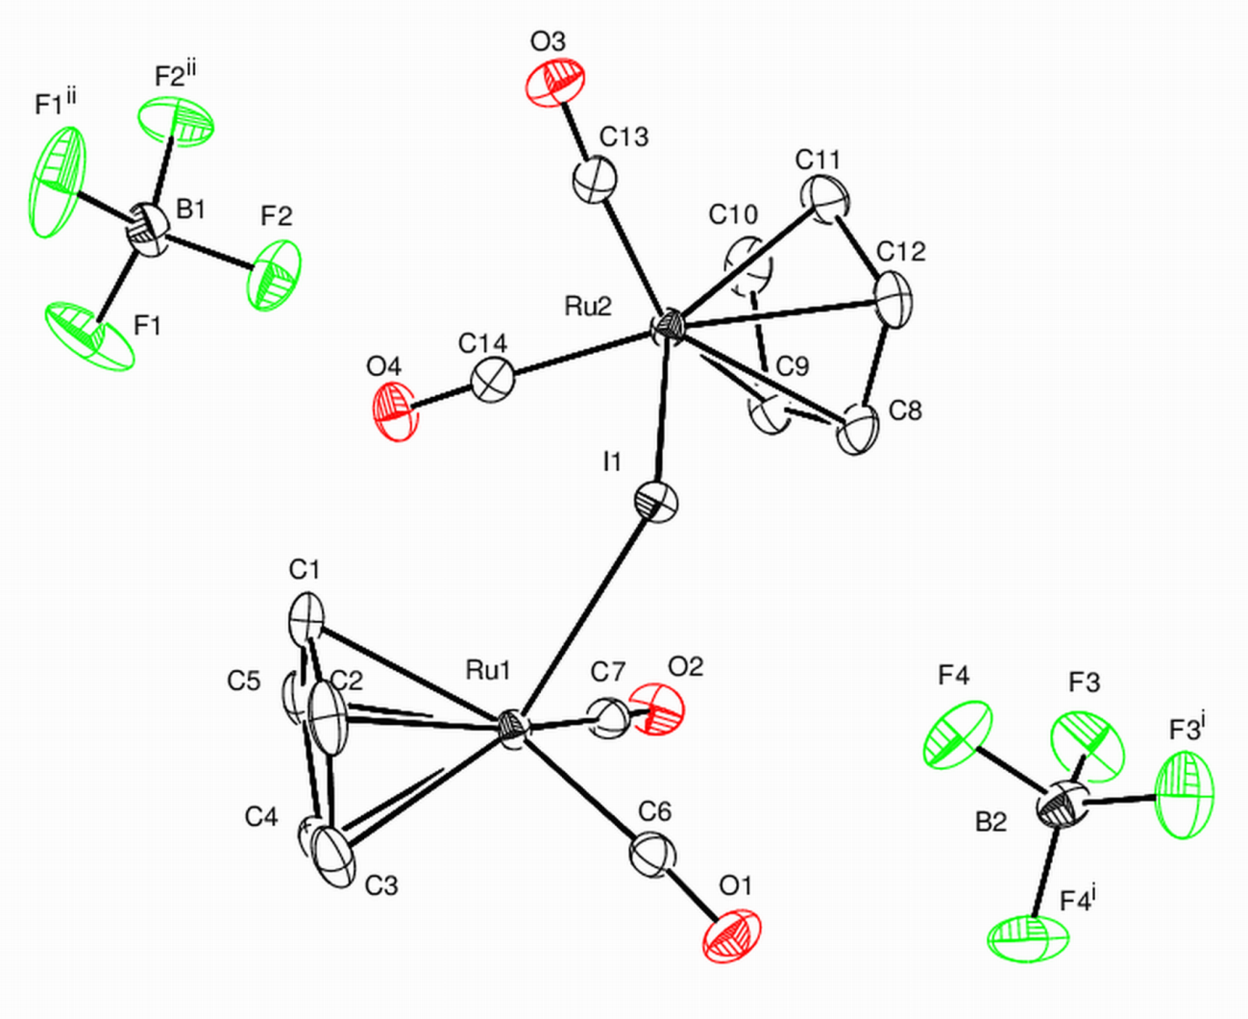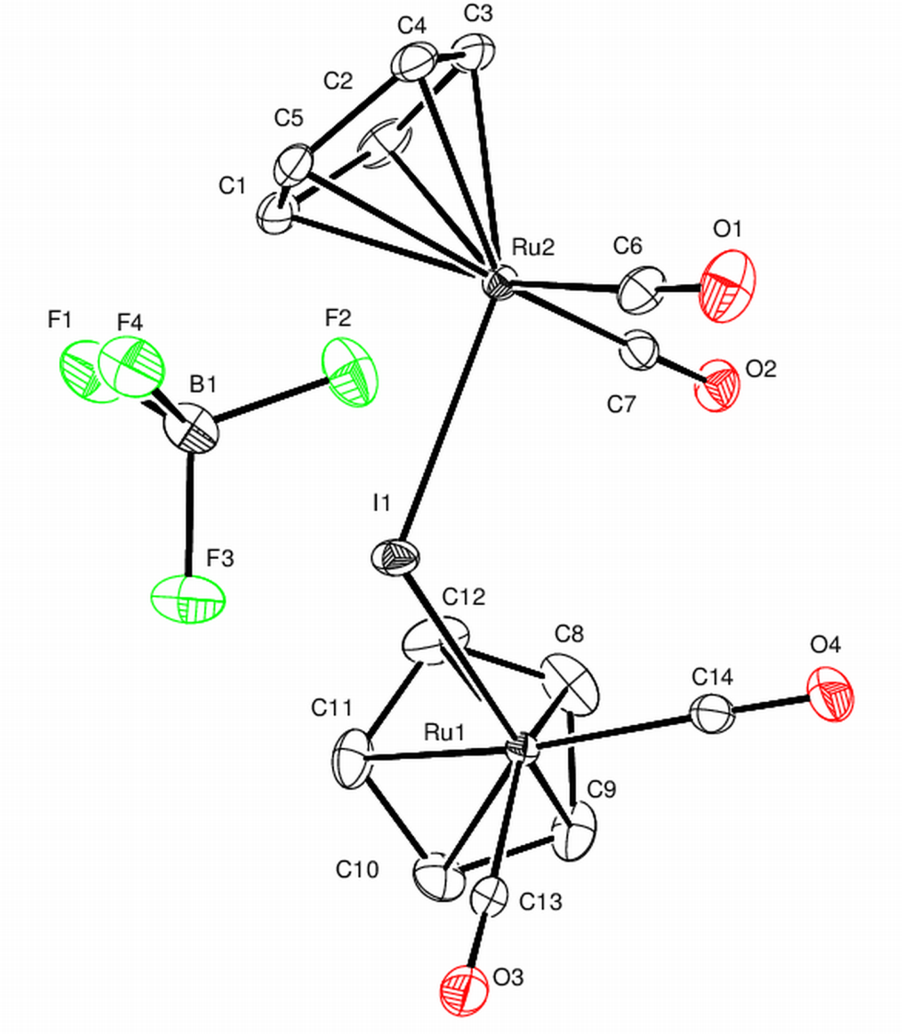
Molecular structures of two polymorphs of ruthenium(I)tetracarbonylbis(η⁵-cyclopentadienyl)-µ-iodido tetrafluoroborate showing the atomic numbering scheme. Displacement ellipsoids are drawn at the 50% probability level and H atoms are not shown

References
- L. Ke, Z. Zi-Zhuo, B. Hua-Ben, H. Xiao-Juan, W. Jin-Quan. Frontiers in Pharmacology, Vol 9 (2018) pp 1323
- P. Aguirre, R. Sariego & S. A. Moya (2001) J. Coord. Chem. 54:3-4, 401- 413
- L. Zeng, P. Gupta, Y. Chen, E. Wang, L. Ji, Hui Chao, and Z. Chen. Chem Soc Rev. 2017 Oct 2; 46(19): 5771–5804.
- E. A. Nyawade, H.B. Friedrich, B. Omondi,H. Y. Chenia, M. Singh and S. Gorle. J. Organomet. Chem. 799-800 (2015) 138-146
- E. A. Nyawade, H.B. Friedrich, B. Omondi and P. Mpungose. Organometallics, 34(20), (2015) 4922 – 4931
- E. A. Nyawade, H.B. Friedrich, B. Omondi. Inorganica Chimica Acta 44 (2016) 9-14

