**DO IONIC CHARACTERS HAVE AN IMPACT ON THE QUALITY OF MOLECULAR ORGANIC CRYSTALS?**

**Oluwatoyin Akerele1, Catharine Esterhuysen,2 Delia Haynes3**

Stellenbosch University, Western cape, South Africa

[oa@sun.ac.za](mailto:oa@sun.ac.za)

The importance of organic crystals in drug development, technology advancement, and the development of materials owing to their unique properties cannot be over-emphasized. But growing good-quality crystals has been a challenge, particularly since the invention of X-ray crystallography due to the complexity that surrounds crystal formation. Synthetic chemists often have an intuitive feeling that if they use a particular molecule as a co-crystallising agent during the crystallisation process, they will get good crystals. In fact, Etter *et al.* state in their paper on crystal growth strategies for molecular crystals1 that inorganic salts with charged ions grow larger and higher quality crystals than neutral organic molecules. Similarly, there is an expectation that salts of organic compounds will give better crystals than their neutral counterparts.In this project, we investigate multi-component crystals (salts and co-crystals) to assess the link (if any) between the ionic characters of the components and the quality of crystals obtained experimentally.

The study reveals that the interaction energies between components in salts are greater than co-crystals, suggesting that salts are more stable than co-crystals. A similar observation was obtained for the lattice energies, the free energy of interactions, electrostatic nature, polarisation energy, and the strengths of hydrogen bond donor and hydrogen bond acceptor, which means the presence of ionic components makes these interactions stronger and thereby stabilise the multi-component crystals. However, the strength of these interactions in salts does not automatically translate into a good-quality crystal, as we observed both good and poor-quality crystals of salts and co-crystals. The mosaicity, which is an indication of a crystal’s quality, is used to classify crystals according to quality. The lattice energy, which is often used to predict the stability of crystal structure, does not correlate with the quality of crystals obtained experimentally either. So, the quality of crystals is not necessarily associated with the strength of interactions in salts or the ionic nature of the components of salts but rather a combination of different factors.

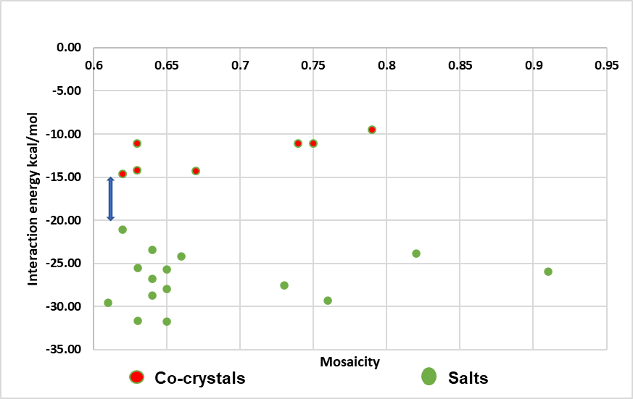

Figure 1: Interaction energy in solvent phase vs mosaicity

1. Etter, M.C., Jahn, D. A., and Donahue, B.S. 1986. *J. Cryst. Growth,* 76, 645-65