The role of electrostatic interactions in maintaining three-dimensional networks in hybrid compounds based on nitrogen bases

Rim Benali-Cherif¹, Radhwane Takouachet¹, Nourredine Benali-Cherif²

¹ Laboratoire des Structures, Propriétés et Interactions Interatomiques, Université Abbes Laghrour-Khenchela, Khenchela, 40000, Algeria
²Académie Algérienne des Sciences et de la Technologie (AAST) Algiers. Algeria
Corresponding author e-mail address: rym_46@hotmail.com

1. Introduction

Nucleobases are key structure directing agents due to their rich and diverse combination of hydrogen bond donor and acceptor positions. Their propensity to self-assemble through hydrogen-bonding interactions has led to a plethora of supramolecular structures. As a significant nucleobase of DNA, adenine is an important naturally occurring nitrogen heterocycle present in nucleic acids. Owing to its unique biological activity and multiple supramolecular interaction, adenine has been extensively studied in varieties of fields such as pharmacology [1] optoelectronics [2] and photovoltaic [3]. The different properties mentioned above are fundamentally correlated to the structural organizations and to the various intermolecular interactions that govern them

2. Results

The two adeninium based organic-inorganic hybrid compounds: adeninium hydrogen diselenite (I) and adeninium hydrogen selenite (II): were characterized by single- crystal XRD studies, and a well detailed structural study was illustrated.

The inspection of hydrogen bonding network in both compounds shows a direct hydrogen-bond interactions between the adeninium cations and the hydrogen (diselenite/selenite) anions. Furthermore, supramolecular homo and hetero-synthons found in (I) and (II) play an important role in shaping these supramolecular compounds. Moreover, the structural investigation shows that the 1H,9H-adeninium in both crystal structures generate cationic ribbons. In addition to the N—H ···N and C—H ···N hydrogen bonds connecting the purine bases in (I) and (II), weak stacking interactions are observed between the aromatic rings of the adeninium base in both compounds. The stacking of organic cations is stabilized in the crystal packing of (I) and (II) by the ionic bridges with the surrounding anions; indeed, anions play an important role in maintaining the three-dimensional network through hydrogen bonds and electrostatic charge-charge interactions. In (I) the anions exercise their role in solo while in (II) they do it as hexamers. Further, the connectivity between these hexamers in (II) generates a three-dimensional honeycomb-like inorganic framework. This effect should be considered as important in crystal engineering. There is an interesting electrostatic association, seen only in compound (I), between the SeOH oxygen electron lone pairs and the aromatic cation.

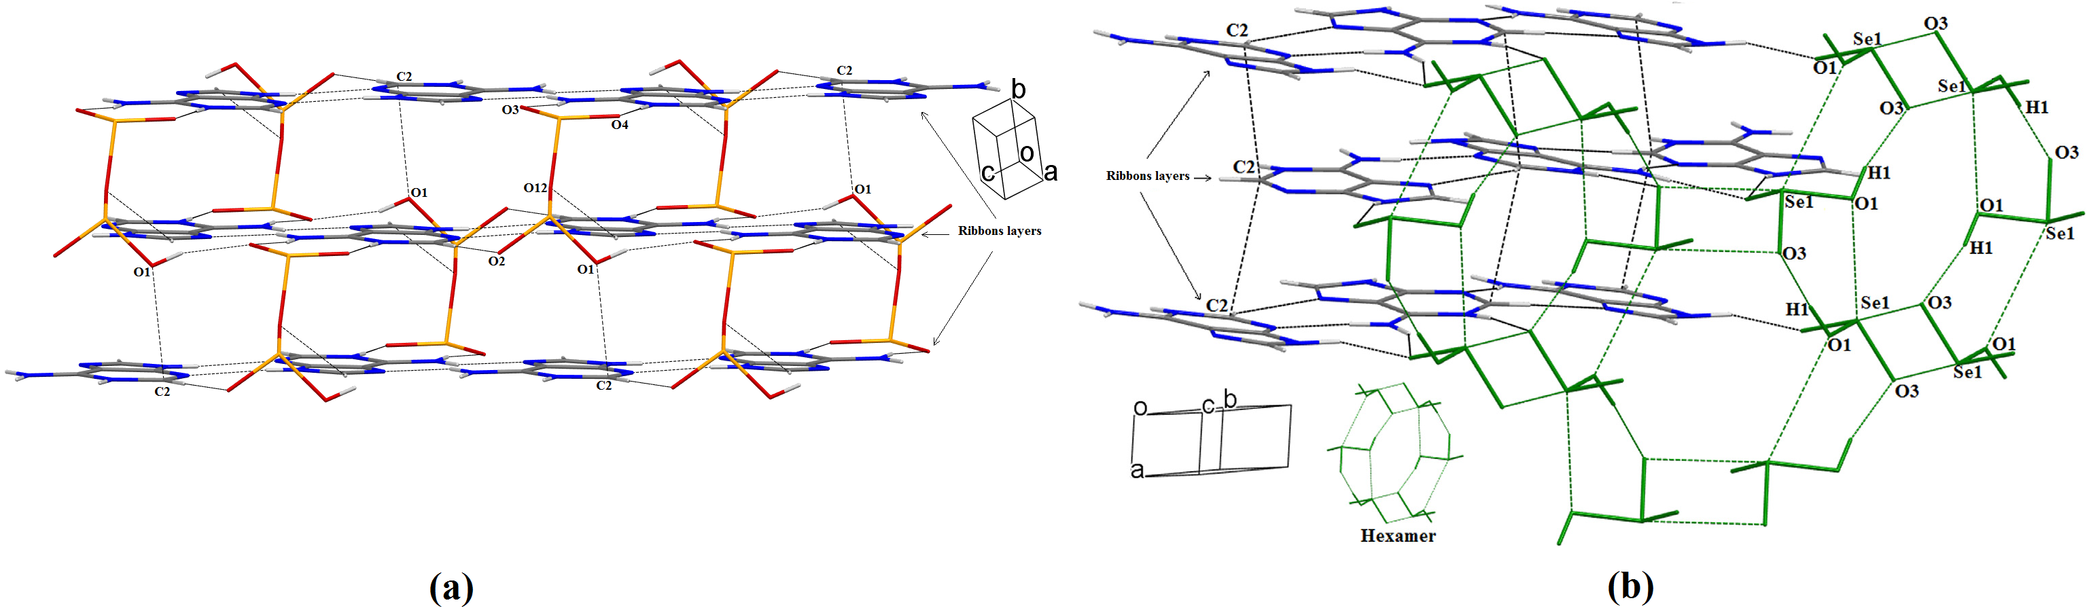
Fig. 1: (a) Electrostatic interaction between the O1 atom and the adeninium cation in (I). Intermolecular interactions are shown as black dashed lines. (b)Three dimensional crystal structure of (II) showing the role of selenite hexamers and aromatic stacking in stabilizing the crystal packing.

3. References

[1] H. Cai, S. Su, Y. Li, H. Zeng, Z. Zhu, J. Guo, et al. , J. Ethnopharmacol. 212 (2018) 153–165.
[2] I. Burneo, K.C. Stylianou, S. Rodríguez-Hermida, J. Juanhuix, X. Fontrodona, I. Imaz, D. Maspoch, Cryst. Growth. Des. 15 (2015) 3182–3189.
[3] H. Athmani, C. Kijatkin, R. Benali-Cherif, S. Pillet, D. Schaniel, M. Imlau, N. Benali-Cherif, E.-.E. Bendeif, Acta Cryst. A75 (2019) 107–114.

