Using Synchrotron microanalysis tools to study the formation of glauconite on the African coast
Paul Northrup¹, Benjamin C Bostick², Sarah Nicholas³, Sidney Hemming², Edem Mahu⁴, Nubi Olubunmi Ayoola⁵, Madelyn Cook⁶, Ingrid Hendy⁶
¹Stony Brook University, Stony Brook NY, USA; ²Columbia University and Lamont-Doherty Earth Observatory, New York NY; ³NSLS-II, Brookhaven National Laboratory, Upton NY; ⁴University of Ghana, Ghana; ⁵Nigerian Institute For Oceanography & Marine Research, Nigeria; ⁶University of Michigan, Ann Arbor, MI, USA; Corresponding author e-mail address: paul.northrup@stonybrook.edu
1. Why is glauconite important?
Glauconite, K(Fe³⁺,Al,Mg)₂(Si,Al)₄O₁₀(OH)₂, is a K-rich, phyllosilicate that forms discrete pellets 0.05 to 1 mm in diameter in coastal sediments under moderately reducing conditions, and is known to form in the Gulf of Guinea area. It is an important mineral because its formation participates in global cycling of both Fe and K while also having a component of local-scale redox. It records those processes as well as environmental conditions over geologic time. An improved understanding of glauconite formation and preservation is central to understanding geological history, including what regulates the biological productivity of coastal waters, and the connection between shallow seas and the larger continents. Glauconite is a target for direct dating of sediments, and with modern K-Ar methods a single pellet can be dated, making characterization of individual pellets a key need.
2. Synchrotron tools for microanalysis
Glauconite grains are small, dispersed and heterogeneous in sediments, requiring targeted microanalysis. Synchrotron-based microbeam analysis techniques, including XRF (X-ray fluorescence) imaging, XAS (X-ray absorption spectroscopy) and XRD (diffraction), are ideal. We use these techniques to probe structure, crystallinity, and ordering in natural glauconites from the Gulf of Guinea. Fig. 1 shows an XRF image of a single glauconite pellet, which can be used to determine K concentration. Fig. 2 shows a typical microbeam XRD pattern. Based on [1], XRD can be used to determine K as a function of degree of maturity. Highly mature glauconite is best for dating, and has the highest K. Pellets with lower K are more disordered and less crystallographically “mature,” and may not be completely locked in for dating. XANES (X-ray Absorption near edge structure) can identify oxidation state of Fe and other elements with multiple valence, as well as fingerprint chemical species or mineral phase. This is particularly important since glauconite incorporates Fe³⁺ but forms under conditions dominated by Fe²⁺. EXAFS (extended X-ray absorption fine structure) can provide local structural information including the distance, identity and number of neighboring atoms, in crystalline or non-crystalline materials. Fig. 2 shows microbeam K XANES of a mature glauconite pellet; peak positions and shape match K coordinated within the glauconite structure rather than adsorbed or more hydrated K. These measurements can be made on individual grains or sediment samples showing the local biogeochemical context of glauconite formation.
Microbeam XRD, as well as XRF and XAS of Fe and other transition metals and trace elements, are conducted at the NSLS-II XFM “hard” X-ray microprobe beamline. XRF and XAS of lighter elements including K, S, P, Si and Al were measured at TES, a lower-energy “tender” X-ray microprobe beamline. It is important to note that these techniques are non-destructive, and look at samples in their native state without extensive sample preparation.
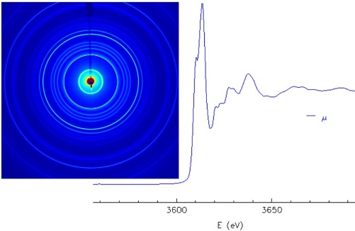
Fig. 2: Microbeam XRD pattern (left) and microbeam XANES spectrum (right) of a single glauconite grain.
Fig. 1: microbeam XRF image of K fluorescence showing a single rounded grain of glauconite.

3. Results and Conclusions
Initial results of our emerging survey of glaucony from a range of samples and ages from around the globe confirm that we can quantitatively measure K and Fe concentrations in glauconite grains, determine Fe oxidation state, and evaluate maturity via XANES and XRD. For our modern glaucony study, we are using pellets from ODP Site 959, Gulf of Guinea. In addition to microanalysis of individual pellets, we examined several sediment-core samples to evaluate the local-scale context of glauconite formation. Our work on the grain-scale processes that lead to modern glauconite formation and maturation is just beginning, and is being incorporated into international collaborations including the COESSING summer school (COESSING.org). This study illustrates application of synchrotron tools to environmental, geologic, marine and mineralogical systems, and can be important to research efforts in climate and environmental science, and economic geology. The African Light Source will not only benefit local research efforts, but this is potentially an area where the AfLS can take a leadership role among global facilities.
3. References
[1] G Odin, A Morton. Authigenic green particles from marine environments. Developments in Sedimentology. 43, (1988) 213-264. Elsevier

