Hydrogen and halogen bonds involving Au(I) complexes

Catharine Esterhuysen¹

¹ I Department of Chemistry and Polymer Science, Stellenbosch University, Matieland, Stellenbosch, 7602, South Africa
Corresponding author e-mail address: ce@sun.ac.za

1. Introduction

The most challenging aspect in understanding the properties of materials in the solid state is to identify the role that intermolecular interactions play in their behaviour. This has been further complicated in recent years by the realisation that close contacts between two electronegative atoms are not necessarily repulsive. For instance, in halogen bonding formally negatively-charged halogens form attractive interactions with other electronegative species through a positively-charged region on the halogen, known as a σ-hole [1]. These interactions are further strengthened by polarisation and dispersion. Similarly, dispersion interactions lead to aurophilic interactions between formally positively-charged gold centres in complexes [2].

2. Results

In this work we show that the ligands in a range of Au(I) complexes affect the relative electrophilicity of the gold centre, which in extreme cases enables the gold to behave as a Lewis base by acting as an acceptor for hydrogen and halogen bonds. Depending on the nature of the ligands in the gold complex the resultant hydrogen bonds may be even stronger than those between two water molecules [3], while the halogen bonds are of similar strength to that found within the triiodide ion (Fig. 1) [4]. The interactions are, nevertheless, weaker than those involving the auride ion. We show that the effect is very subtle, with the electronegativity and polarisability of the Au(I) centre playing a crucial role in its formation of hydrogen and halogen bonds.

In addition, the computational results show that a second hydrogen-bonding interaction is typically present to support the stabilisation of an Au⋅⋅⋅H hydrogen bond (Fig. 2). Analysis of the Cambridge Structural Database (CSD) shows that some form of additional stabilisation is a common feature: most of the crystal structures containing close intermolecular contacts between Au and H exhibit multiple interactions. Further investigation of the CSD suggests that the additional stabilisation can also be achieved by the the formation of 5-, 6- or 7-membered intramolecular Au⋅⋅⋅H hydrogen-bonded rings, with graph set notations S(5), S(6) or S(7) [5]. These are less common than 4-membered rings containing short Au⋅⋅⋅H distances, however, the latter appear to merely be Au⋅⋅⋅H close contacts and are not structure determining. On the other hand, the additional stabilisation obtained through the formation of hydrogen-bonded rings appears to be lost for larger rings as there are very few examples of these.
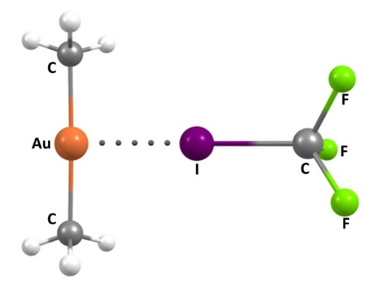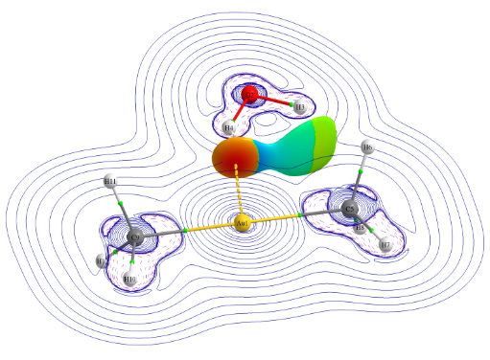
Fig. 1: Au⋅⋅⋅X halogen bond between dimethylaurate ion and trifluoroiodomethane.

Fig. 2: Au⋅⋅⋅H hydrogen bond between dimethylaurate ion and water showing its strength relative to that of the supporting interaction.

3. References

[1] (a) L. C. Gilday, S. W. Robinson, T. A. Barendt, M. J. Langton, B. R. Mullaney and P. D. Beer, Chem. Rev. 115 (2015) 7118; (b) G. Cavallo, P. Metrangolo, R. Milani, T. Pilati, A. Priimagi, G. Resnati and G. Terraneo, Chem. Rev. 116 (2016) 2478.
[2] (a) H. Schmidbaur, F. Scherbaum, B. Hubert and G. Müller, Angew. Chem. Int. Ed. Engl. 27 (1988) 419; (b) S. S. Pathaneni and G. R. Desiraju J. Chem. Soc., Dalton Trans. (1993) 319.
[3] (a) F. Groenewald, J. Dillen, H. G. Raubenheimer and C. Esterhuysen, Angew. Chem. Int. Ed. 55 (2016) 1694; (b) F. Groenewald, J. Dillen, H. G. Raubenheimer and C. Esterhuysen, Dalton Trans. 46 (2017) 4960.
[4] F. Groenewald, J. Dillen and C. Esterhuysen, New J. Chem. 42 (2018) 10529.
[5] M. C. Etter, J. C. MacDonald and J. Bernstein, Acta Crystallogr., Sect. B: Struct. Sci. 46 (1990) 256.

