Materials Characterization Using Powder Diffraction Techniques and the Powder Diffraction FileTM

T. Blanton, J. Blanton, S. Kabekkodu, S. Gates Rector, V. Bosnic

International Centre for Diffraction Data, Newtown Square, Pennsylvania, USA
Corresponding author e-mail address: tblanton@icdd.com

Powder X-ray diffraction (XRD) has historically been the analytical technique of choice for phase identification of crystalline materials. Today advances in radiation sources, optics and detectors, allow scientists to use XRD to probe beyond phase identification and extend studies to investigate material microstructure as well as nanostructure properties. Whether the material of interest being studied is crystalline or amorphous, randomly or preferentially oriented, inorganic or organic, powder or solid, there are many diffraction methods available that can be used to analyze a sample and provide help in understanding how material processing affects material properties. In addition to improvements in diffraction instrumentation, new developments in the ICDD® Powder Diffraction File (PDF®)[1] databases have produced an array of solid-state analysis tools resulting from a combination of single crystal and powder diffraction data. Advanced features include: atomic coordinates for Rietveld refinement techniques; amorphous and nano material references; digital simulation tools for evaluating X-ray, synchrotron, electron and neutron diffraction data as well as crystallite size and analysis of two-dimensional diffraction data.

Diffraction methods and the Powder Diffraction File together create a synergy between data collection and data analysis that has been proven to assist scientists in finding a more complete and correct answer to their materials characterization questions. The origins of the PDF will lead to a review of current capabilities of databases and software, resulting in solutions for materials analyses.

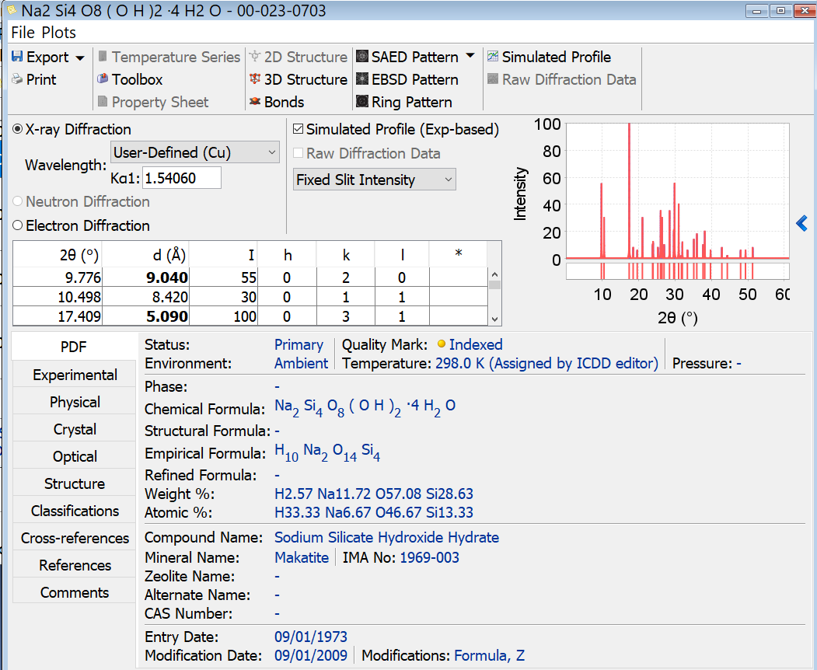
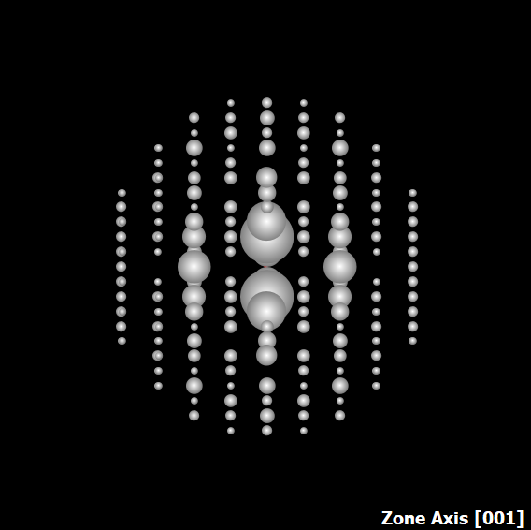
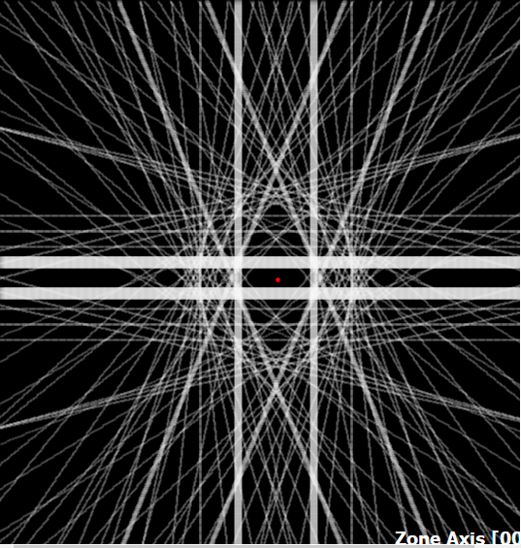
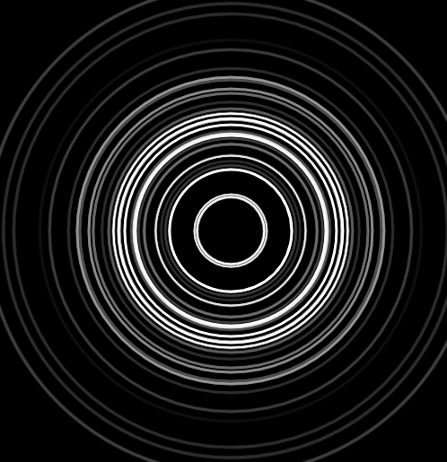
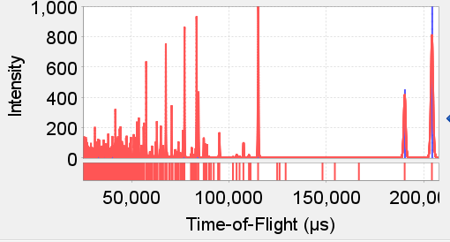
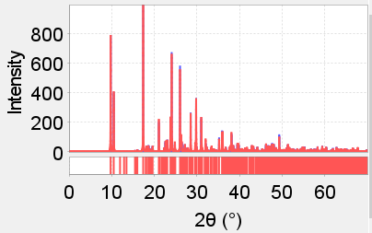

Fig. 1: ICDD PDF entry (card) for Makatite, Na₂Si₄O₈(OH)₂·4H₂O. The presence of atomic coordinates allow for characterization of data collected using X-ray (lab, synchrotron), electron, and neutron diffraction (constant wavelength and time-of-flight) techniques.

Reference

[1] S. Gates-Rector and T. Blanton. Powd. Diffr. 34(4) (2019) 352-360.

