Al₂O₃-supported Co₃O₄ nano-catalysts for the preferential oxidation of carbon monoxide: A synchrotron-based in situ XAS study

Thulani M. Nyathi^{1,}*, Nico Fischer¹, Andrew P. E. York², Emma K. Gibson³, Peter P. Wells⁴,
Sir C. Richard A. Catlow^{5,6}, Michael Claeys^{1,}*

¹ Catalysis Institute and c*change (DSI-NRF Centre of Excellence in Catalysis), Department of Chemical Engineering, University of Cape Town, Rondebosch 7701, South Africa
² Johnson Matthey Technology Centre, Sonning Common, Reading RG4 9NH, United Kingdom
³ School of Chemistry, Joseph Black Building, University of Glasgow, Glasgow G12 8QQ, United Kingdom
⁴ School of Chemistry, University of Southampton, University Road, Southampton SO17 1BJ, United Kingdom
⁵ Department of Chemistry, University College London, 20 Gordon St., London, WC1H 0AJ, United Kingdom
⁶ Cardiff Catalysis Institute, Cardiff University, Main Building, Park Place, Cardiff, CF10 3AT, United Kingdom
* Corresponding authors’ e-mail addresses: thulani.nyathi@uct.ac.za and michael.claeys@uct.ac.za

1. Introduction

Cobalt(II, III) oxide (Co₃O₄) is a promising catalyst for the preferential oxidation of carbon monoxide (CO-PrOx) in hydrogen-rich gases, however, Co₃O₄ suffers from bulk reduction at elevated temperatures (> 200 °C), resulting in the formation of metallic Co (Co⁰). The formation of Co⁰ changes the conversion pathway of CO from oxidation to hydrogenation, forming methane (CH₄) instead of carbon dioxide (CO₂), which is an undesired outcome [1]. We attempted to stabilise Co₃O₄ nanoparticles on an alumina (Al₂O₃) support using two different anchoring methods, which resulted in two Al₂O₃-supported Co₃O₄ catalysts, i.e., CAT 1 and CAT 2, where the strength of the Co₃O₄-Al₂O₃ interaction was different between the two prepared catalysts. The phase stability of the catalysts was monitored in situ, i.e., during a CO-PrOx reaction, using synchrotron-based X-ray absorption spectroscopy (XAS) in Diamond Light Source, United Kingdom (session number: SP16006-1). This was later consolidated with kinetic data obtained via gas chromatography at the University of Cape Town, South Africa [1].

2. Results

Our results show that the Co₃O₄ nanoparticles in CAT 1 reduce to CoO and finally to Co⁰ to a greater extent than in CAT 2 (Figure 1), which can be attributed to the weaker interactions existing between Co₃O₄ and Al₂O₃ in CAT 1. The weak interactions also allow for high CO₂ formation (i.e., high CO₂ outlet flow rates) over CAT 1, however, this catalyst also produces high amounts of undesired CH₄ at relatively low temperatures than in the case of CAT 2 (Figure 2) due to the high amounts of unwanted Co⁰ formed in CAT 1 (Figure 1). In conclusion, in situ XAS was utilised successfully to confirm the phase changes occurring in each catalyst, and to help explain the differences between the catalysts in terms of their catalytic performance during CO-PrOx.

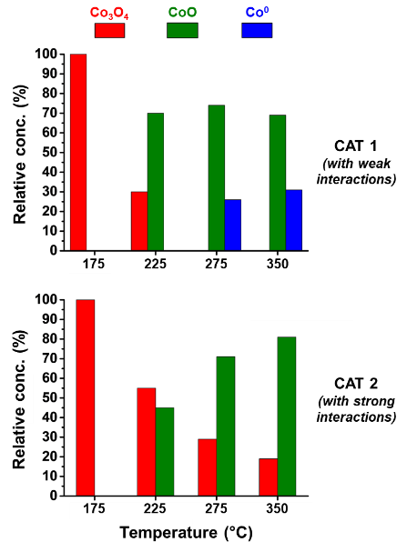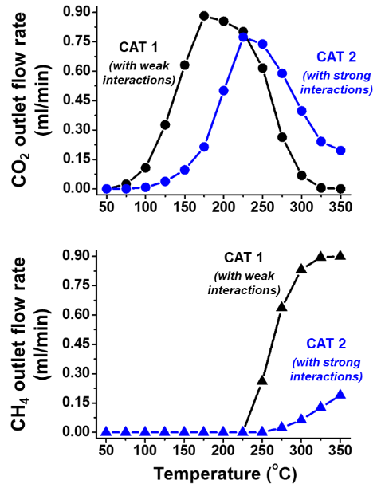
Fig. 1: Relative phase concentrations as a function of temperature as detected using in situ XAS during CO-PrOx.

Fig. 2: Outlet flow rates of CO₂ and CH₄ as a function of temperature during CO-PrOx.

3. References

[1] T.M. Nyathi, N. Fischer, A.P.E. York, D.J. Morgan, G.J. Hutchings, E.K. Gibson, P.P. Wells, C.R.A. Catlow and M. Claeys. ACS Catal. 9 (2019) 7166.

