Ternary Mn_{x}Ni_{1-x}Co₂O₄ spinel oxides for oxygen reduction and supercapacitor applications; the role of carbon support and tunning metal compositions

Tarekegn Heliso Dolla¹, Thabo Matthews², Patrick Ndungu², Nobanathi Wendy Maxakato²

¹ Department of Chemistry, Wolaita Sodo University, Wolaita Sodo, Ethiopia
²Department of Chemical Sciences, University of Johannesburg, Doornfontein 2028, South Africa
Corresponding author e-mail address: tarehel@gmail.com

Environment-friendly energy conversion and storage devices through the electrochemical processes have received extensive attention due to the common interests in the pursuit of a clean energy economy [1]. The development of efficient and low-cost electrocatalysts for using in these devices is imperative to achieve optimum use of renewable energy alternatives. Multimetallic oxides/carbon hybrid catalysts show excellent potentials in electrocatalysis, and they have been developed as alternatives for expensive and scarcer noble metals [2]. The multimetal oxides possess effective synergy between different metal elements, which are expected to promote electrocatalytic reactions [3].

In this study, a systematic investigation of ternary spinel oxides Mn_{x}Ni_{1-x}Co₂O₄ (x = 0, 0.3, 0.5, 0.7, and 1) was carried out to understand the effect of metal compositions and role of carbon support on the structural and electrocatalytic properties. The oxides were prepared using the citric acid-assisted sol-gel method followed by calcination under air. The lattice parameters were observed to vary with increasing values of x owing the substitution of Ni by Mn. After evaluating their oxygen reduction reaction (ORR) performance in alkaline media, Mn_{0.5}Ni_{0.5}Co₂O₄ was considered as an optimum composition and was supported on carbon nanosheets employing NaCl template and glucose as a carbon source followed by pyrolysis under an inert atmosphere. Cyclic voltammetry (CV) was used to screen out the oxygen reduction performance and Mn_{0.5}Ni_{0.5}Co₂O₄ was found to be the best performing electrocatalyst. Upon supporting the Mn_{0.5}Ni_{0.5}Co₂O₄ on a carbon sheet, the electrocatalytic activity was significantly enhanced owing to its large surface area and the improved charge transfer brought about by the carbon support. Rotating disk electrode studies show that the ORR activity of Mn_{0.5}Ni_{0.5}Co₂O₄/C proceeds via a four-electron pathway. Mn_{0.5}Ni_{0.5}Co₂O₄/C was found to possess E_{1/2}(V) = 0.856, a current density of 5.54 mA cm⁻², and a current loss of approximately 0.11% after 405 voltammetric scan cycles. This study suggests that the interesting electrocatalytic performance of multimetallic transition metal oxides can be further enhanced by supporting them on conductive carbon materials, which improve charge transfer and provide a more active surface area.

When tested as a supercapacitor electrode, Mn_{0.5}Ni_{0.5}Co₂O₄/C exhibited specific capacity of 91.2 mA h g⁻¹ at a current density of 1 A g⁻¹ in 2 M KOH. Moreover, after 3000 cycles the composite achieved a specific capacity of 74.6 mA h g⁻¹ at a current density of 6 A g⁻¹ and high capacitance retention of 96.4%.

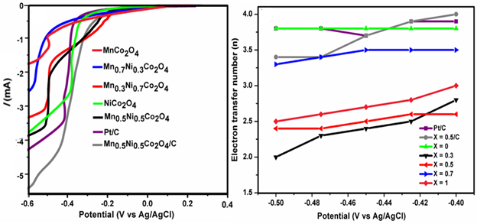

Fig. 1: RDE curves comparison of Mn_{x}Ni_{1-x}Co₂O₄ in oxygen saturated 0.1 M KOH at 1600 rpm at cathodic sweep of 10 mVs⁻¹ and plot of number of electrons transferred.

References

[1] S. Ghosh and R. N. Basu. Nanoscale, 2018,10, 11241-11280.
[2] R. J. Toh,,A. Y. S. Eng, Z. Sofer, D. Sedmidubsky, M. Pumera. ChemElectroChem, 2015, 2.7: 982-987.
[3] Y. Huang, S. L. Zhang, X. F. Lu, Z.-P. Wu, D. Luan, X. W. (. Lou. Angew. Chem. Int. Ed. 2021, 60, 11841

