111Equation Chapter 1 Section 1
How to manage a modern X-ray scattering lab – a modest example

Brian Richard Pauw¹, Glen Jacob Smales²

¹ German Federal Institute for Materials Research and Testing (BAM), Unter den Eichen 87, 12205 Berlin, Germany
Corresponding author e-mail address: brian.pauw@bam.de

1. Introduction (section 1) 10 pt Bold

A good laboratory organization can help address the reproducibility crisis in science, and easily multiply the scientific output of a laboratory, while greatly elevating the quality of the measurements. We have demonstrated this for small- and wide-angle X-ray scattering in the MOUSE project (Methodology Optimization for Ultrafine Structure Exploration) [1]. In the MOUSE, we have combined: a) a comprehensive laboratory workflow with b) a heavily modified, highly automated X-ray scattering instrument. This combination allows us to collect fully traceable scattering data, with a well-documented data flow (akin to what is found at the more automated beamlines). With two full-time researchers, the lab collects and interprets thousands of datasets, on hundreds of samples for dozens of projects per year, supporting many users along the entire process from sample selection and preparation, to the analysis of the resulting data.
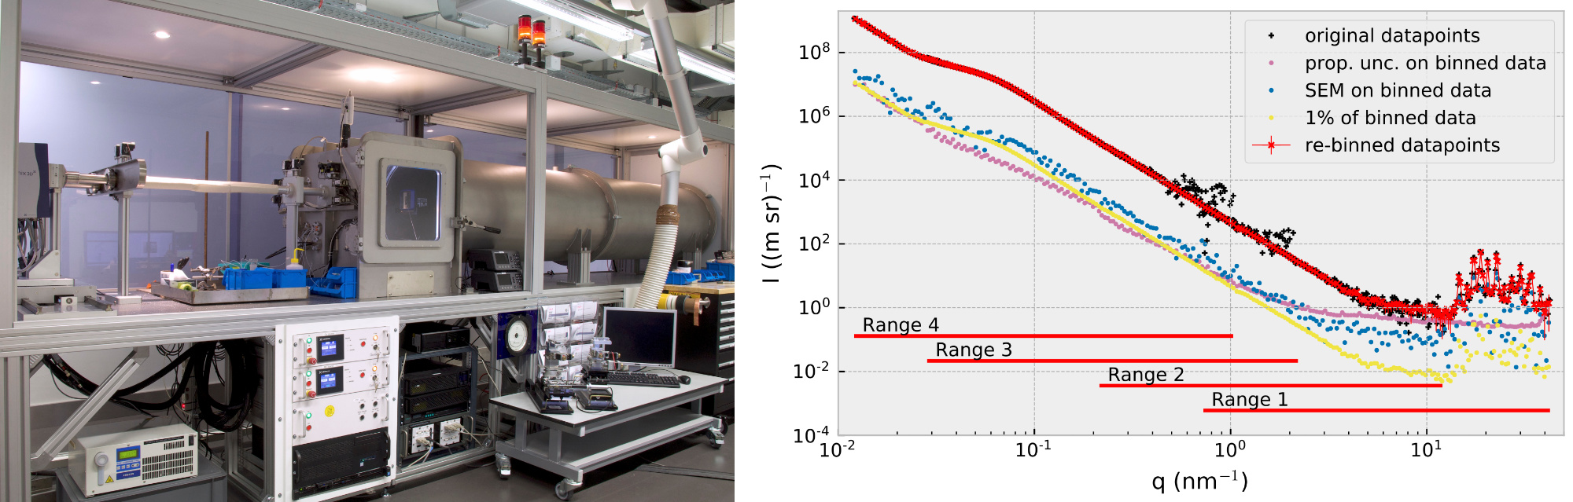Figure 1: The current MOUSE instrument, and the data resulting from the application of the MOUSE methodology. Reproduced from [1].
While these numbers do not light a candle to those achieved by our hardworking compatriots at the synchrotron beamlines, the laboratory approach does allow us to continually modify and fine-tune the integral methodology. So for the last three years, we have incorporated e.g. FAIR principles, traceability, automated processing, data curation strategies, as well as a host of good scattering practices into the MOUSE system. We have concomitantly expanded our purview as specialists to include an increased responsibility for the entire scattering aspect of the resultant publications. This ensures full exploitation of the data quality, whilst avoiding common pitfalls.

2. Talk scope

This talk will present the MOUSE project as implemented to date, and will introduce foreseeable upgrades and changes. These upgrades include better pre-experiment sample scattering predictions to filter projects on the basis of their suitability, exploitation of the measurement database for detecting long-term changes and automated flagging of datasets, extending the measurement range through an Ultra-SAXS module [2], and enhancing MC fitting [3] with sample scattering simulations for better matching of odd-shaped scatterers.

3. References

[1] Smales, G. J., and Pauw, B. R. The MOUSE project: a meticulous approach for obtaining traceable, wide-range X-ray scattering information. Journal of Instrumentation. 16, P06034 (2021). DOI: 10.1088/1748-0221/16/06/P06034
[2] B. R. Pauw, A. J. Smith, T. Snow, O. Shebanova, J. P. Sutter, J. Ilavsky, D. Hermida-Merino, G. J. Smales, N. J. Terrill, A. F. Thünemann and W. Bras: Extending synchrotron SAXS instrument ranges through addition of a portable, inexpensive USAXS module with vertical rotation axes. Journal of Synchrotron Radiation 28 (3). DOI: 10.1107/S1600577521003313
[3] I. Breßler, B. R. Pauw, A. F. Thünemann, McSAS: A package for extracting quantitative form-free distributions, Journal of Applied Crystallography 48: 962-969, DOI: 10.1107/S1600576715007347

