Elastic stability analysis of non-prismatic bridge-pier under one phase lateral fluid loads
L. Ngou Zeufo^{1,*}, H. Simo Kaptue¹, Y. Mbono Samba¹

¹ Laboratory of Applied Mechanics, University of Yaoundé 1, P.O Box 812, Yaoundé, Cameroon
*Corresponding author e-mail address: ngouloic@yahoo.fr

1. Introduction
Bridge piers are subjected to compressive forces of deck and vehicle, and they are also subjected to transverse forces such as lateral loads dues to water or wind flow. Generally they are taken as Beam-columns that are structural members subjected to combined axial forces and bending moments created by lateral loads. Such solicitations can modify elastically the stability in the behavior of the pillar. Elastic stability is a significant research subject [1-5]. It can be evaluated when analyzing critical buckling load [5] or stability functions [4]. More, investigation on elastic stability depends on the geometric of the beam.

In this study, we analyze the elastic stability of a non-prismatic beam-column when subjected to axial compressive forces and variables lateral loads dues to flow (wind or water). For this, a formulation of equilibrium equation is made according to geometric nature of the pillar and all loads. Then analytical method based on power series [4,5] is used to solve the fourth-order differential equation and evaluate the stability functions. Numerical examples based on the link between depth ratio and beam-column's length are taken to check effectiveness and validity of this study.
Within the limitations of the beam-column theory [1], the governing fourth-order ordinary differential equation with variable coefficients for a typical non-prismatic beam-column member subjected to axial compressive force P and lateral fluid loads (as shown in Fig. 1) is as follows:
$\frac{d^{2}}{dx^{2}}\left[EI(x)\frac{d^{2}y}{dx^{2}}\right]+P\frac{d^{2}y}{dx^{2}}+\frac{1}{2L}ρU^{2}D\left(x\right)C_{D}=0$, | (1)
where $y$ is the beam transverse displacement, $x$ is axial coordinate,$E$ and $I(x)$ express Young’s modulus of elasticity and variable moment of inertia of column’s cross-section, respectively. $\frac{1}{2L}ρU^{2}D\left(x\right)C_{D}$ is the lateral fluid load in term of drag coefficient [3], with a dimension of a force per unit length . U is flow velocity, $ρ$ the volume mass, $C_{D}$ the drag coefficient, $D\left(x\right)$body dimension estimated as a variable depending of beam transverse displacement. Using powers series method to solve this equation, we obtained stability functions.

2. Results
The small but noticeable difference observed between the beam-column without lateral loads and the one with lateral loads (Fig. 1), show the impact of lateral loads considered in this study on the beam. This low impact can comes from the fact that we considered the fluid flow here as being a stable fluid with little backwash. As we can observe in Fig. 2, stability function increases when beam-column length becomes important and this is in accordance with results obtained by Al-Sadder [4] when the depth ratios value was increased. The influence of fluid lateral load combined to axial load on elastic stability becomes significant here for high values of beam-columns length.
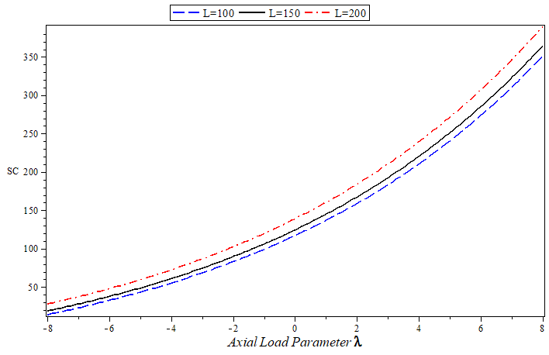
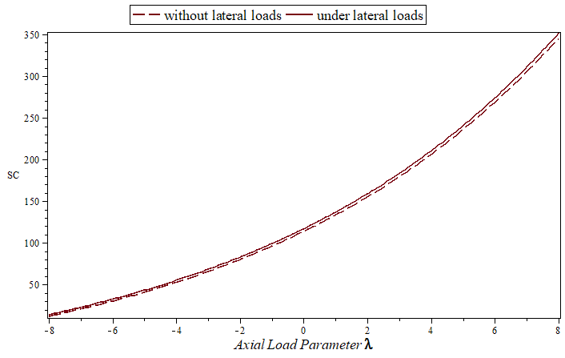

Fig. 1: Function SC for tapered solid circular section under axial and lateral loads

Fig. 2: Function SC for different beam-column's length

3. References
[1] WF. Chen, T. Atsuta, Theory of beam columns, volume 1: In-plane behaviour and design, New York, 1936.
[2] S.P. Timoshenko, J.M. Gere, Theory of elastic stability, 2nd Ed, New York, McGraw-Hill, 1961.
[3] M. Soltani, A. Sistani, Elastic stability of columns with variable flexural rigidity under arbitrary axial load using the finite difference method, Num. Meth. Civil Eng. 2017.
[4] S. Al-Sadder, Exact expression for stability functions of a general non-prismatic beam-column member, J. constructional Steel Research 60 (2004) 1561-1584.
[5] M. Soltani, F. Mohri, Stability and vibration of tapered columns resting on one or two-parameter elastic foundations, Numerical Methods in Civil Eng. Vol1, 2014.

