Phase dependent Hapticity change: Synergetic evidence from ¹H NMR, MS, and X-Crystallography of Cationic Pyridyl(benzoazole) Ruthenium(II) Complexes

Aloice Ogweno^{1,2}, Stephen Ojwach²

¹ Department of Pure and Applied Sciences, Technical University of Mombasa, P.O. Box 90420-80100, Mombasa, Kenya
² School of Chemistry and Physics, University of KwaZulu-Natal, Private Bag X01, Scottsville, Pietermaritzburg, 3209, South Africa
Corresponding author e-mail address: aoogweno@tum.ac.ke

1. Introduction

Transition metal complexes have a wide range of applications in catalysis, materials synthesis, photochemistry, and biological systems [1]. They exhibit varying physical and chemical properties which makes them suitable for the possible applications [2]. Their properties and by extension reactions are strongly dependent on the coordinated supporting ligand [3]. The attaching ligands mainly influence the steric and the electronic properties of the metal ions thereby controlling their chemical reactivity [4]. One way of controlling the electronic properties is by causing central metal ion charge variation [5]. Most transition metal complexes are prepared through a substitution reactions, where a ligand is reacted with metal complex precursor. The weakly coordinating ligands of the precursor are replaced by the incoming ligand [6]. One class of transition metal complexes are metallocenes which are made of either sandwiched or half-sandwiched highly conjugated cyclic ligands. The chemistry of metallocenes has been very important for synthetic and industrial applications [7]. This is partly because they exhibit interesting trends in molecular structure stabilities and influences bond energies depending on the nature of the conjugated ring and on the central atom [8]. The effect on the structure of the metal complex can also be influenced when metallocenes are used as metal precursors in the preparation of other complexes. Highly conjugated cyclic ligand in these complexes manifest varying denticity by changing their hapticity depending the type of the central metal ion and the other coordinated ligands [9, 10]. The hapticity change can also be observed depending of the phase: solution or solid phase [11]. In this contribution, we report the synergetic evidence from different spectroscopic techniques in explaining the change of hapticity of 2-phenoxyethanol ligand on Ru(II) complexes.

2. Results

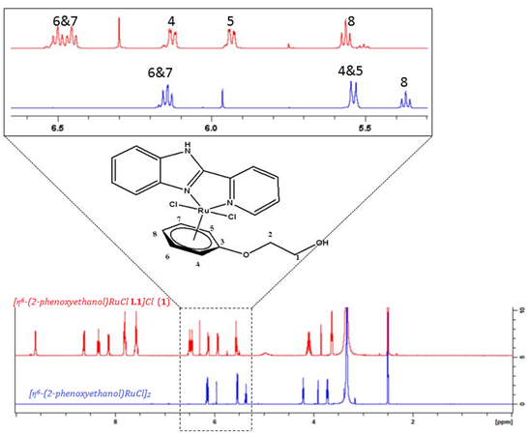
Fig. 2: Molecular structure of2-(2-pyridyl)benzoxazole [η6-(2-phenoxyethanol)RuCl(L3)]Cl showing η6 coordination.
Fig. 1: An overlay of 1H NMR spectra for complex 1 and [η6-(2-phenoxyethanol)RuCl2]2 dimmer

3. References

[1] R. K. Sodhi and S. Paul, Canc Therapy & Oncol Int J. 14 (2019): 555883
[2] I. Turel, Molecules 20, (2015) 7951-7956
[3] C. Chen, S. M. Bellows, and P. L. Holland, Dalton Trans., 44 (2015) 16654–16670
[4] F. Tang, S. V. Park, N. P. Rath and L. M. Mirica, Dalton Trans., 47 (2018) 1151-1158
[5] J. P. Stambuli, C. D. Incarvito, M. Bühl, and J. F. Hartwig, J. Am. Chem. Soc. 126 (2004) 1184–1194
[6] C. Chiu, F. Shieh, and H. Gavin Tsai, Inorg. Chem. 58 (2019) 14457–14466
[7] A. Togni and R. L. Haltermann (Eds.), Metallocenes, (Wiley–VCH, 1998)
[8] G. Frison and A. Sevin, Internet Electron. J. Mol. Des. 3 (2004) 222–232
[9] D. Soto and R. Salcedo, Molecules. 17 (2012) 7151–7168
[10]D. M. Spencer, R. L. Beddoes, M. Helliwella and M. W. Whiteley, Dalton Trans., (2003), 638-650
[11] B. M. Day and M. P. Coles, Organometallics 2013, 32, 15, 4270–427

