Short Antimicrobial peptides: Small-angle X-ray Scattering as a tool to study membrane interactions on bacterial membrane models

Charlotte Jennifer Chante Edwards-Gayle^{,1}, James Doutch² Glyn Barrett,³ Ian Hamley,³ Nathan Cowieson¹

¹ Diamond Light Source LtD, Harwell Research and innovation Campus, Didcot, OX11 0DE
² ISIS Facility, STFC Rutherford Appleton Laboratory, Harwell Campus, Didcot, Oxfordshire, United Kingdom
³ University of Reading, Reading, RG6 6AH

Corresponding author e-mail address: charlotte.edwards-gayle@diamond.ac.uk, nathan.cowieson@diamond.ac.uk

1. Introduction

The increased prevalence of multi antibiotic-resistant pathogens has been listed by the World Health Organisation (WHO) as one of the biggest threats to modern day healthcare, food security and development.¹ It is essential to drive the discovery of new alternate antimicrobials now, due to the time taken to for molecules to undergo clinical trials, and the rate in which multiple drug resistant strains are arising.

Antimicrobial peptides (AMPs) are attracting attention as an alternative to conventional antibiotics, and can target a range of microbes including viruses, fungus, bacteria, and parasites. They can be highly effective against gram-negative bacteria, which are harder to target due to their double membrane cell wall.² Moreover, short AMPs commonly interact non-specifically with microbes, leading to a ‘multiple-hit’ strategy, killing microbes through multiple antimicrobial mechanisms.^{3,4} This combined with the rapid action of AMPs decreases the likelihood of organisms to develop resistance. In this category, short AMPs are becoming increasingly popular due to their comparative cheap cost of synthesis. Moreover, amphipathic short AMPs that can self-assemble may have improved efficacy and in vivo stability.
Figure 1. Antimicrobial results showing the effects of four designed peptides against pseudomonas aeruginosa

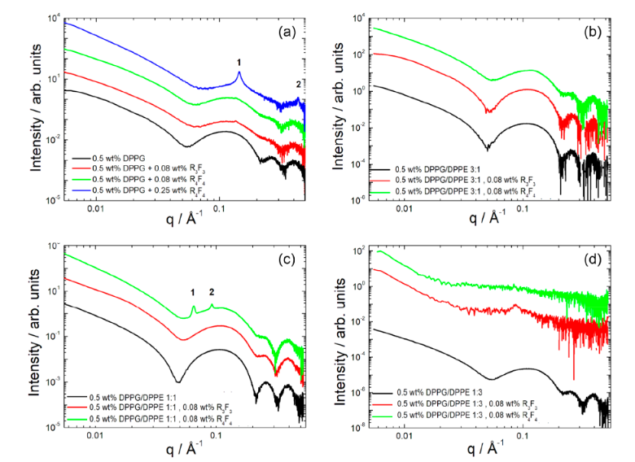
2. Results

Short AMP peptide R₄F₄ was shown to have selective activity against different pseudomonas bacteria within the cytocompatibility range.⁵ This peptide had weak self-assembling ability, and was effective at preventing biofilm formation. Here we examine some new designed peptides, examining how SAXS data can be related to and assist in understanding the bioactivity of these short antimicrobial peptides.

Peptides that were shown to have antimicrobial activity were measured with a series of different membranes based on bacteria at different life stages. SAXS data at beamline B21 indicate changes to the bilayer as a result of peptide interaction, when using lipid rations similar to different gram positive and gram-negative bacteria. ^{5–8}
Figure 2. SAXS profiles for different liposome compositions in the presence of two previously studied peptides, indicating changes in bilayer ordering when exposed to different peptides.

Understanding the mechanism of interaction of these peptides may lead to increased design tunability when designing membrane disrupting AMPs.

3. References

(1) WHO Publishes List of Bacteria for Which New Antibiotics Are Urgently Needed. Saudi Medical Journal. 2017.
(2) Band, V. I.; Weiss, D. S. Mechanisms of Antimicrobial Peptide Resistance in Gram-Negative Bacteria. Antibiotics 2014, 4 (1), 18–41. https://doi.org/10.3390/antibiotics4010018.
(3) Bahar., A. A.; Ren, D. Antimicrobial Peptides. Pharmaceuticals 2013, 6 (12), 1543–1575. https://doi.org/10.1007/978-3-319-29785-9_6.
(4) Fjell, C. D.; Hiss, J. A.; Hancock, R. E. W.; Schneider, G. Designing Antimicrobial Peptides: Form Follows Function. Nat. Rev. Drug Discov. 2012, 11 (1), 37–51. https://doi.org/10.1038/nrd3591.
(5) Edwards-Gayle, C. J. C.; Barret, G.; Roy, S.; Castelletto, V.; Seitsonen, J.; Ruokolainen, J.; Hamley, I. W. Selective Antibacterial Activity and Lipid Membrane Interactions of Arginine-Rich Amphiphilic Peptides. ASC Appl. Biomater. 2020, 3, 1165–1175.
(6) Castelletto, V.; Barnes, R. H.; Karatzas, K. A.; Edwards-Gayle, C. J. C.; Greco, F.; Hamley, I. W.; Rambo, R.; Seitsonen, J.; Ruokolainen, J. Arginine-Containing Surfactant-Like Peptides: Interaction with Lipid Membranes and Antimicrobial Activity. Biomacromolecules 2018, 19 (7), 2782–2794. https://doi.org/10.1021/acs.biomac.8b00391.
(7) Castelletto, V.; Barnes, R.; Karatzas, K.-A.; Edwards-Gayle, C. J. C.; Greco, F.; Hamley, I. W.; Seitsonen, J.; Ruokolainen, J. Restructuring of Lipid Membranes by an Arginine-Capped Peptide Bolaamphiphile. Langmuir 2018, 35 (5), 1302–1311. https://doi.org/10.1021/acs.langmuir.8b01014.
(8) Edwards-Gayle, C. J. C.; Castelletto, V.; Hamley, I. W.; Barrett, G.; Greco, F.; Hermida-Merino, D.; Rambo, R. P.; Seitsonen, J.; Ruokolainen, J. Self-Assembly, Antimicrobial Activity, and Membrane Interactions of Arginine-Capped Peptide Bola-Amphiphiles. ACS Appl. Bio Mater. 2019, 2 (5), 2208–2218. https://doi.org/10.1021/acsabm.9b00172.

