**Anthelmintic flavonoids and other compounds from *Combretum glutinosum* Perr. ex DC (Combretaceae) leaves**

**Placide M. Toklo1, Eléonore Yayi Ladekan1* Anthony Linden2, Sylvie Hounzangbe-Adote3, Siméon F. Kouam4, Joachim D. Gbenou1**

1Laboratoire de Pharmacognosie et des Huiles Essentielles, Faculté des Sciences et Techniques, Université d’Abomey Calavi, 01 BP: 918 ISBA Cotonou, Benin,

2Department of Chemistry, University of Zurich, Winterthurerstrasse 190, CH-8057 Zurich, Switzerland,

3Laboratoire d’Ethnopharmacologie et de Santé Animale, Faculté des Sciences Agronomiques, Université d’Abomey Calavi, 01 BP: 526 Cotonou, Benin,

4Department of Chemistry, Higher Teacher Training College, University of Yaounde I, PO Box 47, 4124 Yaounde, Cameroon.

*Correspondence e-mail: eleoyayi@yahoo.fr

**1. Introduction**

*Haemonchus contortus* is one of the most prevalent parasites in tropical developing countries due to its frequency, pathogenicity and morbidity in livestock production, despite the progress of modern veterinary medicine [1]. It is the parasite responsible for haemonchosis, a disease that can affect animals of all ages and is essentially expressed by an anaemia syndrome whose evolution is rapidly fatal in case of massive infestation [2]. While we are witnessing an increasing resistance to synthetic anthelmintics in the treatment of gastrointestinal strongyles of small ruminants due to counterfeiting and misuse of these products of modern medicine [3], the search for other alternatives for parasite control is essential to the economic viability of the livestock sub-sector. The present study was undertaken on *Combretum glutinosum*, an anthelmintic plant of the Beninese flora, in order to valorize its pharmacological properties and chemical composition.

**2. Results**

Crude extracts of *C. glutinosum* leaf powders were prepared by aqueous decoction and hydroethanol maceration. These extracts were studied for their anthelmintic activities *in vitro* on two developmental stages of the *H. contortus* parasite. It was found that the extracts inhibited larval migration and motility of adult worms of the parasite (p < 0.001). Compounds were isolated from the hydroethanol extract using a combination of chromatographic methods while their structures were determined by mass spectrometry, NMR and X-ray diffraction techniques. Thus, we were able to identify the structure of nine (9) compounds including three (3) flavonoids [5-demethylsinensetin (1), umuhengerin (2), corymbosin (3)], four (4) triterpenoids [(20S,24R)-ocotillone (4); lupeol (5); oleanolic acid (6); betulinic acid (7)] and two (2) steroids [β-sitosterol (8); β-sitosterol glucoside (9)]. The crystal structures of compounds (2) and (4) were obtained for the first time in our work (Figure 1) [4]. The isolated compounds were studied *in vitro* for their anthelmintic activities and 5-demethylsinensetin, a flavonoid, seems to be the one that confers this property to the plant with 75% inhibition of larvae and 100% reduction of adult worm motility after 9 hours of contact.

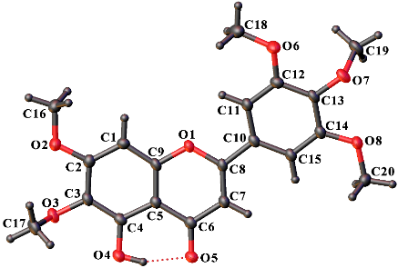

Umuhengerin

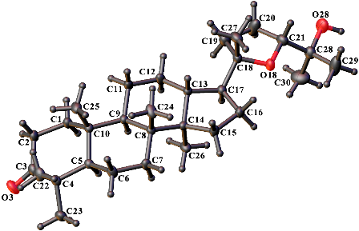

(20S,24R)-ocotillone

**Figure 1:** View of the molecular structures of (2) and (4), showing the atom-labelling scheme. Displacement ellipsoids are drawn at the 50% probability level. H atoms are represented by spheres of arbitrary size.

**3. References**

[1] M. S. Hounzangbe-Adote, V. Paolini, I. Fouraste, K. Moutairou, H. Hoste. *Research in Veterinary Science*.

**78** (2005) 155.

[2] R. Chermette. *Point Vétérinaire*. **13** (1982) 21.

[3] P. A. Olounladé, M. S. Hounzangbé-Adote, E. V. B Azando, T. B. Tam Ha, S. Brunet, C. Moulis, N. Fabre, I.

Fouraste, H. Hoste, A. Valentin. *International Journal of biological and Chemical Science*. **5** (2011) 1414.

[4] P. M. Toklo, E. Yayi Ladekan, A. Linden, S. Hounzangbe-Adote, F. Kouam, J. D. Gbenou. *Acta Cryst.*  **C77** (2021) 505.