Chaos and energy transport in disordered nonlinear lattices

Bob Senyange^{1,2}

¹ Muni University, Arua 725 - Uganda
²Nonlinear Dynamics and Chaos group, University of Cape Town, Rondebosch 7701 – South Africa
bsenyange@muni.ac.ug

1. Introduction

The spreading of wave packets has been studied numerically in a number of classes of wave equations. In this work we study the mechanisms of energy transport in multidimensional heterogeneous lattice models, studying, in particular, the case of the Klein-Gordon model of coupled anharmonic oscillators in two spatial dimensions. The Hamiltonian [1,2] of the system is
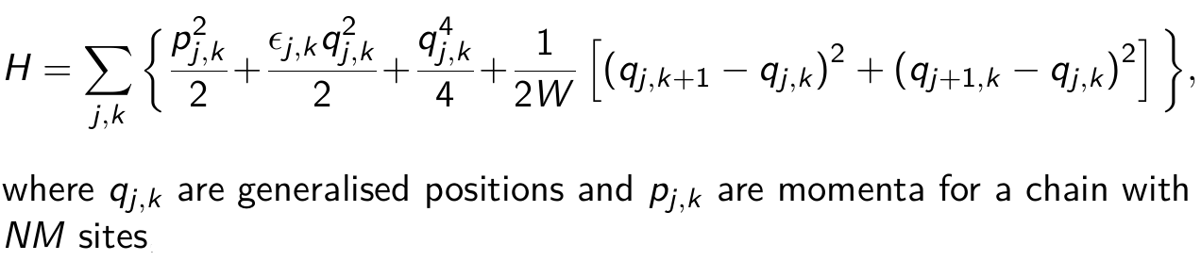
where, W is the strength of disorder and є_{i,k} is the disorder.
We perform an extensive numerical investigation of the dynamics of the model revealing (i) the effects of the type of the impurity (heterogeneity) parameter on the systems’ transport properties and classify the transport mechanisms of the nonlinear versions of the models into various dynamical regimes (ii) that for it’s nonlinear version, chaotic transport persists and (iii) chaotic hotspots meander in the region of energy concentration supporting the spreading mechanism of energy.

2. Results

The extent of the wave packet (energy distribution) and the deviation vector distribution (DVD) are shown in Figures 1 and 2. In Figure 1, the results for the average of the (energy distribution) second moment m₂ [panels (a) and (b)] over 50 different values of the disorder together with the corresponding rates [panels (c) and (d)] of expansion are presented for the so-called weak and strong regimes of chaos. In Figure 2, results for the evolution of the energy distribution and the DVD for a representative case are presented for different times of evolution of the system.

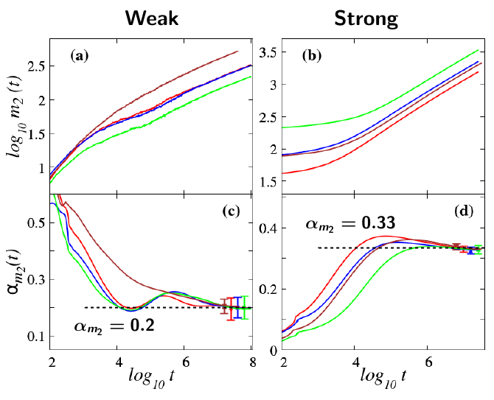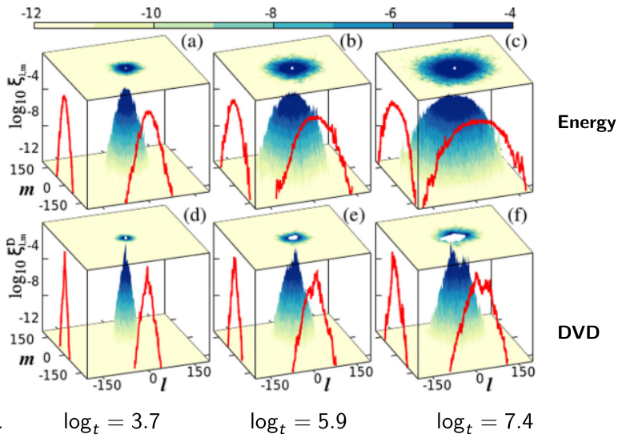
Fig. 1: [2] Results for the time evolution of the second moment m₂ [(a) and (b)] and the corresponding slopes [(c) and (d)] for the energy distributions in the weak and strong chaos dynamics regimes.

Fig. 2: [1] Results for snapshots of the energy and deviation vector distributions for a representative set of disorder parameter at different times of the evolution.

3. References

[1] B. Many Manda, B. Senyange and Ch. Skokos. Phy. Rev. E. 101, (2020) 032206.
[2] B. Senyange. Chaotic behavior of disordered nonlinear lattices (UCT 2021), Chap 5.

