Conservation of charged particle magnetic moment with finite Larmor radius effects in a tokamak magnetic field

Isaac Asante¹, Ekaterina Sorokina^{1,2}

¹People’s Friendship University of Russia, Ordzhonikidze st. 3, Moscow, Russia
²National Research Center “Kurchatov Institute”, Akademika Kurchatova pl. 1, Moscow, Russia
Corresponding author e-mail address: asanteisaac.k@outlook.com

Abstract
The paper investigates the accuracy of preserving the modified expression for the magnetic moment, taking into account the corrections associated with the effects of the finite Larmor radius (FLR) of charged particles in the magnetic configuration of a tokamak characterized by the presence of a system of toroidally nested magnetic surfaces. The calculations were carried out numerically for the parameters and magnetic configuration of the T-10 tokamak. It is shown that the FLR corrections have the most noticeable effect on the conservation of the magnetic moment of the passing particles. The amplitude of the modified magnetic moment oscillations at the bounce oscillation frequency is more than an order of magnitude lower than the amplitude of the zero-order magnetic moment oscillations. In addition, the spectrum of fluctuations of the modified magnetic moment completely lacks the high-frequency cyclotron component associated with the inhomogeneity of the magnetic field at the Larmor radius of the charged particle. A similar picture occurs for trapped particles, but the effect of FLR corrections is less pronounced in this case.

1. Introduction

The study of the motion of charged particles in complex electromagnetic fields has played significant roles in many physics achievements. Describing the trajectories of particles in such fields can be a rigorous exercise even with the help of computational tools unless a lot of simplification is factored in calculations. The dynamics of charged particles in axisymmetric tokamak field configuration have been a topic under profound studies for several decades. In this configuration, the motion of charged particles is constrained by integrals of motion including the toroidal component of canonical momentum and the total energy. In addition to these, there are adiabatic invariants whose conservation is subject to slow changes in the external magnetic field along the particle trajectories. Description of the first order effects of adiabatic theory involves averaging out the fast cyclotron rotation of the charged particles about the guiding center [1]. The magnetic moment is defined as the ratio of the transverse kinetic energy of the charged particle to the magnetic field. Its conservation is crucial for the validity of the drift kinetic theory. The drift kinetic theory only gives an approximate description of the actual dynamics of charged particles with the condition that the Larmor radius is sufficiently small in comparison to the characteristic length of inhomogeneity of the electromagnetic field. However this condition is violated especially for highly energetic particles present in modern tokamaks, which are equipped with additional heating components. As such, the magnetic moment defined as $mv_{⊥}^{2}/2B$ is poorly conserved and so a correct use of the drift kinetic theory requires some modifications by taking into account the finite Larmor radius effects. Several methods of incorporating the FLR effects into the drift kinetic theory have been developed and the work done in this paper is based on the expansion of the Vlasov kinetic equation in powers of the inverse cyclotron frequency in terms of magnetohydrodynamic variables [2]. We study the extent of conservation of the magnetic moment of charged particles in a typical magnetic configuration of a tokamak with FLR effects and how these affects the trapped and passing particle magnetic moments. The equations of motion and the implemented numerical schemes used in solving them are described in section 2. The results obtained and a discussion of the FLR effects on the magnetic moment as well as conclusions are given in Section 3.

2. Method of Calculations

As the initial equation we use the non-relativistic equation of motion describing the acceleration of a charged particle under the action of Lorentz force in an external electromagnetic field. The equation of motion is rewritten in a cylindrical coordinate system $\{r, φ, z\}$ associated with the geometric center of the tokamak. Thus, the problem was reduced to solving six related differential equations: three equations for the velocity components (radial, toroidal and z-components) and three equations for the coordinates of the particle. The following normalization is performed in the equations: time is normalized to the inverse cyclotron frequency, coordinates – to the Larmor radius, velocity – to the initial velocity of the particle, which allowed us to get rid of the dimensional constants in the equations. This leaves the equations in the form:

$$\frac{dv_{r}}{dt}=\frac{v_{φ}^{2}}{r}+v_{φ}B_{z}-v_{z}B_{φ},$$  $$\frac{dv_{φ}}{dt}=\frac{v_{φ}v_{r}}{r}+v_{z}B_{r}-v_{r}B_{z},$$  $$\frac{dv_{z}}{dt}=v_{r}B_{φ}-v_{r}B_{z},$$  $$\frac{dr}{dt}=v_{r},$$  $$\frac{dφ}{dt}=\frac{v_{φ}}{r},$$  $$\frac{dv_{z}}{dt}=v_{z}.$$ | (1)

Here $v_{r}, v_{φ}, v_{z}$ are the components of the velocity vector v and $B_{r}, B_{φ}, B_{z}$ represents the components of the magnetic field B. It should be noted that the exact equations of motion of the particle not its drift center were studied. To set the initial direction of the particle velocity, we define the pitch angle $Θ$ as the angle between the velocity vector and the toroidal magnetic field and the phase $ϕ$ of the Larmor rotation such that:
$$v_{r}\left(t=0\right)=\sqrt{1-Λ^{2}}cos ϕ,$$  $$v_{φ}\left(t=0\right)=Λ,$$  $$v_{z}\left(t=0\right)=\sqrt{1-Λ^{2}}sin ϕ,$$ | (2)
where $Λ=\cos{Θ}$. The fourth order Runge-Kutta method was used to find numerical solutions to the Cauchy problem (1) with initial conditions (2). The algorithm was implemented in the MATLAB computing environment and tested on several model problems with known analytical solutions.

To describe the magnetic field, a mixed representation was used $B=∇ψ×∇φ+F\left(ψ\right)∇φ$, where $ψ$ is the poloidal flux, and $F$ is the poloidal flux function. We consider a tokamak with concentric magnetic surfaces assuming $ψ=B_{a}∫\left(\frac{ρ}{q\left(ρ\right)}\right)dρ, F=B_{a}R.$ The coordinate $ρ=\sqrt{{\left(r-R\right)}^{2}+z^{2}}$ gives a label of a magnetic surface, $B_{a}$ represents the magnetic field at the tokamak magnetic axis, $q$ is the safety factor and $R$ is the tokamak major radius. In this case the components of the magnetic field are given by the expressions:
$$B_{r}=-\frac{1}{r}\frac{∂ψ}{∂z}=\frac{B_{a}}{qr}z, B_{φ}=\frac{F}{r}=\frac{B_{a}R}{r}, B_{z}=\frac{1}{r}\frac{∂ψ}{∂r}=\frac{B_{a}}{qr}\left(r-R\right).$$ | (3)
For further calculations, the parameters of the T-10 tokamak [3] with the aspect ratio $A=5$ were used. The protons with the energy of 5 keV were considered. The numerical code was supplemented with a procedure for visualizing trajectories in toroidal and poloidal cross-sections of the tokamak. To check for the corrections of the trajectory calculations, we ensured the conservation of some exact integrals of motion such as the energy and the toroidal component of canonical momentum.

Corrections to the magnetic moment were taken from Ref. [2] that develops a guiding center theory for description of arbitrary three dimensional collisionless plasmas. The modified expression for the magnetic moment with FLR corrections is given by the expression:
$$μ=μ_{0}-\frac{μ_{0}}{B}b⋅rot\left(v_{∥} b\right)+\frac{μ_{0}}{B}e_{ϕ}\left\{v_{⊥}\frac{∇B}{B}+\frac{2v_{∥}^{2}}{v_{⊥}}\left(b∇\right)b\right\}+\frac{μ_{0}}{B}e_{ϕL}\left[v_{∥} b\right].$$ | (4)
Here $μ_{0}=v_{⊥}^{2}/B$, $e_{ϕL}\left[ \right]$ is the oscillating part of the value $e_{ϕ}(e_{L}∇)$ and the following basis in the velocity space is used: $v=v_{∥} b+v_{⊥}e_{L}$,$b=B/B,$ $e_{ϕ}=[ b×e_{L}]$.

3. Results and Conclusions

The variation with time of the modified magnetic moment $μ$, given by Eq. (4), and the standard expression $μ_{0}$ is shown in fig.1 for a trapped particle and in fig. 2 for a passing particle. In the chosen time interval of $2×{10}^{4}$ inverse cyclotron frequency, the trajectory of the particle shows several bounce periods. We observe that $μ_{0}$ (violet and blue) is not conserved but undergoes some oscillations with high frequency (cyclotron) and low frequency (bounce) amplitude within its spectrum. The modified magnetic moment $μ$ (shown in green and red) is considerably conserved in comparison to $μ_{0}$. The most noticeable effects on the magnetic moment conservations occurs for the passing particles. The amplitude of the modified magnetic moment oscillations at the bounce oscillation frequency is more than an order of magnitude lower than the amplitude of the zero order magnetic moment oscillations. In addition, the spectrum of fluctuations of the modified magnetic moment completely lacks the high frequency cyclotron component associated with the inhomogeneity of the magnetic field at the Larmor radius of a charged particle. A similar picture holds for the trapped particles however the effects of the FLR corrections are less pronounced.

Thus, taking into account the FLR corrections of the magnetic moment leads to improvement of the conservation of the magnetic moment of particles in a tokamak by more than an order of magnitude and motivates the use of an extended drift-kinetic equations for descriptions of plasmas [2,4,5]. The latter is especially relevant in the study of high energy plasma particles and products of thermonuclear reactions.

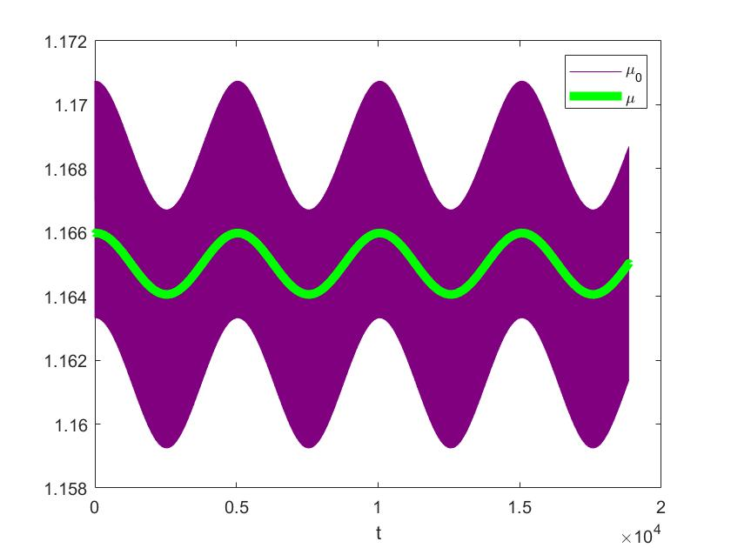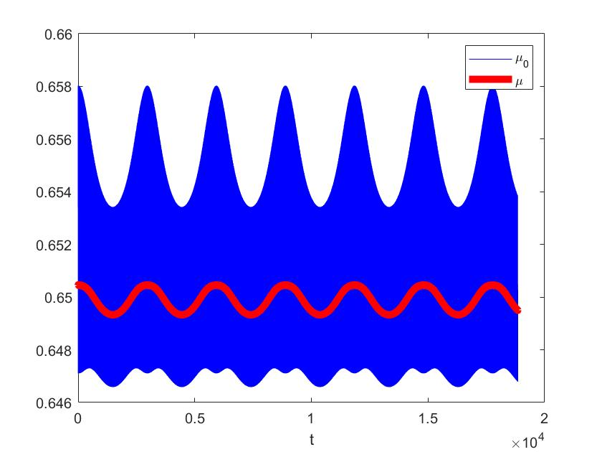
Fig. 2: Dependence of $μ_{0}$ (blue) and $μ$ (red) on time for passing particle with $R\left(t=0\right)=\left\{R+0.25R, 0,0\right\};Λ=0.7, ϕ=0$.
Fig. 1: Dependence of $μ_{0}$ (violet) and $μ$ (green) on time for trapped particle with $R\left(t=0\right)=\left\{R+0.25R, 0,0\right\};Λ=0.2, ϕ=0.$

4. References

[1] Northrop T. The Adiabatic Motion of Charged Particles. Wiley-Interscience: New York, 1963.
[2] Ilgisonis V.I. Guiding-center theory for three-dimensional collisionless finite Larmor radius plasmas. Physics of Fluids B. – 1993. – V. 5. – P. 2387.
[3] Strelkov V. History of the T-10 tokamak: Creation and development. Plasma Physics Reports. – 2001. – V. 27. – P. 819.
[4] Antonsen T.M., Lane B. Kinetic equations for low frequency instabilities in inhomogeneous plasmas. Phys. Fluids. – 1980. – V. 23. – P. 1205.
[5] Catto P. Linearized gyro-kinetics. Plasma Physics. – 1978. – V. 20. – P. 719.

