Crystal Engineering and Solid-Solutions: from Precessional Motion to Binary and Ternary Solid Solutions of Ionic Plastic Crystals

Simone d’Agostino¹, Luca Fornasari¹, Michele R. Chierotti², F. Rossi², Roberto Gobetto², Dario Braga¹

¹ Department of Chemistry “Giacomo Ciamician”, University of Bologna, 40127, Bologna, Italy.
² Department of Chemistry and NIS Centre, University of Turin, 10125, Turin, Italy.

Corresponding author e-mail address: simone.dagostino2@unibo.it

1. Introduction

Crystal engineering [1] is a multidisciplinary branch of chemistry that aims to design molecular solids with specific physical and chemical properties through an understanding of the crystal packing and manipulation of intermolecular interactions governing the final assembly in the resulting solid. The two main strategies currently in use in crystal engineering are based on (i) polymorphism, namely the phenomenon wherein the same chemical compound exists in more than one crystal form, and (ii) preparation of multi-component systems (co-crystals and solid-solutions). Co-crystals are supramolecular assemblies held together by intermolecular interactions (hydrogen and halogen bonds), and offer the possibility of achieving discrete variations of the chemical-physical properties. On the other hand, solid-solutions are materials in which some components are randomly distributed, and whose chemical-physical properties can be varied continuously. Solid-solutions can be formed when mixing isomorphous, or at least isostructural, crystals with difference of the molecular components in terms of electronic features, size, and shape are less than the 15% [2].

2. Results

In this talk, I will show two examples [3,4] concerning the solid-state dynamic behavior and phase transition of supramolecular salts made up of globular cations and halides as counterions, and how it is possible to modulate their order-disorder transitions though the formation of crystalline solid-solutions. In the first example the solid state dynamic behavior and phase transition of the supramolecular salts of general formula [1∙(DABCOH₂)]X₂ (where 1 = 12-crown-4; X = Cl⁻ or Br⁻) and of their solid solutions [1∙(DABCOH₂)]Cl_{2x}Br_{2(1-x)} is investigated by a combination of solid state techniques (Fig. 1). In the second example we describe a simple, though effective, approach for the modulation of the plastic transition in the ferroelectric salts (R)-3-hydroxlyquinuclidinium halide, [QH]X (X⁻= Cl⁻, Br⁻, and I⁻), based on the formation of binary and ternary solid solutions. Formation of mixed systems allows the modulation of plastic transitions over a wide range of temperature (0 - 69°C). The results are rationalized on the basis of the structural differences between the components (Fig. 2).

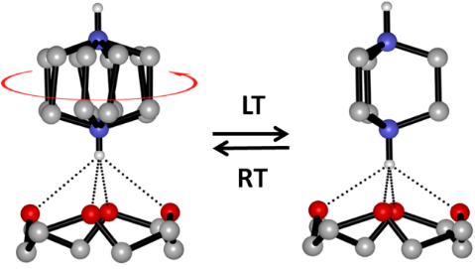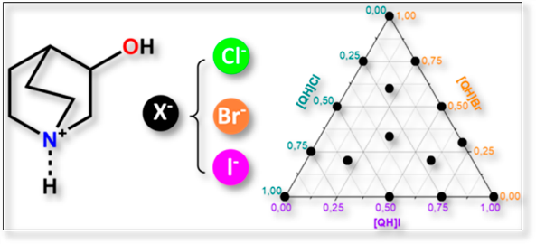
Fig. 2: Ternary diagrams showing plastic transition of the solid solutions. (left) and the corresponding plastic transition
temperature.
Fig. 1: Representation of the fully reversible interconversion between the RT and LT phases.

3. References

[1] G. M. Desiraju. J. Mol. Struct. 656 (2003) 5.
[2] M. Lusi. Cryst. Growth Des.18(2018) 3704.
[3] S. d'Agostino, L. Fornasari, D. Braga, F. Grepioni, M. R. Chierotti, R. Gobetto, F. Rossi. Chem. Eur. J. 24 (2018) 15059.
[4] S. d'Agostino, L. Fornasari, D. Braga. Cryst. Growth & Des. 19 (2019) 6266.

