Annealing Effect on Nanostructures VO₂ and Potential Application as Gas Sensor Device

A. Simo^{1, 3,} R. Madjoe³, B.T. Sone¹, L. Kotsedi¹, B.Mwakikunga², M. Maaza^{1, 4}
¹Nanosciences African Network, Nanoscience Laboratories, Materials Research
Dept., iThemba LABS-National Research Foundation, PO Box 722, Somerset West 7129,
²DST/CSIR National Centre for Nano-Structured Materials, Pretoria, South Africa
³Physics Dept., University of Western Cape, Belleville, South Africa
⁴Faculty of Sciences, Pretoria-Tshwane University of Technology, Private Bag X
680, Pretoria, South Africa.

E-mail: simo@tlabs.ac.za

Abstract. In this study we present the synthesis of nanoplatelets VO₂ (A) by the hydrothermolysis method. The prepared samples were subjected to an annealing treatment in argon and nitrogen gas ambience at 500˚ C for 3 hours. This was done to study the effect of heat catalyst on the atomic structure and vibrational modes of the material. The composition and nanostructure were analysed using Raman spectroscopy. The differential scanning calorimetry analysis showed that the crystallization temperature of the annealed samples shifted to approximately 67 ˚C transition temperature of VO₂ (M). This properties of the synthesized material resulted in efficient gas sensing of hydrogen gas at 50 ˚C.

1. Introduction
Interesting physical properties and potential device applications have drawn much attention of one dimensional nanoscale materials since the discovery of carbon nanotubes [1]. Different kinds of materials have been successfully synthesized including the fabrication of nanometer scale electronic devices with a variety of functions. Furthermore, as the demand for fabrication of special nanoplatelets structures increase, development of a method not only for synthesizing but also for modifying the properties of as-synthesized nanoplatelets is becoming increasingly important. For example excellent H₂ sensors need high surface to volume ratio for quickest response at low operating temperature and high surface interactions with H₂ [13]. VO₂ tetragonal [VO₂ (A)] is based on an oxygen bcc lattice with vanadium in the octahedral where the oxygen atoms are mainly aligned along one direction [2, 3] as seen in figure 1. It possesses a tetragonal structure with P42/nmc and can be directly transformed to VO₂ monoclinic [VO₂ (M)] under annealing treatment. Although there have been some reports on the synthesis of VO₂ (A), no reports on the synthesis of nanoplates VO₂ (A) + VO₂ (M) structures and on their annealing effect and direct application as gas sensing have been done. In the present study we use bulk V₂O₅ as the precursor material and hydrothermally reduce it to metastable VO₂ (A) nanoplates using simple aliphatic alcohols and aldehydes simultaneously as the reducing and structure-directing agents. Subsequently an annealing process is used to transform the VO₂ (A) nanostructures to monoclinic VO₂ (M) under Argon gas and compare to the one annealed under Nitrogen. VO₂ (A) is the thermodynamically stable phase compared with VO₂ (B) and is much more stable than VO₂ (R) ( VO₂ (R) and VO₂ (B) represent the polymorphic phases in VO₂ system where VO₂ (R) present a reversible phase transition at 68˚ C) according to the calculations principles using the hybrid function HSE06. VO₂ (A) possesses a density of 4.035 g/cm³ and band gap energy of 0.21eV. See the crystalline structure on figure 1a).

2. Experimental techniques
All the reagents were of analytical grade and used without further purification. 0.75ml of Sulfuric acid H₂SO₄ (Kimix, 98%) followed by the drop-wise addition of 0.25ml of N₂H₂·2H₂O (Merck) were added into an aqueous suspension (10 mL) containing 0.45g of V₂O₅ (Alfa Aesar). After being warmed at 95˚C while stirring, the solution changes from yellow to green, then green to blue, characteristic of the presence of V⁺⁴ ions in the solution, finally blue to gray[7]. For the H₂ gas sensing experiments, a standard in-situ 2 contact points-based system was used. The cold pressed VO₂ (A) nanobelt pellet was squeezed between two Al electrodes and a Si substrate wafer while the whole was interfaced to a heating stage (25-170 °C).
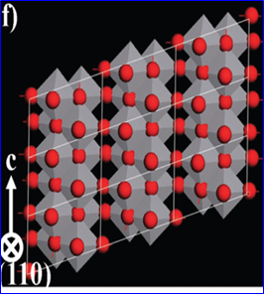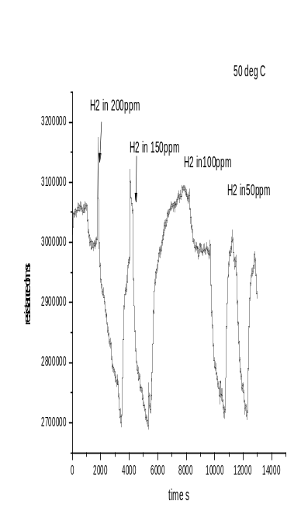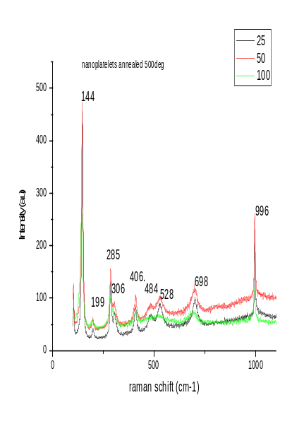
- b) c)
Figure 1: a) Arrangement of VO₆ octahedra in real crystalline structure in (010) of VO₂ (A), b) various responses at room temperature for different H₂ concentrations in dry air, c) Raman spectra collected for nanoplateletsVO₂ annealed at differents output power 25mW, 50mW and 100mW.

3. Results and discussion

3.1 Gas sensing properties
The gas sensing properties of VO₂ nano-platelets has been investigated at room temperature in N₂ dry air at different pressures of H₂ gas using the conductometric sensor signal. The increase in the resistivity is due to the injection of the H₂ gas describing the charge transfer with the material and because the low temperature favors the adsorption of negatively-charged hydroxyl species according to the equation below [4]:
(1) (Below 100 ˚ C)

Intrinsic oxygen atoms trap the electron in the n-type VO₂ (A) metal reducing the charge carrier density in a depletion region close to the surface due to the band bending at the surface [5]. Depletion regions occur between grains giving higher resistance. A wide variety of events occur when a molecule impinges upon a surface. It may be reflected with no loss of energy or it may suffer a redistribution of momentum and be diffracted by the surface again with no loss of energy. In the case where the hydrogen molecules lose sufficient quantity of energy they become effectively bound to the surface with strength depending on the kinds of atoms involved. The resistance underwent a drastic drop when the gas is shut off exhibiting n-type semiconductor characteristic of VO₂ (A). This whole process responsive behavior has been qualified as conduction type inversion n-to-p of the sensing material whose conduction is surface trap limited owing to the high surface to volume ratio of this material [6]. Nanoparticles have appreciable fraction of their atom at the surface as the data. A number of properties of materials composed of nanometer sized grains depend strongly on the surface area. The specific surface area of a catalyst is customarily reported in the units of the square meter per gram. ρ is the density expressed in g/cm³, d is the diameter and V the volume. A cylinder of diameter d and length L has a Volume πd²L⁄4 and A=2 πrL. Hence the surface area is given by:
S = area/ρV = A/ρV, and S (m²/g) = 4×10³/ρd for d≪L. (2)
This relation is justified for nanowires, nanosheet or nanoplate. The recovery response is rapidly restored after injection of the gas. This proved the good stability of the gas sensor with high surface to volume ratio. Figure1 c) presents Raman response of VO₂ (M) annealed under N₂ at room temperature giving structural information of the material, obtained by excitation of continuous wave laser light with a 514.5 nm line from argon ion. It is possible to identify the in situ molecule and to determine the amount of the molecule present in the sample. Most molecules at rest prior to interaction with the laser and at room temperature are likely to be in the ground vibrational state.
Table1. Size Variation from 20-500 nm obtained giving different surface area ratio:
Size (nm) | 20 | 30 | 60 | 70 | 80 | 95 | 120 | 150 | 500
S (m²/g) | 19826.52 | 33.04 | 16.52 | 14.16 | 12.39 | 10.44 | 8.26 | 6.61 | 1.98
Therefore the majority of Raman scattering will be Stokes Raman scattering. The ratio of the intensities of the Stokes and anti-Stokes scattering is dependent on the number of molecules in the ground and excited vibrational levels. We notice that the output power at 50 mW was the best choice providing the best spectral resolution of the full width at half maximum. The spectrum presents some raman lines of V₂O₅ which are very close to the lines of VO₂: 144cm⁻¹, 199 cm⁻¹, 306 cm⁻¹, 406 cm⁻¹. We note that the change of the surface stoichiometry oxidation induced by a local heating at 100 mW (lowering of the vibration modes) may be responsible for the change of Raman line position. Hence nanoscale interactions occur at the surface which present small amount of V₂O_{5.}
3.2 Morphological studies and elemental analysis
The morphology of the synthesized crystals was observed by A Tecnai G2 F20X-Twin MAT field emission high resolution transmission electron microscope (HR TEM) operated at 200 KV Field emission used to investigate the atomic structure and the presence of different oxidation state of the nanocrystals equipped with an elemental EDAX system. As typically reported on figure 2, the surface morphology of the samples exhibit one dimensional nanoplatelet structures. This was found to be correlated to the V₂O₅ initial concentration and the high surface-energy liable with chemical reactions of the medium and becauseV₂O₅ crystallizes in an orthorhombic structure comprising layers of [VO₅] square pyramids sharing edges and corners with a structure only weakly bound along the crystallographic b axis, which enables the facile intercalation of different molecular species within the interlayer sites [8]. The dimension of the crystallites is in the range of 20 nm to 150 nm for the as-prepared material and around 50-500 nm for the annealed sample. That means that annealing temperature induces significant grain growth promoting twin formation in larger grains. The elemental composition of the material acquired from the X-rays emitted shows that the elemental composition is only constitute of vanadium atoms and oxygen with high intensity showing the nucleation of grains and crystallization of the particles.
3.3 DSC Analysis and structural study of as-synthesized material
The metal insulator phase transformation has been studied via DSC on cooling and on heating. See figure 3. The isotherms that occur during the thermal cycling explain the kinetics of the phase transformation of the system. In both samples (as-synthesized and annealed), two peaks were detected during the experiment from room temperature to 110°C at 10 °C/min with the presence of a flowing of nitrogen gas at 5 ml/min. The as prepared presents a big hysteresis in order of 9 °C comparing to the one anneal with 6.7 °C. This is due to the particle size of the material. The as synthesized material peaks transition is due to the presence of slightly metallic atoms inserted in the tetragonal metastable domains for the VO₂ (A). The insulator to metallic transition in the annealed sample occurs at 67.1°C with an enthalpy of -3.596 W/g related to the exothermic peak where the crystallization of the material occur and the metallic to insulator transition occurs at 60.4°C with an enthalpy of 3.1W/g transition, only 85.28 % recovery of the monoclinic phase with a giving hysteresis of 6.7°C in peaks temperature between heating and cooling different from the literature which can be assigned to the stress in the sample. Changes in enthalpies of transformation are attributed to elastic stored energy and to some untransformed rutile phase [9, 14] that we determine as percolative phenomena.

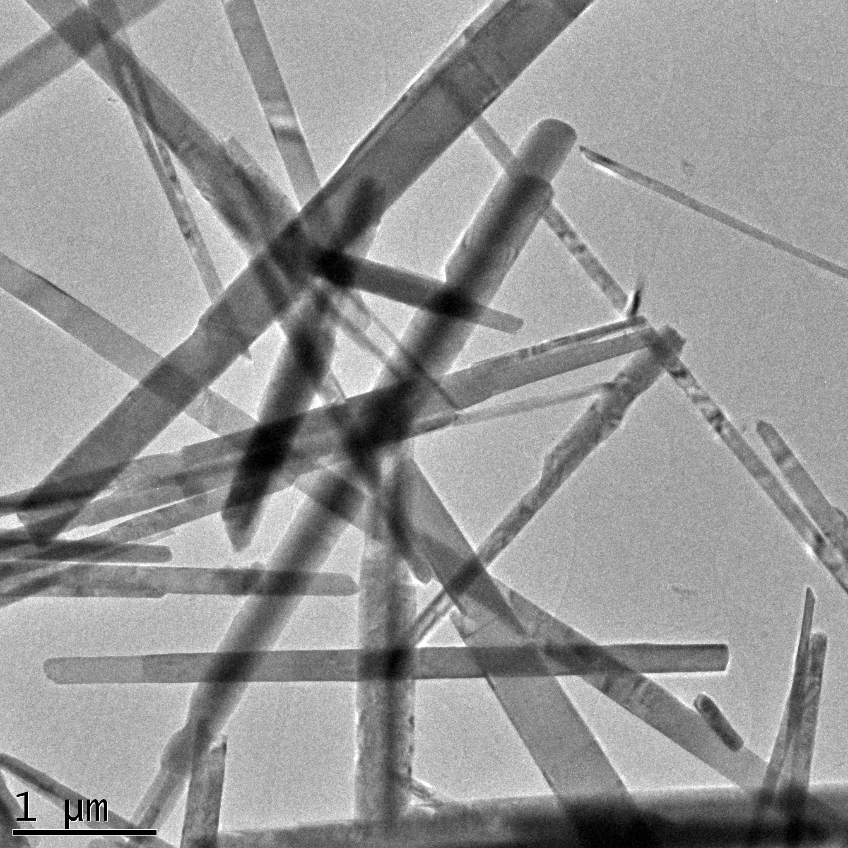
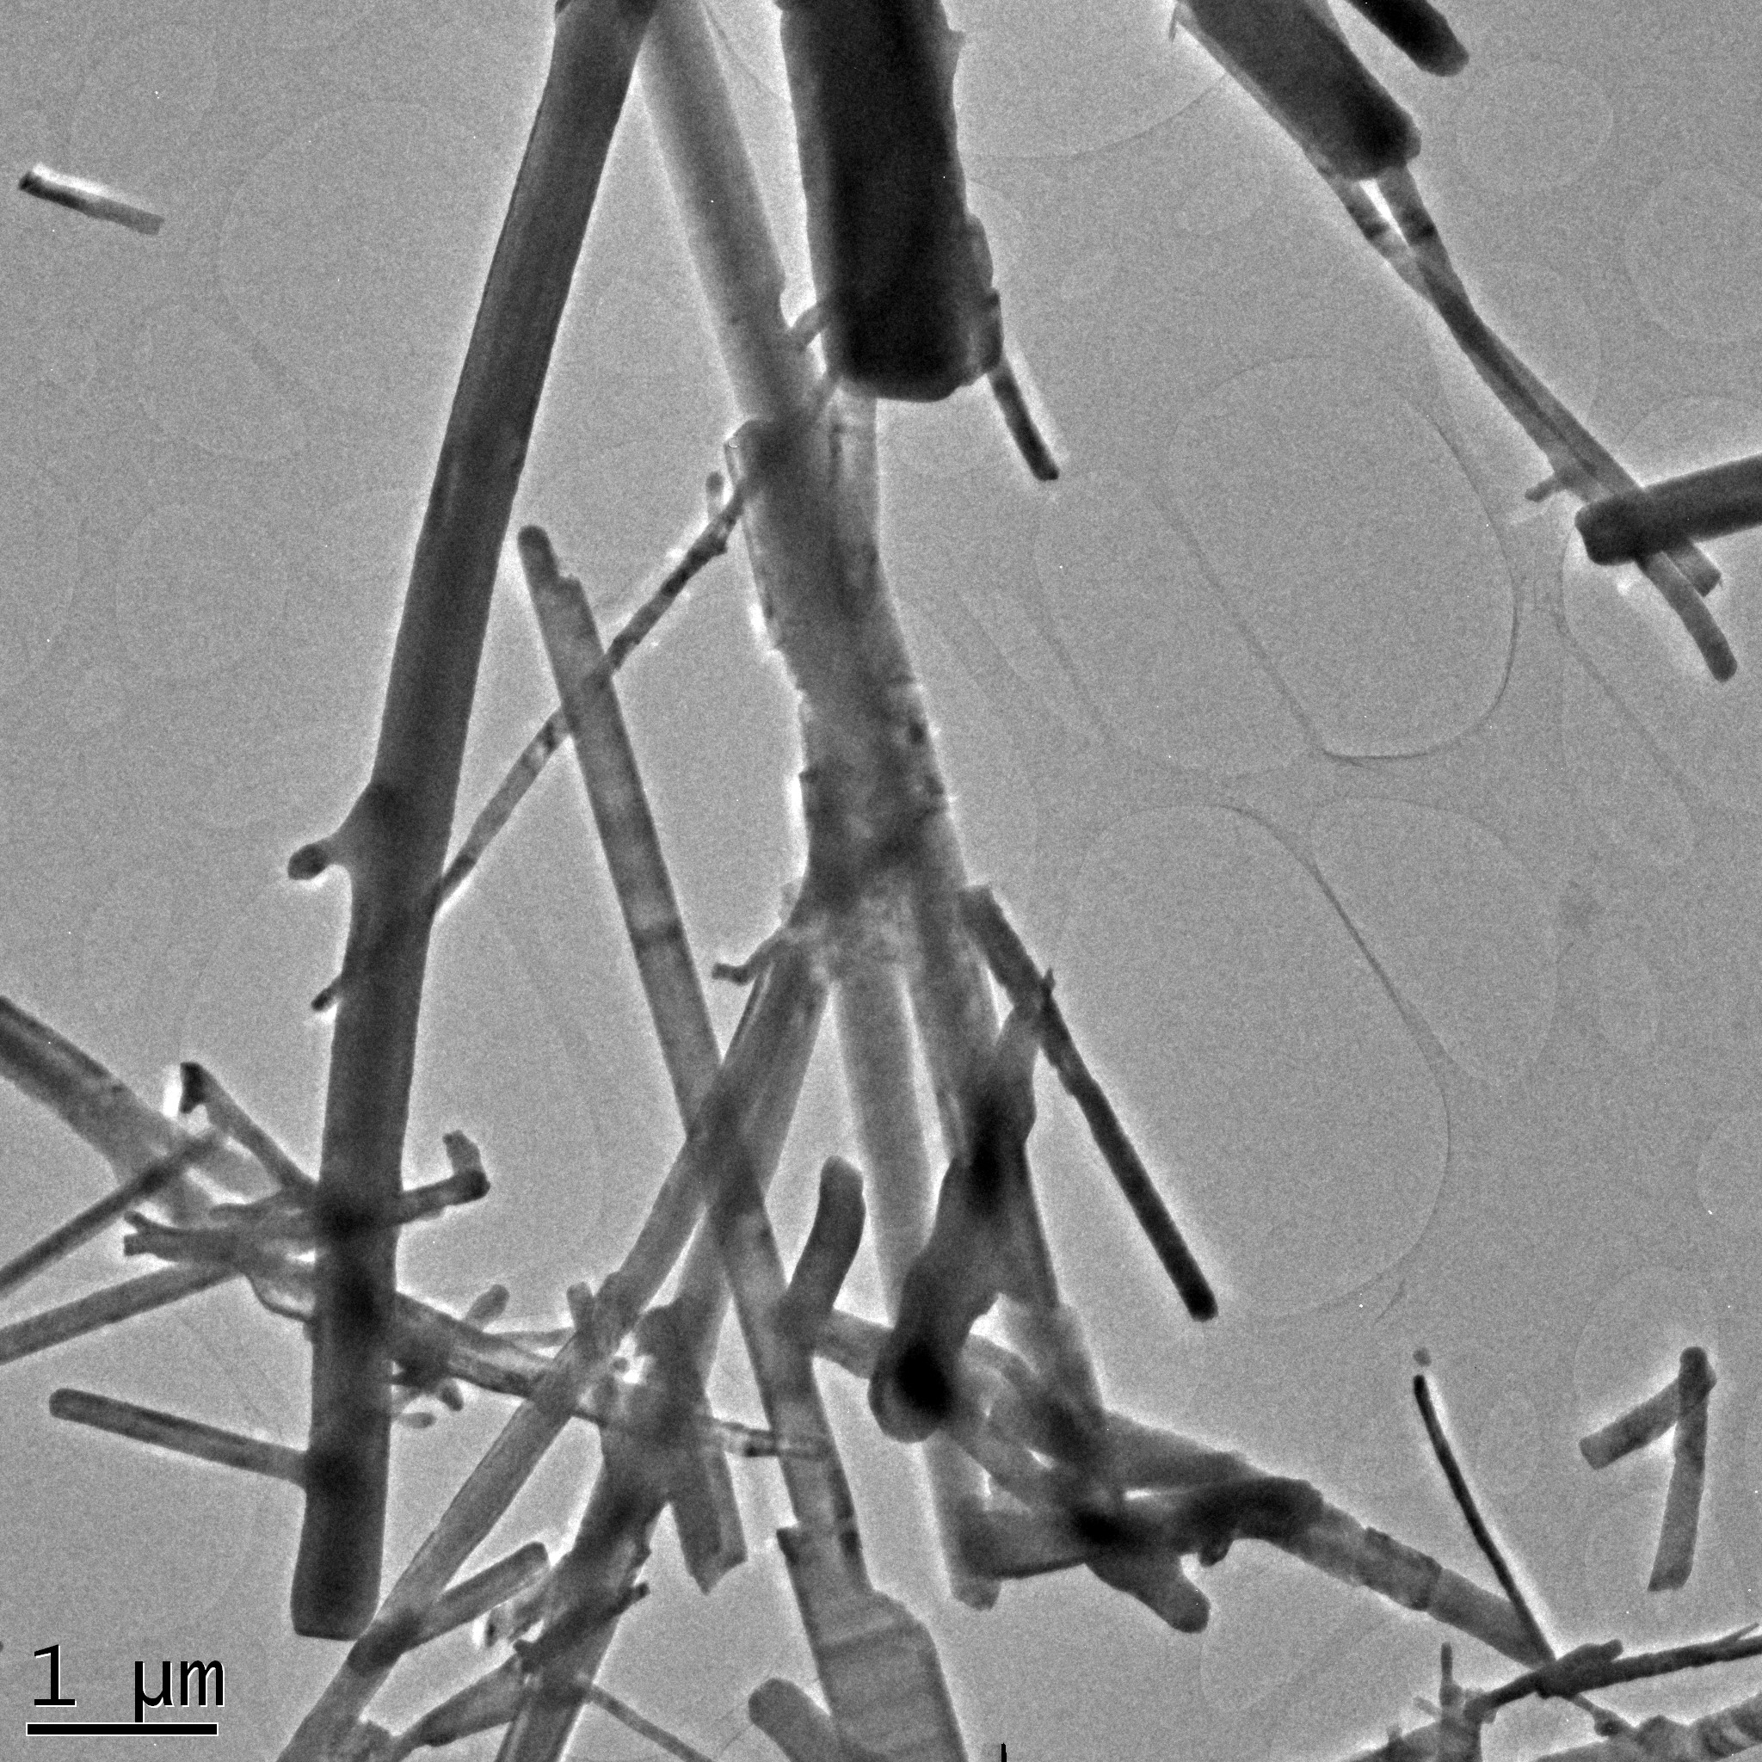
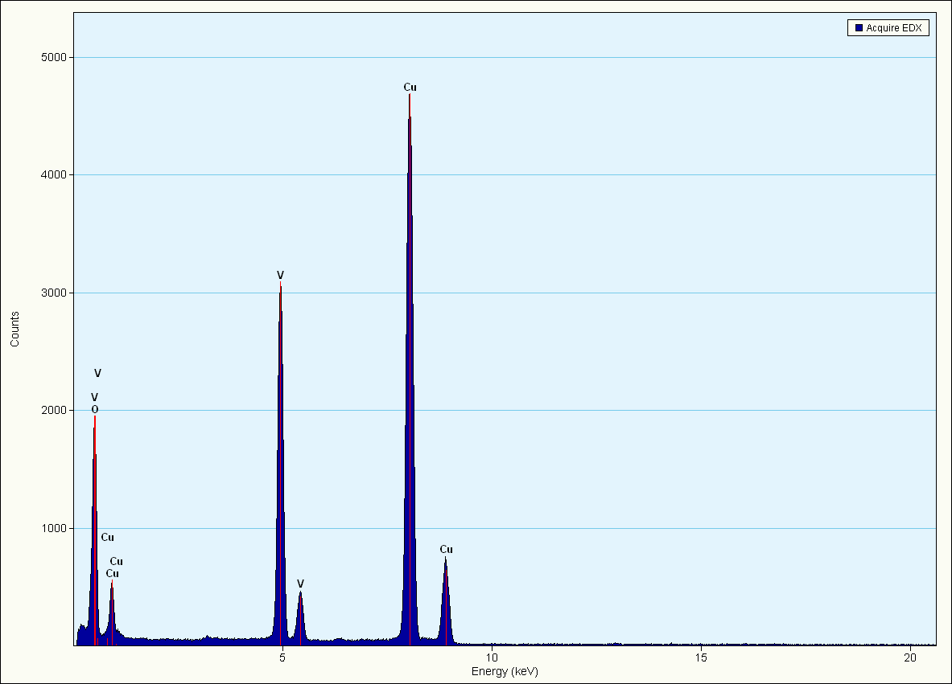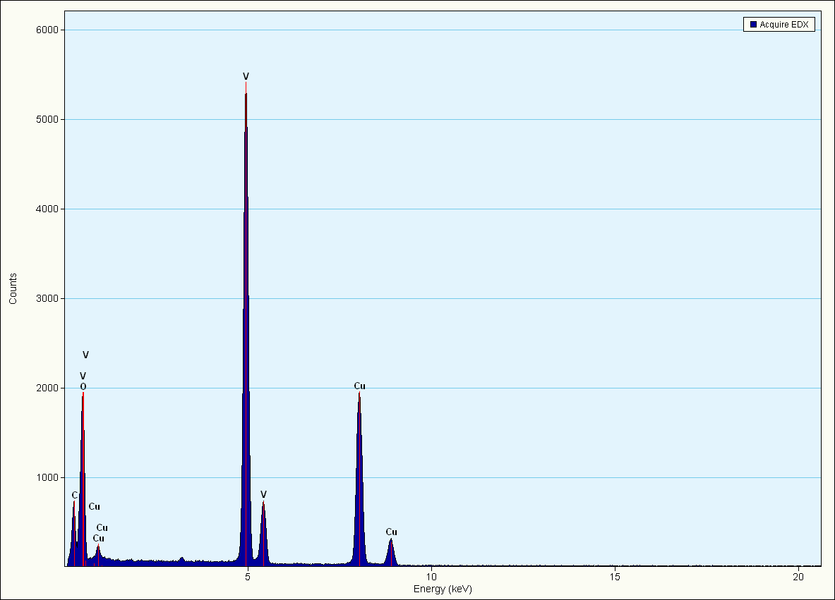

Figure 2. High magnification Transmission electron microscopy images and EDX spectra of VO₂ as-synthesized and anneal nanoplatelets.

The kinetics phenomena occur at different times. The well crystallized material after annealing present the transition temperature from VO₂(M) to VO₂ (R) taking place after 10 min and stop after 18 min while in the as-synthesized sample only few metallic domain transit to VO₂ (R) just for 2 min approximately. Hence the ultrafast of the metal to insulator transition is proportional to the density of atoms intending to nucleate upon annealing temperature. Multiple physical phases or domains with dimensions of nanometres to micrometres can coexist in these materials at temperatures where a pure phase is expected. Making use of the properties of correlated electron materials in device applications will require the ability to control domain structures and phase transitions in these materials [11]. Measures of the temperatures and heat flows associated with transitions in the material as a function of time and temperature in a controlled atmosphere (N₂) were obtained via Differential Scanning Calorimetry (DSC).
The grain structure measured with the Software Image J presented in figure 4 shows that the grain size is smaller for high interspacing lattice for as-synthesized material approximately 0.400-0.600 nm ([110]) while for annealed sample the grain junction is shrinked and the intespacing become smaller 0.300 nm reducing residual stresses and optimization of the uniformity of the sample. The determination of the material phase and crystallinity was done using XRD crystallography. The majority of the peaks are indexed as VO₂ (A) according to a JCPDS card 00-042-0876. The lattice parameters a and c are 8.45000 Å and 7.68600 Å respectively and Z=16. The space group is P42/nmc. Figure 5 reveals sharp peaks and intense diffraction with a preferential orientation along (110) which demonstrates that the sample is well crystallized without impurities and we note also the presence of some peaks belonging to VO₂ (M) with a weak intensity. It has been demonstrated that the distortion of the VO₆ octahedra in the low temperature VO₂ (A) phase is similar to the monoclinic VO₂ (M) phase [12].
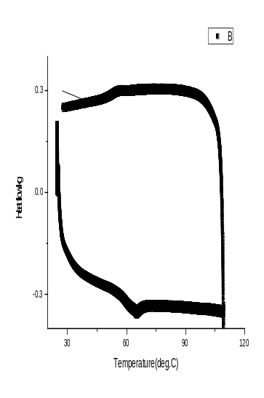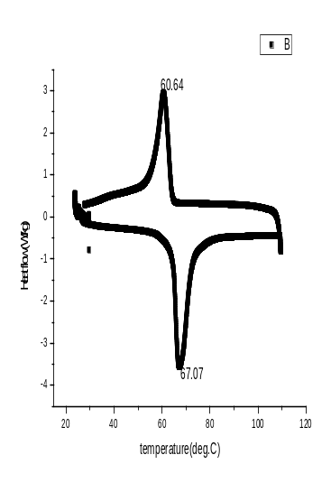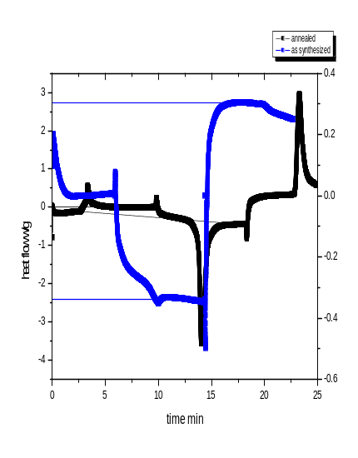
Figure 3. DSC curve showing the reversible phase transformation in the material during the thermal cycling in as synthesized material VO₂ (A) and VO₂ (M) and kinetics effects of both samples.

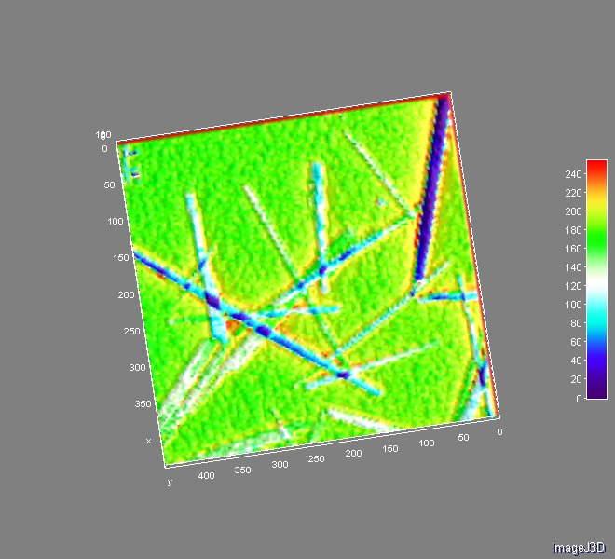
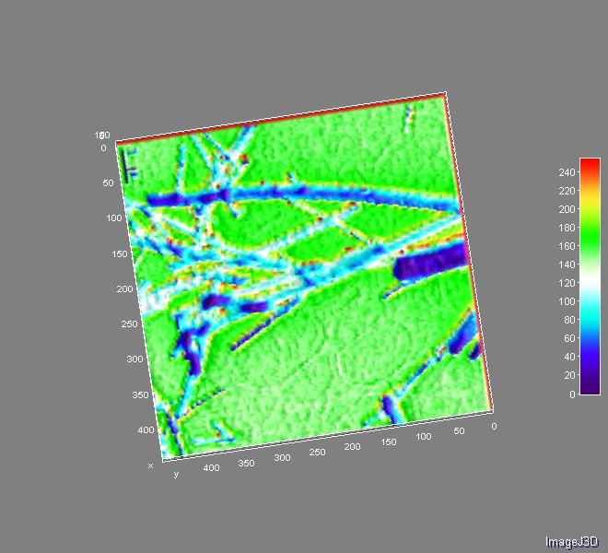
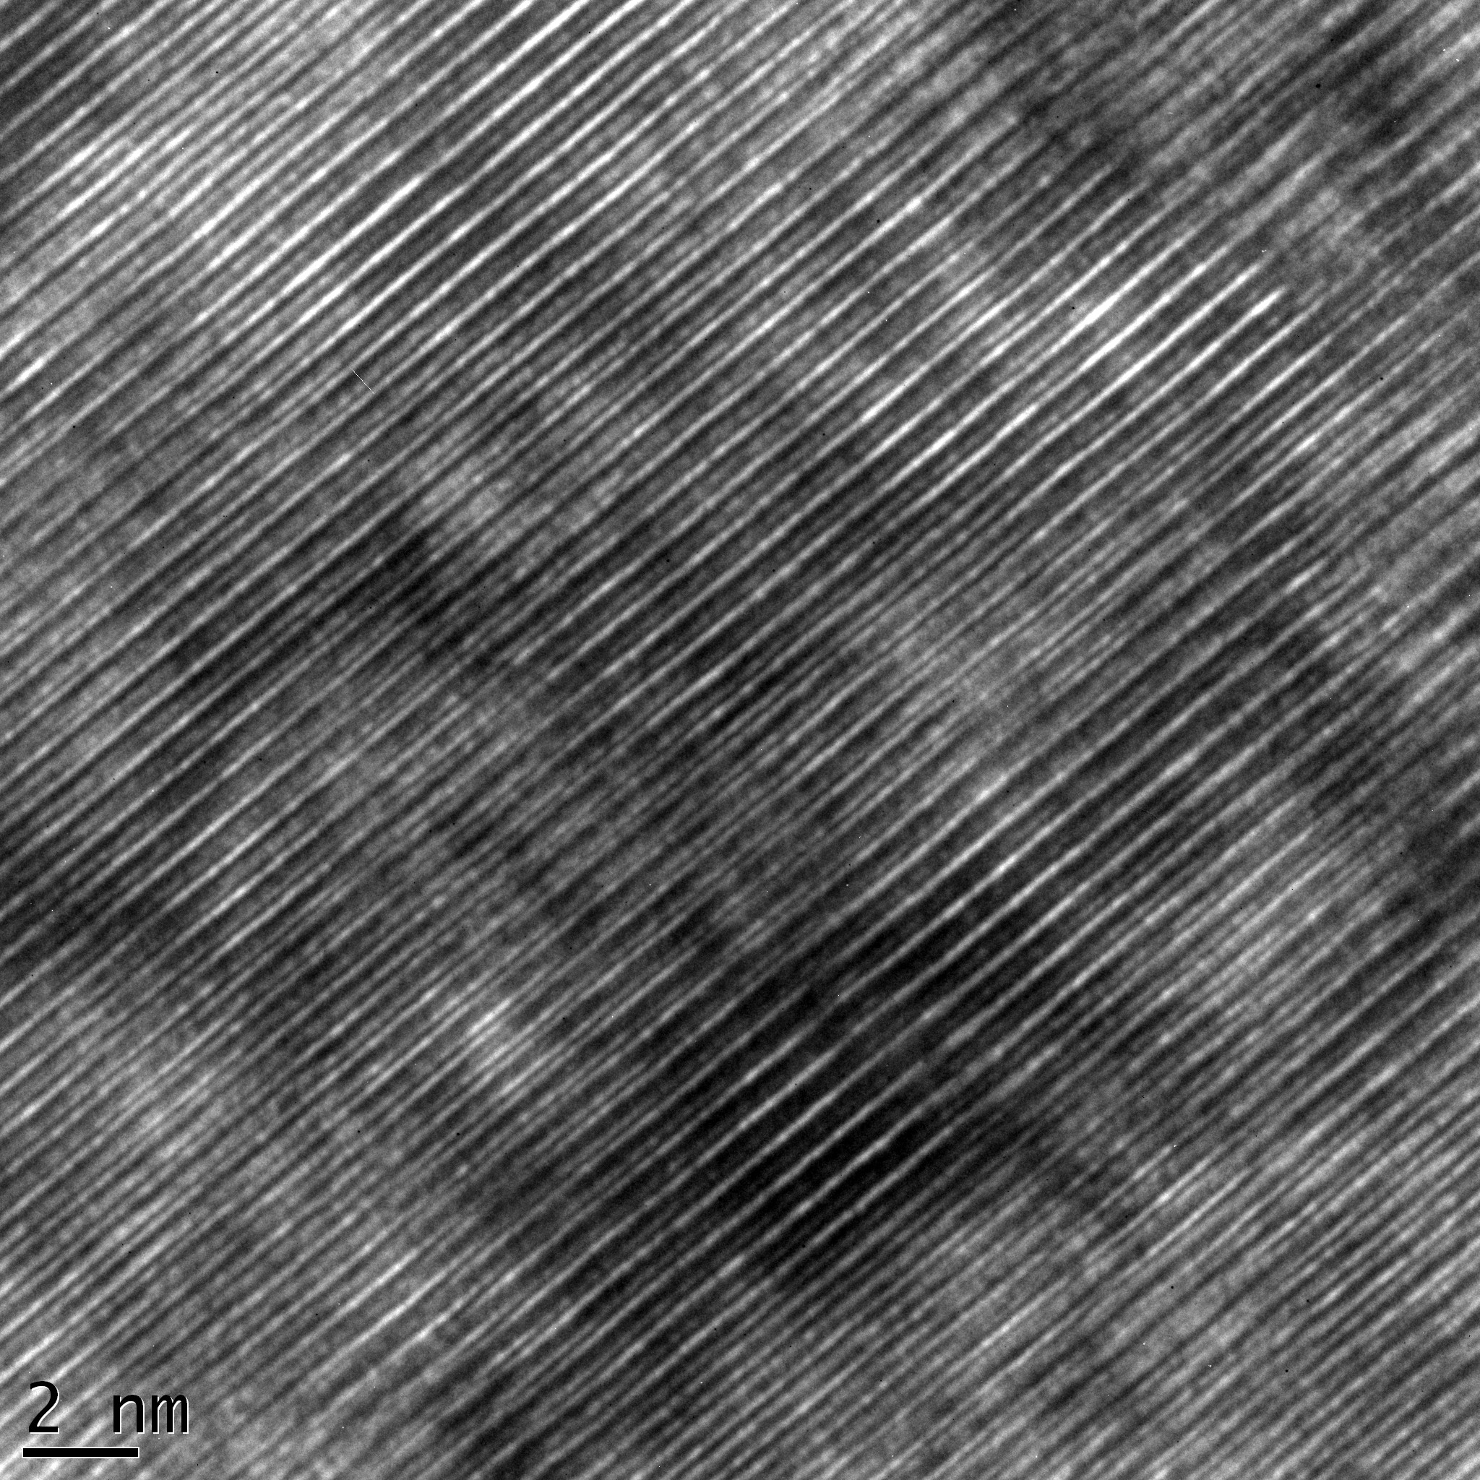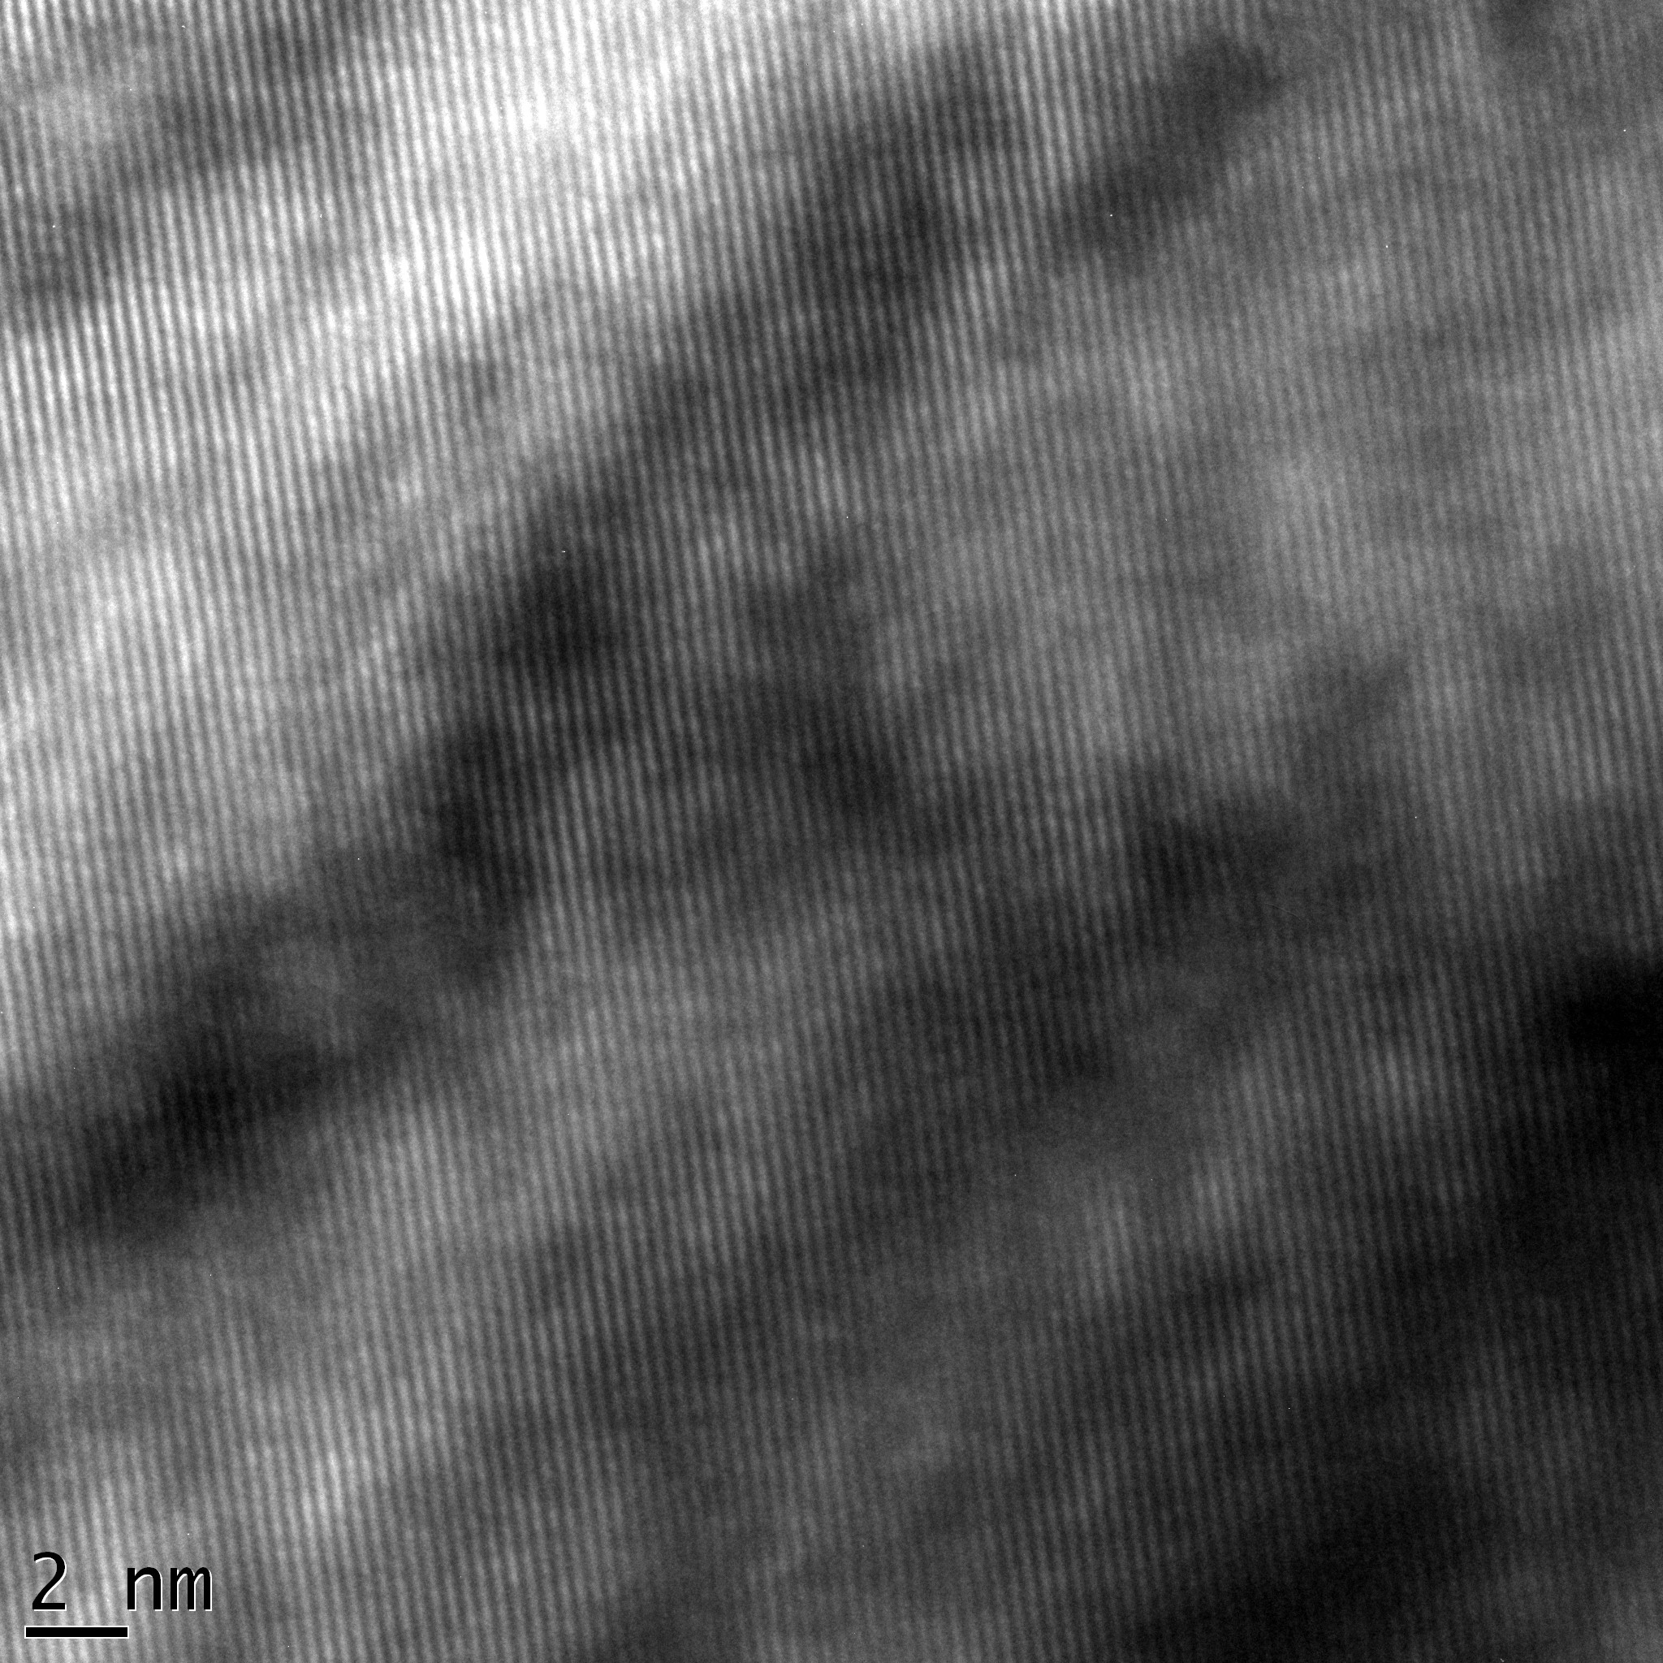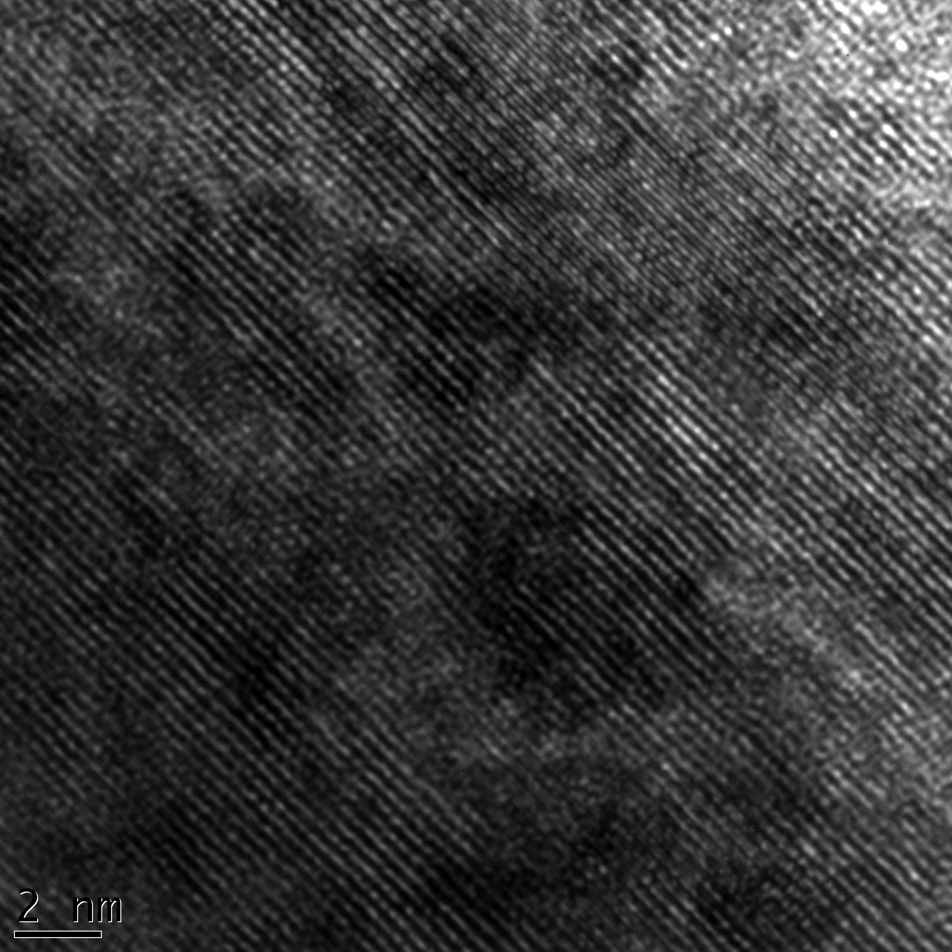
0.600 nm
0.300 nm
As-synthesized Argon treatment N₂ annealing

Figure 4. Grains structure observed at different annealing gas as indicated.

After annealing at 500 °C, the (110) peak decreases in intensity when the material has been annealed under Nitrogen while it is completely vanished under Argon. The nanostructures exhibit two crystallographic structures: stable monoclinic and metastable tetragonal. Generally two main processes determined the phase transformation in annealing process: annealing temperature and time and interfacial stress. Here we see that the complete phase transformation is only possible with an annealing under Argon gas which is inert and act as gas purifier to prevent oxidation from the vanadium oxide, comparatively to the one under Nitrogen which interacts with the material and delays the metal insulator phase transition. The surface region appears as an imperfect region due to the presence of high surface region to volume ratio meaning that the number of atoms on the surface is comparable to the one inside the particles where atoms relax inside the normal lattices sites. The surface structure of nanoplatelet indicating interior of nanoplatelets as synthesized and annealed respectively presents highly surface active atoms with high surface energy where transition begins upon thermal treatment.

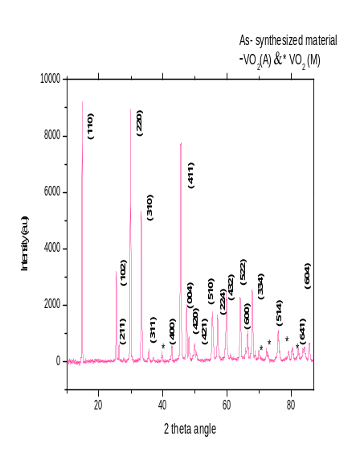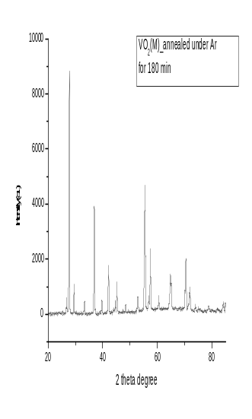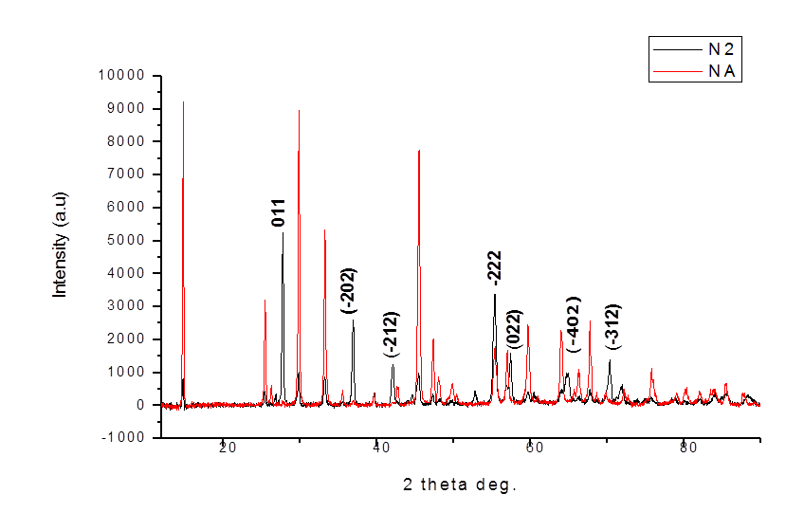
- b) c)
Figure 5. Typical room temperature indexed X-rays diffraction of the as-synthesized a) annealed under Argon b) and annealed under Nitrogen c) nanostructures materials.

4. Conclusion
In summary, nanoplatelets VO₂ (A) nano-crystals was well synthesized by hydrothermal process with a percentage of crystallinity of 89%, presenting high surface to volume ratio due to the smallest size of the particles. The annealing treatment under N₂ gas and Ar gas gives good insight of internal transformation taking place in the material. The annealing under Argon gas appears preferable due to the optimum crystallization and purity of the material comparatively to the one under Nitrogen which interacts with the material and delays the metal insulator phase transition. Additionally, the as-synthesized material was discovered for the first time to be applicable as gas sensing device at room temperature under H₂. As future work the optimization of the nanoscale structure to enhance the sensitivity of the material is required and the testing of the annealing sample under same conditions and operating at differents temperatures to follow the effect of annealing time and annealing temperature on the electronical properties are highly demanded for the development of the gas sensing device.

Acknowledgements
This work was sponsored by the OWSDW with iThemba LABS-MRD/ National Research Foundation of South Africa, Tshwane University of Technology and the Council for Scientific and Industrial Research in South Africa, as well as the Abdus Salam ICTP-Trieste, Italy.

References
[1] Hyoun W K, Seung H S, Jong W L, Chongmu L, Sae C J 2008 Optical Materials 30 1221-
1224
[2] Leroux C, Nihoul G, Tendeloo G V 1998 Physica Review B 57 9
[3] Zhang S, Shang B, Yan J, Yan W, Wei S and Xie Y 2011 Phys.Chem.Chem. Phys. 13 15873-
15881
[4] Koch C C Nanostructured Materials Processing, Properties and Potential Applications 2002
(Noyes Publications/William Andrew Publishing)
[5] Bochenkov V V E, Sergeev G B Metal Oxide Nanostructures and their Applications
Department of Chemistry 2010 p 31-52
[6] Huang J and Wan Q Review Sensors 2009 9903-9924
[7] Simo A, Edomwonyi-Out L C, Madjoe R and Maaza M 2012. Direct Synthesis of Pure
Radiative VO₂ (M) Plate Like Structures via Hydrothermolysis at Low Temperature. MRS
Proceedings, 1406
[8] Whittaker L, Zhang H and Banerjee S, J. Mater. Chem. 2009 19 2968
[9] Tselev A, Strelcov E, Luk’yanchuk I, Budai J, Tischler J, Ivanov I, Jones K, Proksch K
Kalininand S, Kolmakov A Nano Lett 2009 10 2003-2011
[10] Nag J, Haglund R F, Payzant E and More K, Cond-Mat 2010 3876
[11] Cao J, Ertekin E, Srinivasan V, Fan W, Huang S, Zheng H, Yim J W L, Khana D R,
Ogletree D F, Grossmanand J,Wu J C, Nature Nanotechnology 2009 4 732
[12] Zhang S, Shang B, Yan J, Yan W, Wei S and Xie Y Phys.Chem.Chem.Phys. 2011 13 15873-
15881
[13] Ou J Z, Yaacob M H, Campbell J L, Breedon M, Kalantar-zadeh K and Wlodarski W Sensors
and Actuators B 2012 1–6 166–167
[14] Bai H, Berkhan M and Cortie M B, PROCEEDINGS – 31ST ANNUAL CONDENSED
MATTER AND MATERIALS MEETING – 2007

