Microstructural properties of thermal induced microcrystalline silicon carbide thin films deposited by HWCVD
J Khoele, S Halindintwali, B A Julies and S Mkhwanazi
Physics department, University of the Western Cape, Private Bag X17, Bellville 7535, South Africa
E-mail: 3075072@uwc.ac.za
Abstract. Amorphous Silicon carbide samples were prepared by Hot –Wire Chemical Vapor Deposition (HWCVD) at low temperature of the substrate. A gradual thermal annealing under vacuum induced a network rearrangement as shown by a change in the samples microstructure. The breaking of Si-H_{n} and C-H_{n} bonds, followed by hydrogen effusion, led all the available carbon atoms, originating mainly from C-H_{n} groups to bond to the Si atoms originating mainly from the SiH_{n} groups, and crystallize into SiC phase. The structural details are presented as studied by Fourier transform infrared spectroscopy (FTIR), transmission electron microscopy (TEM) and non contact atomic force microscopy (AFM).
- Introduction
Crystalline silicon carbide (SiC) has a number of unique properties, like a wide band gap and high carrier mobility, which make the material an excellent candidate for various optoelectronic devices [1]. The wide optical band gap and the good electrical properties of SiC make the material particularly suitable for application as a window layer in silicon (Si) based solar cells. Because of the aptitude of the HWCVD to avail a high density of H radicals, crucial for microcrystalline growth, this deposition technique has been used by many groups to produce microcrystalline SiC films at low temperature of the substrate below 400 °C using monomethyl-silane (MMS) [1-4]. In this study we employed a SiH₄/CH₄/H₂ mixture to grow amorphous and nanocrystalline SiC by HWCVD at a low substrate temperature of 260°C. Thermal annealing of the films led to a fully crystalline SiC phase. We monitor these changes using FTIR and AFM analytical techniques.
- Experimental details
The samples used in this study were deposited onto Corning glass and c-Si (100) substrates kept at 260 ºC; a tungsten filament temperature of 2000 ºC and a process pressure of 7.5 Pa were used in a commercial HWCVD system described elsewhere [5]. All samples were processed for a period of 40 minutes in order to achieve a thickness of less than 1μm. The thickness of the deposited layer was measured by a Veeco Dektak profilometer using the procedure described in [6]. Table 1 summarizes the deposition conditions. In order to study the re-organization and thermal crystallization, the samples were annealed at 700°C, 900°C and 1100°C for 60 minutes under vacuum conditions. FTIR absorption measurements were performed using a PerkinElmer Spectrum 100 spectrometer in the range between 400 and 4000 cm⁻¹. The surface morphology of the films were investigated using a non-contact atomic force microscope (AFM) using a nanoscope instrument from Veeco Metrology Group. The TEM investigation was carried out by a TECNAI F20 (S)TEM instrument equipped with EDX (Energy Dispersive X-ray Spectroscopy) and EELS (Electron Energy Loss Spectroscopy).

Table 1. Deposition conditions of the samples used in this study.
Sample | F(SiH₄) (sccm) | F(CH₄) (sccm) | F(H₂) (sccm) | Thickness (nm)
S₁ | 1.5 | 6 | 25.3 | 450
S₂ | 1.5 | 6 | 5 | 580

- Results
  - Structural properties
Figure 1 shows the FTIR spectra of the samples as deposited on c-Si substrate and of those annealed under vacuum at different temperatures. The spectra of the as-deposited samples (top graphs figure 1(a) and figure1 (b)) show the characteristic features corresponding to (SiH₂)_{n} rocking / wagging at 630 cm⁻¹ [7] in both samples S₁ and S₂; this peak is more pronounced in S₂ that has been deposited with a much smaller partial flow rate of hydrogen in the gas mixture. Additional features of SiH_{n} are observed in the sample S₂ at ~830 cm⁻¹ and 930 cm⁻¹ that have been assigned to SiH₂ and SiH₃ bending modes respectively [7]. Both spectra show also a sharp absorption peak due to SiC stretching bonds at 670 cm⁻¹ and a broad band that extends from 960 cm⁻¹ to 1100 cm⁻¹ due to CH_{n} wagging/bending modes for the lower wavenumbers below 1050 cm⁻¹ and to the asymmetric Si-O-Si stretching vibration or Si-O-C stretching modes for the higher wavenumbers above 1050 cm⁻¹ [8-10]. Again additional absorption bands observed in the S₂ spectrum provides more insight into the SiC bonding: Well defined absorption bands were observed at 765 cm⁻¹ and 800 cm⁻¹, they are assigned to SiCH₃ stretching /wagging mode [11] and ordered Si-C crystalline phase [2] respectively. Moreover the absorption band from 960 cm⁻¹ to 1100 cm⁻¹ show much better distinguishable CH_{n} and oxidation corresponding components. The three subsequent graphs in fig. 1(a) and fig. 2(b) display the spectra of the samples annealed at 700°C, 900°C and 1100°C. The main observation drawn from the spectra of the annealed samples at 700°C is a complete disappearance of the SiH_{n} related vibration bands in S₁ and a sharp decrease in their intensity in S₂.The main feature observed on the spectra of the annealed samples at 900°C is a re-crystallization into SiC phase as shown by the emergence of the SiC signal at 800 cm⁻¹ wavenumber but the CH_{n} component just above 960°C is still visible. The bottom graphs in figure 1(a) and figure 1(b) of the samples annealed at 1100°C display the only remaining vibration band centred around 800°C with a superimposed shoulder above 840 cm⁻¹ wavenumber concomitant with the disappearance of the CH_{n} vibration component above 960 cm⁻¹.
Figure 2 gives the AFM images of the as-deposited films and of those annealed. The images of both as- deposited films show as smooth surface with clear dispersed crystals; these are mainly Si polycrystals (as it has been revealed by the EDX investigation in STEM mode). The AFM images of the samples annealed at 700°C show distorted elongated grains; at this temperature the cracking of the SiH_{n} and the effusion of the released hydrogen are complete. The images of the samples annealed at 900°C reveal an increased density of the crystallites with conical shape while at 1100°C temperature of anneal, the AFM images of both studied samples show a microstructure characterized by a coalescence of the small grains in large clusters. Table 2 gives a summary of the average roughness and grains/clusters diameter calculated from AFM data.
Figure 3(a) displays a typical cross-section TEM image of the films as taken from the as-deposited S₂ sample; a crystalline columnar growth mainly perpendicular to the c-Si substrate is observed. This feature is similar to that obtained in microcrystalline Si ( μc-Si:H) films with high crystalline volume fraction [12]. The crystalline columns are built from smaller crystalline grains of a few tens of nanometers in size; in low crystalline material the column structure is less developed and individual small features are normally observed [13]. The EDX spectrum profile collected over a line scan in STEM mode of the same sample (see figure 3(b)) shows a much more dominant peak of Si compared to that of C; this result indicates that the observed SiC phase is embedded in a μc-Si:H matrix.

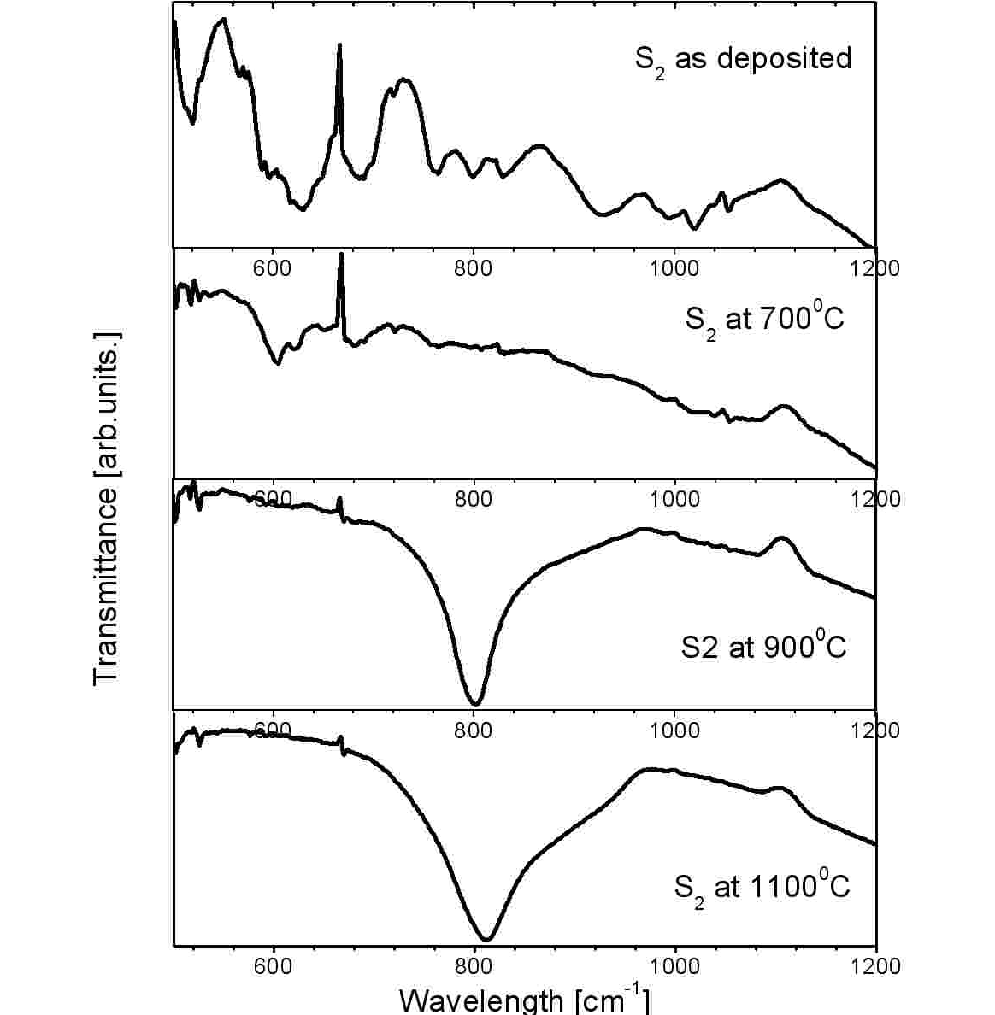
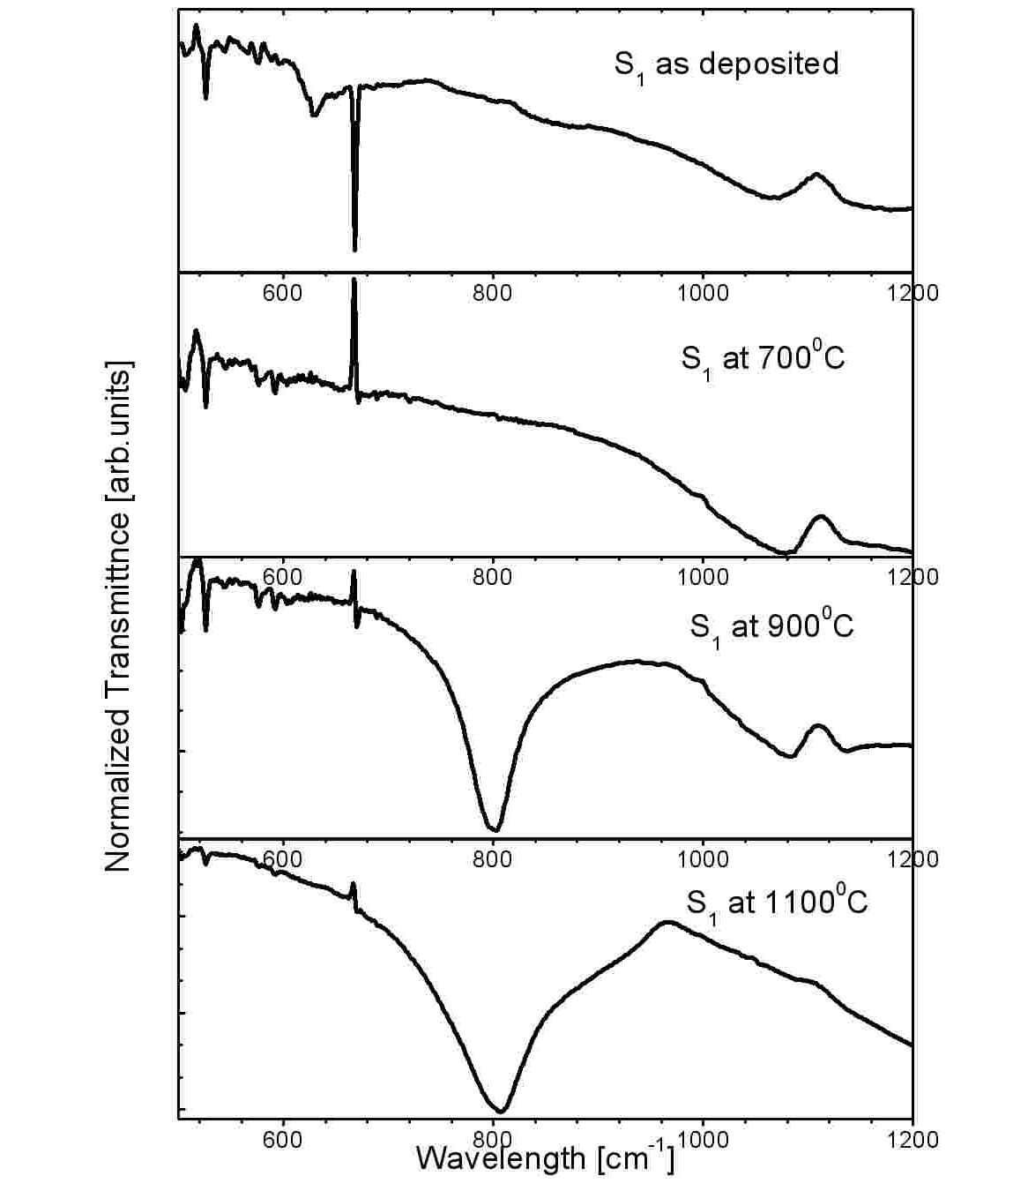
(a)

(b)

Figure 1. FTIR spectra of as- deposited and annealed samples (a) sample S₁ (b) sample S₂

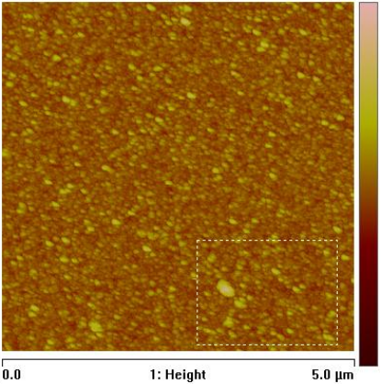
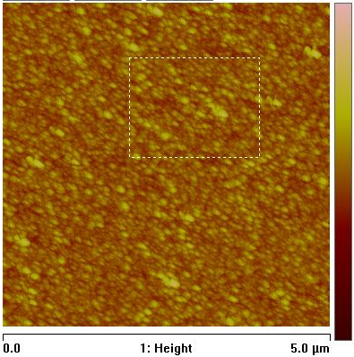

(a)
(b)

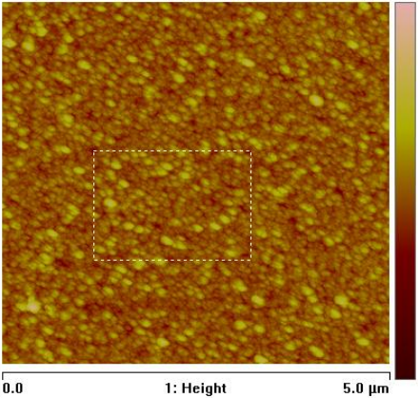
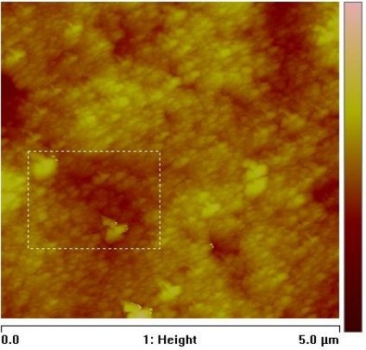

(c)
(d)

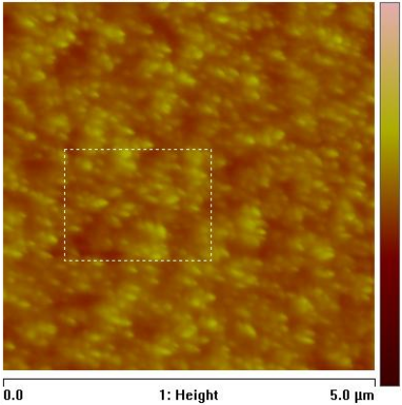
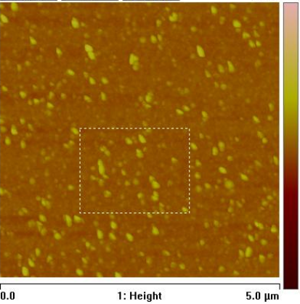

(e)
(f)

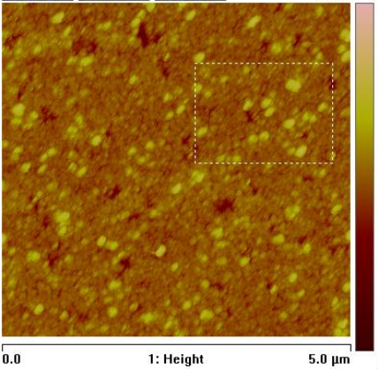
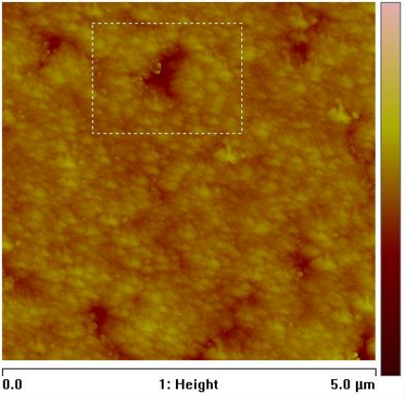

(g)
(h)

Figure 2. AFM images of the samples as-deposited and annealed: (a) S₁ as deposited, (b)-(d) S₁ annealed at 700°C, 900°C and 1100°C respectively; (e) S₂ as deposited, (f)-(h) S₂ annealed at 700°C, 900°C and 1100°C respectively.

Table 2. Average roughness and crystals/clusters diameter.
Sample |  | As-depo | 700°C | 900°C | 1100°C
S1 | Roughness (nm) | 4.83 | 5.27 | 6.19 | 21.10
S1 | Diameter (μm) | 0.15 | 0.14 | 0.22 | 0.34
S2 | Roughness (nm) | 3.27 | 4.18 | 5.64 | 13.30
S2 | Diameter (μm) | 0.14 | 0.13 | 0.16 | 0.30
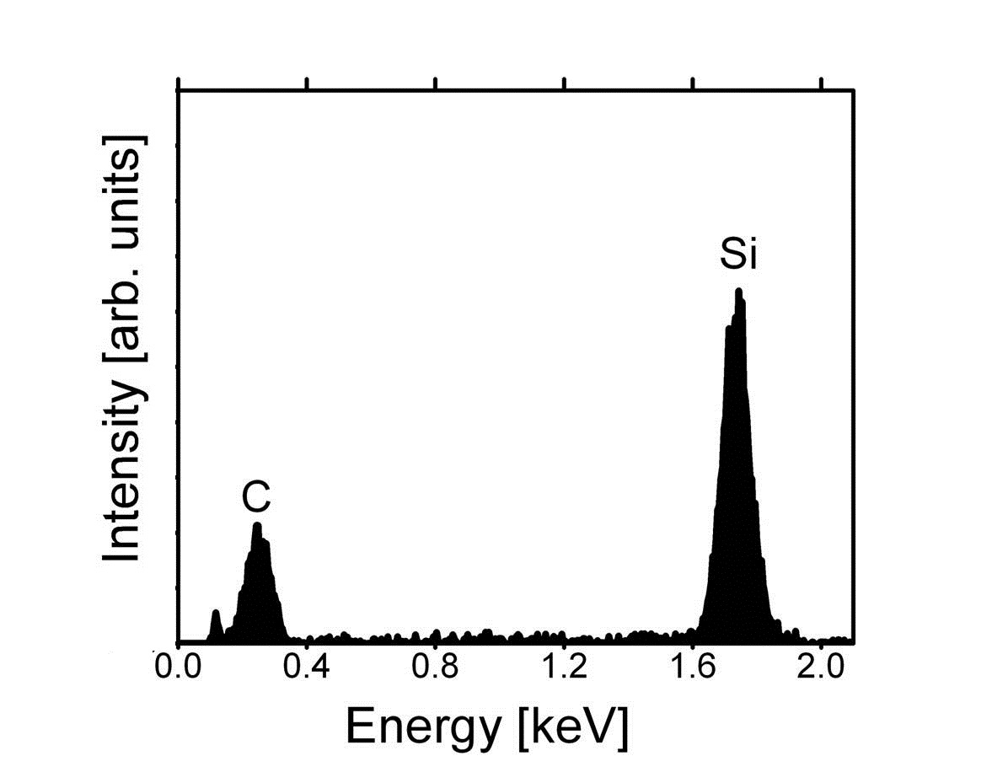
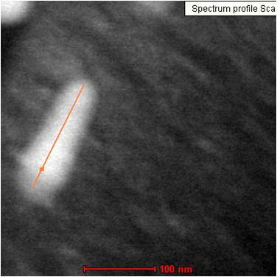
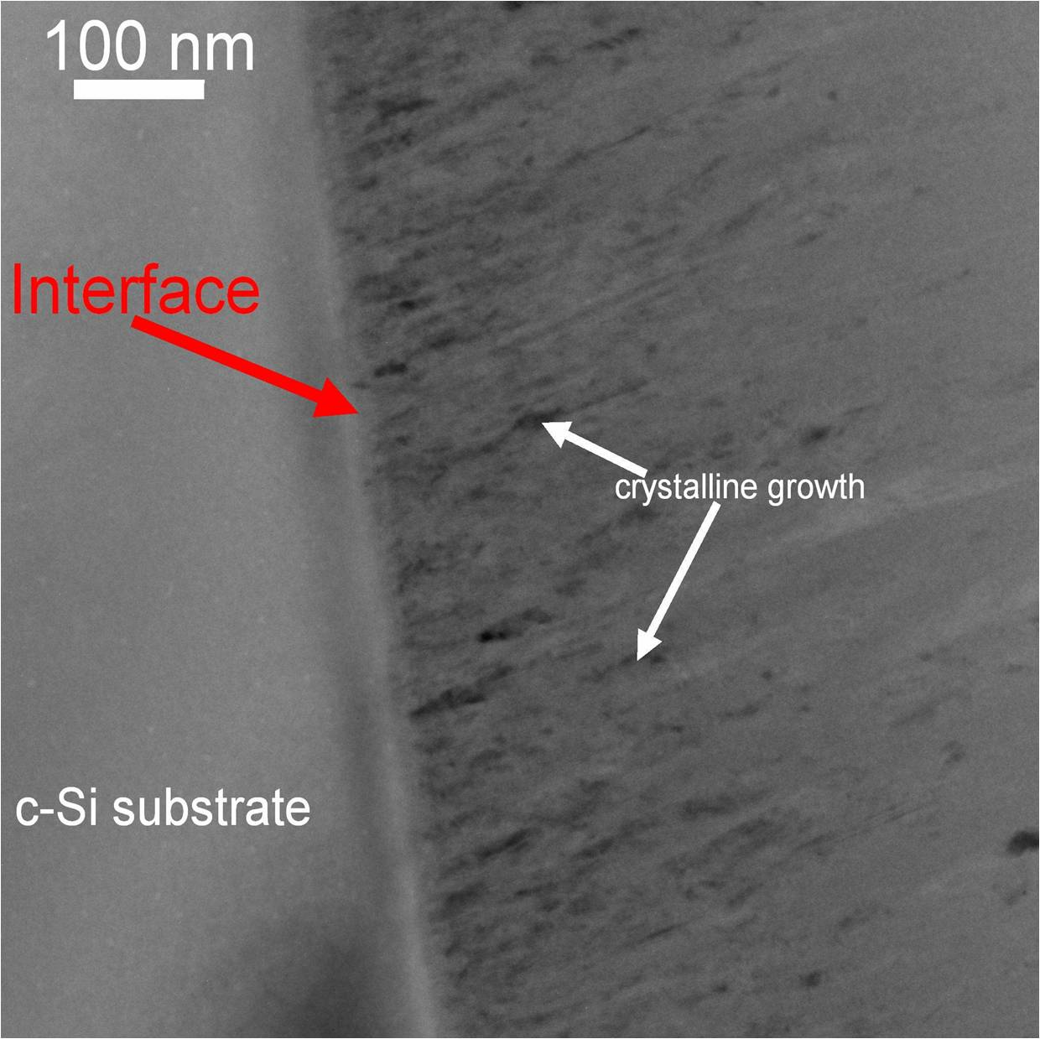
(b)
(a)

Figure 3. (a) TEM cross-section image of a specimen prepared from sample S₂ as-deposited.(b) EDX spectrum taken at one of the points of the line scan indicated on the STEM micrograph in the insert.
  - Discussion
The microstructure of thermally induced μc-SiC:H was extensively investigated by FTIR, AFM and TEM. The films are grown either as amorphous (S₁) or nanocrystalline SiC:H (S₂). The annealing treatment of the samples causes first the cracking of the Si_H_{n} molecules whose absorption bands in FTIR are observed to decrease in intensity and vanish at 700°C annealing temperature. At this stage, following the effusion of hydrogen from the samples, a rearrangement of the network is observed on the AFM image that shows rather distorted crystal grains. On the sample annealed at 900°C, a quasi-symmetrical absorption band due to crystalline SiC phase coexists with a signature of the remaining C-H_{n} bonds around 1000 cm⁻¹. A much more interesting fact though is observed at the annealing temperature of 1100°C where a shoulder is appearing on the 800 cm⁻¹ SiC vibration peak around 850 cm⁻¹ wavenumber while the 1000 cm⁻¹ CH_{n} vibration band is simultaneously disappearing. The resultant band is only well fitted by 2 Gaussian peaks centred at 770 cm⁻¹ and 856 cm⁻¹ as well as a Lorentzian centred at 800 cm⁻¹. While the first Gaussian at 770 cm⁻¹ and the Lorentzian at 800 cm⁻¹ along with another SiH related Gaussian peak at 830cm⁻⁻¹ – 850cm⁻¹ have been widely reported in as-deposited SiC materials [2, 14-15], to our knowledge this broad Gausian peak observed at high wavenumber in annealed samples has not been reported previously. Given the nature of its wide width, it signifies a broad distribution of SiC bond lengths and bond angles in the network. We propose thus that it should be included in the estimation of the SiC crystalline volume fraction (f_{SiC}) in the films; f_{SiC} should be given by

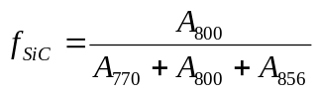 (1)
where A₇₇₀, A₈₀₀ and A₈₅₆ are the areas under the deconvoluted peaks centred at 770 cm⁻¹, 800 cm⁻¹ and 856 cm⁻¹ respectively. Applied to the annealed films at 1100°C, the method returns f_{SiC} values equal to 43.8 % and 48.3 % for S₁ and S₂ samples respectively.

- Conclusion
a-SiC:H and nc-SiC:H have been prepared by the HWCVD process using a SiH₄/CH₄/H₂ mixture at low temperature of the substrate. The samples have been subjected to a vacuum annealing up to 1100°C. The structural properties of the films are studied by FTIR, AFM and TEM. It is shown that the SiH_{n} related peaks are the first to disappear at the annealing temperature of 700°C while those associated to CH_{n} crack completely only above 900°C. The resulting material at the last annealing temperature of 1100 °C shows a unique vibration signature corresponding to crystalline SiC, as detected by FTIR at 800 cm⁻¹ wavenumber. This peak can be deconvoluted into two broad disorder-related Gaussian components at 770 cm⁻¹ and 856 cm⁻¹, and a narrow Lorentzian peak that signifies the presence of SiC ordered phase.

Acknowledgements
The authors wish to thank the National Research Foundation (NRF) for funding the main author’s research project, the Chemistry department at UWC and iThemba LABS for FTIR and AFM measurements respectively.

References
- Finger F, Astakhov O, Bronger T, Carius R, Chen T, Dasgupta A, Gordijn A, Houben L, Huang Y, Klein S, Luysberg M, Wang H and Xiao L 2009 Thin Solid Films 517 3507
- Chen T, Köhler F, Heidt A, Huang Y, Finger F and Carius R 2011 Thin Solid Films 519 4511
- Miyajima S, Haga K, Yamada A and Konagai M 2006 Jpn. J. Appl. Phys. 45 432
- Kunii T, Honda T, Yoshida N and Nonomura S 2006 J. Non-Cryst. Solids 352 1196
- Halindintwali S, Knoesen D, Swanepoel R, Julies B A, Arendse C, Muller T, Theron C C, Gordijn A, Bronsveld P C P, Rath J K and Schropp R E I 2007 Thin Solid Films 515 8040
- Halindintwali S, Knoesen D, Swanepoel R, Julies B A, Arendse C, Muller T, Theron C C, Gordijn A, Bronsveld P C P, Rath J K and Schropp R E I 2009 South Afric. J. Sci. 105 290
- Lau W S 1999 Infrared Characterization of Microelectronics World Scientific (Singapore)
- Zhang S, Pereira L, Hu Z, Ranieiro L, Fortonato E, Ferrira I and Martins R 2006 J. Non Cryst. Solids 352 1410
- Waman V S, Kamble M M, Pramod M R, Gore S P, Funde A M, Hawaldar R R, Amalnerkar D P, Sathe V G, Gosavi S W and Jadkar S R 2011 J. Non Cryst. Solids 357 3616
- Swain B P 2006 Materials letters 60 2767
- Swain P B and Dusane O R 2006 Materials Chemistry and Physics 99 240
- Finger F 2010 Thin-Film Silicon Solar Cells EPFL Press (Switzeland) 97-143
- Houben L, Luysberg M, Hapke P, Carius R, Finger F and Wagner H 1998 Philos. Mag. A 77 1447
- Chen T, Yang D R, Carius R and Finger F 2010 Jpn. J. Appl. Phys. 49/4
- Kerdiles S and Rizk R 2002 Philos. Mag. A Phys. Condens. Matter Struct. Defects Mech. Prop. 82/3 601

