**A new white light emitting nanophosphor**

**Shaat SKK1,2, Swart HC1 and Ntwaeaborwa OM1,\***

1 Department of Physics, University of the Free State, Bloemfontein, ZA9300,

South Africa.

2 Department of Physics, Islamic University, P. O. Box 108, Gaza, Palestine.

* Corresponding author: [*ntwaeab@ufs.ac.za*](mailto:ntwaeab@ufs.ac.za)

**Abstract**. White light was produced from CaAl2O4 nanophosphor co-doped with Tb3+and Eu3+. The short time and low temperature reaction combustion route was used to synthesize CaAl2O4:Tb3+,Eu3+ nanophosphors using metal nitrates precursors and urea as fuel. The crystalline structure and particle morphology were determined using X-ray diffraction and Scanning electron microscopy, respectively. The optical properties were studied by photoluminescence (PL) spectroscopy and the UV-Vis spectrometer in the range 800-200 nm. The excitation spectra were recorded by monitoring the three main emissions, namely blue at 438 nm, green at 543 nm and red at 617 nm. 227 nm was found to be the most suitable excitation wavelength to generate, simultaneously, blue and green emission from Tb3+ and red emission from Eu3+ whose combination constituted white light. The blue and green were respectively attributed to the 4f-4f transitions of Tb3+ by 5D3–7FJ (J= 6-2) and 5D4→7FJ (J = 0-6) while the red emission was attributed to 5D0→7FJ (J=0-4) transitions of Eu3+. Preliminary results on the structure and PL properties of this phosphor are reported.

1. Introduction

Scientists and researchers are conducting research in search for suitable host lattices that can be used to prepare phosphors for solid state lighting. The host must, among other things, be chemically and thermally stable. Alkali earth aluminates with a general formula MAl2O4 (M = Ba, Ca or Sr) are widely used as hosts for trivalent rare-earth (Dy3+, Nd3+, etc) and divalent europium (Eu2+) ions for the preparation of light emitting materials (phosphors) with persistent luminescence. Aluminates are more chemically stable, environmentally friendly [1] and they can be easily produced cost-effectively. Therefore the study of the preparation and characterization of aluminates based phosphors is growing rapidly. Phosphors such as SrAl2O4:Eu2+, CaAl2O4:Eu2+ and BaAl2O4:Eu2+ phosphors, co-activated with different rare-earths (Dy3+,Nd3+, Pr3+) have been reported [2**]**. These phosphors are usually produced cost-effectively, at relatively low temperature and a short reaction time by the combustion method using metal nitrates as starting materials and urea as a fuel. White light in many practical applications is generated by combining currently three available colours blue, green and red phosphor in appropriate ratios. For example, in traditional white light emitting diodes (LEDs), white light is generated by combining a lnGaN-based blue diode with a yellow phosphor such as YAG:Ce3+ or by combining a UV chip with a three converter system of red, green and blue phosphors. Furthermore, white light from fluorescent lamps is produced from combining tri-colour phosphors which emit blue, green and red light upon excitation by ultraviolet radiation. Shaat et al, [3] produced white light from CaxSr(1-x)Al2O4:Tb3+,Eu3+ nanocrystalline phosphor for application in solid state lighting devices such as fluorescent lamps and LEDs. In this study, a potential white light emitting nanocrystalline phosphor was prepared by co-doping terbium (Tb3+) and europium (Eu3+) in a calcium aluminate (CaAl2O4) host.

1. Experimental

**2.1 Sample Preparation**

A combustion method was used to prepare Tb3+ and Eu3+ single and co-doped CaAl2O4 nanophosphor. The metal nitrates of Ca(NO3)2.4H2O, Al(NO3)3.9H2O, Tb(NO3)3.5H2O, Eu(NO3)3.5H2O and urea CO(NH2)2 of AR grade purchased from Merck, South Africa were used as starting materials (precursors) and were used as obtained without further purification. The distilled water was used to dissolve the precursors with vigorous stirring at 50°C for 0.3 hr until the solution became clear. The resulting solution was transferred to a muffle furnace maintained at 450±10% oC. The transparent solution started to boil and undergo dehydration, followed by decomposition and large amounts of gases (nitrogen, ammonia and oxides of carbon) escaping. White foamy and voluminous ash was produced after spontaneous ignition occurred and underwent smouldering combustion with enormous swelling. The combustion reaction was completed in ~5 minutes. The product was cooled to room temperature and the ashes were ground gently into fine powders. The powders were characterized without any further post-preparation treatment.

**2.2 Experimental Techniques**

The crystalline structure of CaAl2O4:Tb3+;Eu3+was analysed using a Bruker D8 ADVANCEpowderdiffractometer with Cu K*α* radiation, *λ*=1.5406Å. The optical properties were characterized by UV-Vis spectroscopy (Lambda 950) and the Varian Cary Eclipse fluorescence spectrophotometer. PL (excitation and emission) were measured for 3 different samples namely: CaAl2O4:Tb3+, CaAl2O4:Eu3+and CaAl2O4:Tb3+;Eu3+with different excitation wavelengths**.** All measurements were carried out at room temperature and atmospheric pressure.

1. Analysis and results discussion

**3.1. XRD Study**

|  |
| --- |
| Figure 1 shows the X-ray diffraction (XRD) patterns of CaAl2O4:Tb3+;Eu3+ nanophosphor. The patterns correspond to the standard monoclinic structure of CaAl2O4 in JCPDS file No. 70-0134. The diffraction peak at 2θ=25.34o was indexed as the (012) peak of Al2O3 [4] which was possibly formed during an unwanted reaction between Al3+ and O2- from the precursors. The Debye-Scherrer relation was used to estimate the average particle size for the (220) diffraction peak and was found to be ~16 nm. The calculated lattice parameters are a = 8.71 Ao , b = 8.084 Ao , c = 15.23 Ao with α and γ = 90o but β= 90.45o which are in a good agreement with the standard monoclinic CaAl2O4 referenced in JCPDS file No. 70-0134 (a = 8.700 Ao , b = 8.092 Ao , c = 15.19 Ao with α and γ = 90o but β= 90.17o ). |
| **Figure 1.** XRD spectrum of CaAl2O4:Tb3+;Eu3+nano-phosphors. |

3.2. SEM micrograph study

Figure 2(a-b) show the SEM micrograph images of the as-prepared monoclinic CaAl2O4:Tb3+;Eu3+nanophosphor with two different magnifications. The foamy and agglomerate particle nature of the powder is clear in figure 2(a-b). The foamy structure of CaAl2O4:Tb3+;Eu3+ reflects the inherent nature of the combustion process. Figure 2 (a-b) shows an irregular shape with a lot of voids and pores of the surface of the powder, which may be formed by the evolved gases during combustion reaction.

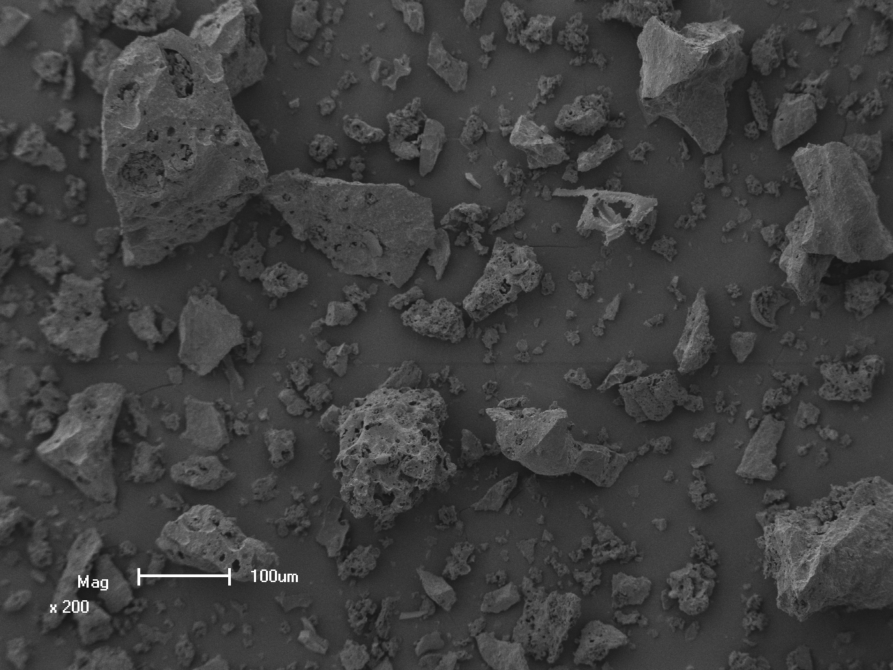

(a)

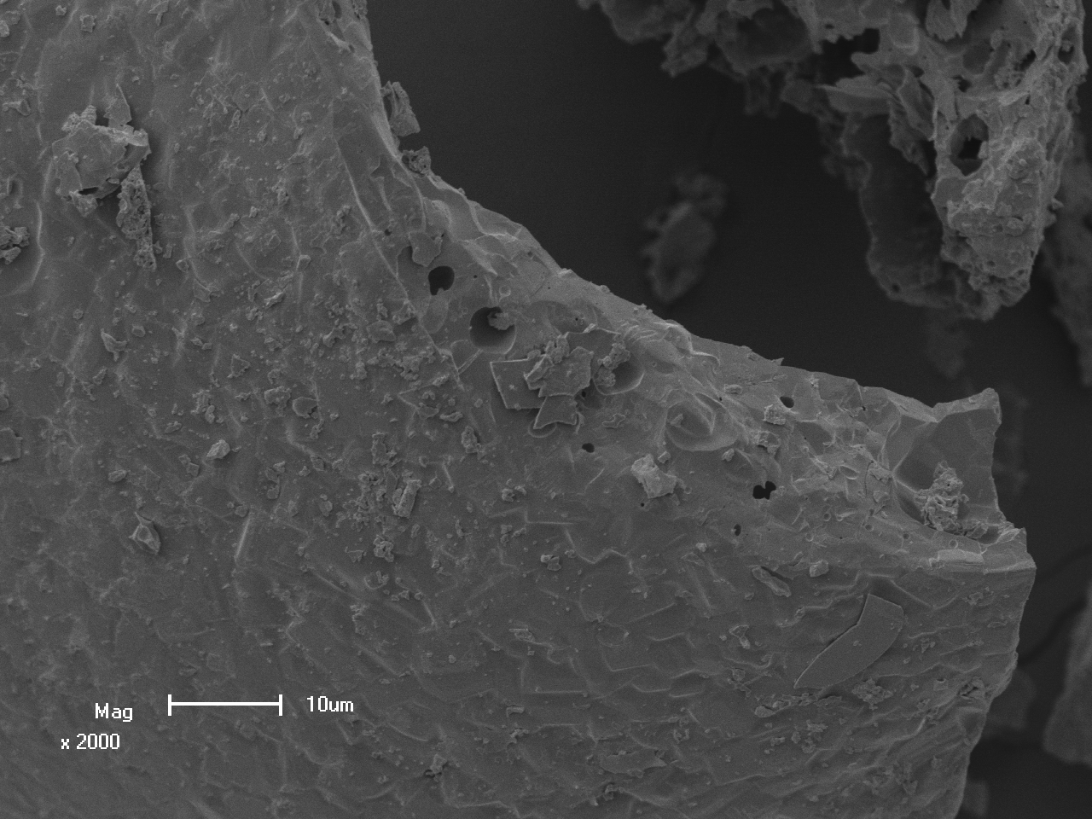

(b)

**Figure 2(a-b).** SEM micrograph images of the CaAl2O4:Tb3+;Eu3+ nanophosphor.

3.3 UV-Vis study

Figure 3 shows the diffuse reflectance spectrum of the CaAl2O4:Tb3+;Eu3+ nanophosphor. Two clear changes in the slope of the reflectance spectrum are seen at 213 nm and 330 nm. The peak observed at 213 nm is attributed to the interband transition of CaAl2O4  [5]. The peak near 330 nm was assigned to the O2–-Eu3+ charge transfer band [6]. The band gap energy of the CaAl2O4:Tb3+;Eu3+ was estimated from a plot of (αE)2 versus photon energy E shown in figure 4. The band gap energy was estimated from the linear part of the straight line to the (αE)2 = 0 axis andby extrapolating was found to be 5.3±0.1eV. This result is close to the value of 5.78 reported in ref. [7].



**Figure 3.** Diffuse reflectance spectrum of the CaAl2O4;Tb3+;Eu3+ nanophosphor.



**Figure 4.** Plots of (αhν)2 versus photon energy (*hv*) to determine the band gap energy of the CaAl2O4;Tb3+;Eu3+ nanophosphor.

**3.3. Photoluminescence study**

Photoluminescence (PL) excitation spectrum of CaAl2O4:Tb3+,Eu3+ nanophosphor is shown in figure 5. The excitation spectra were recorded for three different emissions at 437 and 543 nm from Tb3+ and 617 nm from Eu3+. There are two major peaks located at 227 and 237 nm due to direct excitation of Tb3+ and are assigned to the 4f→5d transitions [8.9]. The excitation peak at ~240 nm are due to Eu3+→O2- charge transfer transitions resulting from transfer of electrons from O2- (2p6) orbitals to the 4f7  and 4f6 states [10]. The PL emission spectrum of the CaAl2O4:Tb3+,Eu3+ nanophosphorobserved when exciting the phosphor at 227 nm is shown in figure 6. The PL emission spectra of Tb3+ and Eu3+ single doped CaAl2O4 also were recorded when exciting the phosphors at 227 nm are shown in the insets. The PL emission spectra of CaAl2O4:Tb3+ consists of major green emission at 543 nm due to the 5D4→7F5 transitions of Tb3+ and minor emissions at 380 nm (violet), 416 nm (blue), and 437 nm (blue) due to the 5D3→7FJ (J = 6,5,4) transitions of Tb3+. The PL emission spectrum of the CaAl2O4:Eu3+ in the other inset consist of major red emission at 617 nm due to the 5D0→7F2 electric dipole transitions of Eu3+ and minor emission at 593 nm due to magnetic dipole transitions of Eu3+ [11]. The PL emission spectrum of the CaAl2O4:Tb3+,Eu3+ nanophosphor exhibits white light which is a result of simultaneous emissions of blue and green light from Tb3+, and red light from Eu3+. When exciting at the wavelength of 227 nm (i.e. the point where the excitation spectra of the 543 and 617 nm emissions overlap as shown in Fig. 5) there is a slight increase in the 542 nm peak intensity and a slight decrease in the 617 nm peak intensity indicating that Tb3+ and Eu3+ where excited simultaneously resulting in simultaneous emissions from both ions.



Figure 5: PL excitation spectra of CaAl2O4:Tb3+;Eu3+nanophosphor.



Figure 6: PL emission spectrum of CaAl2O4:Tb3+;Eu3+nanophosphor and the two insets are the PL emission spectra of CaAl2O4:Tb3+ and CaAl2O4:Eu3+. All were excited at 227 nm.

Figure 7 depicts the CIE diagram and the chromaticity coordinates for the (a) CaAl2O4:Tb3+, (b) CaAl2O4:Eu3+ and (c) CaAl2O4:Tb3+,Eu3+. The calculated chromaticity coordinates for the white light emitted from CaAl2O4:Tb3+,Eu3+ nanophosphor are given by x = 0.354, y = 0.337, which is in agreement with the chromaticity coordinates of standard white light (x = 0.333, y = 0.333) [12]. Also shown in the figure are the chromaticity coordinates of the red CaAl2O4:Eu3+given by x = 0.637, y = 0.360 and the green CaAl2O4:Tb3+ given by x = 0.286, y = 0.477.

**Figure 7:** The CIE diagram and the chromaticity coordinates of

(**a**) CaAl2O4:Tb3+ at (x = 0.286, y = 0.477),

(**b**) CaAl2O4:Eu3+ at (x = 0.637, y = 0.360) and

(**c**) CaAl2O4:Tb3+;Eu3+ at (x = 0.354, y = 0.337).



1. Conclusion

In conclusion, a new potential white light emitting CaAl2O4:Tb3+;Eu3+ nanophosphor was synthesized using the combustion method. The structure of the phosphors is consistent with standard monoclinic CaAl2O4. The SEM images confirm the irregular particle shape that was produced from the combustion reaction. The estimated band gap energy agrees with the other measured values. Furthermore, PL excitation spectrum confirmed that the excitation through absorption of the 4f→5d transitions of Tb3+ and charge transfer transitions of O2-→Eu3+ which agreed with different studies. Finally, the white light occurred after excitation by photons of sufficiently high energy which come from 4f→5d transitions of Tb3+ and O2-→Eu3+. This materials has the potential application in different types of light emitting devices such as laser phosphor display (LPD), field emission displays (FEDs), fluorescent lamps and phosphor panel displays (PDP).

**Acknowledgement**

The authors send gratitude to the National Research Foundation (NRF) for funding the project.

**References**

|  |  |
| --- | --- |
| [1] | Mothudi BM, Ntwaeaborwa OM., Pitale SS and Swart HC 2010 *Journal of Alloys and Compounds* **508** 262. |
| [2] | Eeckhout KV, Philippe FS and Poelman D 2010 *Materials*  **3** 2536. |
| [3] | Shaat S K K, Hendrik S C and Odireleng MN 2012 *Optical Materials Express* **2** 962. |
| [4] | Rivas Mercury JM, De Aza AH and Pena P 2005 *Journal of the European Ceramic Society* **25** 3269. |
| [5] | Kunimoto T, Kakehi K, Yoshimatsu R, Honda S, Ohmi K and Tanaka S 2002 *UVSOR Act Rep* **2001** 116. |
| [6] | Bohdan P, Marek G, Benedykt K, Yuriy O, Oleksandr S, Dmitriy K and Andrew P 2010 *Optica Applicata* **2** 413. |
| [7] | Bo L, Chaoshu S and Zeming Q 2005 Applied Physics Letters **86** 191111. |
| [8] | Martínez-Martínez R, Àlvarez E, Spanghini A, Falcony C and Caldiño U 2010 *Materials Research Society* **25(3)** 484. |
| [9] | Wang D, Yang P, Cheng Z, Wang W, Hou Z, Dai Y, Li C and Lin J 2012 Journal of Colloid and Interface Science **365** 320. |
| [10] | Stanislava J, Linda S, Guillaume R, Yaroslav F, Damien B, Philippe B 2007 *Journal of Physics and Chemistry of Solids* **68** 1147. |
| [11] | Grobelna and Bojarski 2009 *Journal of Non-Crystalline Solids* **355** 2309. |
| [12] | Fan S, Yu C, He D, Wang X and Hu L 2012 Optical Materials Express **26** 765. |