The effect of temperature on the calculated bulk vacancy formation energy in Al and Cu

**C. van der Walt**[1] **, HC Swart and JJ Terblans**[2]

Department of Physics, University of the Free State, PO Box 339, Bloemfontein, South Africa

E-mail address: terblansjj@ufs.ac.za

**Abstract.** The bulk vacancy formation energies (*Ev*) were calculated for Al and Cu single crystals in a molecular dynamics simulation. The Sutton-Chen many-body potential was used to calculate the vacancy formation energies for the single crystal with the surface orientations of (111), (100) and (110) at temperatures ranging from 0 K to below the simulated melting temperatures. The values obtained for vacancy formation energies at 0 K compared well to values obtained from literature and exhibited *Ev* values that reflect the respective surface stabilities. The (111) surface has the greatest stability and had the highest bulk vacancy formation energy, followed by the (100) surface, and finally the (110) surface showed the greatest instability and had the lowest bulk vacancy formation energy. The *Ev* values at higher temperatures show surface instability, particularly in Cu(110), where it is caused by an adatom layer that forms on the surface at temperatures well below melting point. A general trend of a decrease of vacancy formation energy was observed for increasing temperature.

1. Introduction

The vacancy formation energy is an important factor in atomic transport, and is of fundamental importance in diffusion kinetics. The vacancy formation energy, (*Ev*) has been shown to be dependent on surface orientation in both Al and Cu. [1,2] What has not yet been extensively studied is the effect of temperature on these vacancy formation energies, but with the use of density functional theory (DFT) it has been shown for Pt, Pd and Mo that the vacancy formation energy increases with temperature. [3]

Although modern quantum mechanical calculations can more accurately simulate these interactions, calculations are costly in time and limited in the number of atoms they are able to handle. The code used for the calculations in this article was written by the authors and this article serves to show that the code not only duplicates the results of previous Sutton-Chen calculations [1,2] which was only conducted at 0 K, but is also able to investigate the effects of temperature. The code can handle larger calculations of several thousand atoms, well beyond the capabilities of quantum mechanics calculations, in conditions that can more closely approximate bulk materials. The method of modelling surface binding energies to determine the effect of temperature on surface orientations is also new.

Perfect crystals of Al and Cu were simulated with the use of an embedded atom potential developed by Sutton and Chen. [4] The crystals were simulated with surface orientations of (100), (110) and (111) at a range of temperatures. The Sutton–Chen potential (*Ui*) is an embedded atom potential with a many-body term that uses particle densities in FCC metals and can determine pair wise distributions. The total energy of the simulated crystal (*Utotal*) can be calculated by using

(1)



Where *ε* is an energy parameter and *c* is a dimensionless parameter. *V* is the pairwise repulsive potential and *ρi* is a density like term;



(2)



(3)

with *rij* the distance between atoms *i* and *j*, *a* is the lattice constant, *n* a positive integer that determines the repulsive potential and *m* is a positive integer that determines the range of the repulsive potential such that *n* > *m*. The parameters that were used for Al and Cu are those published by Sutton and Chen, which are listed in Table 1.

|  |  |  |  |  |  |  |
| --- | --- | --- | --- | --- | --- | --- |
| **Table 1.** The Sutton–Chen parameters for Al and Cu. [4] | | | | | | |
| Element | ε (eV) | | *a* (A° ) | c | n | m |
| Al | 3.3147 10-2 | 4.05 | | 16.399 | 7 | 6 |
| Cu | 1.2382 10-2 | 3.61 | | 39.432 | 9 | 6 |

1. Calculations

Using the Schottky mechanism to describe the vacancy formation energy (*Ev*) has been defined as finding the difference between the energy needed to remove an atom from inside the crystal volume and the energy obtained from adding an atom to the crystal surface.[1,2,5]

(4)



Here  is the cohesive binding energy for an atom in the bulk of a crystal and  is the binding energy for the added atom (adatom) on the surface. To calculate the bulk vacancy formation energy (*Ev*), the total energy (*Utotal*) for a perfect crystal the Sutton–Chen potential needs to be calculated. Single crystals of Al and Cu with different surface orientations were simulated as shown in figure 2. Each of the crystals, Al(100), Al(110), Al(111), Cu(100), Cu(110) and Cu (111) with 1944 atoms each was simulated. The crystals each had six layers of 18 x 18 atoms. The corresponding vacancy formation energies were calculated at temperatures ranging from 0K at 100K intervals to a temperature below their respective melting points and compared. A Berendsen thermostat regulated the system temperatures with a coupling constant τ of 0.05 ps.

A standard cut-off distance of 2.5*σ* was used and the time step used was 0.001 ps. Using the Sutton–Chen empirical many-body potential and the Verlet leapfrog integration method, the interactive forces between the atoms were calculated and the crystal structures were allowed to relax for 20 000 steps and the total energy (*Utotal*) was then obtained. A vacancy was then created and moved to a distance of 1 m from the crystal surface to approximate infinity. The total energy (*Utotal*) of the crystal with a vacancy was then measured again. The difference between these two total crystal energies is the bulk cohesive binding energy.

|  |  |  |  |  |
| --- | --- | --- | --- | --- |
| Al(100) 0K small  **(a)** |  | Al(110) 0K small  **(b)** |  | Al(111) 0K small  **(c)** |
| **Figure 1**. shows schematics of the three different surface orientations of the bulk crystals: (100) in 2(a), (110) in 2(b) and (111) in 2(c). | | | | |

To find the cohesive surface binding energy for the adatom  the total energy (*Utotal*) was calculated for the same crystal setup, where the adatom was moved closer to the surface to a distance *x* from the surface. The energy difference between the two crystal total energy (*Utotal*) where the adatom is at infinity from the surface, and where the adatom is a distance x from the surface, is equivalent to the binding energy between the adatom and the surface with the adatom at a distance *x* from the surface. The adatom was moved closer to the surface and each time this energy difference was measured until a maximum binding energy for an adatom on a surface was found. Figure 1 shows the calculated potential energy curve as the adatom is moved closer to Cu(100), Cu(110) and Cu(111) surfaces.

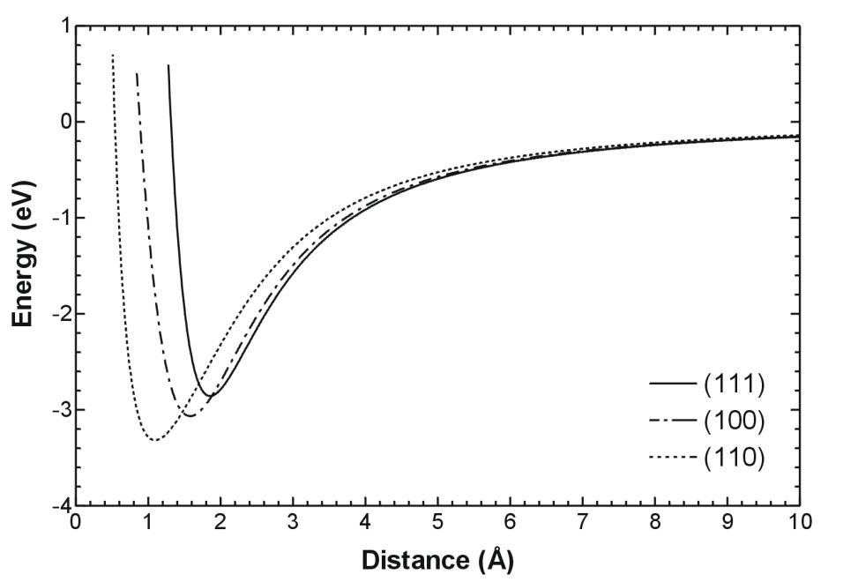

**Figure 2.** A potential energy curve of a single atom added to Cu(100), Cu(110) and Cu(111) orientated surfaces respectively.

The surface binding energies were measured for the points most likely to bond an atom on the surface. Preferred binding sites were chosen as the points with the lowest maximum surface binding energy. Using likely bonding sites, the average surface binding energy for each crystal was determined for each of the various temperatures. The binding energies were measured five times over time to obtain a good average of the surface binding energy for each temperature.

1. Results And Discussions

As described in section 2, the binding energies for adatoms added onto Al(111), Al(100) and Al(110), and Cu(100), Cu(110) and Cu(111) surfaces were calculated. The values obtained for the maximum surface binding energies on each point of the surface was plotted in a contour plot for selected temperatures of Cu and is shown in figure 3. To find the best binding sites, the binding energy of preferred binding sites were averaged. The results for the calculated surface binding energies for Cu and Al at 0 K are summarized in Table 2 and compared to values from literature. The values of 3.09 eV, 3.14 eV and 2.96 eV for Al(100), Al (110) and Al(111) respectively correspond very well with the values of 2.81 eV, 2.94 eV and 2.65 eV from the literature. [2] The values calculated the surface binding energies in low index Cu also compare very well. [1]

|  |
| --- |
| Thermodynamics of Cu surfaces |
| **Figure 3.**  A contour plot was drawn showing the surface binding energies of the adatom on the Cu(100) surface at 0 K in 3(a), at 400 K in 3(b) and at 800 K 3(c). The corresponding binding energies measured for each point on the Cu(110) bulk crystal surface is shown in figure 3(d-f) and the plots of Cu(111) can be seen in figure 3(g-i). |

From the cohesive surface binding energy for the adatom and the bulk cohesive binding energy  the bulk vacancy formation energy (*Ev*) was calculated. The same process as described in section 2 was repeated for 0 K and the results of the bulk vacancy formation energy (*Ev*) was also tabulated in table 2, along with values from literature.

|  |  |  |  |  |
| --- | --- | --- | --- | --- |
| **Table 2**. Summary of the calculated surface binding energies and the calculated bulk vacancy formation energies compared results from literature. | | | | |
| Surface | Calculated *Ev* (eV/atom) | *Ev* from literature (eV/atom) | Calculated (eV/atom) | from literature (eV/atom) |
| Al(100) | 0.67 | 0.50 [2] | 3.09 | 2.81 [2] |
| Al(110) | 0.58 | 0.37 [2] | 3.14 | 2.94 [2] |
| Al(111) | 0.78 | 0.66 [2] | 2.96 | 2.65 [2] |
| Cu(100) | 1.35 | 1.34 [1] | 2.99 | 3.05 [1] |
| Cu(110) | 1.07 | 1.07 [1] | 3.22 | 3.32 [1] |
| Cu(111) | 1.52 | 1.54 [1] | 2.81 | 2.85 [1] |

The calculated *Ev*’s of 1.52 eV for Cu(111), 1.35eV for Cu(100) and 1.07 eV for Cu(110) correspond well to the literature values of 1.54 eV for Cu(111), 1.34eV for Cu(100) and 1.07 eV for Cu(110), and there is a good agreement between the calculated and literature values of the Al *Ev*’s.

The calculations were repeated for crystals at higher temperatures. The Cu crystals were simulated at temperatures ranging in 100 K steps from 0 K up to 1000 K. At high temperatures various surface effects were observed, especially in Cu(110), which exhibited roughening and the formation of an adlayer as can be seen in figure 3(f). Previous work in literature with the embedded atom model simulating Cu(110) surface also showed the formation of an adlayer at 900 K through a generation of vacancies, and surface premelting at 80 K below the simulated bulk melting point. [6] Another study used a semi-empirical potential based on the tight-binding method to study the thermal behaviour of low index copper surfaces. [7] It was found in Cu(110) that above 700 K an adlayer formed due to adatom/vacancy formation, which lead to roughening and premelting of the Cu(110) surface. The Cu (100) surface showed disordering above 800 K, whereas the Cu(111) surface was observed to be the most stable with an ordered surface observed for high temperatures. The bulk vacancy formation energies for Cu at various temperatures is shown in figure 4, and shows a general trend of decreasing vacancy formation energy with increasing temperature. Further the error also increases with increasing temperature, which would suggest that the crystal simulated may have been too small as the roughening in the surface at higher temperatures causes a greater spread in surface binding energies, and that more sampling should be done in future calculations.

The Sutton-Chen potential used to simulate the Al crystals showed melting of the surface at very low temperatures. Although the melting temperature of Al is found at 660 K, melting was found to occur at temperatures as low as 400 K. This underestimation of the melting temperature in Al has been observed before in thermodynamic studies of Al clusters and bulk simulations. [8–12] The Al surface was further found to premelt at temperatures below its melting temperature. [13] Al crystals were simulated for temperatures ranging up to 300 K and the resulting calculated vacancy formation energies (*Ev*) are shown in figure 5.

|  |  |
| --- | --- |
| Cu Ev vs T1 | **Figure 4.** The vacancy formation energies (*Ev*) obtained for temperatures from 0 K to 1000K for Cu(100), Cu(110) and Cu(111) orientated surfaces. |

In both materials, the bulk vacancy formation energy of the (111) surface crystals was larger than that of the (100) surface crystals, and that the bulk vacancy formation energy of the (100) surface crystals was found to be larger than that of the (110) surface crystals. The values calculated the vacancy formation energy of Schottky defects in low index Al and Cu compare very well to values found in the literature. As the temperature increased the *Ev*’s tended to decrease, indicating a tendency for more vacancies to form at higher temperatures, which confirms observations.

|  |  |
| --- | --- |
| Al Ev vs T1 | **Figure 5.** The effect of temperature on the vacancy formation energy in Al(111), Al(110) and Al(100). |
|  | |

1. Conclusion

Cu (100), (110) and (111), and Al (100), (110) and (111) bulk crystals were successfully simulated using the Sutton-Chen Potential. The bulk and surface cohesive energies for each of these crystals were measured at temperatures ranging from 0 K to 1000 K for Cu and 0 K to 300 K for Al. The Al melting temperature was underestimated by the Sutton-Chen potential and premelting in the surface was also observed. The Sutton-Chen also underestimates the melting temperature in Cu and surface effects such as a surface adlayer were observed. This effect was especially pronounced in Cu(110). Generally with temperature increase, the vacancy formation energy was found to decrease.

Acknowledgments

Funding from the University of the Free State and the NRF is gratefully acknowledged.

1. References
2. Terblans J J 2002 *Surf. Interface Anal*. 33 767–770
3. Terblans J J 2003 *Surf. Interface Anal*. 35 548–551
4. Mattsson T R and Mattsson A E 2002 *Phys*. *Rev*. B. 66 214110
5. Sutton A P and Chen J 1990 *Phil. Mag. Lett.* 61 139–146
6. Terblans J J, Erasmus W J, Viljoen E C and du Plessis J 1999 *Surf. Interface Anal*. 28 70
7. Barnett R N and Landman U 1991 *Phys*. *Rev*. B. 44 3226
8. Resende F J, Carvalho V E, Costa B V and de Castilho C M C 2004 *Braz. J. Phys.* 34 414–8
9. Puri P and Yang V 2007 *J. Phys. Chem.* C 111 11776-11783
10. Ozgen S and Duruk E 2004 *Mater. Lett.* 58 1071– 1075
11. Stoltze P, Norskov J K and Landman U 1988 *Phys. Rev. Lett.* 61 440–3
12. Qi Y and Krajewski P E 2007 *Acta Mater.* 55 1555–63
13. Budi A, Henry D J, Gale J D and Yarovsky I 2009 *J. Phys.: Condens. Matter* 21 144206
14. Ojwang’ J G O, van Santen R, Kramer G J, van Duin A C T and Goddard III W A 2008 *J. Chem. Phys*. 129 244506–14

1. Main author
2. 2 To whom any correspondence should be addressed.