Effect of Li composition on HCP to BCC phase transformation in ultra-lightweight binary Mg-Li alloys: an ab initio study
MJ Phasha^{1,2}, PE Ngoepe^{1,2}
¹Council for Scientific & Industrial Research (CSIR), Materials Science and Manufacturing, P.O. Box 395, Pretoria 0001, South Africa
²University of Limpopo, Materials Modelling Center, School of Physical and Minerals Sciences, Private Bag X1106, Sovenga 0727, South Africa

E-mail: mphasha@csir.co.za

Abstract. Density functional theory based first-principles total energy calculations were used to determine the effect of lithium concentration on the equilibrium lattice parameters, theoretical density, binding and mixing energies (phase stability), as well as elastic properties of random binary Mg_{1-x}Li_{x} alloys spanning 0 to 30 atomic percent concentration range in the HCP, FCC and BCC crystal structures. A theoretical model for predicting phase stability and elastic properties of random alloys comparable to experiment is proposed. The Li composition that induces crucial HCP to BCC phase transition is analysed on the basis of c/a axial ratio and electron per atom (e/a) ratio.
- Introduction
The demand for weight reduction in several transportation industries such as automotive, aircraft or aerospace renders magnesium (Mg) a material of high interest. Consequently, Mg and its alloys have received great scientific and technological attention, mainly due to low density and high specific strength that they posses [1,2]. However, due to a hexagonal close-packed (HCP) structure with non-ideal c/a ratio, Mg alloys exhibit low formability near room temperature. Indeed, metals and alloys with HCP crystal structures present a limited number of available slip systems compared to body centered cubic (BCC) and face centered cubic (FCC) counterparts, which makes the accommodation of plastic deformation difficult. In order to activate the five independent slip systems required by the von Mises criterion [2] in the Mg alloys, the forming temperature needs to be raised to approximately 250-300ºC [3].

An important factor in influencing the formability of HCP metals is the axial ratio [2]. Within the HCP metals, there are variations in room temperature formability, which have been associated to the axial ratio. This effect was attributed to the change in the critical resolved shear stress (CRSS) on the basal plane with varying axial ratio. It is reported in literature that the addition of lithium (Li) reduces the stress for cross-slip of the HCP Mg phase at low and high temperatures [3]. In order to respond positively to the industrial demand for improved low-temperature ductility of Mg alloys, it is important to understand the effect of alloying elements on mechanical properties. On the other hand, most of the theoretical investigations carried out so far on binary Mg-Li system were conducted treating Mg-Li alloys as ordered intermetallic phases [4-8], instead of random solid solutions presented in Mg-Li phase diagram [9]. Moreover, in order to study effects of small additions of Li in Mg using such approach requires the use of supercell containing many atoms, thus making the calculations to become computationally heavy. As a result, a systematic approach to handle disordered alloys has been lacking for sometime. Recently, an alternative density functional theory (DFT) based doping method representing random (disordered) alloys was proposed by the current authors and applied to study the effect of Li composition on structural and elastic properties of Mg-Li alloys [10]. In the current contribution, an emphasis is on the role of Li in the important HCP to BCC phase change within the α/α+β and α+β/ β phase boundary on the basis of c/a and e/a (valence electron per atom) ratios.

- Methodology
  - Background
In this work, a random solid solution with BCC, FCC and HCP crystal structures are represented by a model shown in figure 1 (a), (b) and (c), respectively. Ideally using this model, Mg-Li solid solution may be formed when an atom of Mg or Li occupy randomly any position in the crystal, thus only changing the composition. Thus by maintaining correct symmetry and crystal structure as reported in experimental data [9], the composition can be varied by representing atoms as a fractional composition, A_{100-x}B_{x}.

Figure 1. Representation of (a) BCC, (b) FCC and (c) HCP pseudo-binary solid solutions (A_{1-x}B_{x}) comprised of pseudo atoms. Every atom consists of the overall fractional composition of the solid solution.

  - Computational details
Current ab initio calculations were performed using the well-established total energy code, CASTEP [11], which has been described in details in preceding two chapters. Geometry optimization calculations were carried out using cut-off energy of 500 eV and k-points of 19x19x10 for HCP and 18x18x18 for FCC and BCC phases. Choice of denser k-points did not yield any significant difference. In this case, the hard norm-conserving pseudopotentials of Kleinman-Bylander (1982) were employed to describe the electron-ion interaction [12]. Hence very dense k-points were used. We employed convergence criterion of less than 5 x 10⁻⁶ eV on total energy per atom, maximum displacement of 5x10⁻⁴ Å, residual forces of 3 x 10⁻² eV Å⁻¹ and 0.02 GPa on the residual bulk stress. For each crystal structure, the geometry optimization was performed to obtain the equilibrium structural properties, from which the elastic constants were computed as described below.

  - Numerical details
    - Cohesive and formation energy
The cohesive (binding) energy of the pure elements and pseudo element or solid solution (A_{1-x}B_{x}) alloy was computed according to the relation [10,13]:
$E_{\text{coh}}^{A}=\frac{1}{n}E_{\text{tot}}^{\text{solid}}−E_{\text{tot}}^{\text{atom}}$ (1)
where $E_{\text{tot}}^{\text{solid}}$is the total energy of the element (Mg and Li) or pseudo element (Mg_{100-x}Li_{x}) in their ground-state crystal structures and $E_{\text{tot}}^{\text{atom}}$ is the total energy of free atom (Mg and Li) or pseudo-atom (Mg_{100-x}Li_{x}), respectively. The fractions indicate the total number of atoms of constituent species in the unit cell, usually referred to as fractional composition. Energy of a free atom is calculated by creating a supercell (P1 symmetry) with lattice parameter a=10 Å and placing an atom or pseudo atom at the center.

On the other hand, the formation energy, ΔH, of the disordered solid solution is computed according to the relation:
$ΔH=E_{\text{coh}}^{{\text{Mg}}_{\text{100}−x}{\text{Li}}_{x}}−[(1−x)E_{\text{coh}}^{\text{Mg}}+{\text{xE}}_{\text{coh}}^{\text{Li}}]$ (2)
where $E_{\text{coh}}^{\text{Mg}}$ and $E_{\text{coh}}^{\text{Li}}$ are the cohesive energies of elemental Mg and Li in their respective ground-state crystal structures. The fractional (atomic) composition of element B is represented by $x$. It thus follows from the above expressions (1) and (2) that the formation enthalpy of a solid solution depends on the cohesive energy of materials.

    - Elasticity
The stress-strain relation may be used to distinguish the elastic and plastic regimes of solid materials [14]. The elastic moduli are the fundamental physical parameters which establish the stress-strain relation in the elastic regime. For an isotropic polycrystalline solid, the two independent elastic parameters are the bulk modulus (B) and the shear modulus (G). On the other hand, the resistance of solids to plastic or permanent deformation is governed by dislocation motion and may be expressed via the yield stress or mechanical hardness. The hardening mechanism in alloys, which arises from disturbances in the lattice caused by the solute atoms in the matrix, is often described by the classical Labusch-Nabarro model [15,16]. Furthermore, the ratio of B to G is used to describe the brittleness and ductility of metal. High (low) B/G ratio corresponds to ductile (brittle) material. Of importance in metallurgy is how the solute atoms affect the elastic properties of α Mg.

For each material, both stress and strain have three tensile and three shear components, giving six components in total. According to the theory of elasticity, 6 x 6 symmetry matrix with 36 elements is thus needed to describe the relationship between stress and strain. The structural symmetry of the crystal makes some of the matrix elements equal and others fixed at zero. For the cubic structures, only three elastic constants, corresponding to C₁₁, C₁₂ and C₄₄, are independent. Appling two kinds of strains (ε₁ and ε₄) can give stresses relating to these three elastic coefficients, yielding an efficient method for obtaining elastic constants for the cubic system. This method has been successfully used to study the elastic properties of a range of materials including metallic systems [17]. The mechanical stability criteria of cubic systems as outlined elsewhere [18] are given as follows:
$C_{\text{44}}>0,$$C_{\text{11}}>\left|C_{\text{12}}\right|$ and $C_{\text{11}}+2C_{\text{12}}>0$ (3)
where C₁₁, C₁₂ and C₄₄ are the only three independent elastic constants. For the tetragonal and hexagonal structures, there are six elastic constants, corresponding to C₁₁, C₁₂, C₁₃, C₃₃, C₄₄, and C₆₆ (for hexagonal crystal, $C_{\text{66}}=(C_{\text{11}}−C_{\text{12}})/2$), are independent. The corresponding mechanical stability criterion for tetragonal crystal reads as
$C_{\text{44}}>0,$$C_{\text{66}}>0,$, $C_{\text{11}}>\left|C_{\text{12}}\right|$ and $C_{\text{11}}+C_{\text{12}}−\frac{2C_{\text{13}}^{2}}{C_{\text{33}}}>0$. (4)
For hexagonal crystals, the criterion is
$C_{\text{11}}>0,$$C_{\text{44}}>0,$$C_{\text{66}}=\frac{C_{\text{11}}−C_{\text{12}}}{2}>0$and $C_{\text{11}}+C_{\text{12}}−\frac{2C_{\text{13}}^{2}}{C_{\text{33}}}>0$. (5)
Based on three independent single crystal elastic constants of a cubic crystal, C₁₁, C₁₂, C₄₄, the elastic moduli of polycrystalline material were calculated following averaging schemes of Voigt (upper bound) and Reuss (lower bound) by Hill [19] as follows:
$E=\frac{9\text{BG}}{3B+G}$, $ν=\frac{E}{2G−1}$, $G_{V}=\left[\frac{C_{\text{11}}−C_{\text{12}}+3C_{\text{44}}}{5}\right]$, $G_{R}=\left[\frac{C_{\text{44}}(C_{\text{11}}−C_{\text{12}})}{4C_{\text{44}}+3(C_{\text{11}}−C_{\text{12}})}\right]$, $G=G_{H}=\left[\frac{G_{V}+G_{R}}{2}\right]$, $B=\left(\frac{C_{\text{11}}+2C_{\text{12}}}{3}\right)$, $C'=\frac{C_{\text{11}}−C_{\text{12}}}{2}$, $A=\frac{(2C_{\text{44}}+C_{\text{12}})}{C_{\text{11}}}$
(6)
where E is the Young’s modulus, ט Poisson’s ratio, G isotropic shear modulus, B bulk modulus, C′ tetragonal shear modulus and anisotropic factor A. The Hill average, in general, is selected as the estimation of bulk modulus and shear modulus.
The calculated elastic constants for hexagonal and tetragonal phases allow us to obtain their macroscopic mechanical parameters, namely isotropic bulk (B) and shear moduli (G) in the Voigt (V) approximation as follows:
$B_{V}=\frac{2}{9}(C_{\text{11}}+C_{\text{12}}+2C_{\text{13}}+\frac{1}{2}C_{\text{33}})$, (7)
$G_{V}=\frac{1}{\text{30}}(C_{\text{11}}+C_{\text{12}}+2C_{\text{33}}−4C_{\text{13}}+\text{12}C_{\text{55}}+\text{12}C_{\text{66}})$. (8)
Similarly, Young’s modulus can be calculated by
$E_{x}=\frac{[C_{\text{33}}(C_{\text{11}}+C_{\text{12}})−2C_{\text{13}}^{2}](C_{\text{11}}−C_{\text{12}})}{C_{\text{11}}C_{\text{33}}−C_{\text{13}}^{2}}$, $E_{z}=\frac{[C_{\text{33}}(C_{\text{11}}+C_{\text{12}})−2C_{\text{13}}^{2}]}{C_{\text{11}}−C_{\text{12}}}$. (9)
As given in equation (9) above, E_{x} represents the Young’s modulus along the [100] and [010] directions, whereas E_{z} on the other hand represents Young’s modulus along the [001] direction.
Young’s modulus E is defined as the ratio between stress and strain and is used to provide a measure of the stiffness of the solid, i.e. the larger the value of E, the stiffer the material. It is acknowledged that the bulk modulus B₀ is a measure of resistance to volume changed by applied pressure. Thus the macroscopically measurable quantities obtained for materials are the shear modulus G, which represents the isotropic response for shearing, Young’s modulus E corresponding to the stress–strain ratio in the case of tensile forces and bulk modulus B₀, which are all important for technological and engineering applications.

- Results and discussions
  - Structural properties

In figure 2, the predicted equilibrium (T= 0K, P= 0 GPa) lattice parameters of HCP Mg_{100-x}Li_{x} solid solutions (0≤ x ≤30), the corresponding theoretical densities (ρ) as well as the lattice parameters of cubic-based counterparts, all plotted against Li atomic composition (bottom x-axis) and corresponding e/a ratio (top x-axis), are presented in (a), (b) and (c), respectively. As expected, the norm-conserving pseudopotentials have underestimated the lattice parameters of pure Li more than those of Mg and as a result a slightly higher density is predicted [20]. Despite the underestimation, an interesting trend of lattice parameter a and c with Li variation is noticed, as shown in figure 2(a). First, the lattice parameter c (indicated by empty circles) decreased with Li addition as expected, but only up to 15 at.%. On the other hand, the lattice parameter a surprisingly increased with introduction of Li for up to the same concentration, 15 at.%. This anomalous behaviour of lattice parameter a resulted in a decrease in c/a ratio reaching a minimum at 15 at.% Li, as shown in figure 2(b). However, the established trends of c/a ratio within this concentration range leading to HCP-BCC phase transition is in excellent agreement with theoretical [21] and experimental results [2, 22, 23]. Although Mg HCP-BCC transition on Li addition has been a subject of research for many years [2, 21-23], it is for the first time that this phenomena is presented with such accuracy using theoretical methods. This behaviour of a decrease in the axial ratio (c/a) as a function of Li content which led to enhanced prismatic <a> slip was earlier observed by Hauser et al [22], but explained by Agnew et al [23] for the improved ductility at maximum solid-solubility limit of 15 at.% Li. Furthermore, this α region of Mg-Li system was more recently investigated by Becerra and Pekguleryuz [2], who also concluded that the addition of monovalent Li decreased the axial ratio of Mg from 1.624 to 1.6068 due to the decrease in electron per atom ratio. This further indicates that the axial ratio is an important factor influencing the room temperature formability of HCP metals. However, above the 15 at.% Li composition the behaviour normalizes as a decreased monotonically while c increased gradually until HCP to BCC phase transition at 30 at.% Li. As shown in figure 2(b), the corresponding c/a ratio increased gradually until 30 at.% Li, which is an indication that HCP→BCC transition in Mg-Li system is not c/a driven but rather occurs due to e/a of ≤ 1.70. Contrary to the observed changes in lattice parameters of HCP Mg_{100-x}Li_{x} solid solutions in figure 2(a), the change in the theoretical density with Li concentration remained linear for all phases as shown in figure 2(c). The linear change of theoretical density with variation of Li content is in accordance with experimental results [24]. For the lattice parameters of cubic-based Mg_{100-x}Li_{x} solid solutions, as shown in figure 2(b), a slight deviation from Vegard’s law is noticed with increasing Li composition. Nonetheless, simple alloys are expected to follow Vegard’s law for the volumes, that is, the volume per atom in the disordered A_{x}B_{1-x} alloys can be expressed as:
$Ω_{x}=xΩ_{A}+(1−x)Ω_{B}$ (10)
However, King [25], after taking into account that the size of an atom is dictated by its environment, calculated the effective atomic volume (Ω*_{A}) occupied by a solute in different solvents from reported values of lattice parameters of several substitutional solid solutions as follows:

$Ω_{x}=xΩ_{A}^{}+(1−x)Ω_{B}$ (11)

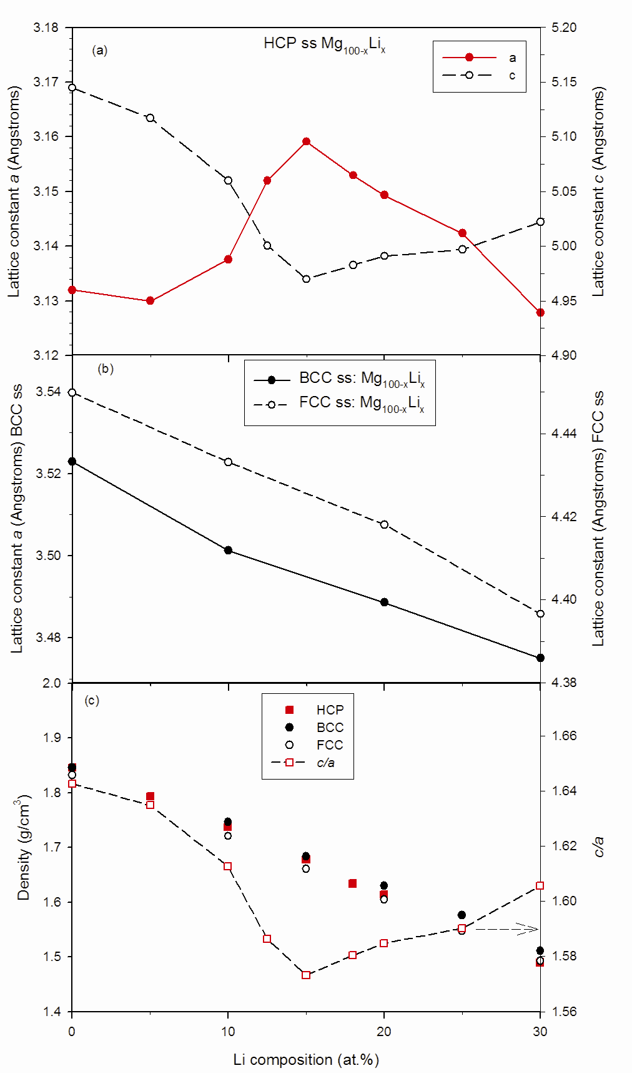 |  | 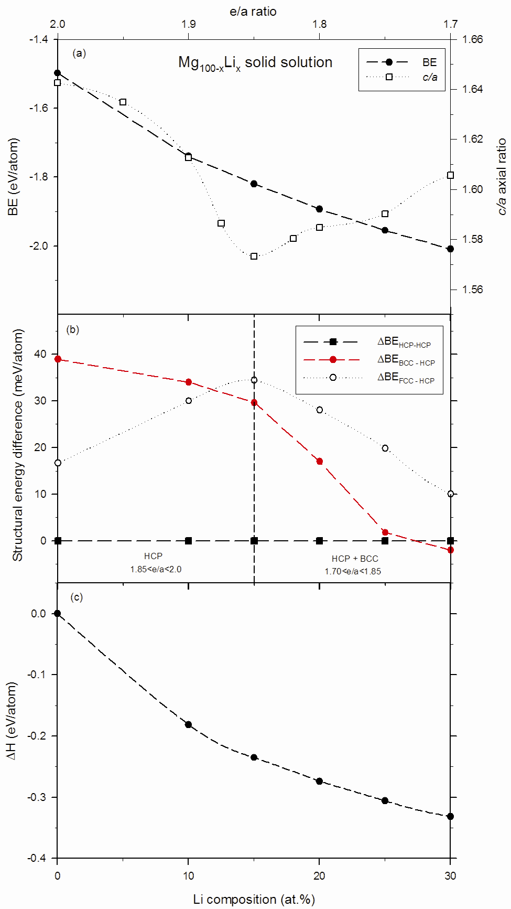
Figure 2. (a) Lattice parameters for HCP Mg_{100-x}Li_{x}, (b) corresponding c/a ratio and theoretical density, (c) lattice parameters for cubic Mg_{100-x}Li_{x} solid solutions. |  | Figure 3. The calculated (a) binding energy for Mg_{100-x}Li_{x}, (b) structural energy difference with respect to HCP lattice and (c) heats of formation at equilibrium. The plotted binding and formation energy were calculated from the most stable phase at every composition.

Our lattice parameter variation of BCC Mg_{100-x}Li_{x} solid solutions are in agreement with earlier experimental results of Levinson, Herbstein and Averbach [26-28] at least up to 70:30 composition.
  - Phase stability

The calculated binding energy, structural energy difference with respect to HCP lattice and heats of formation of HCP, FCC and BCC Mg_{100-x}Li_{x} solid solutions are plotted against Li composition in figure 3(a), (b) and (c), respectively. As shown in figure 3(a), the binding energy decreases rapidly with Li composition. In terms of the structural energy difference, as presented in figure 3(b), pure Mg is most stable in HCP structure with large difference in atomic energies of the three phases. In addition, the phase stability trend is similar: HCP-FCC-BCC. However, on Li addition, the energy difference between HCP and FCC lattice widens until reaching maximum at 15 at.% Li while at the same time that between HCP and BCC narrows. Even though after 15 at.% Li composition, the HCP-FCC energy difference begin to reduce, it is still larger than that between HCP and BCC lattices. Between 15 and 30 at.% Li, HCP-BCC energy difference decreases rapidly until BCC lattice becomes more stable at 30 at.% Li. This behaviour is in accordance with experimental observations that 30 at.% (11 wt.%) Li is required to induce a crucial HCP to BCC structural transition [9, 29]. As shown in figure 3(c), the enthalpy of mixing for the most stable phase is plotted against variation in Li composition and e/a. Current results show that heat of mixing becomes more stable with Li addition, in agreement with Hafner’s calculations [30] and very close to the evaluations of Saunders [31] and those determined for liquid alloys [32]. In general, our results have been able to mimic reliable phase stability in the α, α+β and β regions of Mg_{100-x}Li_{x} solid solutions comparable to experiments and other theoretical results, especially the Jones-type analysis [6]. It follows from these results that the possible reason for finding positive mixing enthalpy for systems that have complete solubility lies in the equation used. In almost all these studies, the equation for calculating the heat of formation for ordered intermetallics phases is used. On contrary, if equation (2) is employed in such random systems, the correct heats of solution could be obtained.

  - Elastic properties

The elastic constants C₁₁, C₁₂, C₁₃ and C₃₃ of HCP and C₁₁, C₁₂ of cubic Mg_{100-x}Li_{x} solid solutions are plotted against Li concentration in figure 4(a) and (b), respectively. Since the elastic constant C₄₄ in both the HCP and cubic structures is directly linked to mechanical stability of crystals, it is presented in figure 5. As shown by filled and empty spheres in figure 4(a), the trends of C₁₁ and C₁₂ elastic constants, respectively, of HCP solid solutions are opposite to each other on addition of Li. Within the 15 at.% Li concentration range, C₁₁ increases while C₁₂ decreases, thus increasing mechanical stability
of HCP phase. This behaviour correlates to the anomaly of lattice parameter a and c observed in figure 2(a). Although C₁₁ begins to decrease while C₁₂ increases beyond this point, the trends are not reasonably smooth as evidenced by the fluctuations. On the other hand, the variations of elastic constants C₁₃ and C₃₃ are smooth and closely resembling the behaviour of C₁₂ and C₁₁, respectively. As for cubic phases in figure 4(b), the C₁₁ (filled spheres) of BCC solid solutions up to 20 at.% Li remains lower than C₁₂ (empty spheres) and thus confirming its instability in this region, except for strange behaviour at 10 at.% Li. However, above this composition the changes take an opposite turn, where C₁₁ becomes larger than C₁₂, which is indicative of mechanical stability. The elastic constants of FCC solid solutions, represented by filled (C₁₁) and empty (C₁₂) squares, show a smooth behaviour similar to C₁₂ and C₁₁, respectively, of HCP until up to 25 at.% Li. Within this concentration range the mechanical instability of FCC phase prevails since C₁₁ elastic constant is smaller than C₁₂. At 30 at.% Li the C₁₁ and C₁₂ are almost equal.

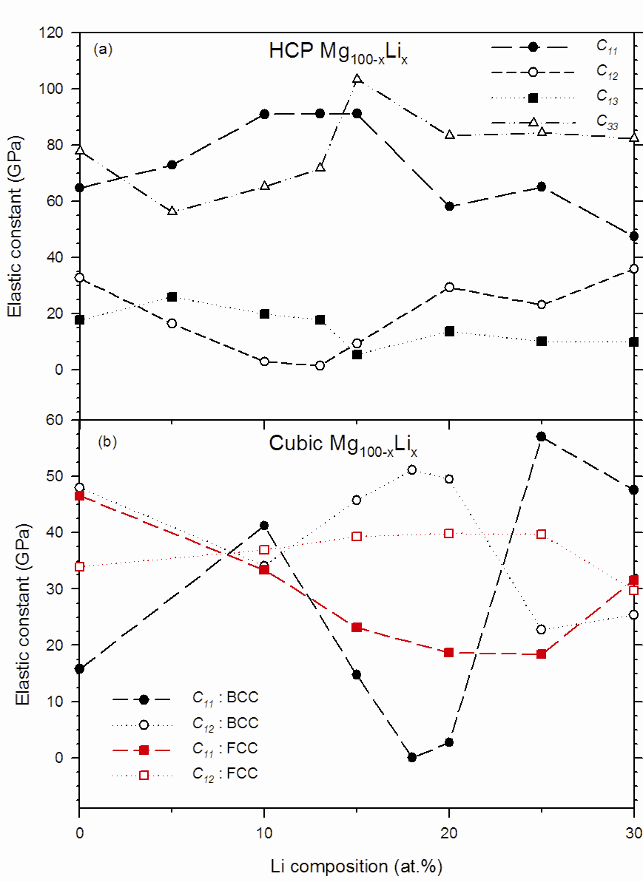 |  | 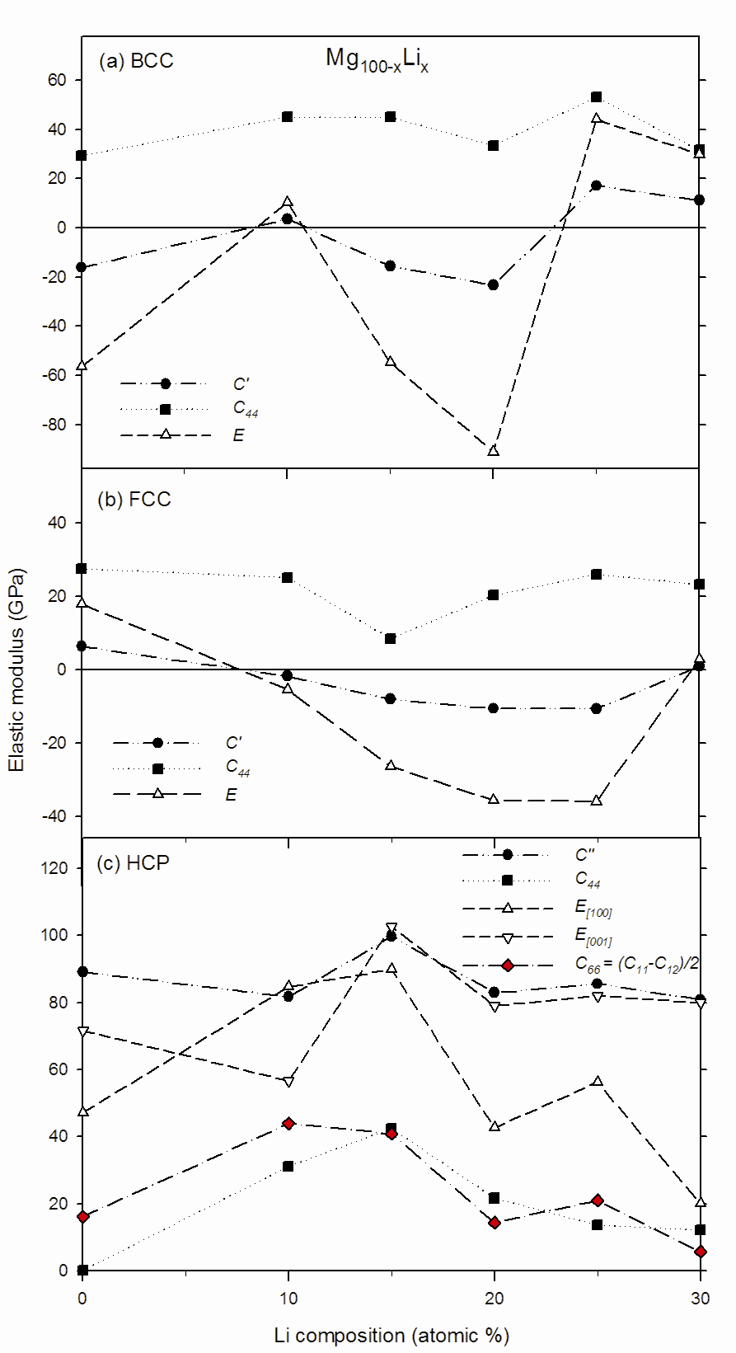
Figure 4. (a) Calculated elastic constants C₁₁, C₁₂, C₁₃ and C₃₃ for (a) HCP and C₁₁, C₁₂ for (b) cubic (FCC and BCC) phases of Mg_{100-x}Li_{x} solid solutions. |  | Figure 5. Predicted mechanical stability moduli for (a) BCC,  (b) FCC and (c) HCP Mg_{100-x}Li_{x} solid solutions.

As described previously, the mechanical instability can be depicted by the following elastic moduli becoming negative: tetragonal, trigonal shear modulus (C’, C₄₄), Young’s modulus (E); and Poisson’s ratio (ט) higher than 0.5. In figure 5, the predicted mechanical stability moduli (C’, C₄₄, E and C₆₆ for HCP) for (a) BCC, (b) FCC and (c) HCP Mg_{100-x}Li_{x} solid solutions are presented. As shown in figure 5(a), the C’ of BCC solid solutions is negative below 25 at.% Li, implying mechanical instability at those compositions. Except at 10 at.% Li composition, it is interesting to note that regions where C’ is positive correlate with concentrations at which BCC solid solutions are either very close or more stable than either HCP counterparts. It is also worth noting that the elastic constant C₄₄ remains positive on Li variation whereas E follows a trend similar to that of C’. Trends similar to those of BCC are observed for FCC Mg_{100-x}Li_{x} solid solutions. However, the mechanical instability of FCC-based solutions indicated by negative C’ and E are noted below 30 at.% Li. In BCC solid solutions, the elastic constant C₄₄ remains positive on Li variation whereas E follows a trend similar to that of C’. It thus follows from these elastic moduli results that C’ is much more reliable compared to C₄₄ in predicting the mechanical stability of cubic crystals. In figure 5(c), the changes of C₄₄, E_{[100]} and C₆₆ shear moduli for HCP solid solutions are similar while those of C’ and E_{[001]} also follows identical path on addition of Li. The mechanical stability of HCP solutions increased below 20 at.% Li as shown by , E_{[100]} and C₆₆ and reached maximum at 15 at.% Li after which it depreciated. It is quite interesting to note that the minima and maxima reported by Vaks and Trefilov [21] for elastic moduli C₄₄ and C’ in HCP, FCC and BCC Mg_{100-x}Li_{x} solid solutions correlate with compositions showing mechanical instability and stability, respectively, in the current work.

Other mechanical properties of interest, namely, the bulk modulus (B), Pugh’s ductility/brittles measure (B/G) and isotropic shear modulus (G) of HCP, FCC, BCC Mg_{100-x}Li_{x} solid solutions are presented in figure 6(a), (b) and (c), respectively. As shown in figure 6(a), B decreases monotonically with increase in Li composition despite the structure-type, in excellent agreement with almost all previous calculations. In the Mg-rich region, the bulk modulus seems to soften more for FCC solid solutions while it gets slightly harder between 25 and 30 at.% Li for BCC solid solutions. In general, the FCC Mg-Li alloys are more ductile above 25 at.% Li composition as shown by B/G ratio being above the critical value of 1.75, in figure 6(b). On contrary, the BCC and HCP Mg-Li alloys tend to be brittle with exception for 30 at.% Li composition in the latter. In addition, the isotropic shear modulus (G) correlates with mechanical stability on Li addition, as shown in figure 6(c). This conclusion emanates from the values of (G), which are negative for compositions which were found to be mechanically unstable in figures 4 and 5 and vice-versa.

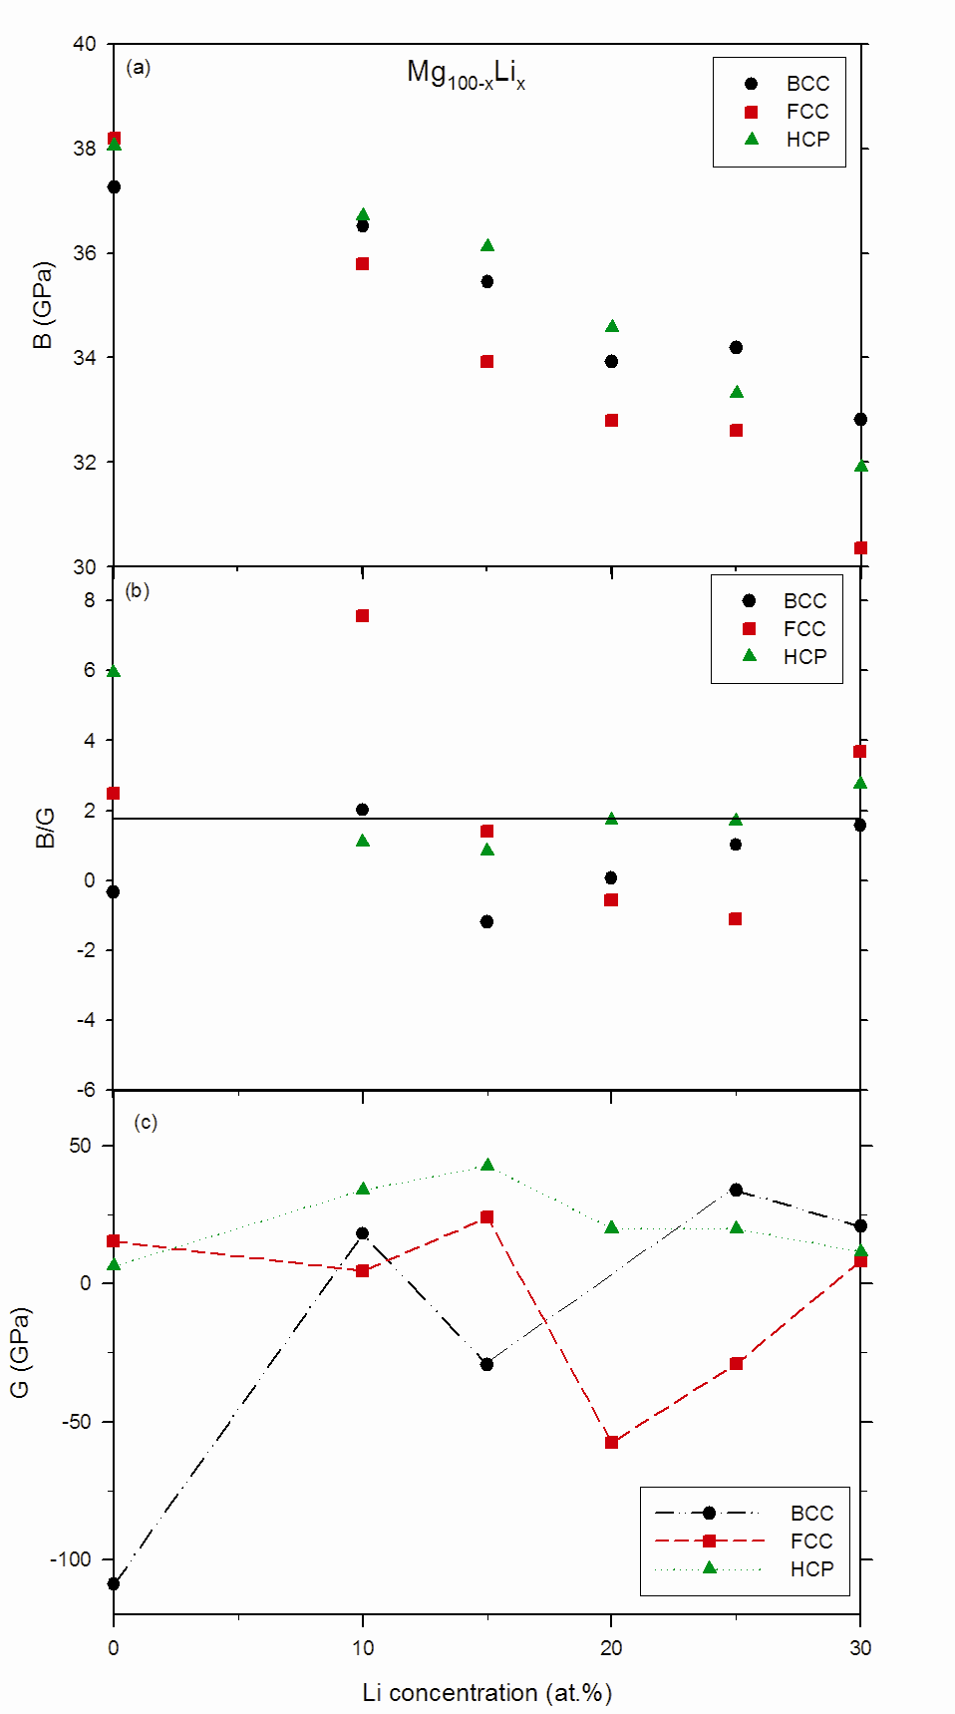 | Figure 6. Th calculated (a) bulk modulus (B), (b) Pugh’s B/G ratio, and (c) isotropic shear modulus (G) for HCP, FCC and BCC Mg-Li solid solutions.

- Conclusions

In summary, a DFT-based model for predicting phase stability and elastic properties of binary random alloys is proposed. The results predicted by the current model are in excellent agreement with experimental and theoretical results for random binary Mg-Li system. The predicted phase stability trends at 0K resemble those observed experimentally in Mg-Li phase diagram in α/α+β and α+β/β phase boundaries, more especially at lower temperatures. Furthermore, based on c/a and e/a ratio with respect to Li composition, it was shown that the β phase in the α+β region of the phase diagram is the high temperature martensitic phase due to low c/a phase while the β phase at and beyond 30 at.% Li is as a result of e/a ≤ 1.70 driven HCP→BCC phase transition. The mechanical properties of random binary Mg_{100-x}-Li_{x} alloys spanning the composition range 0 ≤ x ≤ 30 were predicted for the first time using DFT-based calculations and were found to be in excellent agreement with earlier experiments. The proposed model for random alloys is not only accurate but also less computationally expensive compared to traditional supercell approach. Following correct prediction of structural, cohesive as well as mechanical properties of binary Mg-Li alloys, this approach will enable researchers study other properties such surface properties of disordered binary Mg-Li alloys with ease.

- Acknowledgements

The authors acknowledge the CSIR and NRF for their financial support. The support of the South African Research Chair Initiative of the Department of Science and Technology and the National Research Foundation is highly recognised
6. References

[1] B.L. Mordike, T. Ebert. 2001 Materials Science and Engineering A 302 37
[2] A. Becerra, M.J. Pekguleryuz, 2008 Mater. Res. 23 3379
[3] Y.-M. Kim, I.-H. Jung, B. –J. Lee, 2012 Modelling Simul. Mater. Sci. Eng. 20 035005.
[4] W.A. Counts, M. Friák, D. Raabe, J. Neugebauer, 2009 Acta Mater. 57 69
[5] W.A. Counts, M. Friák, C.C. Battaile, D. Raabe, J. Neugebauer, 2008 Phys. stat. sol. (b) 245 2630
[6] M.J. Phasha, P.E. Ngoepe, H.R. Chauke, D.G. Pettifor, D. Nguyen-Mann, 2010 Intermetallics 18 2083
[7] C.P. Liang, H.R. Gong, 2010 J. Alloys Compd. 489 130
[8] R.H. Taylor, S. Curtarolo, G.L.W. Hart, 2010 Phys. Rev. B 81 024112
[9] T.B. Massalski (Ed.), Binary Alloy Phase Diagrams, ASM International, Metals Park (OH), 1992.
[10] M.J. Phasha, P.E. Ngoepe, 2012 Intermetallics 21 88
[11] M.D. Segall, P.L.D. Lindan, M.J. Probert, C.J. Pickard, P.J. Hasnip, S.J. Clark, M.C. Payne, 2002 J. Phys.: Condens. Matter 14 2717
[12] L. Kleinman, D.M. Bylander, 1982 Phys. Rev. Lett. 48 1425
[13] H. Zhang, S. Shang, J.E. Saal, A. Saengdeejing, Y. Wang, L.-Q. Chen, Z.-K. Liu, 2009 Intermetallics 17 878
[14] G. Ghosh, G.B. Olson, 2002 Acta Mater. 50 2655
[15] R. Labusch, 1972 Acta Metall. 20 917
[16] F.R.N. Nabarro, 1977 Phil. Mag. 35 613
[17] S. Kamran, K. Chen, L. Chen, 2009 Phys. Rev. B 79 024106
[18] J.F. Nye, Physical Properties of Crystals, Oxford University Press, Oxford, 1985.
[19] R. Hill, 1952 Proc. Phys. Soc. A 65 349
[20] J. Hafner, 2000 Acta Mater. 48 71
[21] V.G. Vaks, A.V. Trefilov, 1988 J. Phys. F: Met. Phys. 18 213
[22] F.E. Hauser, P.R. Landon, J.E. Dorn, 1956 Trans. ASM 48 986
[23] S.R. Agnew, J.A. Horton, M.H. Yoo, 2002 Metall. Mater. Trans. A 33 851
[24] W. Gasior, Z. Moser, J. Pstruś, 1998 Journal of Phase Equilibria 19 568
[25] H.W. King, 1966 J. Mater Sci. 1 79
[26] D.W. Levinson, 1955 Acta Met. 3 294
[27] F.H. Herbstein, B.L. Averbach, 1956 Acta Met. 4 407
[28] F.H. Herbstein, B.L. Averbach, 1956 Acta Met. 4 414
[29] J.H. Jackson, P.D. Frost, A.C. Loonam, L.W. Eastwood, C.H. Lorig, 1949 Metals
Trans. AIME 185 149
[30] J.J. Hafner, 1976 Phys. F 6 1243
[31] N. Saunders, 1990 CALPHAD 14 61
[32] V.P. Mashkovetz, L.V. Puchkov, 1965 Zh. Prikl. Chem. 1875

