Analysis of temperature dependent *I-V* characteristics of Pd/n-4*H*-SiC Schottky barrier diodes and the determination of the Richardson constant in a wide temperature range

V E Gora1, F D Auret2, H T Danga2, S M Tunhuma2,, C Nyamhere1, F Mazunga1, and A Chawanda1

1Department of Physics, Midlands State University, P. Bag 9055, Gweru, Zimbabwe 2Deparment of Physics, University of Pretoria, Pretoria 0002, South Africa

goraelifas@gmail.com

**Abstract**. The current voltage (*I-V*) characteristics of Pd/n-type 4*H*-SiC Schottky barrier diode in the 300-800 K temperature range have been analysed. Barrier height and ideality factor were found to be strongly temperature dependent. Barrier height was observed to increase whilst ideality factor decreased with an increase in temperature and the conventional activation energy plot showed some deviation from linearity. This was attributed to barrier inhomogeneities at the metal-semiconductor interface which resulted in a distribution of barrier heights at the interface. From the modified Richardson plot, the Richardson constant, A** was found to be 155 A cm-2K-2 and 87 A cm-2K-2 in the 300-525 K and the 550-800 K temperature ranges respectively.

1. Introduction

Schottky barrier diodes (SBDs) made on 4*H*-SiC have been commercially available for a considerable time but their properties and applications are still not thoroughly understood [1]. Consistent control of metal contact properties is yet to be established so as to optimize reliability [2]. As a result, the inability to physically reproduce the Schottky barrier height is a technologically important concern which is continuously being researched.

In past studies, analysis of current-voltage-temperature, (*I-V-T)* characteristics of SBDs using the thermionic emission theory have revealed unexpected behavioral trends in barrier height and ideality factor with temperature and lower than expected values of the Richardson constant [3]. These deviations have been attributed to the presence of inhomogeneities at the metal-semiconductor interface which have been speculated to be due to doping concentration irregularities, high interface state density and surface defects among other reasons [4].

One well consolidated approach to explain the observations has been proposed by Song followed by Werner and Guttler. It is called the potential fluctuations model and it assumes that the metal-semiconductor interface has roughness at atomic level [5]. In this article the forward bias *I-V* characteristics of Pd/n-4*H*-SiC SBDs were studied on the basis of Werner`s model. The data was analyzed assuming a Gaussian distribution (GD) of barrier heights to yield information on the temperature dependence of Schottky diode parameters in the 300-800 K range. This temperature range is the widest to be investigated when compared to previous studies. Further, palladium is known to form silicides in the 673-873 K temperature range [6]. Therefore we set out to observe if the reaction phase had an impact on the *I-V* characteristics as temperature increased.

1. Experimental procedure

Nitrogen doped n-type 4*H*-SiC wafers supplied by Cree Inc were used. The wafers consisted of an epitaxial-layer of net doping density 7 × 1015cm-3 grown on a SiC substrate with a doping density of 1018 cm-3. Samples were cut and cleaned by first degreasing through boiling in tetrachloro-ethylene, acetone and methanol. Thereafter, the samples were etched by dipping in 2% hydrofluoric acid solution for 60 seconds.

An ohmic contact was formed by resistively depositing 3000 Angstroms of nickel on the sample backside (1018cm-3) at 1.3 × 10-6 mbar, followed by thermal annealing at 950oC for 10 minutes in flowing argon gas at a rate of approximately 3dm3/min. Afterwards, the cleaning procedure was repeated for the epitaxial layer but instead of boiling the samples were placed in an ultrasonic bath.

Circular palladium Schottky contacts, 0.6 mm in diameter and 500 Å thick were thermally evaporated through a metal mask. Temperature dependent *I-V* and *C-V* measurements were carried out at 25 K intervals continuously in the 300 K-800 K temperature range in a HFS600E-PB4 temperature controlled stage made by Likam scientific instruments.

1. Results and discussion
   1. Temperature dependence of the forward bias *I-V* characteristics.

Assuming pure thermionic emission, the *I-V* relationship across a Schottky barrier for (*V* >3k*T*/*q*) can be given by [7].  (1)

where *A* is the diode area, *A*\* is the effective Richardson constant (= 146 A cm-2K-2 for n-4*H*-SiC), *V* is bias voltage, *n* is ideality factor, *ϕBo* is the effective barrier height and *T* is temperature. *I*s is the saturation current which is the intercept of a ln *I* versus *V* curve given by the prefactor of the first exponential in Equation 1 [8]. *ϕBo* is calculated as  (2)

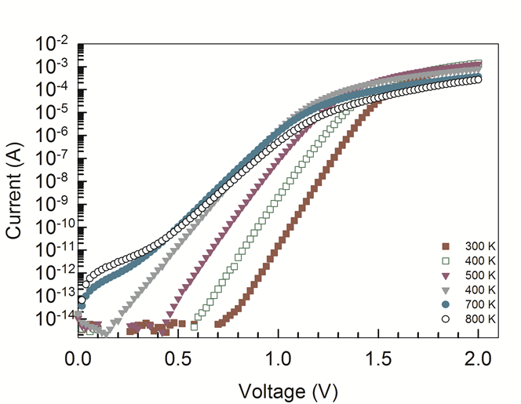

Figure 1. Semi-logarithmic forward bias *I-V* curves as a function of temperature for Pd/*n*-4HSic Schottky barrier diodes.

Figure. 1 shows the semi-log characteristics in the 300-800 K temperature range. The curves have linear regions in the intermediate bias regions where least squares fits of Equation 1 have been performed. *n* is determined from the slope of these fits. The *I-V* plots shift towards high bias voltage with decreasing temperature. In Figure 2 the variation of zero bias barrier height is plotted as a function of temperature. It increases with increase in temperature an observation which contradicts the negative temperature coefficient of n-4*H*-SiC. *ϕBo* increased from 1.42 eV at 300 K to 2.27 eV at 800 K.

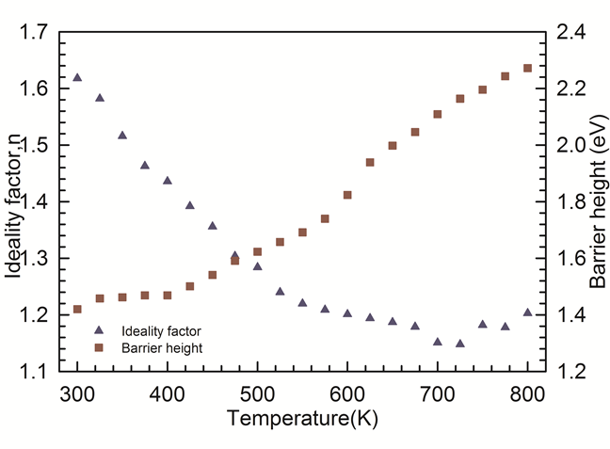

Figure 2. Ideality factor and *I-V* barrier height as a function of temperature for Pd/*n*-4HSiC Schottky barrier diodes in the 300-800 K temperature range.

Temperature dependence of the barrier height is to be expected since current transport across the Schottky barrier is a thermally activated process. However, the negative temperature coefficient means that the barrier height should be higher at low temperatures as at such the electrons will have lesser energy to surmount the barrier.

The ideality factor, *n* decreased with increasing temperature from 1.62 at 300K to 1.15 at 700 K to 1.20 at 800 K. Such a trend of *n* is unexpected since it has shown linear correlation with *ϕ*I-V in past studies [9]. We speculate that this is due to the formation of the Pd3Si phase during silicidation of silicon carbide in the 673-873 K range [6]. The variation of *n* in the 300 -700 K range can be attributed to series resistance and generation recombination current.

* 1. The Richardson constant

The Richardson plot (ln(*I*S/*T*2) vs 1000/*T*) is shown in Figure 3. Such a plot is obtained after linearizing Is from Equation 1. Two linear regions are exhibited. At high temperatures there will be enough energy for the current to flow through high barriers whilst at low temperatures the current will preferentially flow through low barriers, in the potential distribution [10]. The activation energy, *Ea* and A* were obtained from the slope and intercept respectively.

In the 300 - 525 K region the values of *Ea* and A* were obtained as 1.13 eV and 1.5 × 10-3 A cm-2K-2 and for the 550 - 800 K region they were 0.35 eV and 3.4 × 10-11 Acm-2K-2 respectively. These values of A* are much lower than the theoretical widely accepted value of   
146 Acm-2K-2. This difference has been attributed to barrier height inhomogeneities. To correct for barrier height inhomogeneities, a discrete system of lower barriers embedded in a background uniform barrier has been proposed. These can be explained by introducing a Gaussian distribution of barrier heights with a mean value and standard deviation *σ*s as

 (3)

where 1/σS√2π is the normalization constant. P(*ϕB*) is the normalized distribution function giving an occurrence probability of *ϕB*.

|  |  |
| --- | --- |
|  |  |
| Figure 3. Richardson plot for Pd/*n*-4*H*-SiC Schottky barrier diodes in the 300-800 K temperature range | Figure 4.Zero bias apparent barrier height versus q/2kT for Pd/n-4H-SiC Schottky barrier diodes according to the Gaussian distribution of barrier heights. |

Thermionic emission current is integrated with an individual barrier height weighted by the Gaussian distribution function to obtain the total current. The obtained apparent barrier height, *ϕBo* is given by  (4) It is assumed that the modified Schottky barrier height and *σs* are linearly bias dependent on Gaussian parameters such as and standard deviation where *ρ*2 and *ρ*3 are voltage coefficients which quantify the voltage deformation of the barrier height [5, 13]. The temperature dependence of *σ*s is negligible.

Figure 4 obtained from equation (4) shows two distinct straight lines with transition happening at 525 K. A linear fit of the apparent barrier height which obeys Equation 9 is shown in Figure 4. The plot should be a straight line that gives *ϕBo* and *σs* which are Gaussian parameters from the intercepts and slopes respectively. From Figure 4, the values of *ϕBo* and *σs* are 1.90 eV and 0.162 V in the 300 - 525 K range and *ϕBo* and *σ*s are 3.64 eV and 0.429 V in the 550 - 800 K range respectively. This observation indicates the presence of a double Gaussian distribution of barrier heights in the contact area. The lower the *σs* the more homogeneous the barrier height is and the better the diode rectifying performance [14].

* 1. The modified Richardson plot

To correct for the discrepancy in Figure 3, and yield a modified value of the Richardson constant closer to the theoretical value of 146 A cm-2K-2, Equation (2) can be rewritten according to a Gaussian distribution of barrier heights as [15].

 (5)

Based on equation (9) the modified Richardson plot of has been plotted in Figure 5.

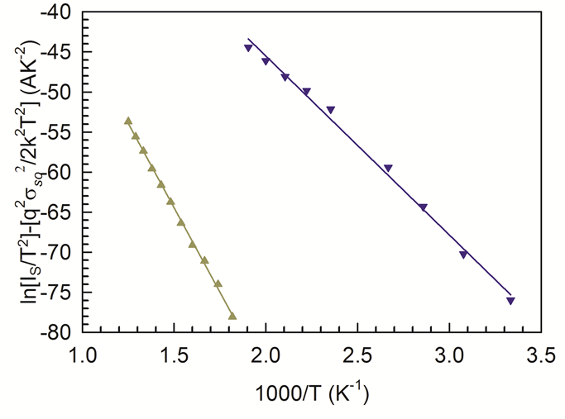

Figure 5. Modified Richardson plot for the Pd/*n*-4*H*-SiC Schottky barrier diodes according to the Gaussian distribution of barrier heights.

This plot takes into account the deviations of the barrier height and must give a straight line whose slope and *y*-intercept to yield a mean barrier height and a modified Richardson constant. From the two values of *σ*s calculated from Figure 4 in the 300 - 525 K temperature range and 550-800 K temperature range. The mean zero bias barrier heights were calculated to be 1.92 eV and 3.22 eV in the 300-525 K range and the 550 - 800 K ranges respectively. Also from the intercepts of Figure 5 the corresponding modified Richardson constants were obtained to be 155 A cm-2K-2 and 87 Acm-2K-2 in the 300 - 525 K and 550 - 800 K temperature ranges respectively. These values are within a reasonable range with the theoretically expected value of 146 Acm-2K-2.

The nature of the inhomogeneities contributes largely to these results and they may involve interface properties like composition/phase, quality, electrical charges and non-stoichiometry amongst others [16]. In the 300 - 525 K range the value obtained is a better approximation of the widely accepted theoretical value than the one in the 550 - 800 K range. The model that was used to calculate the 146 Acm-2K-2 value has limitations because it does not take into account quantum mechanical tunnelling unlike the one by Crowel et.al [17, 18]. As suggested by Pirri et.al an accurate Richardson constant must be calculated from a model that takes into account crystallographic anisotropy like the presence of extended defects in the material [17]. The effects of these could manifest more as the temperature increases providing activation energy thus affecting the Richardson`s constant at higher temperatures.

Close to 300 K carrier transport across the interface would be preferably through lower barriers in the potential distribution. The results indicate that thermionic emission is the dominant current transport mechanism whilst abnormal behaviours can be attributed to other current transport mechanisms.

1. Conclusions

*I-V* characteristics of Pd/4*H*-SiC Schottky diodes were analysed in the 300-800 K temperature range. *ϕ*I-V and *n* were found to be strongly temperature dependent. *ϕ*I-V increased with an increase in temperature a trend that disagrees with the negative temperature coefficient n-4HSiC. Corrections were done by assuming the presence of barrier height inhomogeneities at the metal-semiconductor interface and modelling them with a Gaussian distribution. The modified Richardson constant in the 300 - 525 K range was closer to the theoretical one showing the success of the Gaussian distribution in explaining temperature dependence of *I-V* characteristics in the 300 - 525 K temperature range. The lower value of the modified Richardson`s constant in the 550 K - 800 K range was attributed to the limitations of the model used for calculation of the widely accepted value of the Richardson constant.

References

[1] Ewing, D. J., Porter, L. M., Wahab, Q., Ma, X., Sudharshan, T. S., Tumakha, S., et al. 2007 Inhomogeneities in Ni∕4H-SiC Schottky barriers: Localized Fermi-level pinning by defect states. *Journal of Applied Physics* **101** 114514.

[2] Porter, L. M., & Davis, R. F.1995 A critical review of ohmic and rectifying contacts for silicon carbide. *Materials Science and Engineering: B*, **34** 83-105.

[3] Mayimele, M. A., Diale, M., Mtangi, W., & Auret, F. D. 2015 Temperature-dependent current–voltage characteristics of Pd/ZnO Schottky barrier diodes and the determination of the Richardson constant. *Materials Science in Semiconductor Processing*, **34** 359-64.

[4] Im, H. J., Ding, Y., Pelz, J. P., & Choyke, W. J. 2001 Nanometer-scale test of the Tung model of Schottky-barrier height inhomogeneity. *Physical Review B,* **64** 75310.

[5] Toumi, S., Ferhat-Hamida, A., Boussouar, L., Sellai, A,, Ouennoughi, Z., & Ryssel, H. 2009 Gaussian distribution of inhomogeneous barrier height in tungsten/4H-SiC (000-1) Schottky diodes. *Microelectronic Engineering*, **86** 303-9.

[6] Gentile, M., Xiao, P., & Abram, T. 2015 Palladium interaction with silicon carbide*. Journal of Nuclear Materials*, **462** 100-7.

[7] Özavcı, E., Demirezen, S., Aydemir, U., & Altındal, Ş. 2013 A detailed study on current–voltage characteristics of Au/n-GaAs in wide temperature range. *Sensors and Actuators A: Physical,* **194** 259-68.

[8] Hamida, A. F., Ouennoughi, Z., Sellai, A., Weiss, R., & Ryssel, H. 2008 Barrier inhomogeneities of tungsten Schottky diodes on 4H-SiC. *Semiconductor Science and Technology*, **23** 045005.

[9] Schmitsdorf, R. F., Kampen, T. U., & Mönch, W. 1997 Explanation of the linear correlation between barrier heights and ideality factors of real metal-semiconductor contacts by laterally non uniform Schottky barriers. *Journal of Vacuum Science & Technology B*, **15** 1221-6.

[10] Huang, L., & Wang, D. 2015 Barrier inhomogeneities and electronic transport of Pt contacts to relatively highly doped n-type 4H-SiC. *Journal* *of Applied Physics*, **117** 204503

[11] Werner, J. H., & Güttler, H. H. 1991 Barrier inhomogeneities at Schottky contacts. *Journal of Applied Physics*, **69** 1522-33.

[12] Acar, S., Karadeniz, S., Tuǧluoǧlu, N., Selçuk, A. B., & Kasap, M. 2004 Gaussian distribution of inhomogeneous barrier height in Ag/p-Si (1 0 0) Schottky barrier diodes. *Applied Surface Science*, **233** 373-81

[13] Gümüş, A., Türüt, A., & Yalçin, N. 2002 Temperature dependent barrier characteristics of CrNiCo alloy Schottky contacts on n-type molecular-beam epitaxy GaAs. *Journal of Applied Physics*, **91** 245-50.

[14] Demirezen, S., & Altındal, Ş. 2010 Possible current-transport mechanisms in the (Ni/Au)/Al0.22Ga0.78N/AlN/GaN Schottky barrier diodes at the wide temperature range. *Current Applied Physics*, **10** 1188-95.

[15] Beştaş, A. N., Yazıcı, S., Aktaş, F., & Abay, B. 2014 Double Gaussian distribution of barrier height for FeCrNiC alloy Schottky contacts on p-Si substrates. *Applied Surface Science*, **318** 280

[16] Rajagopal Reddy V., Janardhanam, V., Leem, C-H., & Choi, C-J. 2014 Electrical properties and the double Gaussian distribution of inhomogeneous barrier heights in Se/n-GaN Schottky barrier diode. *Superlattices and Microstructure,* **67** 242-55.

[17] Pirri, C. F., Ferrero, S., Scaltrito, L., Perrone, D., Guastella, S., Furno, M, et al. 2006 Intrinsic 4H-SiC parameters study by temperature behaviour analysis of Schottky diodes. *Microelectronic Engineering*, **83** 86-8.

[18] Crowell, C. R., & Sze, S. M. 1966 Current transport in metal-semiconductor barriers. *Solid-State Electronics*, **9** 1035-48.