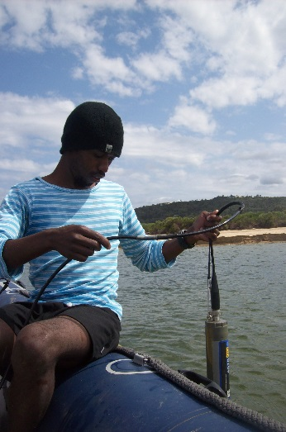 | Athi N. Mfikili.¹ received his BA (Geography) from Nelson Mandela Metropolitan University, Port Elizabeth, South Africa in 2011. He obtained his Honours in Environmental Management from the University of South Africa in 2014. While he was doing his Honours, Athi was doing internship at South African Environmental Observation Network, Elwandle Node through DST/NRF working on coastal wetland, particularly salt marshes of the southern Cape estuaries. After spending 18-month long with SAEON, Athi developed passion and interest about studying environmental drivers responsible for the development of salt marshes, as a result he currently enrolling MSc with Nelson Mandela Metropolitan University co-funded by SAEON and Inkaba YeAfrika Programme. His MSc research interest is on understanding “Influence of sedimentological and hydrological processes on the distribution of salt marshes in the Keurbooms Estuary, Western Cape, South Africa. [133 words]  .¹Department of Botany, Nelson Mandela Metropolitan University – Port Elizabeth, SA  Email: s208016013@live.nmmu.ac.za/ email address (private) athimfikili@gmail.com / Mobile +2773 210 2222  Supervisor(s) : Bornman, Thomas, Title Dr / e.mail address tommy@saeon.ac.za  Mikeš, Daniel, Title: Prof / email address: Daniel.mikes@nmmu.ac.za

