Student understanding of DC circuits: fine-grained issues
Ignatius John¹ and Saalih Allie²
Department of Physics, Cape Peninsula University of Technology, Cape Town¹
Department of Physics, University of Cape Town².
saalih.allie@uct.ac.za
Abstract. We report on a study with 60 first year physics students in which we made contextual changes to an “open circuit” in order to measure the effect of such changes to student’s responses. The 8 question instrument that we designed included representational, linguistic and (circuit) elemental variations. Our findings indicate that while the changes might appear trivial to an expert they significantly affect the way in which students respond.
- Introduction
It is a common experience that students have difficulty in dealing with basic DC circuits. Many studies have been carried out to probe the nature of these difficulties and many curricula try various innovative approaches to introduce the topic. See, for example [1, 2] and the references contained therein. However, it is not clear that the underlying reasons for these difficulties are clearly understood or that the issues are being addressed at a fundamental level. In particular, the degree of sensitivity to seemingly trivial contextual changes has not been well researched. It is common practice, for example, in many studies and laboratory approaches to assume that using the brightness of a light bulb as a proxy for current leads to results that can be generalized insofar as DC circuits are concerned. While this conclusion may indeed be consistent with a classic “misconceptions” view it is not clear that this is true from a “knowledge in pieces” perspective in which context and cognitive “grain-size” are key components. A comparison of these contrasting approaches can be found, for example, in ref. [3].
- Methodology The present programme of research is aimed at trying to probe some of these aspects by studying the response of students to situations in which seemingly small representational, linguistic and (circuit) elemental changes are made, which from an expert point of view have no bearing on the physics at hand.
  - Research questions The present study focuses on three aspects of the broader programme which are summarized in terms of the following specific research questions
    - To what extent does changing a resistor for a light bulb or a heating element affect student response?
    - To what extent does drawing the same circuit vertically or horizontally affect student response?

2.1.2. To what extent does the phrase “charge flow” elicit the same response as the term “current”?
2.2. Instrument
A series of questions based on an open circuit was developed in which three circuit elements were interchanged with each other, namely, a resistor, a light bulb and a heater. These circuit elements were connected with a single wire to one end of a battery in either a horizontal or vertical configuration. The terms “charge flow”, “current” and “heat up” (or “light up”) were interchanged in the text for identical circuits. Thus, we developed a question bank of 120 questions that spanned the “question space” in a systematic manner. For the purposes of the present study 8 questions were selected as shown in the table 1 below. (Sample question is given in figure 1). The table is arranged so as to facilitate comparison both across the rows and down the columns.

Table 1: The eight questions used in the prob. In the horizontal rows the words are being changed and in the vertical columns the elements are being changed.
Q 1  A  B  B  A  A  B  B  A  A  B  B  A  B  A  B  A  B  A  A  B  A  B  “will the bulb light up” | Q 2  “will charge flow in the bulb” | Q 3  B  A  “will there be current in the Bulb”
Q 4  “will the heater heatup” | Q 5  “will charge flow in the heater” | Q 6  “will there be current in the heater”
 | Q 7  “will charge flow in the resistor” | Q 8  “will there be current in the resistor”
The pattern of contextual differences between questions across the rows and the columns can be summarized as follows. With regard to the rows, Row 1 shows 3 questions each consisting of identical scenarios. Each scenario shows two variations of the same circuit, one orientated vertically the other horizontally, comprising one end of a battery connected to a light bulb with a single wire. In the vertical cases the battery is connected to the bottom of the bulb while in the horizontal cases the battery is connected to the side of the bulb. The key variation in each question is the wording of the accompanying text as indicated. Row 2 shows what are essentially the same circuits as in Row 1 but with the bulbs replaced by heaters. In the vertical cases the battery is connected to the bottom of the heater while in the horizontal cases the battery is connected to the top of the heater. The key variation across the row again lies in the text as indicated. Row 3 shows 2 questions each consisting of identical scenarios. Each scenario shows the same circuit configuration but orientated either vertically or horizontally in which one end of a battery is connected to a resistor with a single wire. In both vertical and horizontal cases the battery is connected to the bottom of the resistor. The key variation in each question is the text as indicated. The reason for no scenario being depicted in column 1 is that there is no text that is equivalent to “light up” or “heat up” in the case of the resistor.

If we consider the columns, Column 1 shows 2 scenarios in which the bulb is changed to a heater and the text “light up” is changed to “heat up”, respectively. In addition the point of connection (in the horizontal circuit) to the circuit element is varied from middle (bulb) to top (heater). Column 2 shows 3 scenarios in which the text “is there charge flow” is the same in each case but the circuit element (bulb, heater, resistor) changes. In addition the point of connection to the circuit element is varied (middle-bulb, top-heater, bottom-resistor). Column 3 shows 3 scenarios in which the text “is there current” is the same in each case but the circuit element changes (bulb, heater, resistor). In addition the point of connection to the circuit element is varied (bulb-middle, heater-top, resistor-bottom).

One student connects a light bulb to a battery as shown in figure A. Another student connects the light bulb to a battery as shown in the figure B. The following discussion takes place among the students.
Student 1 says “The bulb in figure A will light up but not the bulb in figure B!”
Student 2 says “No! The bulb in figure B will light up but not the bulb in figure A”
Student 3 says “I disagree! Both bulbs will light up!”
Student 4 says “No! None of the bulbs will light up!”
Student 5 says “I have another idea which I will explain to you!”

With whom do you most closely agree? Circle only one of 1, 2, 3, 4 or 5.

1
2
3
4
5
A
B

Explain the reasons for your choice in detail below.

Figure 1: Question format followed by all questions.

Each question was presented as a situation involving a discussion among a group of students who are posited to be setting up a circuit. A number of different points of view are articulated by the students and offered as options for which (a) a particular option has to be made and (b) the reason for the option has to be provided in detail. In total five options were presented of which the fifth allowed for ideas that were not offered. The response options were presented in a manner that the correct answer was not the same number (1-5) for each question. Figure 2 shows an example of a question in detail.

2.3. Sample
The sample consisted of 60 first year degree students in the extended programs in various courses in the science faculty and was doing Physics1. All these students passed physical science in Grade 12 but they had not received any formal instruction on DC circuits at the university. The majority of the students were from rural schools, aged about 18 years, and for whom English is second or third language. These students are the first group of students who passed matric in 2008 having followed the new Outcomes Based Education curriculum.

2.4. Presentation of the instrument
The questionnaire was presented to the students during a physics practical afternoon session. Students were informed that “we are developing a new curriculum for the 1st years; hence we want to know your basic knowledge in electricity, so that we can develop a suitable curriculum for you. So please answer these questions as sincerely as possible so that we can help you to prepare for your exam”. Six students completed the questionnaire in five minutes while 5 took more than twenty minutes to complete the questionnaire.
3. Results
Analysis of the data comprised two phases. In the first phase only the numerical choices were analysed while the second phase considered the free response writing. Results from the data in which only the numerical choice was analysed are summarised in Table 3. The four different options given in the questions are symbolically represented in the table. The square represents option 1: (element in circuit A will activate), the rhombus represents option 2: (element in circuit B will activate), the triangle represents option 3: (elements in circuits A & B will activate) and the closed circle represents option 4: the correct answer in that “none of the circuits will activate”, since all the circuits are open. Each of the 60 rows in Table 3 represents the 8 answers of a particular student.

From the table it can be seen that only 15% of the sample (the first 9 rows of closed circles) chose the correct answers for all 8 questions. In the remaining cases answers can be seen to be changing from one question to another. We then analysed the different types of reasoning used by each student in answering the 8 questions. A number of different lines of enquiry ensued from these results of which we present the following one. Respondents were grouped on the basis of the number of reasons used to explain their answers to the 8 questions. The results were as follows: 12 students used one reason to answer all the 8 questions, 16 students used two reasons, 13 used 3 reasons, 10 used 4 reasons, 6 used 5 reasons and 3 used 6 reasons. The situation is summarised in the bar graph shown in figure 2 where each bar represents the number of students in each group with the number of different reasons cited per individual student.

4. Discussion
In general students who used more than one explanation did not get all the answers correct.
Of the 12 students who used only one reason, 9 of them answered all the 8 questions correctly. Eight students of these 9 students who based their reasoning on only one concept appeared to consider the circuit as a whole as the unit of reasoning, using the following words (verbatim)

1. Incomplete circuit.
2. Both positive and negative should be connected.
3. Only one end of the battery is connected.
4. No circuit.
5. No closed circuit.
6. Open circuit.
Thus, only students who explicitly or implicitly used “circuit” reasoning got all 8 questions correct i.e. circuit reasoning provided a productive foothold for dealing with all the situations. (light bulb, heating element, resistor, charge flow, current, light up and heat up). In all the other cases where specific
Table 3: The eight columns represents the eight answers and each row represents the answers of each student.

features of the context were used as the primary foothold the resulting reasoning ended up with an incorrect conclusion.

In summary, individual student reasoning about circuits appears to depend strongly on contextual cues provided by the type of circuit elements and the words used. Many of them were influenced by the connection to the light bulb, either on the bottom of the bulb or the side of the bulb. A number of curious conceptions also surfaced amongst the reasons provided. For example, regarding resistors, ideas ranged from the notion that a resistor is a device that is used to connect different elements in the circuit, to notions that the resistor stores electricity or is used to stop current.

Clearly, prior knowledge and experience are playing a strong role in cuing the responses and focussing on a particular aspect of one of the circuit elements does not lead to productive reasoning for circuits as a whole. What we now wish to pursue is the issue of why a particular salient (to the student) feature is used as the starting point. It is of course likely that their responses are intimately related to previous sense-making experience but the details need to be investigated by direct interviews. However, it is already suggestive that any curriculum for teaching circuits might need to address previous experience in an explicit manner that can harness previous experience into a productive cognitive resource.
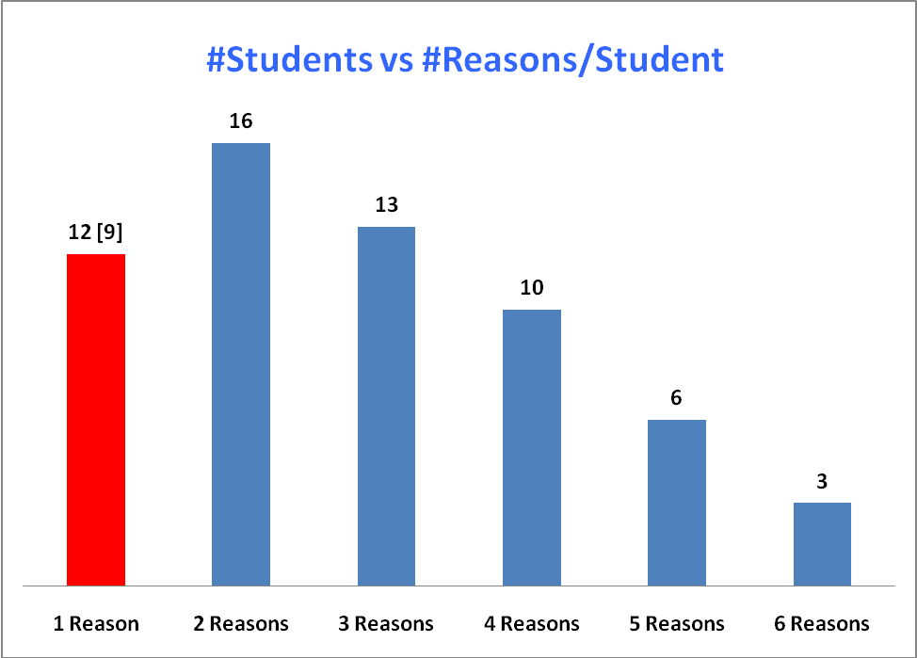
Figure 2: the number of students in six groups with different number of reasons.
References
- McDermott L.C and Shaffer P. S 1992 Research as a guide for curriculum development: An example from introductory electricity. Part l: Investigation of student understanding Am. J. Phys. 60 (11), 994-1000

- Engelhardt P V and Beichner RJ 1997 Examining students' understanding of electrical circuits through multiple-choice testing and interviews. Unpublished doctoral dissertation, North Carolina State University

- Rachel E Scherr 2007 Modeling student’s thinking: An example from special relativity..Am J Phys. 75 (3), 272-280

